Computer One Mobile Site Project

Eray Ozcan

C0700346

BootCamp Project

31 August 2017

**Computer One Mobile Site**

Computer One Mobile Site presents company products to all customers. Mobile Web site includes login page and registration page to register the online shopping, products page includes two different category Tablets and Laptops, Product details page for displaying detail information about selected product, Cart page for listing of cart contents and profile page is used for profile details changes.

Mobile Web Site software developed on four tier architecture. **jQuery** and **jQuery Mobile** is used for front end. Ajax web service call technique is used for reaching web services. Web services layer developed based on **RESTful** (Representational state transfer) web services architecture. **RESTful** services developed on java can run any platform or any computer architecture. On database site, **H2** in memory database is selected for quick response. RESTful web services developed on **Grails** framework and **Groovy** programming language.

**Mobile Website Details**

In this section, detail information and screen shots are given.

**Backend Development:**

Development Tools: Grails 3.3.0, Groovy 2.4.11, JVM JDK 1.8.0_141, Gradle 4.0.2 tools are used for web services.

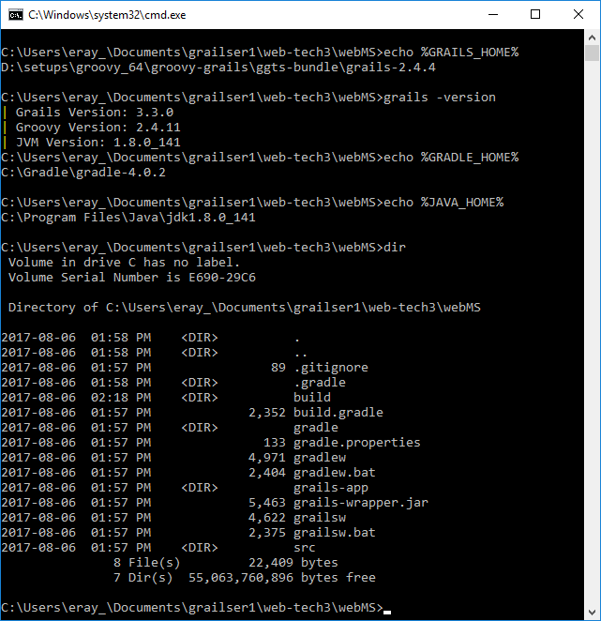

H2 database is used for database development.

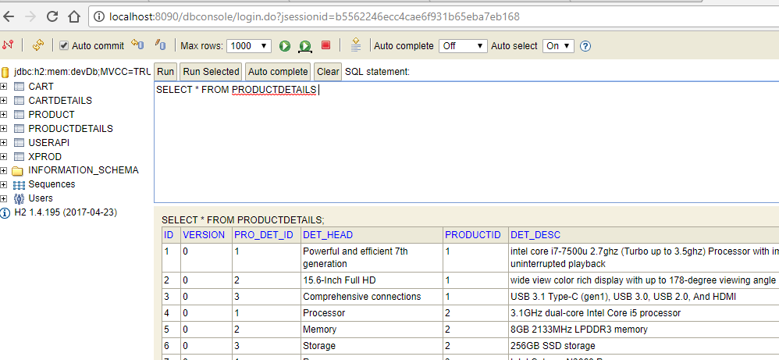

**Frontend Development:**

Development tools: jQuery Mobile 1.4.5, jQuery 1.11.1, Aptana Studio 3, HTML 5, Ajax

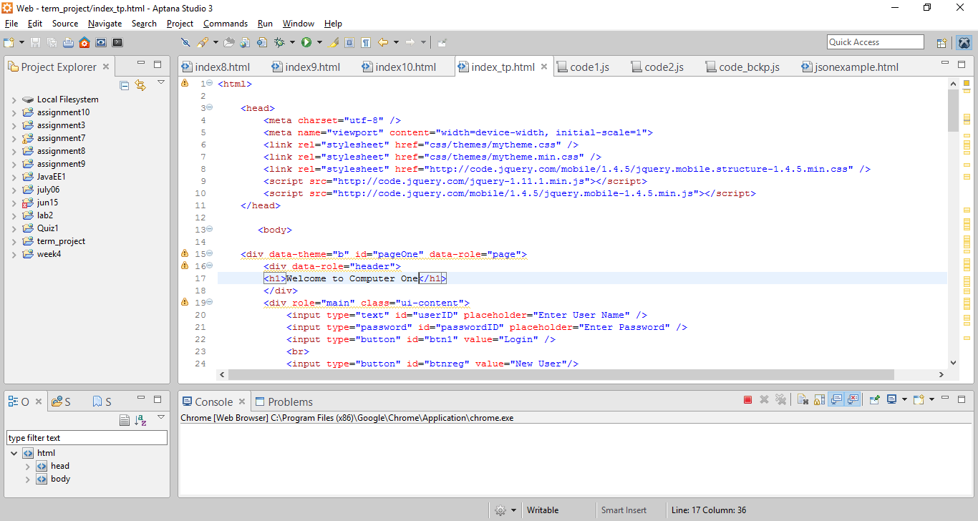

**Application:**

**Login page: New User Page:**

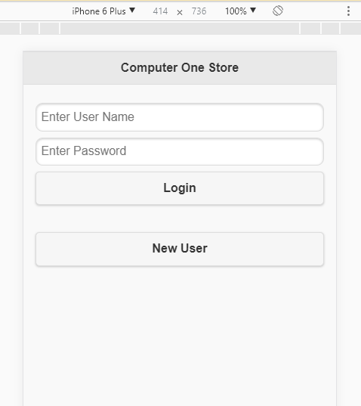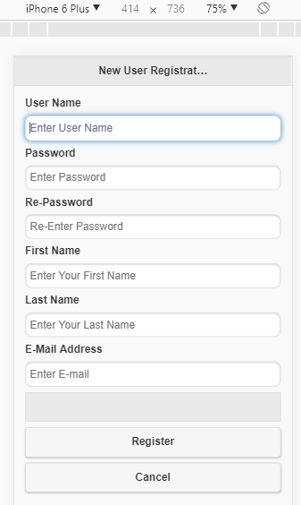

**Products Page: Product Details:**

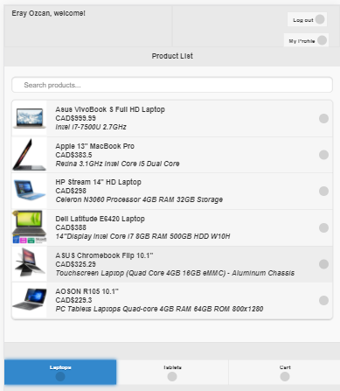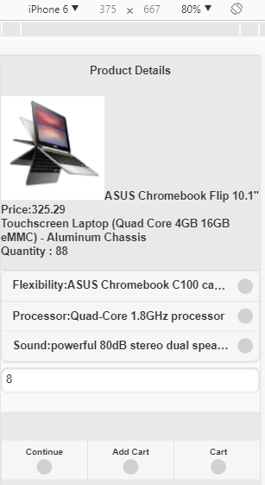

**Cart Page: My Profile Page:**

