Eray Tufan

150120204

Report

1. I calculated the histogram of the image and printed it to the screen. I used an array of size 256 for each color and for each pixel I added 1 to the equivalent color in the array.

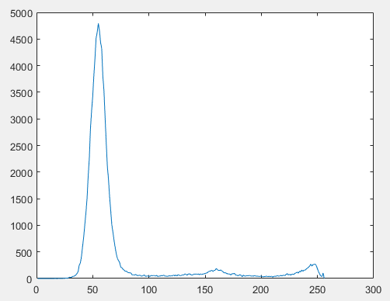

2. I created the threshold code and I added the image for different threshold values.

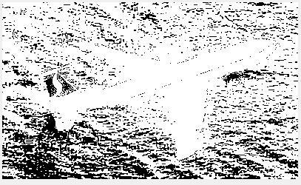

Şekil 1-threshold = 50

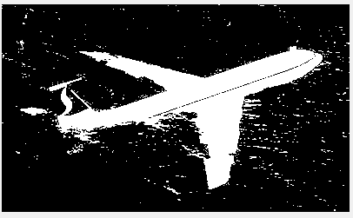

Şekil 2 threshold = 70

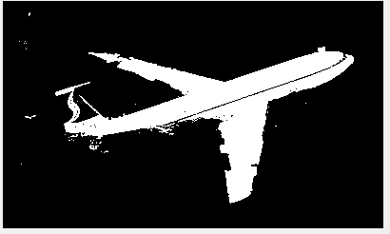

Şekil 3 threshold = 90



Şekil 4 threshold 140

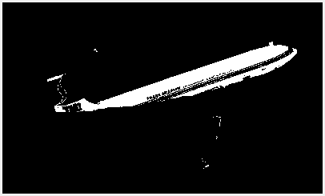

Şekil 5-threshold = 200

3. For each threshold value from 0 to 255 I found true positive, true negative, false positive and false negative values. From these values I used the formula and used the plot to ROC curve.

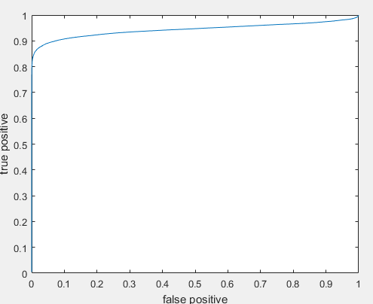

Şekil 6 ROC Curve

