Scenario Analyzer

0.0.5 Exercises

May 19, 2010

**EXAMPLE OPERATIONS**

1. ***Calculate drawdown and create map***

Run ScenarioAnalyzer.exe by double clicking on the executable.

Add a **New Map** by right-clicking in left pane of the window.

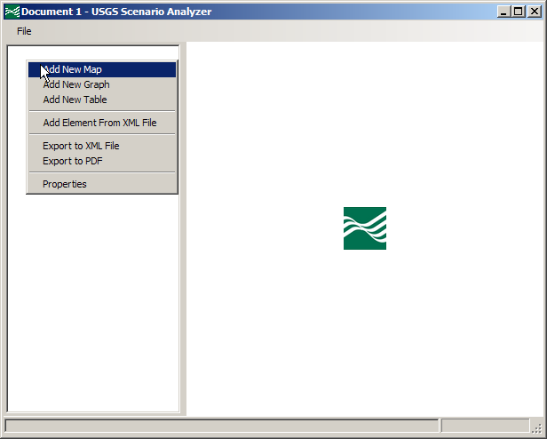

Name the map Drawdown and click **Ok**.

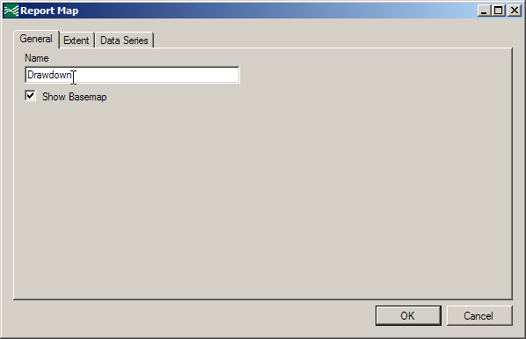

Add a **New Contour Layer** by right-clicking on the Drawdown Map item in the left window.

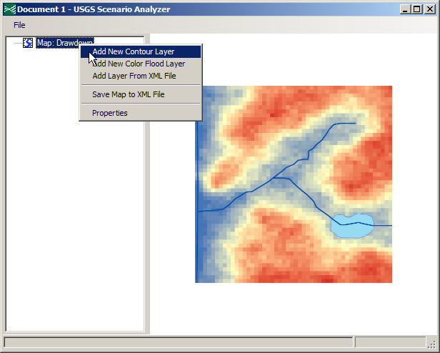

Name the contour data series Pump, set the data type to **Heads Map**, select the heads file   
*..\ PumpingResults\SWRSample08.hds*, select layer 1, stress period 10, and timestep 1.

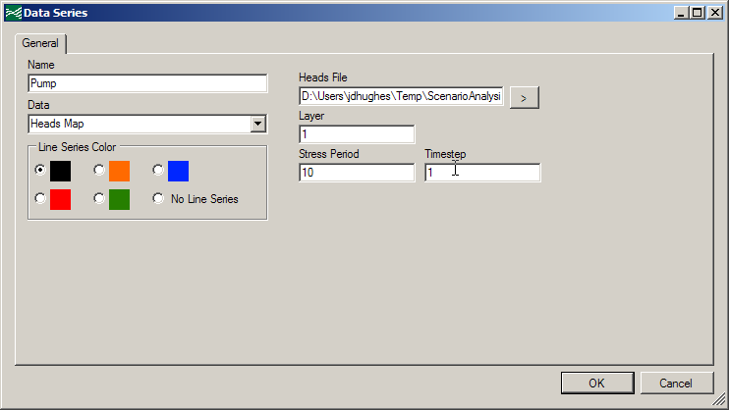

The layer you added will appear on the map preview.

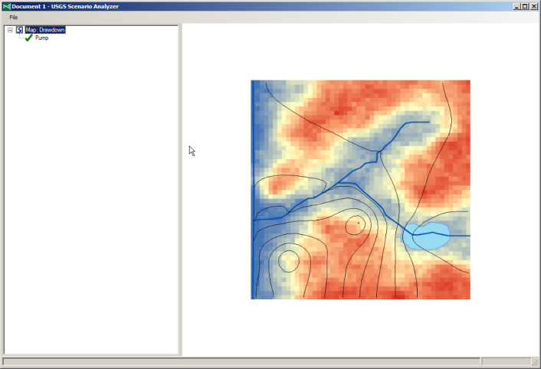

Add another **Heads Map** layer. Name this one No Pump and select the heads file in the *NonPumpingResults* folder.

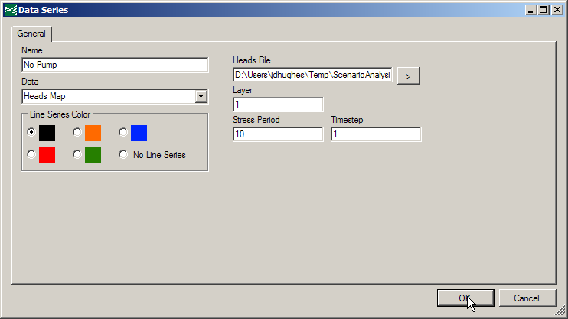

Add a **Dataset Calculator** layer named Drawdown. Choose red in the **Line Series Color** box. For the expression, input [No Pump] – [Pump]. You can input a layer name in the expression box by double-clicking on the layer name in the list.

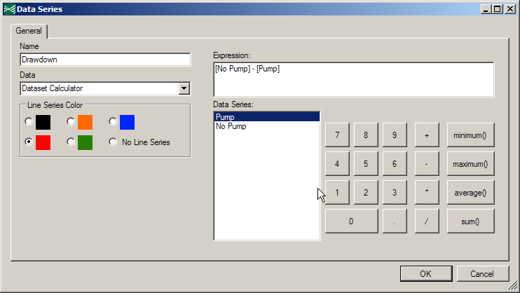

The Drawdown map will appear on your map.

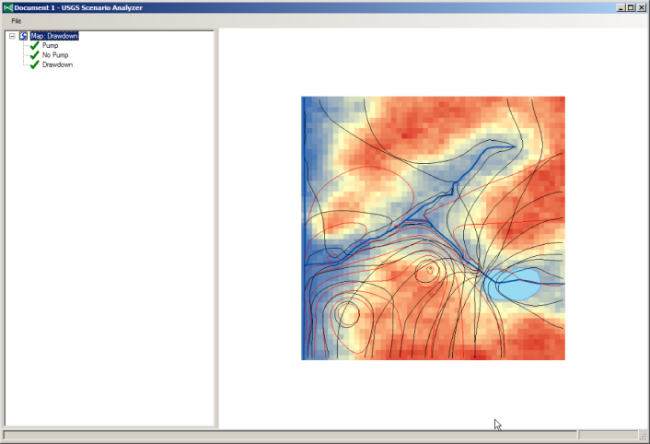

Select **Properties** in the Pump context menu. This will show the dialog box that you used before to configure this layer.

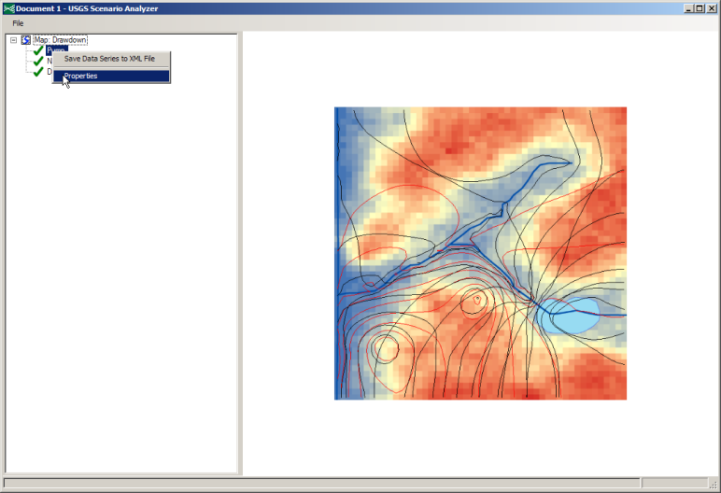

In the **Line Series Color** box, select **No Line Series**. Click **OK** and repeat this process with the No Pump layer.

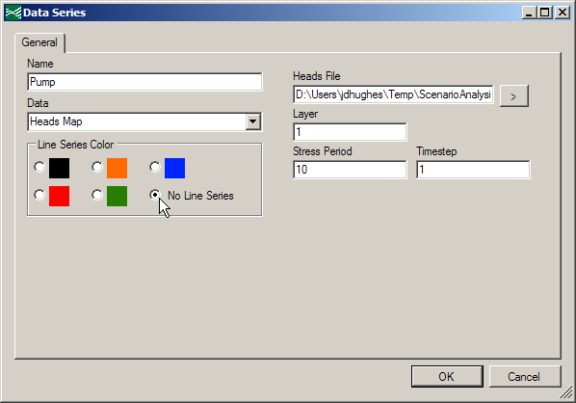

You now have a map that shows the drawdown for stress period 10, timestep 1 in this model.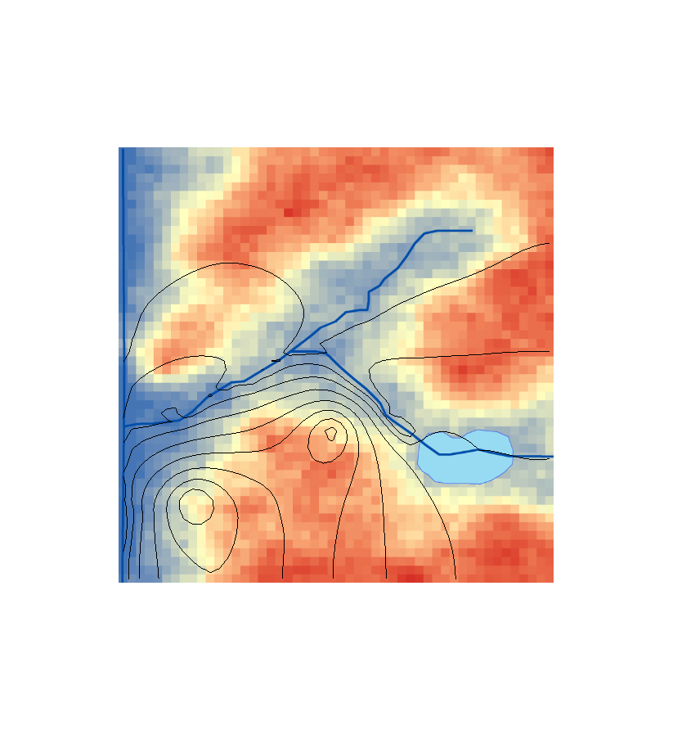

1. ***Create a color flood of heads for the pumping simulation for a subset of the model domain***

Add a **New Map** by right-clicking in left pane of the window.

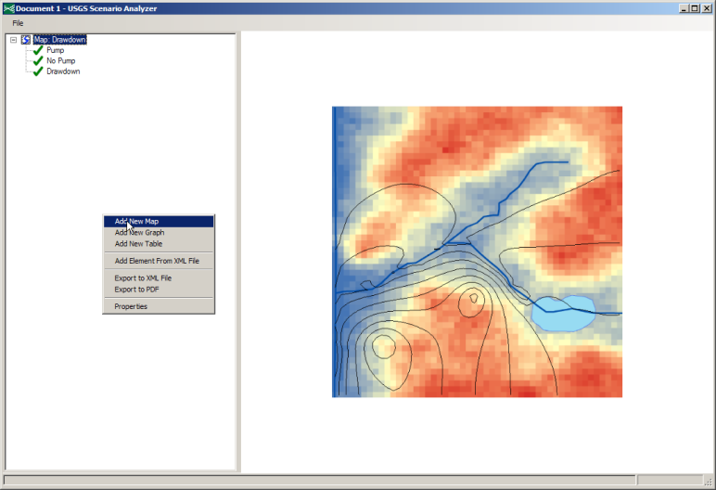

Deselect **Show Basemap** in the map dialog. Name the map Pumping Heads.

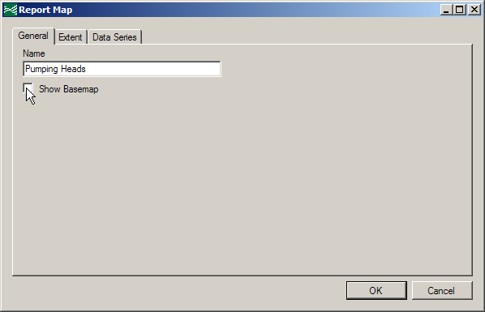

Select the **Extent** tab and change the **Extent** to **Manual** and the maximum value of the y range to 50.

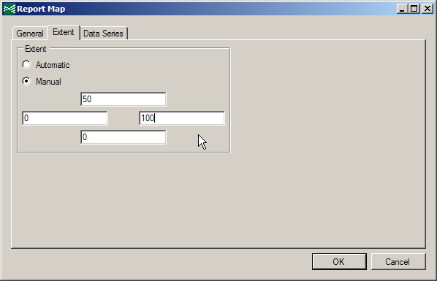

Add a **New Color Flood Layer** to your Pumping Heads map.

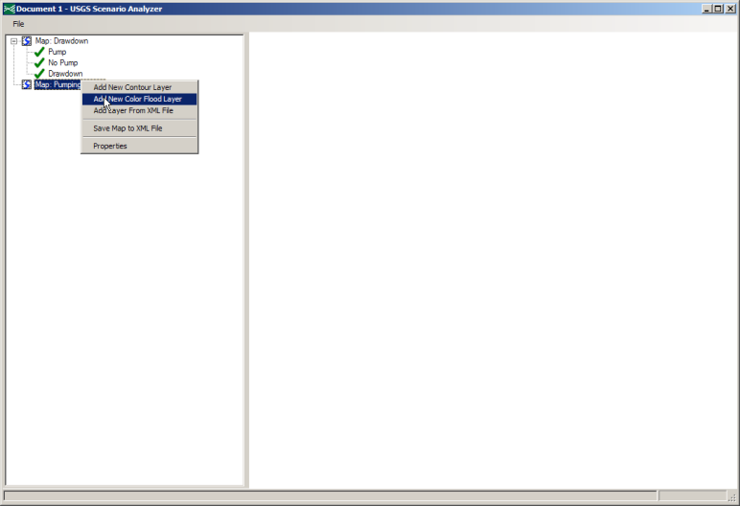

Create a **Heads Map** named Heads. Select the heads file in the *PumpingResults* folder and layer 3, stress period 10, and timestep 1.

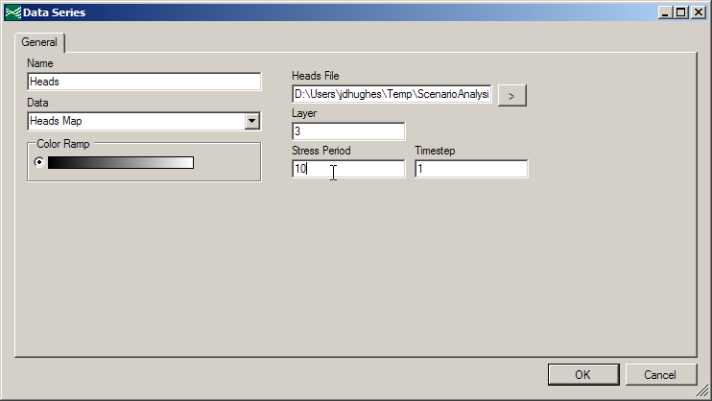

Add a **New Contour Layer** to your Pumping Heads map.

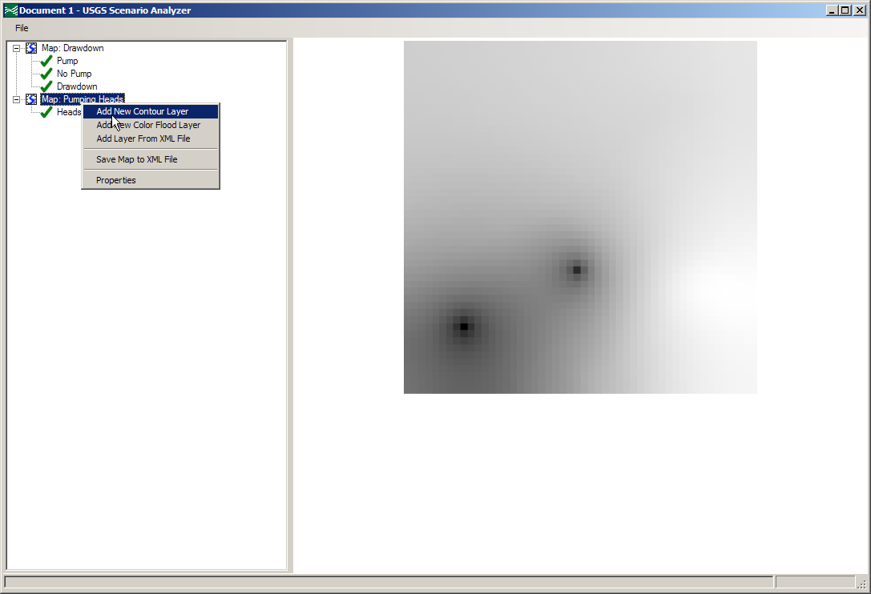

Name this layer Head Contour and choose the same data type, heads file, layer, stress period, and timestep as the previous layer. Choose a red line for **Line Series Color** (if you’re feeling really adventurous, you may even choose a green line).

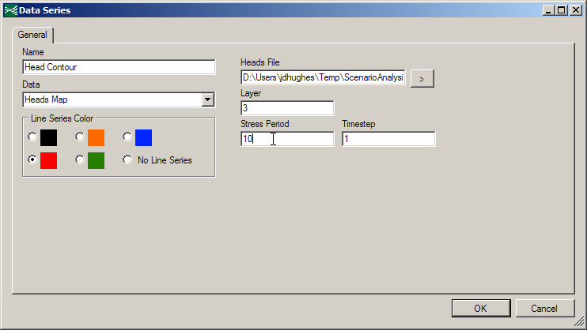

The Head Contour layer is not visible on your map preview. This is because it is being obscured by the Heads color-flood layer.

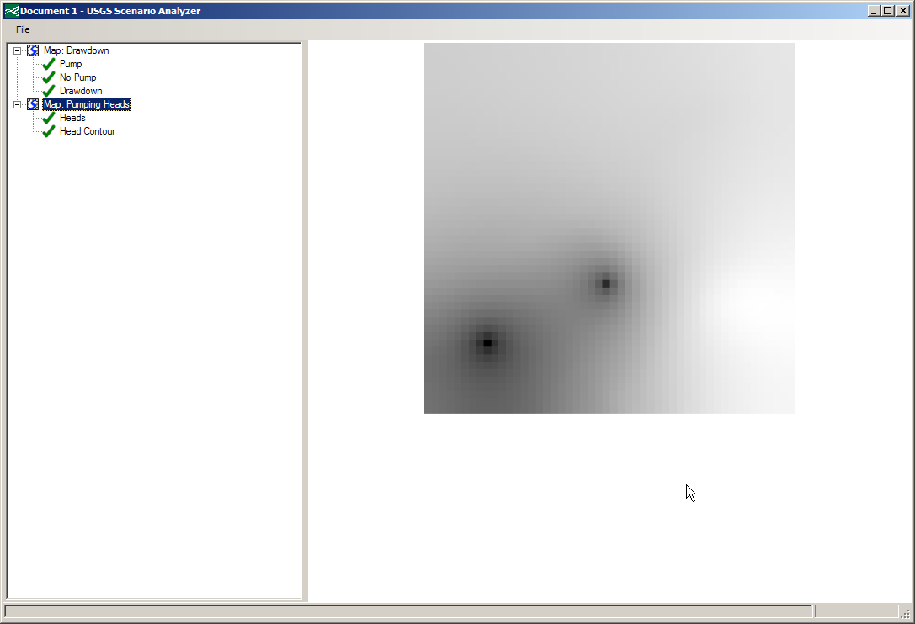

Open the **Properties** of the Pumping Heads map.

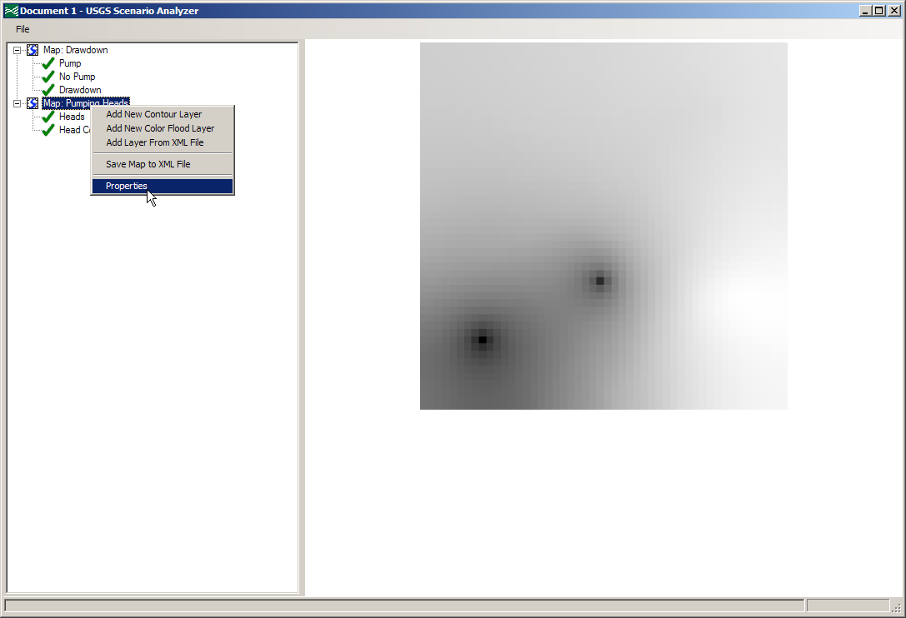

On the **Data Series** tab, select the Head Contour map and click the up arrow on the right side of the dialog.

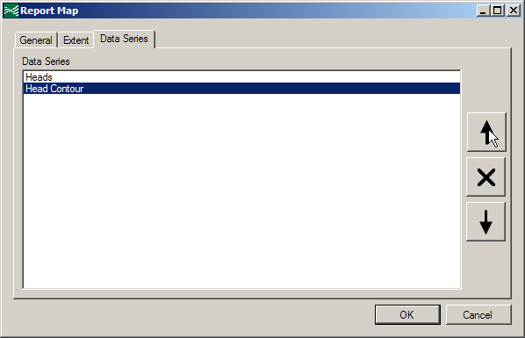

The Head Contour map will move up one position in the list.

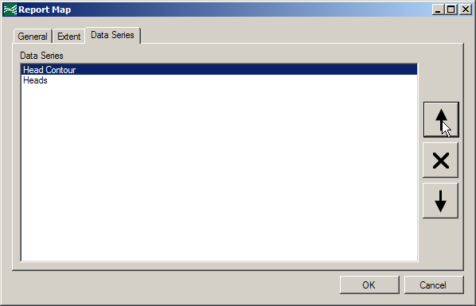

Now, you can see the Head Contour layer in the map preview.

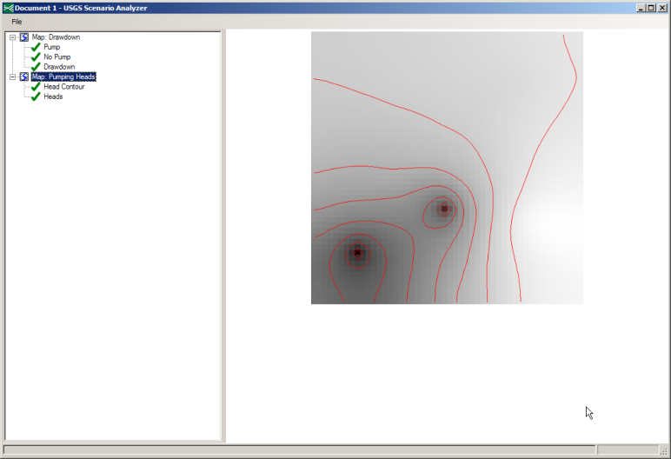

In the **File** menu, select **Save As…** and save your document to a convenient location.

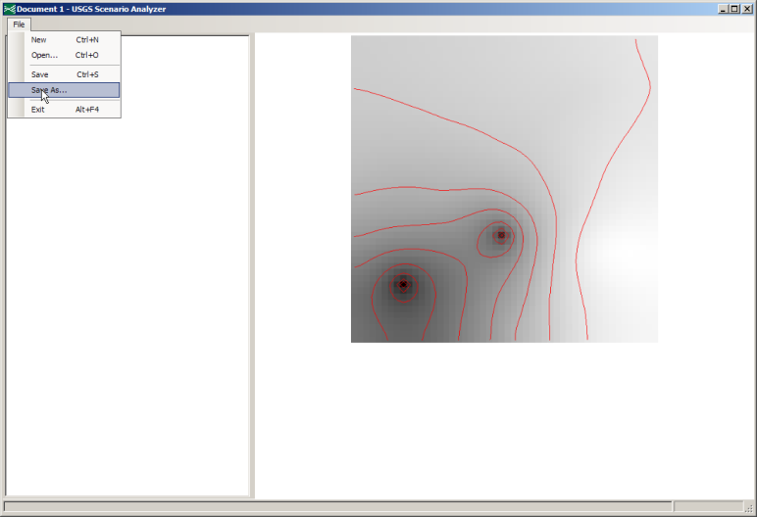

1. ***Extract timeseries of water levels at a point***

Close and reopen the application. Select **Open…** in the **File** menu.

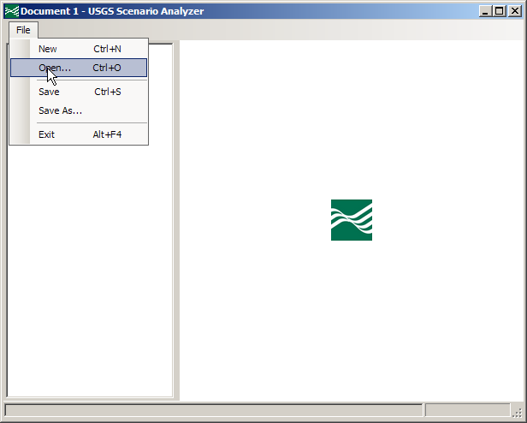

Open the document that you just saved.

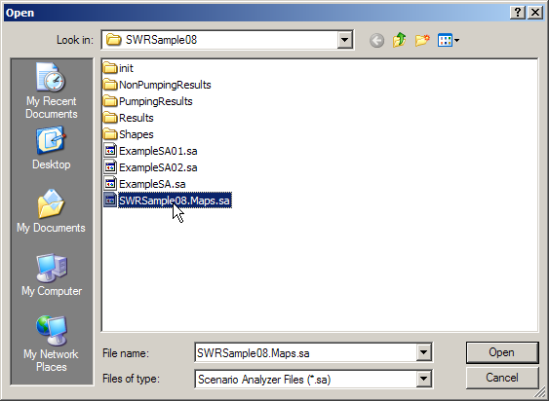

Your document is exactly as you left it before you closed the application.

Add a **New Graph** to your document.

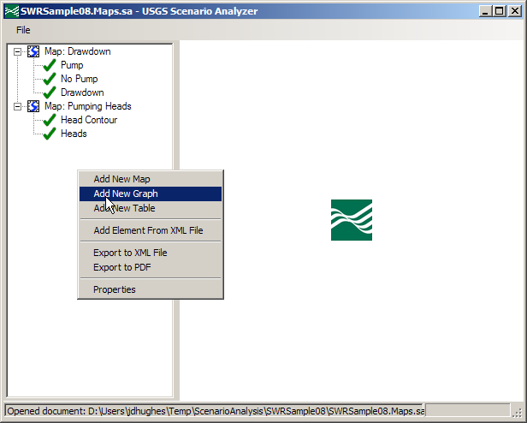

Name this graph Heads and pumping wells.

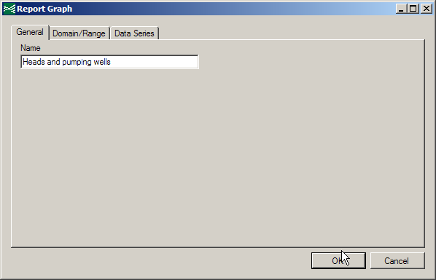

Add a **New Data Series** to the graph.

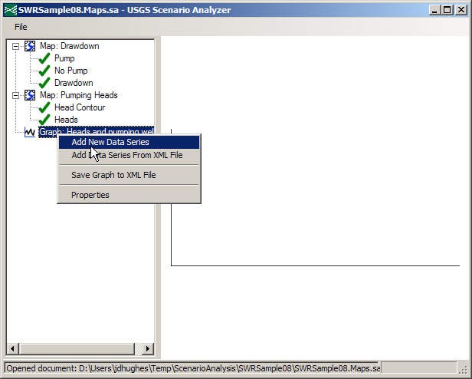

Name the data series PW-01, chose **Head At Point** for the data type, select the heads file from the *PumpingResults* folder, and choose column 9, row 25, layer 3.

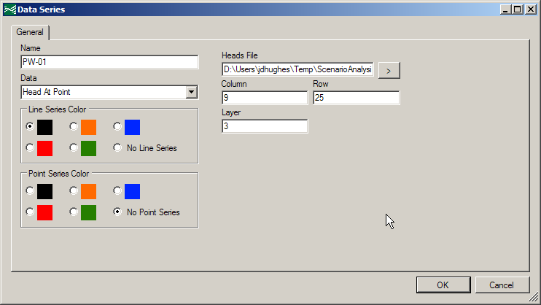

Repeat this for the second well. Name this one PW-02, select a different line color, and choose column 25, row 33, layer 3.

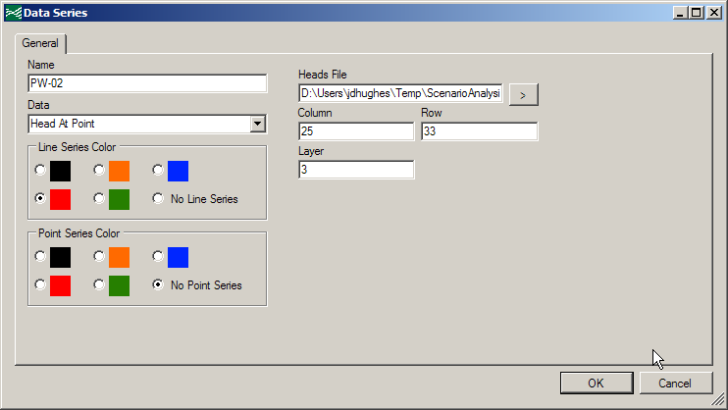

Export a CSV of the PW-01 time series.

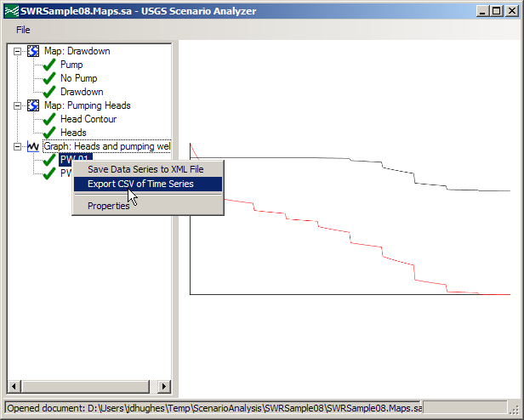

Save the CSV file to a convenient location.

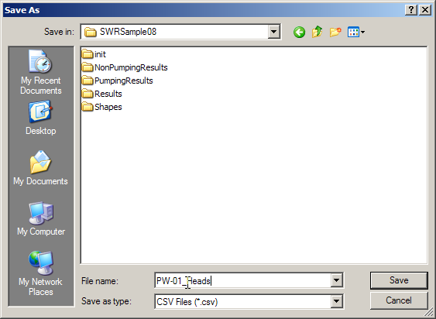

Add another **New Data Series** to your latest graph.

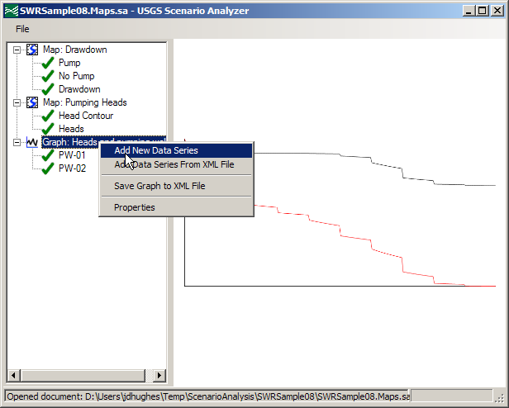

Make this an **Observed Series (SMP file)**. Select the *PW-01_Heads.smp* file in the *SWRSample08* folder. Select **No Line Series** and a **Point Series Color** of black. Name the series PW-01 Obs.

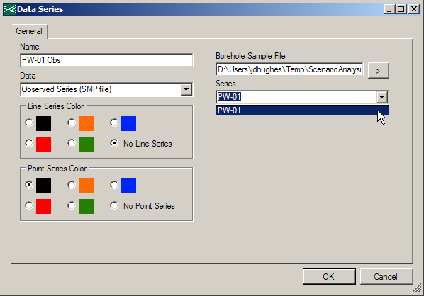

You now have a graph that shows simulated heads at two wells and also shows observed heads at one of those wells.

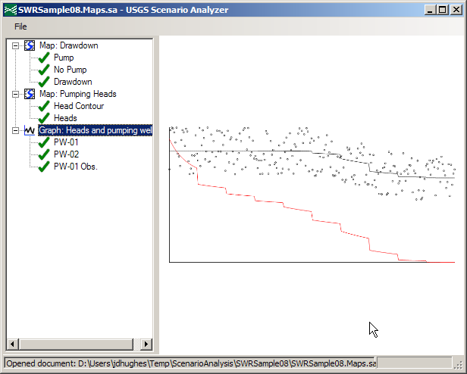

1. ***Extract SWR1 cell-by-cell flows for sub-basins***

Add another **New Graph** to your document. Name this SWR1 Exchanges.

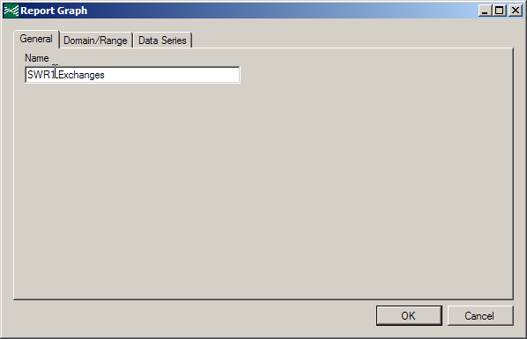

Add a **New Data Series** to this graph. Call this series Pumping, select the CBB file from the *PumpingResults* folder, choose the **SWR LEAKAGE** dataset, and set the layer range from 1 to 3.

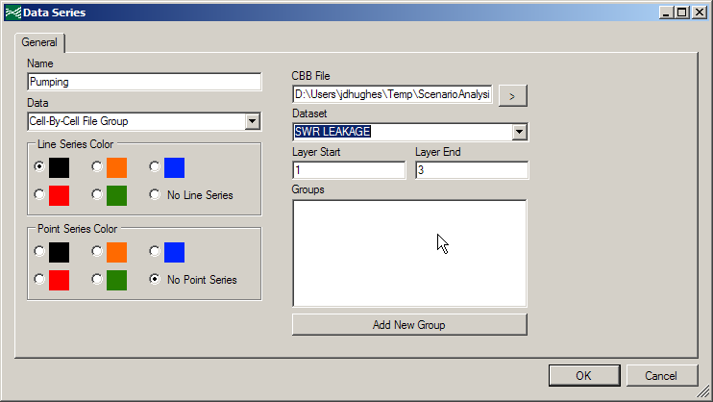

Click the **Add New Group** button and browse to the *SWRSample08_Basins.csv* file in the *GroupFiles* folder.

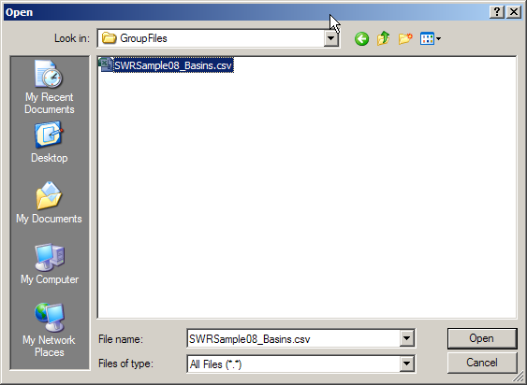

This file is a simple text file that contains the cell indices for all basins in this simulation. The following image shows these basins.

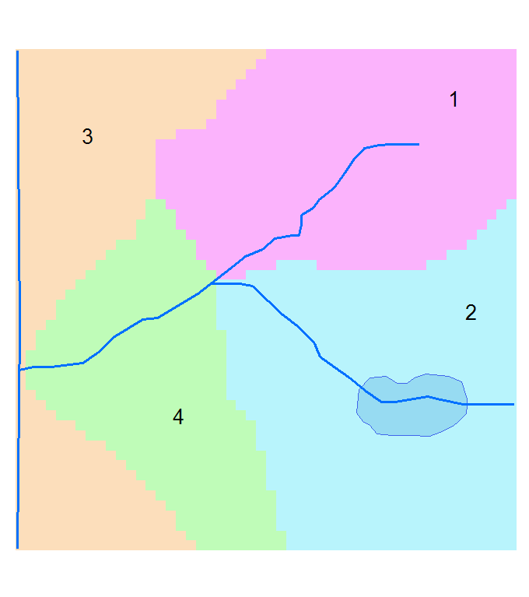

Select **Basin02** in the **Groups** box.

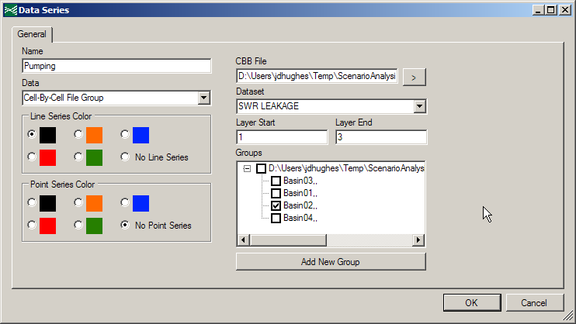

The graph preview shows the sum of SWR leakage for all cells in the selected basin.

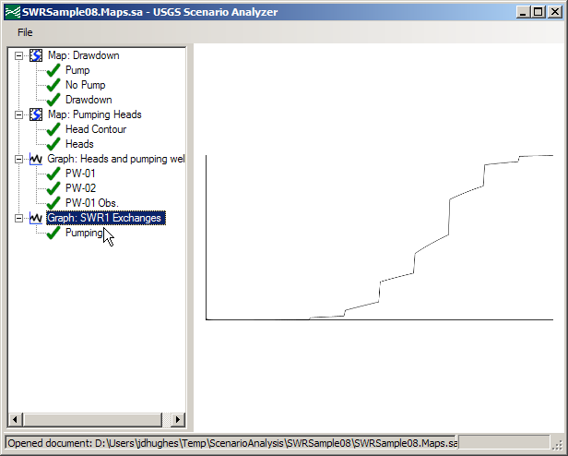

Add another **Data Series**. Name this one No Pumping and select the CBB file in the *NonPumpingResults* folder. Select the same dataset, layer range, and group as for the previous data series.

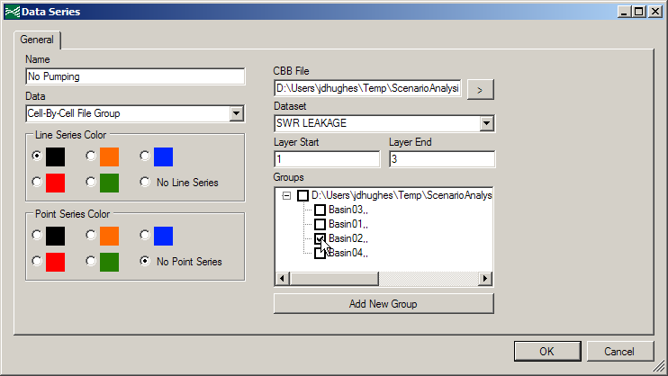

Add a **Dataset Calculator** series. For the expression, input [No Pumping] – [Pumping]. Name this series SWR1 Flux Difference. Choose a different line series color than the other series.

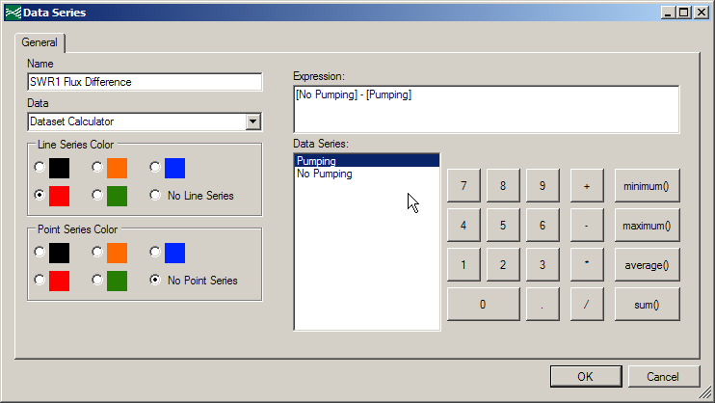

The graph now shows the time series data of the pumping and non-pumping simulations, as well as the difference of these simulations, for all cells in basin 2.

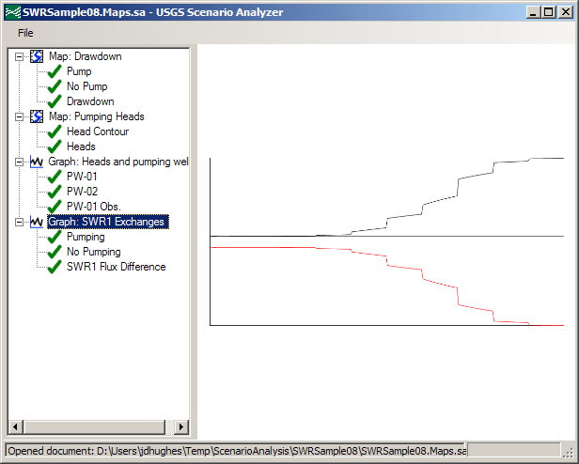

1. ***Add a new graph and evaluate the difference in SWR1 exchanges for basin 4***

Repeat the previous exercise. This time, create a graph for basin 4. The zero line can be created by adding a **Dataset Calculator** series and typing the number 0 for the expression.

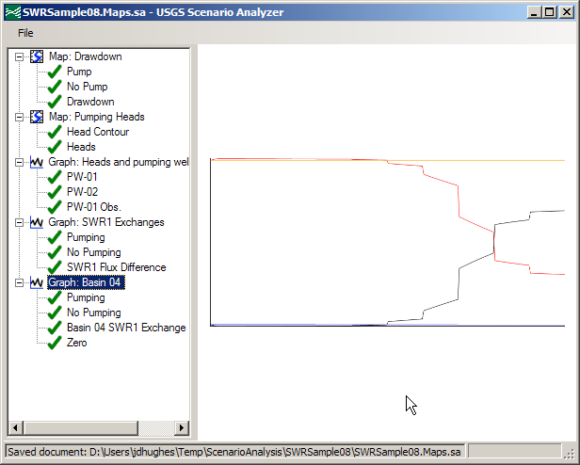

1. ***Create a Table***

Add a **New Table** to your document.

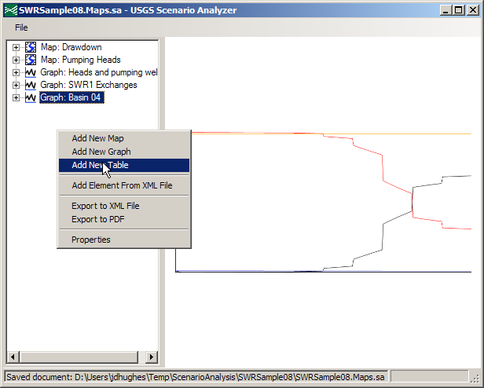

Name this table Sampled Heads.

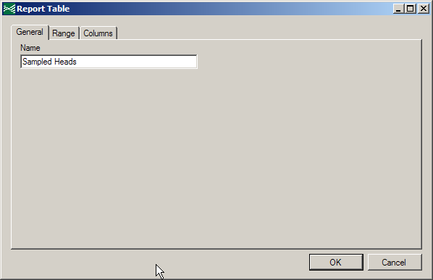

Add a **New Data Series** to the table.

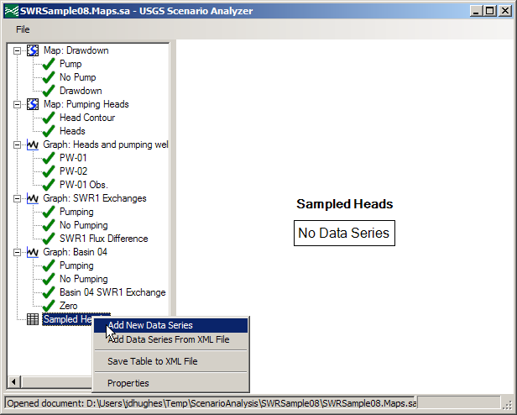

Name this series Sampled Times. Browse to the the *Sample01.smp* file.

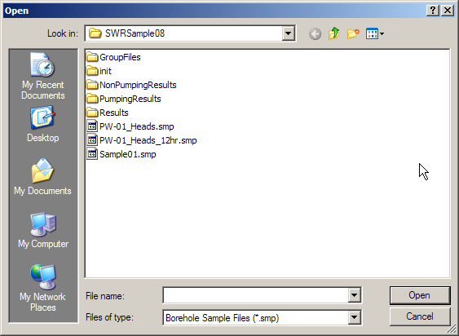

The only series in this file is named Sample01. In a file with multiple series, you could select the appropriate time series from the **Series** list.

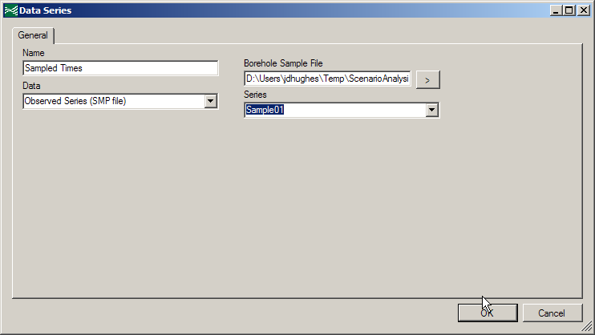

A preview of the table will appear in the preview pane.

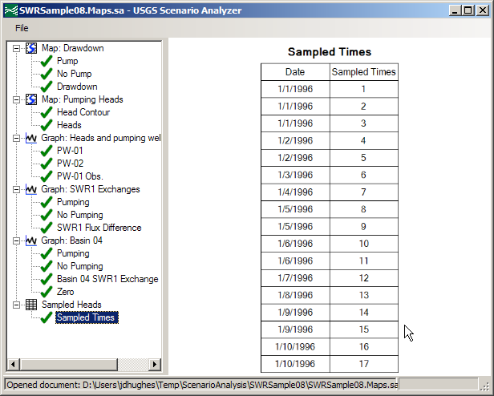

Add a **New Data Series** and select the heads file from the *PumpingResults* folder. Select column 9, row 31, and layer 3.

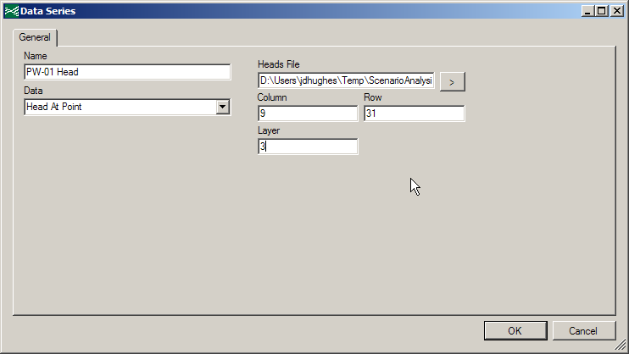

The new data series will appear as a third row in your table.

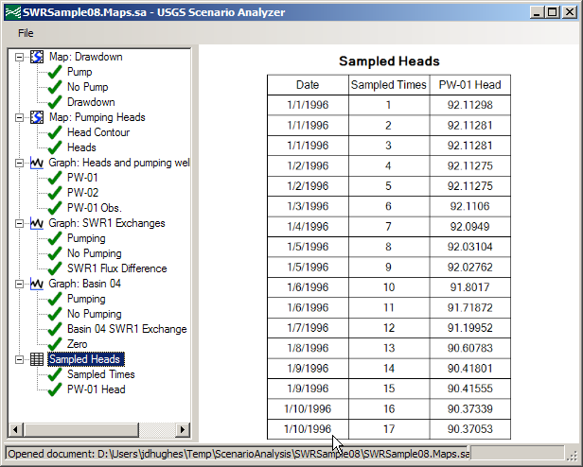

Repeat this process for the second well. This well is located in column 25, row 33, and layer 3.

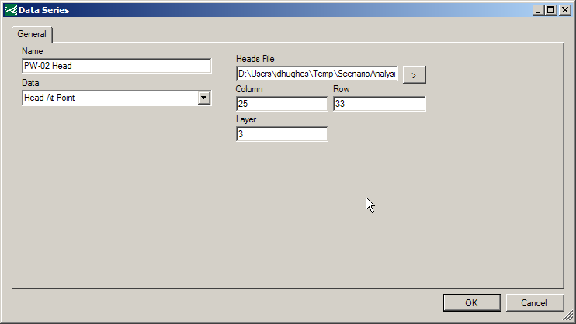

This well will appear as a fourth column in your table.

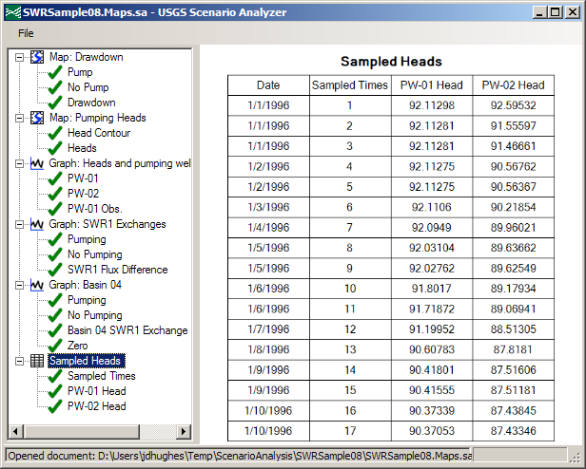

Add a **Cell-By-Cell File Point Series** for the CBB file in the *PumpingResults* folder. Choose the **WELLS** dataset. The well is located in column 9, row 41, layer 3.

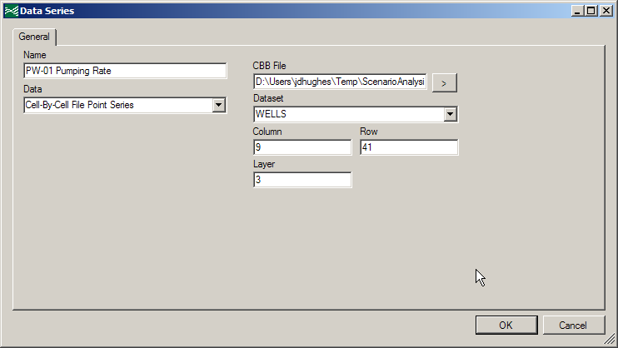

This series will appear as a fifth column in your table. You may wish to resize the window to be able to see the table more clearly.

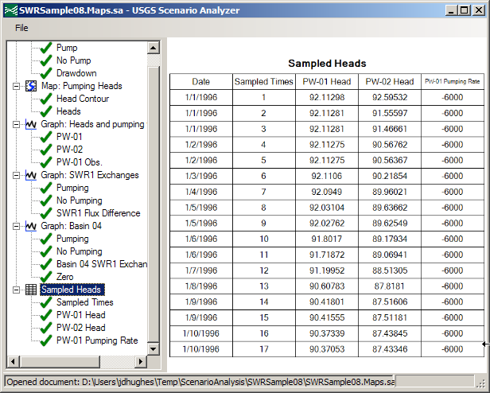

Choose **Save** from the **File** menu to save your document again.

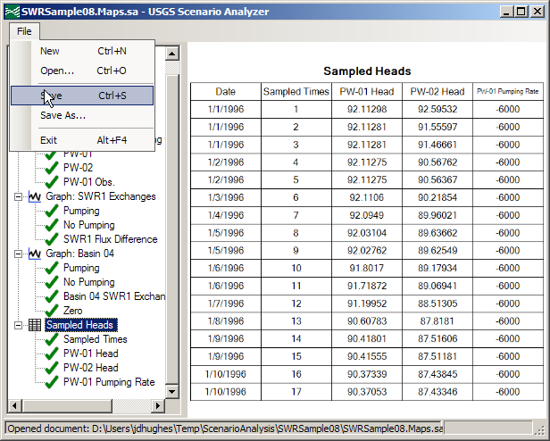

1. ***Export to the document to a PDF report***

Right-click on an empty area of the left pane and select **Export to PDF**.

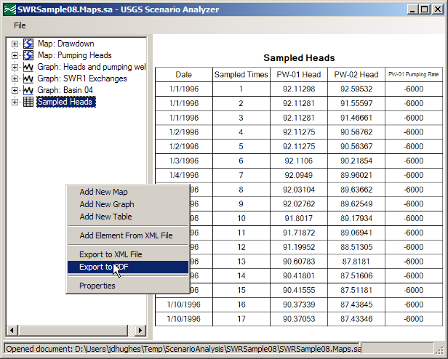

Select a convenient location for the PDF and save it.

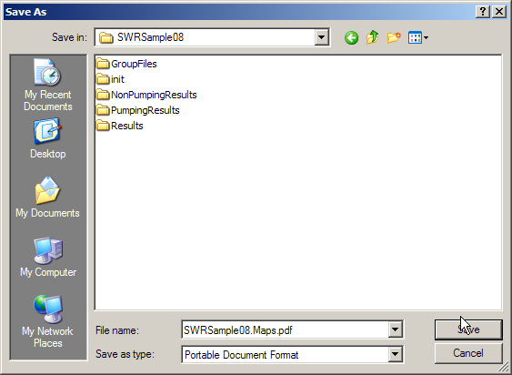

A confirmation dialog will inform you that the report has been saved to the path you selected.

