5.2.1 Album List

This is the first page after logged-in which lists out the main contents of our website including user’s profile, user’s own album and the albums of other users. The presentation of this page looks clear and simple, which is definitely in accordance with our aims. The purpose is that to create a website for the photography lovers who can easily upload their own photos as an album and check out the others’ albums if they want to. Now, let me invite you to go through our tour of this page, you might be having a wonderful site-seeing experience.

First step of all, I would like to introduce an easy-to-read layout style, which is divided the page into two main parts horizontally by different background colours. As you see, the main colour tone of our page is blue, so we have used different lightness of blue colour on the website header, one-side background and the heading of the page to enhance the layering.

About the layers, there is light blue background colour on the left-hand side with an eye-catching word “Welcome!” showing on the top (showing on Pic1). It is also a classic but important message on communication with users because we would like to tell them, “this is your own page, just feel free to do your job”. This is about the first impression of the user on using a page. We surely cannot miss it. After that, there is showing the logged-in user’s profile included display name and profile picture underneath the greetings in order to emphasize the message of HOME PAGE.

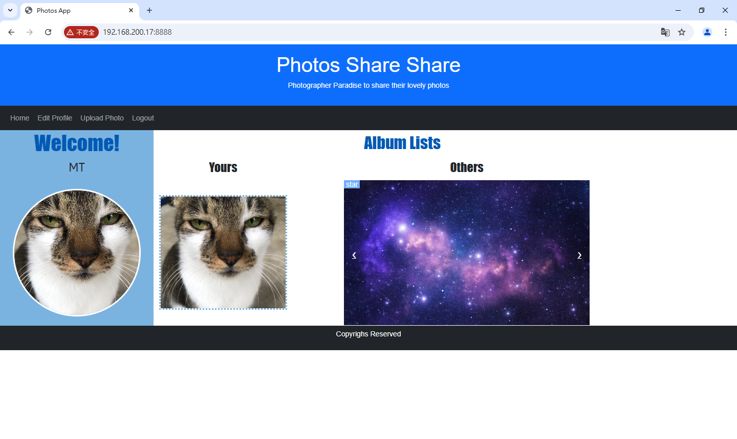

Pic1

Let’s talk about the spot here about the profile picture. We have used CSS to design its display style (check out the coding on Pic2). In CSS, 50% on border-radius is for showing the circle shape. And the result of border-color and border-width is calling to the edge surrounding the profile picture.

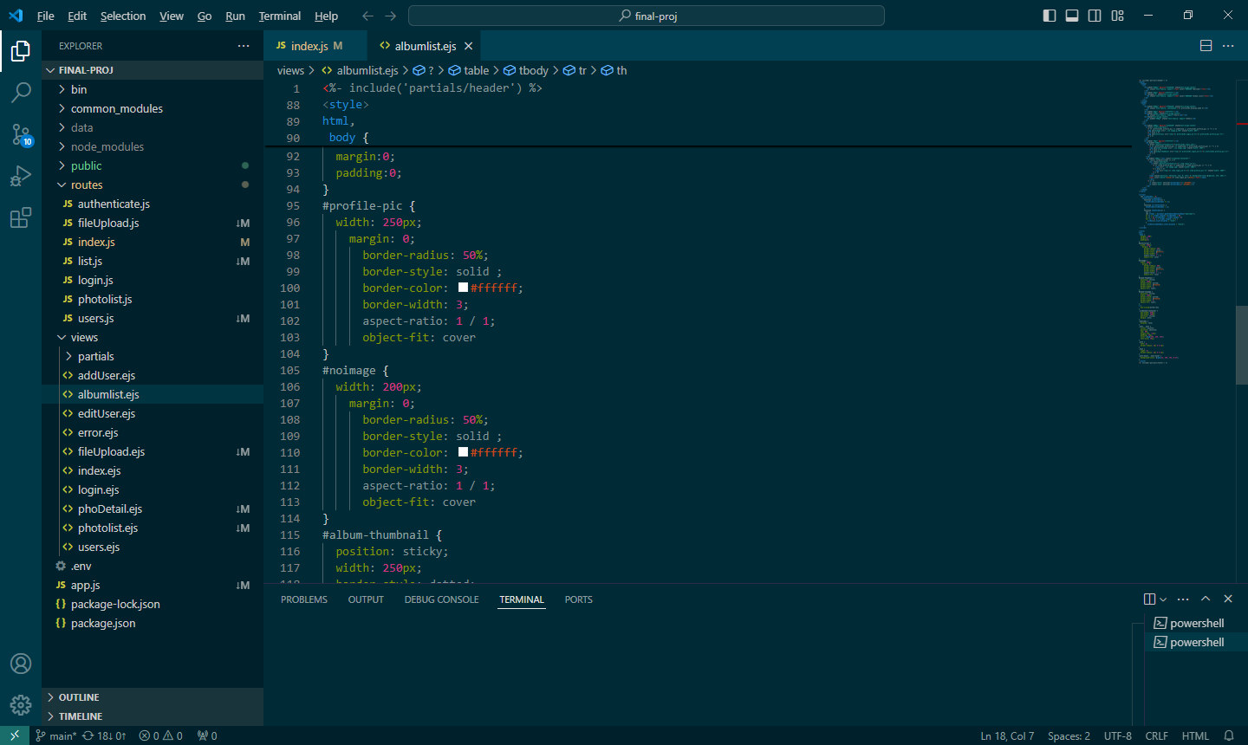

Pic2

Also, when you move your mouse over on the profile picture, there is a surprise waiting for you. YES! A hyperlink which links to “User profile edit” (check it out on 4.3). You are able to change your own details listing out there whenever you want except Login ID (Showing on Pic3).

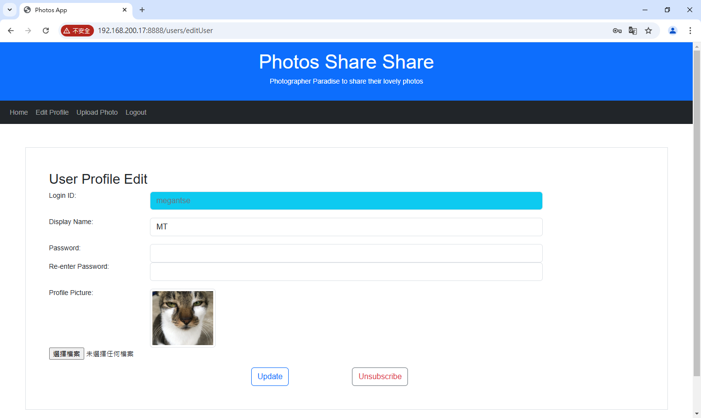Pic3

Next, let’s move to “Album Lists”! You can see that there are “Yours” and “Others” under “Album Lists” on the right column. Obviously, the photo cover showing under “Yours” which is the entrance of your album. Its display style has been written by CSS and html (check out the coding on Pic4 & Pic5).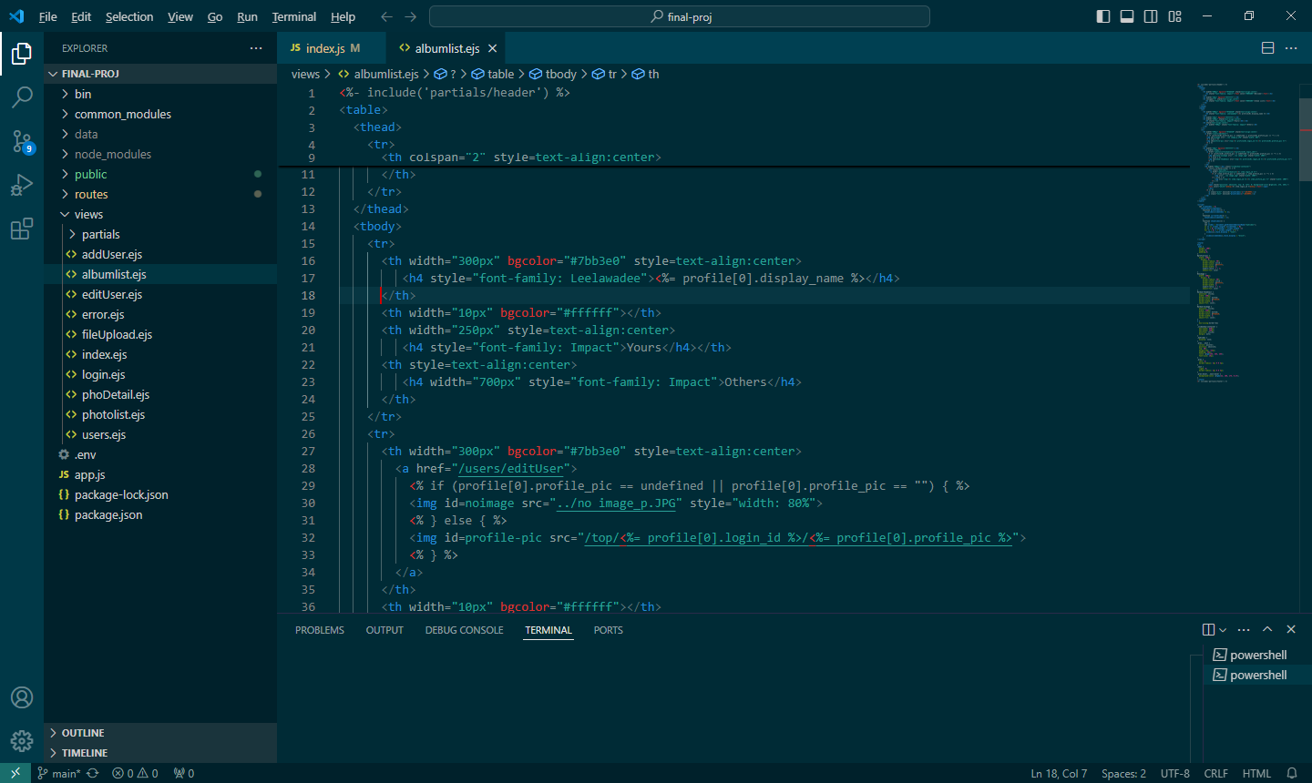

Pic4

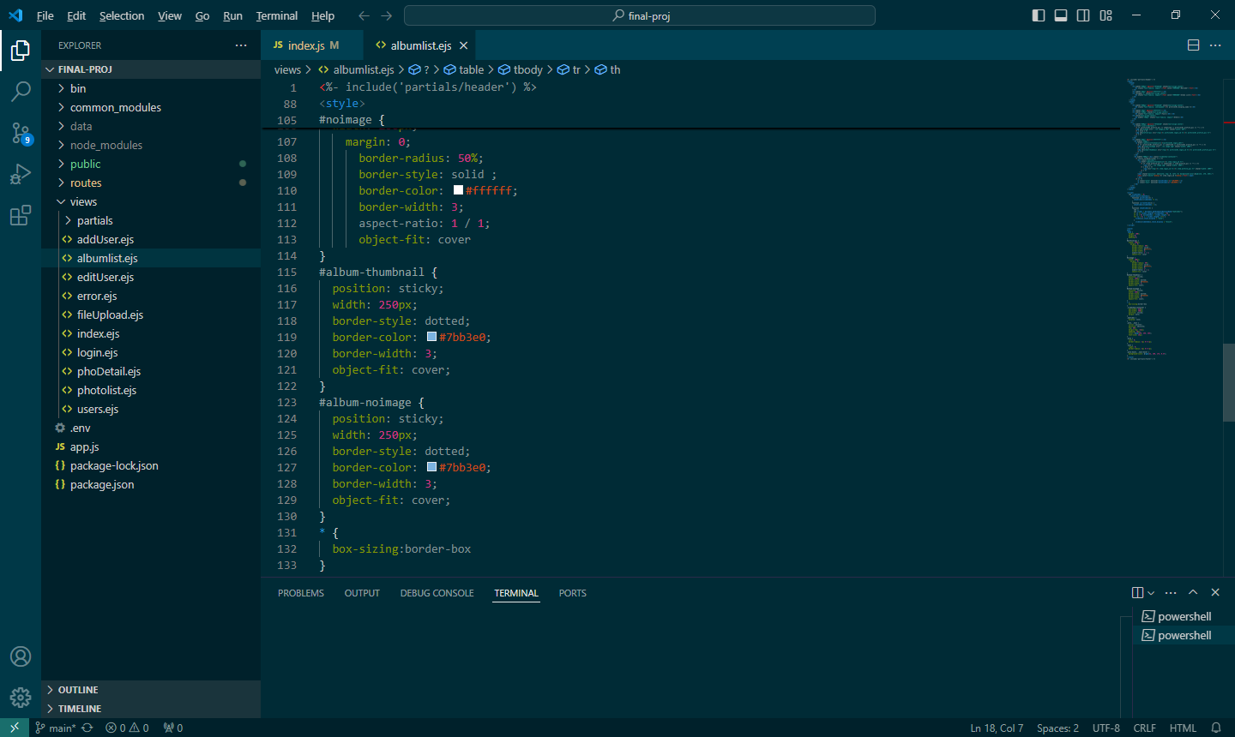

Pic5

When you click on your album cover, it contains a hyperlink which will bring you to the next page named “Photo List” (check it out on 5.2.2). There is your own album, listing out all the photos you have uploaded. But if you haven’t uploaded your profile or no photo on your album? No worries! We have already prepared a default photo for you (Showing on Pic6 & check out the coding on Pic7).

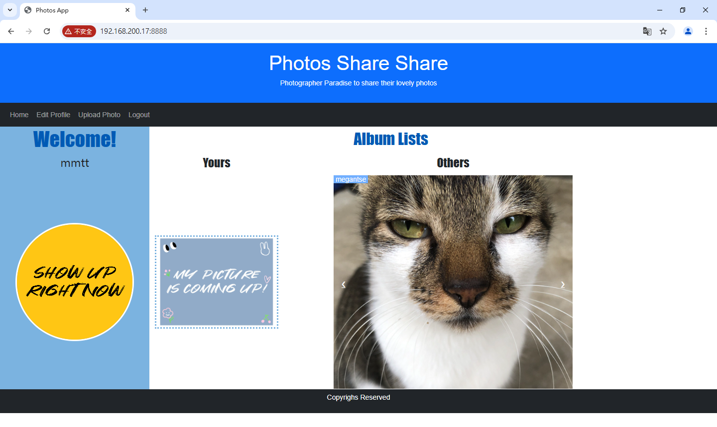

Pic6

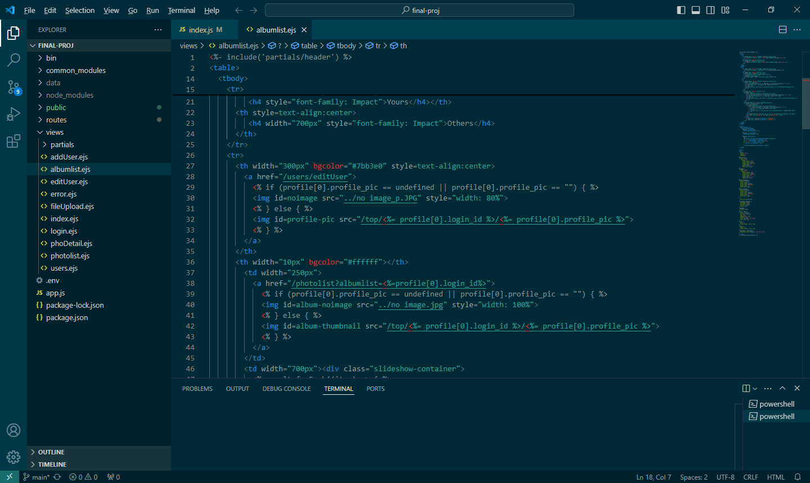

Pic7

So, how about “Others”? You can check out other users’ albums which are showing under the sub-title named “Others” (Showing on Pic8). All of them are signed-in users of “Photos Share Share”. You have right to choose and check out their albums by clicking on their photo cover with a display name. When you move your mouse over on the little white arrow, there is a colour-change to remind you there are another options for you (Showing on Pic9).

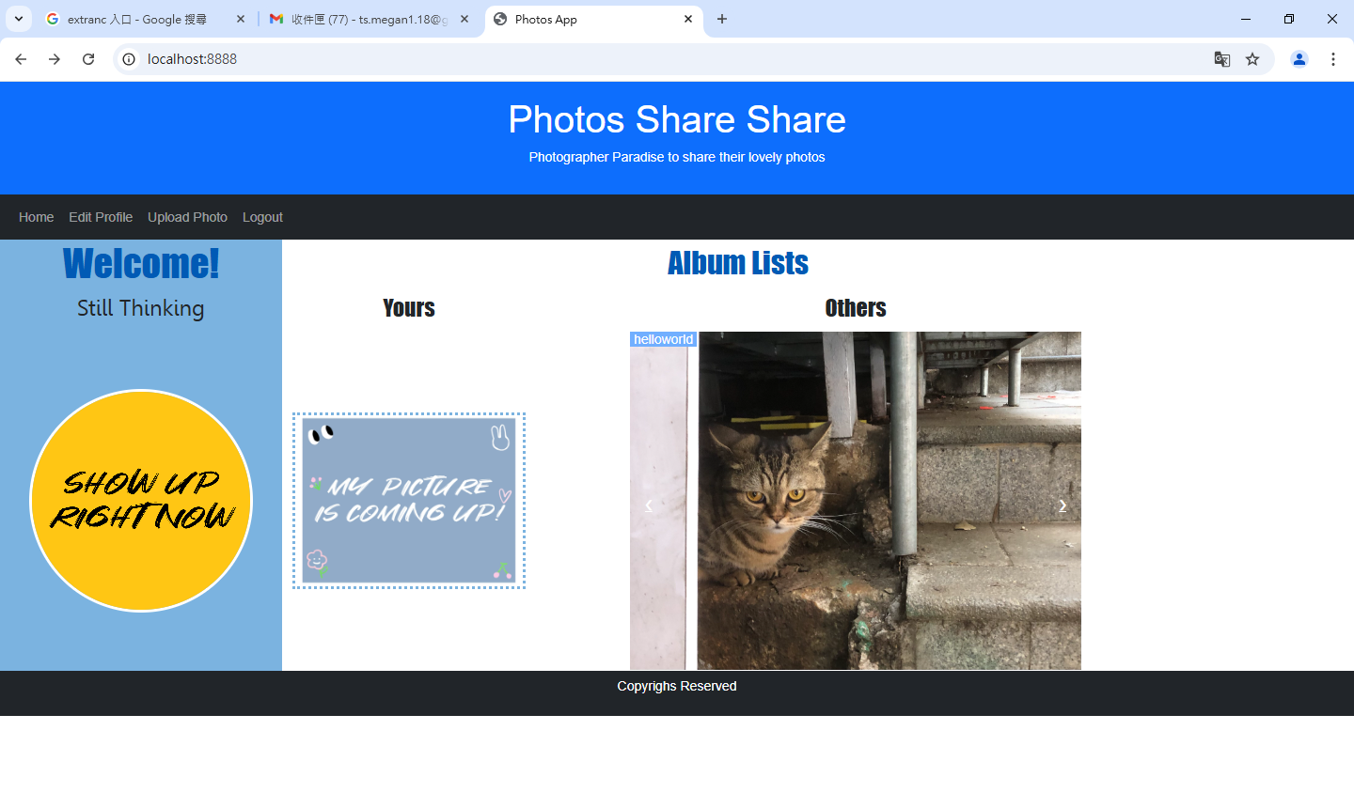

Pic8

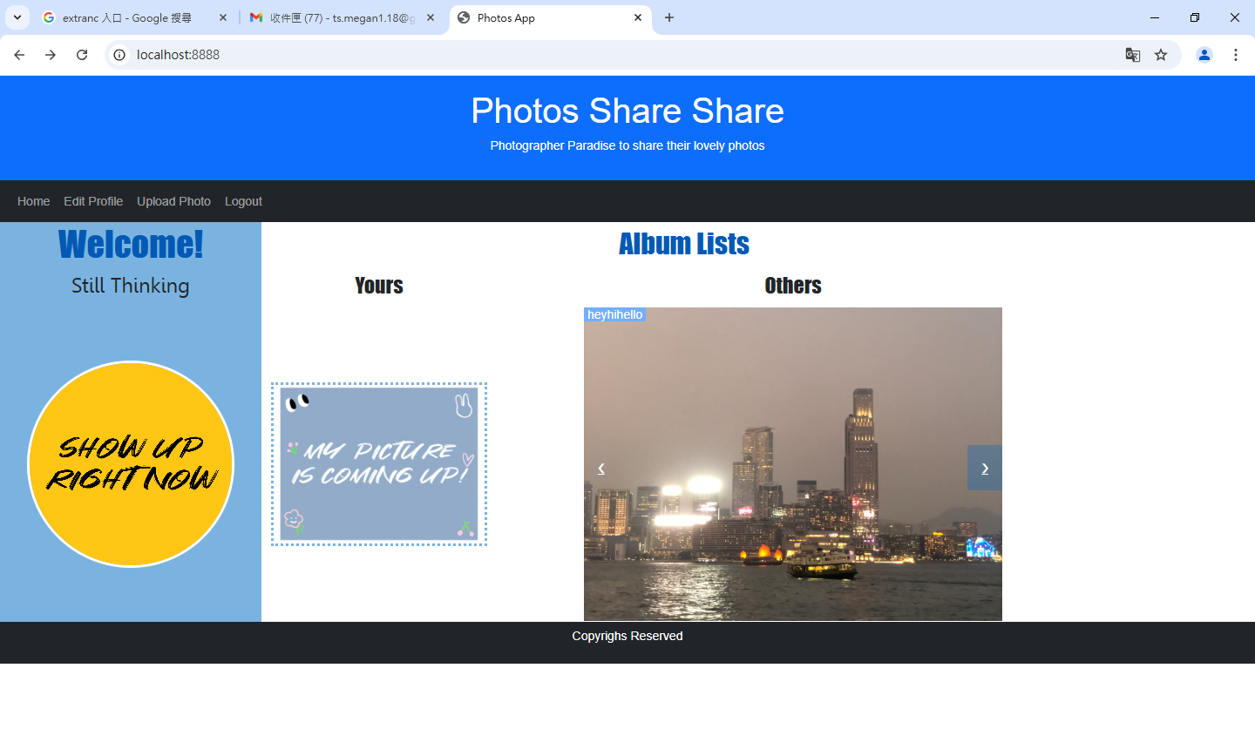

Pic9

If you want to know how does it work. Please check out our coding on Node.js. We have written with CSS, html and JAVASCRIPT (Showing on Pic10, Pic11 & Pic12).

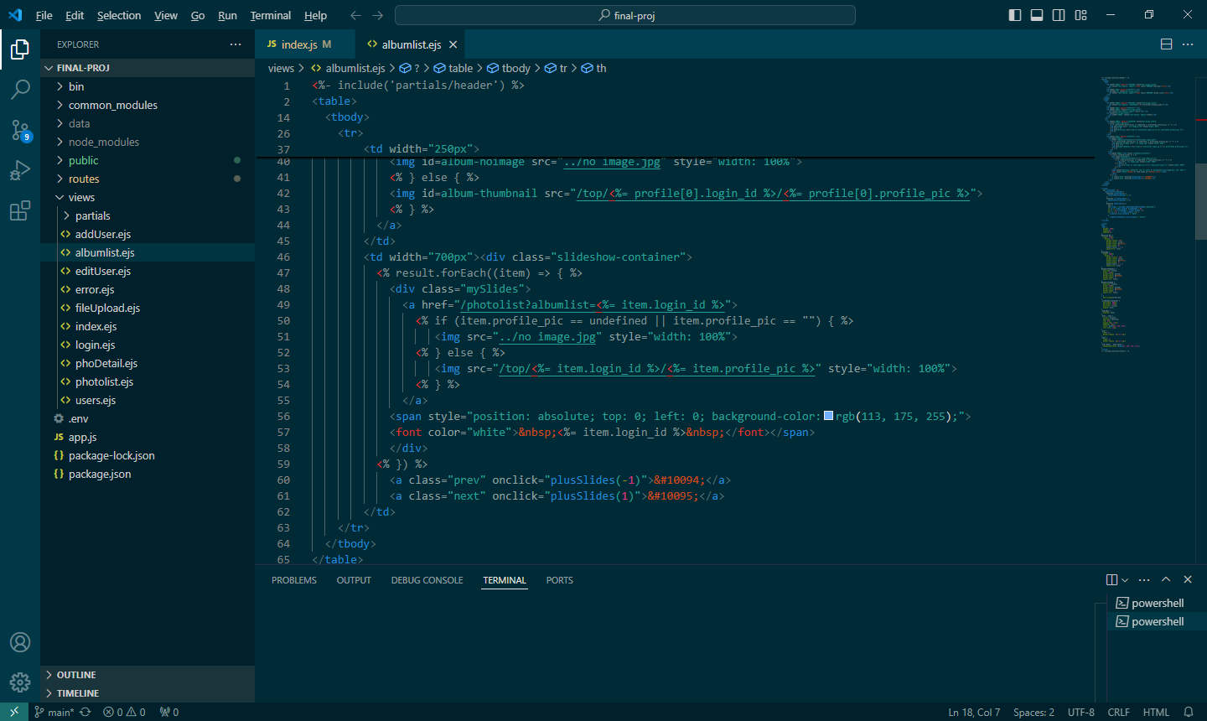

Pic10

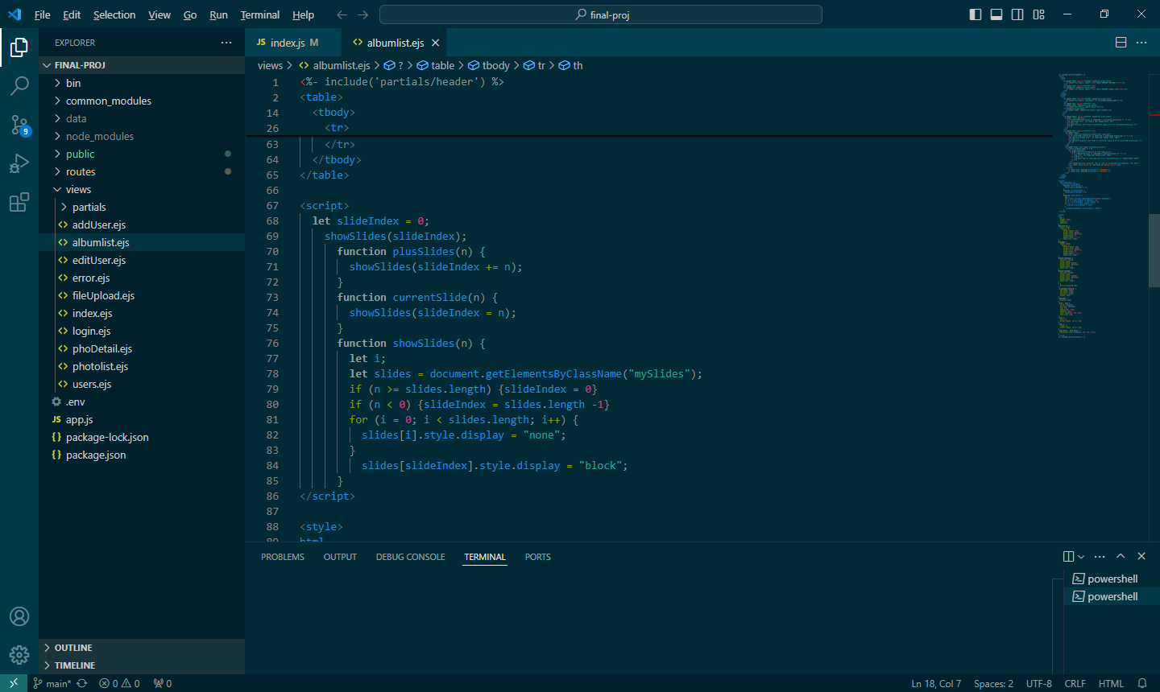

Pic11

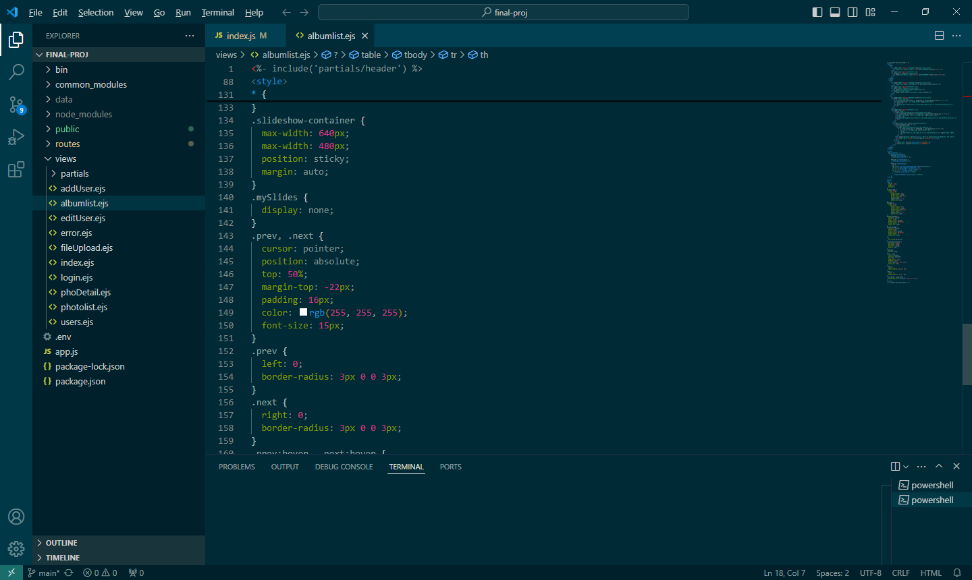

Pic12

6.1

Album Lists

* GET /
  + If users logged in, call out his/her display name, profile picture and photo list
  + (Pic13.1 & Pic13.2)
* GET /top/
  + Call out the users’ data from our data
  + Send out “file not found!” if can’t find any data
  + (Pic14)

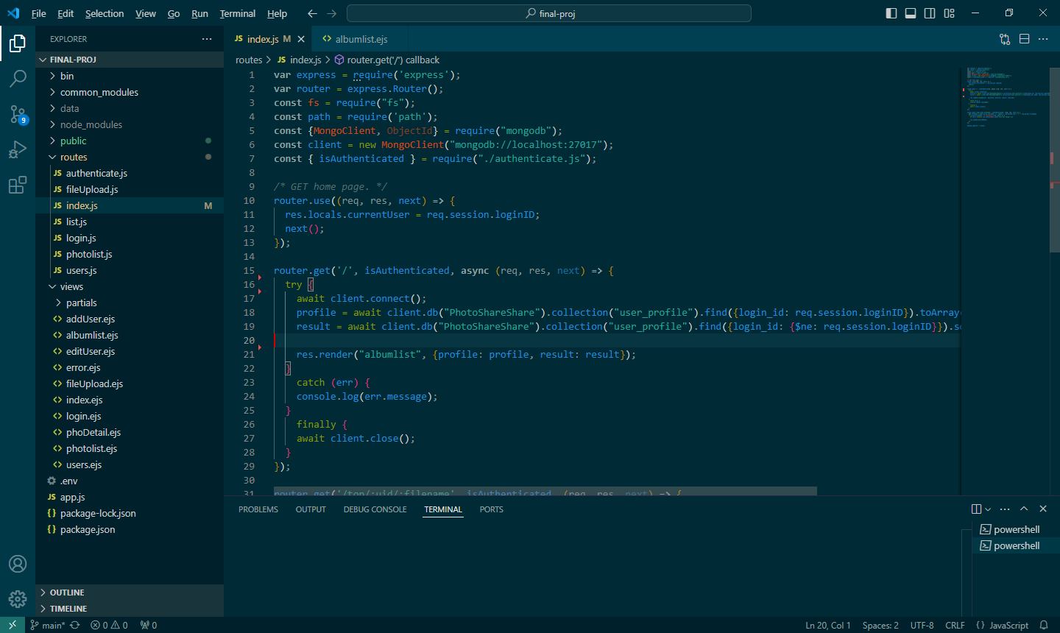

Pic13.1

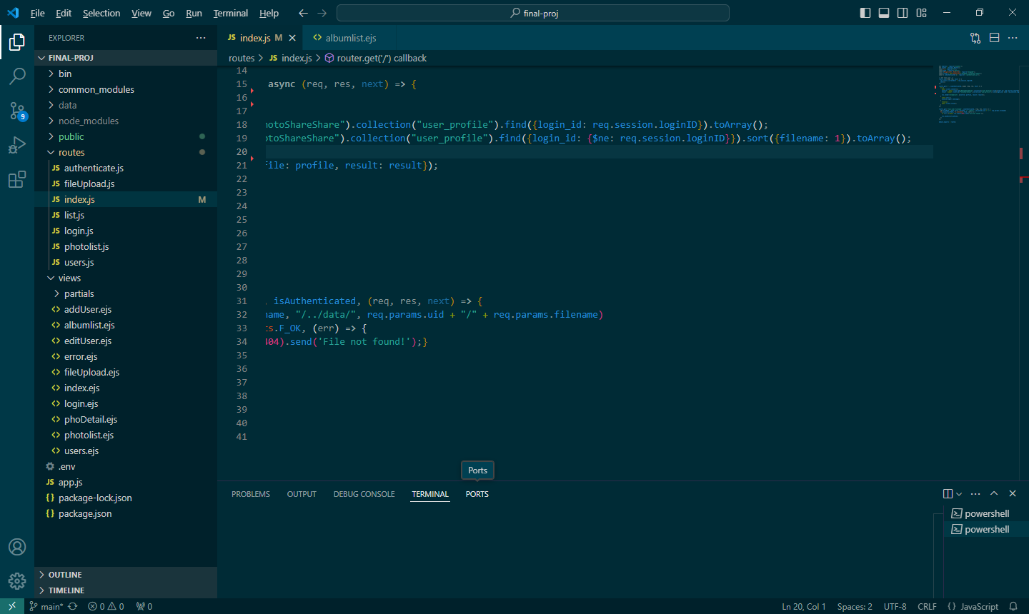

Pic13.2

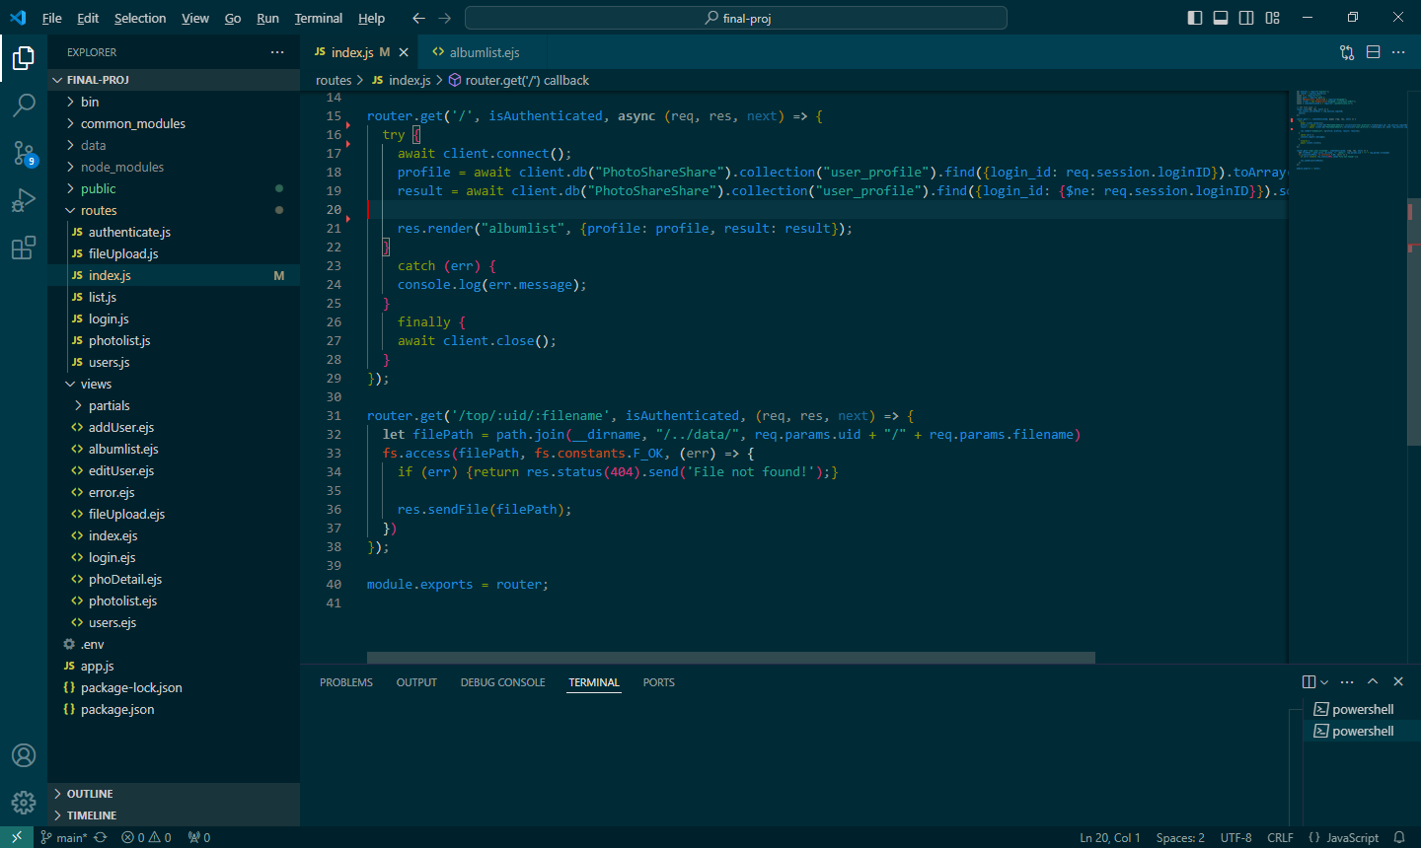

Pic14