**CENG 464**

**INTRODUCTION TO DATA MINING**

**Project Report**

**Eren Berk SALTAŞ**

**201711056**

**İlayda GÖLEN**

**201811032**

**07.01.2021**

Contents

1. Introduction and Aim 1

2. Explanation of Code and Methods 1

3. Bonus Step 2

4. Results 3

5. Conclusion 12

Appendix 17

1. Introduction and Aim

Since our id is even, we used data2. We are expected to use R language in our project. There are five steps we are asked to do for the project. The first is to preprocess the data. Second step, not mandatory, is to find top 5 using Countries_Unique_Count and Countries_First_Author attributes. The third step is to select features that are important for analysis. The next step is to apply clustering algorithms for the output variable J_or_C, compare their results, and apply classification models. The last and the fifth step is to apply the operations in the fourth step for the output variable Quartile.

The most crucial point in the project is the preprocessing of the data. With the new data we have preprocessed, we aim to complete the clustering and classification processes in the most successful way. At the same time, we aim to consolidate our knowledge by seeing the methods we know in theory, in practice.

1. Explanation of Code and Methods

We wrote our code as a whole, not step by step, for the 5 steps requested from us. First of all, we added the necessary libraries to our code. When the names(my_data) [nearZeroVar (my_data)] function is written to the console, it prints columns with variance close to 0 to us. Using this, we assign NULL values to some of the attributes according to the results we get. In order to preprocess the data, we converted the J_or_C attributes to numeric. We copied the data for each of the J_or_C and Quartile attributes before deleting them. While we named these copied ones as my_data_w, we created a new copy as my_data_with. my_data_with, the data of the version with these attributes and we created it for comparison. Next, we deleted the Quartile attribute from the data my_data_w and made the J_or_C attribute numeric for both my_data_w and my_data_with. Likewise, we created two copies of the J_or_C attribute, my_data_w_jc and my_data_with_jc. Then, we wrote the function cor (my_data, my_data $ Quartile) and updated the my_data_w _q that we prepared for the Quartile attribute according to the results. We have added the correlation results to appendix. We did the same for my_data_with_jc. This function returns columns that might be associated with that attribute. Then, we chose those columns with select function and we set those chosen columns sync to the same vector variable. In this way, the columns in the data are processed. Next, we wrote four for loops for the four data copies we created.

If there is any missing value in the data, we did this to fill the empty space with the mean of that column so that the missing data would not fail while preprocessing. After scaling the new data we created, we started the clustering and classification process. In order to capture the maximum value without any loss from the processed data, the tree classification process was performed immediately after preprocessing.

We used K-means clustering and Hierarchical clustering (Ward’s method), Tree classification and Unsupervised classification. The same process is applied for different attributes for the fourth and fifth steps. Before kmeans clustering, tree classification was performed for both attribute J_or_C and Quartile. To give an example for the J_or_C attribute, we calculated using the kmeans function for my_data_with_jc and my_data_w_jc. In this way, k-means clustering and unsupervised classification are done. Two different clusters are created, using and not using the J_or_C column. Later, we visualized using autoplot. We used the fviz_nbclust function we found on the Internet to test the accuracy of our own work. The fviz_nbclust function calculates the optimal number of clusters. Then we did hierarchical clustering and unsupervised classification. Again, one is the attribute is included and the other is not. We plotted it using ggdendrogram.

1. Bonus Step

After vectorizing the column with the header, when we make it a table using the table function, we see that it arranges the data in the column according to the frequency of repetition. Then we achieve the desired goal by using tale and sort functions together. Our results are as follows.

Top5 countries:



Top5 first author’s countries:



1. Results

Before all else, these results are wssplot, k-means cluster, k-means unsupervised classification, hierarchical clustering and fviz_nbclust for J_or_C and Quartile attributes. To begin with, we would like to show the results of the J_or_C attribute.

wssplot result for without J_or_C attribute:

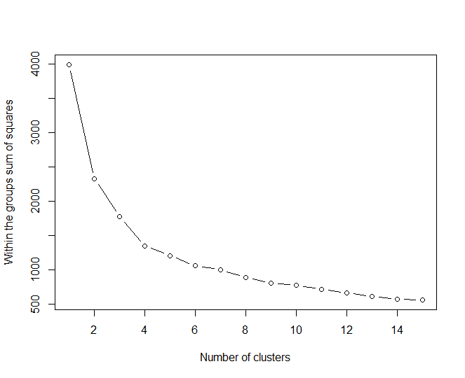

wssplot result for with J_or_C attribute:

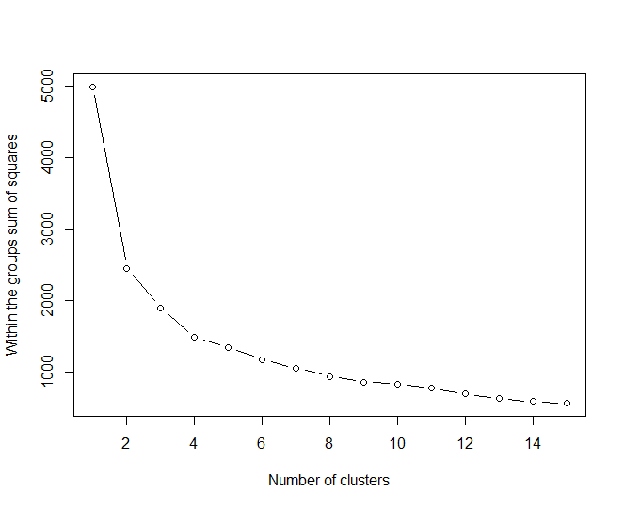

Tree classification result for with J_or_C attribute:

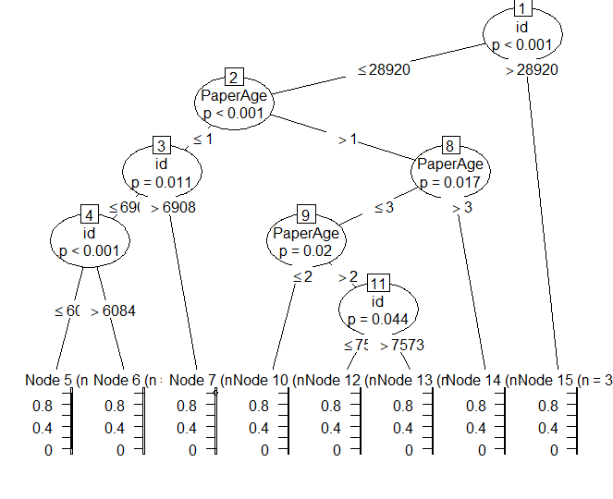

k-means result for without J_or_C attribute:

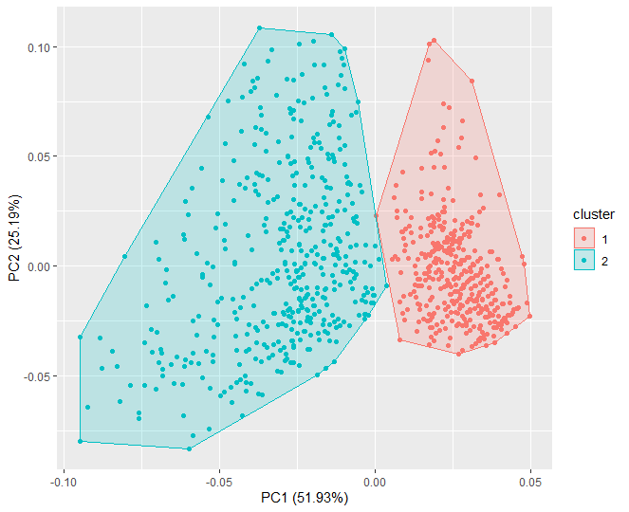

k-means result for with J_or_C attribute:

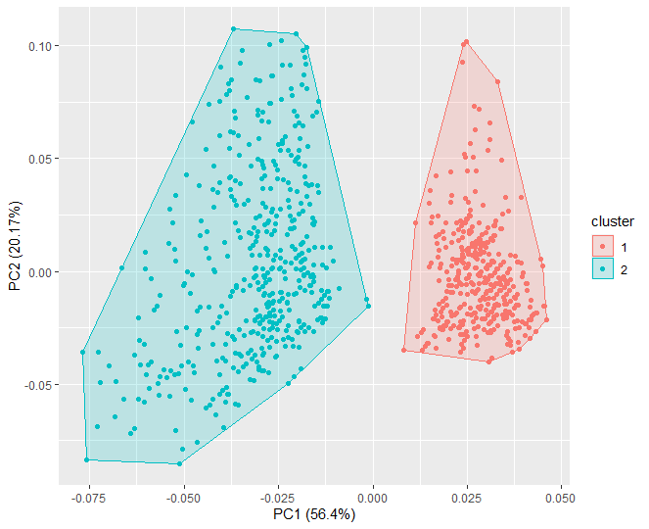

fviz_nbclust result for without J_or_C attribute:

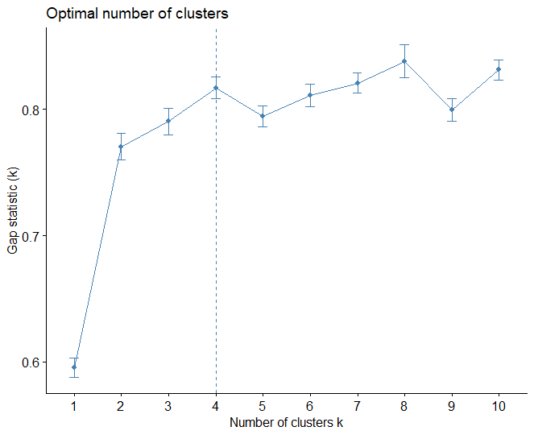

fviz_nbclust result for with J_or_C attribute:

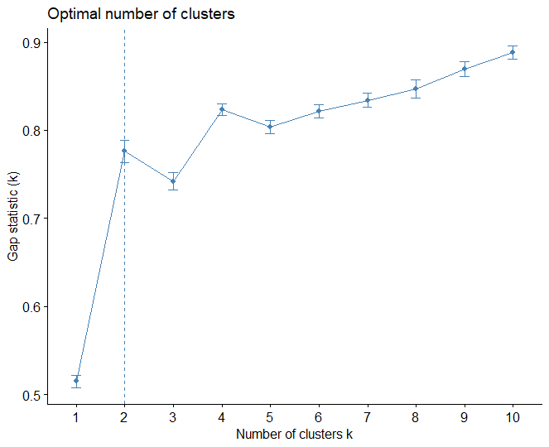

Hclust result for without J_or_C attribute:

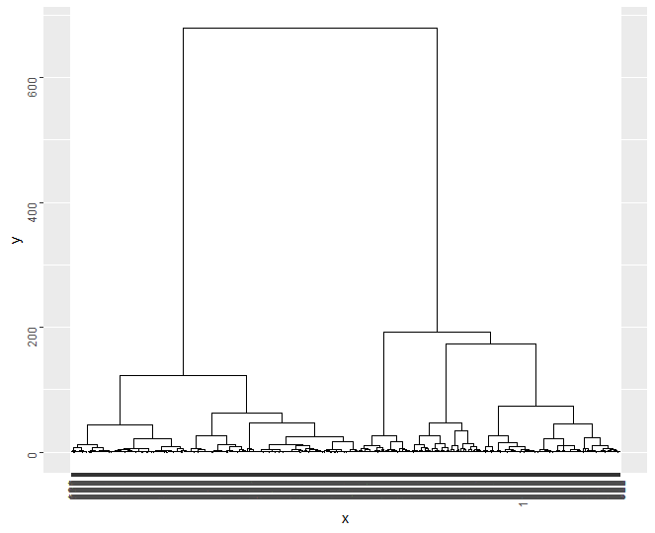

Hclust result for with J_or_C attribute:

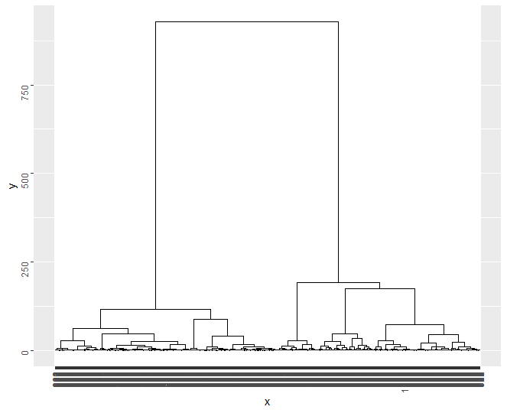

In addition to these, the results of the Quartile attribute are below.

wssplot result for without Quartile attribute:

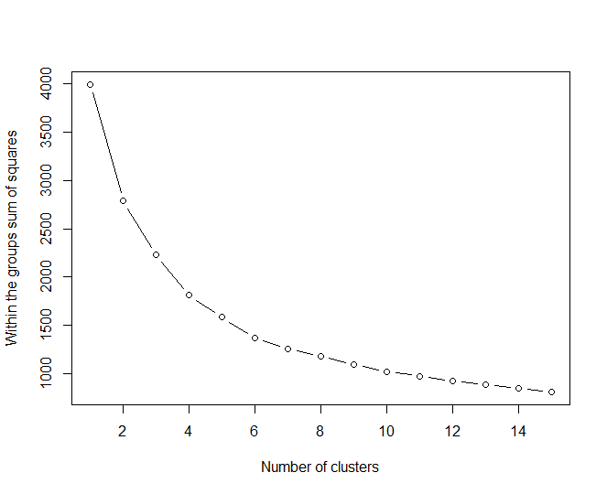

wssplot result for with Quartile attribute:



Tree classification result for with Quartile attribute:

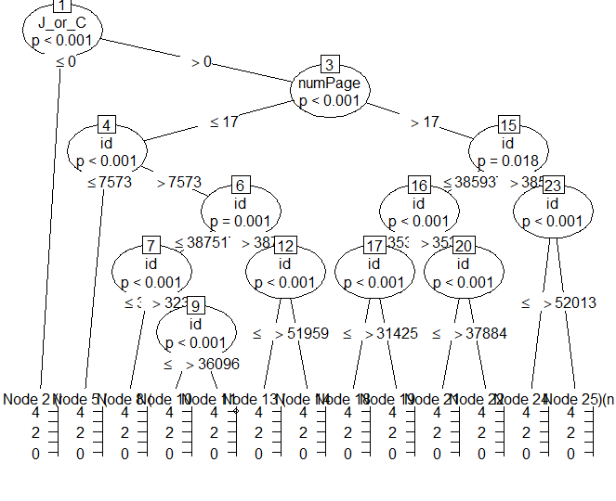

k-means result for without Quartile attribute:

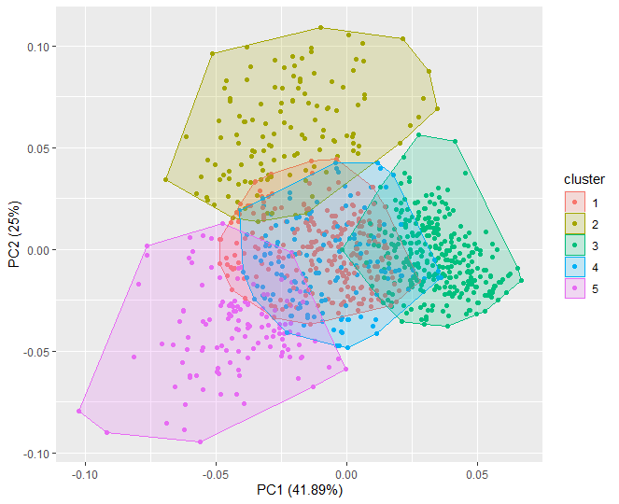

k-means result for with Quartile attribute:

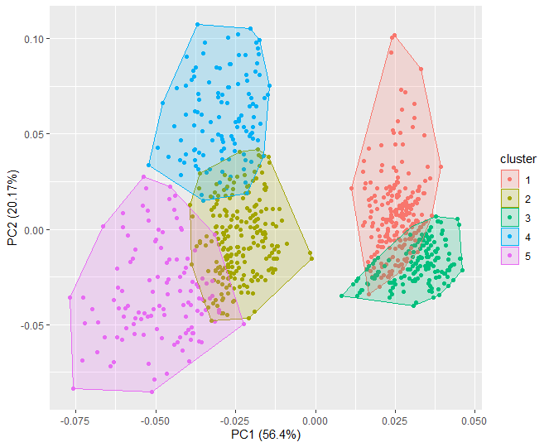

fviz_nbclust result for without Quartile attribute:

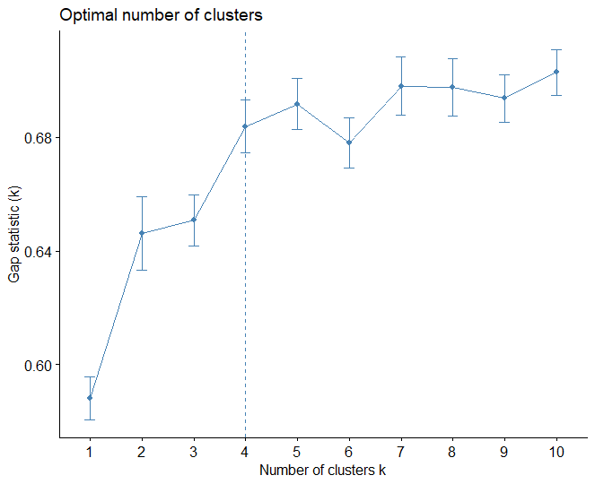

fviz_nbclust result for with Quartile attribute:



Hclust result for without Quartile attribute:

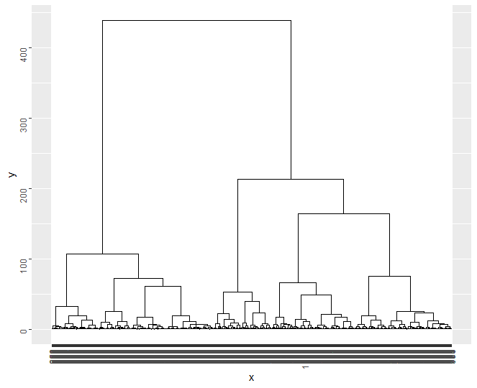

Hclust result for with Quartile attribute:



1. Conclusion

We made the table to make the comparisons more visible.

K-means cluster for J_or_C:

|  |  |  |
| --- | --- | --- |
|  | my_data_w _jc | my_data_with_jc |
| totss | 3996 | 4995 |
| withinss | [1:2] 541 1783 | [1:2] 661 1795 |
| tot.withinss | 2324 | 2456 |
| betweenss | 1672 | 2539 |
| size | [1:2] 525 475 | [1:2] 523 477 |

When we check our results again with the help of the summary () function, we get the following conclusion:



Hclust cluster for J_or_C:

|  |  |  |
| --- | --- | --- |
|  | my_data_w _jc | my_data_with_jc |
| size | [1:2] 477 523 | [1:2] 477 523 |
| separation.matrix | [,1] [,2]  [1,] 0.000000 1.077443  [2,] 1.077443 0.000000 | [,1] [,2]  [1,] 0.000000 1.788012  [2,] 1.788012 0.000000 |
| average.between | [,1] [,2]  [1,] 0.000000 3.239491  [2,] 3.239491 0.000000 | [,1] [,2]  [1,] 0.000000 3.806638  [2,] 3.806638 0.000000 |
| n.within | [1] 250029 | [1] 250029 |
| average.distance | [1] 2.492752 1.272840 | [1] 2.492752 1.408755 |

When we check our results again with the help of the summary () function, we get the following conclusion:



K-means cluster for Quartile:

|  |  |  |
| --- | --- | --- |
|  | my_data_w _q | my_data_with_q |
| totss | 3996 | 4995 |
| withinss | [1:5] 358 319 376 261 269 | [1:5] 266 322 225 162 348 |
| tot.withinss | 1582 | 1323 |
| betweenss | 2414 | 3672 |
| size | [1:5] 248 129 339 158 126 | [1:5] 304 242 219 117 118 |

When we check our results again with the help of the summary () function, we get the following conclusion:



Hclust cluster for Quartile:

|  |  |  |
| --- | --- | --- |
|  | my_data_w _q | my_data_with_q |
| size | [1] 145 287 118 206 244 | [1] 252 317 206 129 96 |
| separation.matrix | [,1] [,2] [,3] [,4] [,5]  [1,] 0.0000000 0.5266336 0.8606468 0.5922712 0.3950468  [2,] 0.5266336 0.0000000 0.2787948 0.5494582 0.2474866  [3,] 0.8606468 0.2787948 0.0000000 0.8904125 0.3267542  [4,] 0.5922712 0.5494582 0.8904125 0.0000000 0.2084245  [5,] 0.3950468 0.2474866 0.3267542 0.2084245 0.0000000 | [,1] [,2] [,3] [,4] [,5]  [1,] 0.0000000 2.2847442 1.7880116 0.4449239 0.2335205  [2,] 2.2847442 0.0000000 0.1189046 2.4271190 2.2713032  [3,] 1.7880116 0.1189046 0.0000000 2.2029073 2.4195640  [4,] 0.4449239 2.4271190 2.2029073 0.0000000 0.5740274  [5,] 0.2335205 2.2713032 2.4195640 0.5740274 0.0000000 |
| average.between | [,1] [,2] [,3] [,4] [,5]  [1,] 0.000000 3.359271 3.686454 3.566923 2.856741  [2,] 3.359271 0.000000 2.016581 3.271499 2.577186  [3,] 3.686454 2.016581 0.000000 3.300911 2.382442  [4,] 3.566923 3.271499 3.300911 0.000000 2.514870  [5,] 2.856741 2.577186 2.382442 2.514870 0.000000 | [,1] [,2] [,3] [,4] [,5]  [1,] 0.000000 3.211663 3.570514 2.929802 2.817373  [2,] 3.211663 0.000000 1.653474 4.495734 3.696474  [3,] 3.570514 1.653474 0.000000 4.733820 4.328527  [4,] 2.929802 4.495734 4.733820 0.000000 3.634494  [5,] 2.817373 3.696474 4.328527 3.634494 0.000000 |
| n.within | [1] 109145 | [1] 115643 |
| average.distance | [1] 2.303828 1.462966 1.313390 1.986066 1.589929 | [1] 1.548693 1.172738 1.211762 2.297341 1.455452 |

When we check our results again with the help of the summary () function, we get the following conclusion:

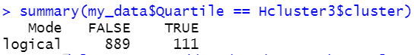

Tree classification results for my_data_with_jc:

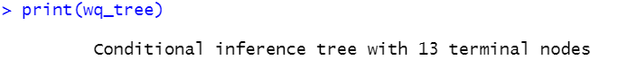

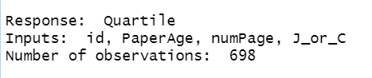

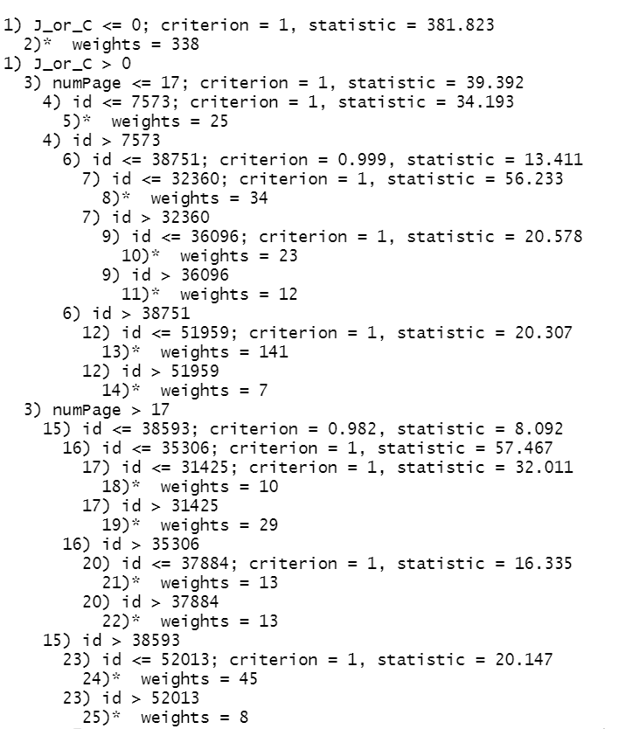

Tree classification results for my_data_with_q:

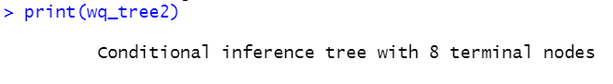

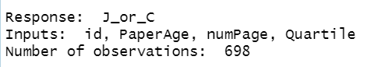

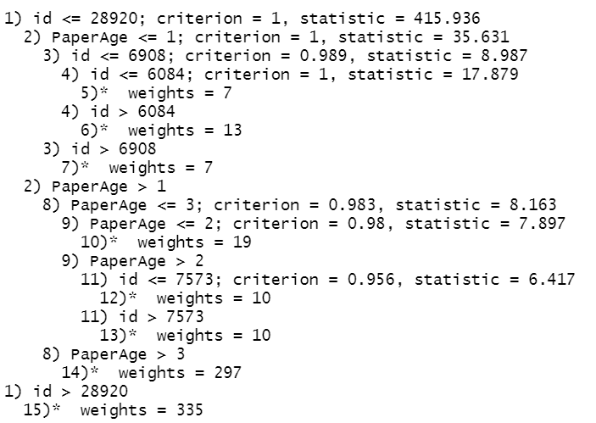

When the results are compared, it is seen that hclust clustering gives better results. Due to the higher True values in the summary () function output.

Appendix

Correlation result for J_or_C:

[,1]

id 0.7695901283

Authors_Num -0.0536400759

Countries_Unique_Num 0.0614238050

FRES_Title -0.0415767181

FLESCH_Title 0.0476400330

numCharTitle_all 0.0568366776

numCharTitle_onlyAlpha 0.0602109989

numCharTitle_nonAlpha 0.0426033155

nonAlphaCharTitle_isExist 0.0122823297

numWordTitle 0.0218441874

numABV_Title -0.0686486104

binABV_Title -0.0748833885

numSentAbstract 0.1341003085

numABV_Abstract -0.0002639689

binABV_Abstract -0.0748833885

PaperAge 0.2003015217

numLexVerb 0.0146084150

numSylGreaThan2 0.0250839268

numPage 0.4393504852

Year -0.2003015217

Cited by 0.1137294360

FRES_Abstract -0.0460733295

FLESCH_Abstract 0.0077471322

isFunding 0.2468480900

keywordsListedAlpha 0.2097446541

numKeywords -0.1670646147

Quartile 0.7408991571

J_or_C 1.0000000000

CitationMetric_1 0.1827314360

CitationMetric_2 0.1032091493

CitationMetric_3 0.1838996395

CitationMetric_4_CB 0.1347132952

CitationMetric_4a_CM2 NA

CitationMetric_4b_CM3 0.2047115491

CitationMetric_5_CB NA

CitationMetric_5a_CM2 NA

CitationMetric_5b_CM3 NA

Dominant_Topic -0.0114268930

single_quote_mark 0.0043796993

parenthesis_mark 0.0587407450

hyphen_mark 0.0656867158

period_mark 0.0782819204

slash_mark 0.0400352103

colon_mark 0.0899246667

question_mark 0.1296179903

presenceColon 0.0766965888

avgPunctuation 0.1131239203

numPreposition 0.1191945494

numFreqLexItems_connectives 0.0566403304

numFreqLexItems_action_markers -0.0205420605

numFreqLexItems_closing -0.0020626981

numTitleSubstantiveWordsWoutStopwords 0.0210552487

numTitleSubstantiveWordsWithStopwords 0.0145262282

numAbstractSubstantiveWordsWoutStopwords 0.1479552017

numAbstractSubstantiveWordsWithStopwords 0.1438372975

presenceInitialPosition_a 0.0725637833

presenceInitialPosition_a_or_the 0.0717338269

presenceInitialPosition_ing 0.0124593729

Correlation result for Quartile:

[,1]

id 0.632649508

Authors_Num -0.041895122

Countries_Unique_Num 0.012876833

FRES_Title -0.056831488

FLESCH_Title 0.065623774

numCharTitle_all 0.069849063

numCharTitle_onlyAlpha 0.072664727

numCharTitle_nonAlpha 0.040268878

nonAlphaCharTitle_isExist 0.028163619

numWordTitle 0.038952080

numABV_Title -0.031661262

binABV_Title -0.038969138

numSentAbstract 0.157633363

numABV_Abstract 0.028419542

binABV_Abstract -0.038969138

PaperAge 0.166901677

numLexVerb 0.032459801

numSylGreaThan2 0.044466404

numPage 0.537468503

Year -0.166901677

Cited by 0.068643861

FRES_Abstract -0.042544540

FLESCH_Abstract 0.012725956

isFunding 0.148911190

keywordsListedAlpha 0.205894208

numKeywords -0.150041700

Quartile 1.000000000

J_or_C 0.740899157

CitationMetric_1 0.100630284

CitationMetric_2 0.037855301

CitationMetric_3 0.098933609

CitationMetric_4_CB 0.070155016

CitationMetric_4a_CM2 NA

CitationMetric_4b_CM3 0.100676264

CitationMetric_5_CB NA

CitationMetric_5a_CM2 NA

CitationMetric_5b_CM3 NA

Dominant_Topic -0.020245882

single_quote_mark -0.028803605

parenthesis_mark 0.069004957

hyphen_mark 0.055982750

period_mark 0.113892732

slash_mark 0.057546078

colon_mark 0.023162837

question_mark 0.136562048

presenceColon 0.045363532

avgPunctuation 0.119479756

numPreposition 0.166142960

numFreqLexItems_connectives 0.039462590

numFreqLexItems_action_markers -0.031459617

numFreqLexItems_closing 0.018410147

numTitleSubstantiveWordsWoutStopwords 0.040944063

numTitleSubstantiveWordsWithStopwords 0.038720864

numAbstractSubstantiveWordsWoutStopwords 0.176529513

numAbstractSubstantiveWordsWithStopwords 0.171547042

presenceInitialPosition_a 0.070655716

presenceInitialPosition_a_or_the 0.071428060

presenceInitialPosition_ing -0.007684693

>