SignalHarbour
Systematic Multi-Asset Funds with News-Sentiment Analytics
FINS5545 FinTech Project B

Student: Erbo Wang
Student ID: z5729415

1. The Funds and the Backtest Design

1.1 Product and fund design
SignalHarbour is a prototype investment app for financially literate retail investors who want to compare systematic multi-asset funds without working directly with raw market and news data. In this stage, I turn the Part A data foundation into two fund prototypes and a public Streamlit interface. The two portfolio methods are minimum variance and maximum Sharpe. I kept both long-only and fully invested, with weights summing to one. I preferred this simple setup because it is easier to explain to a retail user. No leverage, no short positions, and fewer hidden assumptions.

1.2 Walk-forward out-of-sample design
The backtest is walk-forward and out of sample. Returns are calculated separately for each ticker from adjusted close prices before the equity and cryptocurrency panels are combined. I align the combined panel to the equity trading calendar and use a 252-trading-day estimation window, with rebalancing every 21 trading days. The first live portfolio return is 4 January 2021. Each estimation window ends before the return being tested, so the current decision does not use current or future returns. I caught one issue during testing: the first return row was incomplete. I removed it so that both equity and crypto assets had a full 252-day history at the first rebalance.

1.3 Optimisation and assumptions
For the minimum-variance fund, I minimise portfolio variance using the covariance matrix from the trailing window. For the maximum-Sharpe fund, I maximise expected return relative to volatility using trailing mean returns and covariances. I use 252 periods per year, a zero risk-free rate and zero transaction costs. These assumptions keep the model simple, but they are not fully realistic. Real investors face trading costs, and the risk-free rate is not always close to zero. Portfolio weights are constrained between zero and one. I also checked the latest holdings because I did not want to trust a successful optimiser message on its own.
The calendar choice took more thought than I expected. Equities contribute 50 return series and crypto contributes 10, but they do not share the same trading week. I calculate returns first and only then align crypto to the equity calendar. This avoids creating artificial multi-day crypto returns from price levels and gives every rebalance a common decision date. The cost is that weekend-only crypto moves are excluded. I was comfortable with that trade-off because this version of SignalHarbour is treated as a combined fund that rebalances on equity trading days, not as a continuously traded crypto strategy.
I treat the optimiser outputs as estimates, not as proof that a stable economic optimum has been found. Maximum-Sharpe optimisation is especially sensitive to noisy mean-return estimates, so concentration can become extreme. I checked the realised weight paths and latest holdings after the backtest. The two methods produced very different allocations. That was reassuring. It showed that the solver was not simply returning the same starting vector under two different names.

2. Out-of-Sample Results and Fund Fact Sheets

2.1 Out-of-sample performance
The two base funds produced very different out-of-sample outcomes from 4 January 2021 to 29 December 2023. Minimum variance earned an annualised return of 5.70% with 12.76% volatility, a Sharpe ratio of 0.447 and a maximum drawdown of -14.97%. Maximum Sharpe earned 25.18% annualised with 24.48% volatility, a Sharpe ratio of 1.028 and a maximum drawdown of -24.17%. A $1 investment finished at about $1.18 in minimum variance and $1.96 in maximum Sharpe. The gap is large. Figure A1 also makes clear that the stronger return came with a much rougher path.

2.2 Risk-return trade-off
I do not read these results as one fund simply being 'better'. Minimum variance delivered the smaller drawdown and much lower volatility, which is exactly what I would expect from its objective. Maximum Sharpe took substantially more risk but earned enough extra return to push the Sharpe ratio above one in this sample. For a user, that difference matters more than the headline return alone. Figure A4 shows the Sharpe gap, while Figure A2 shows the minimum-variance drawdown path.

2.3 Holdings and portfolio behaviour
The latest holdings make the contrast even clearer. At the 5 December 2023 rebalance, minimum variance was relatively diversified, with its largest positions in KO (19.13%), WMT (15.19%), V (9.67%), MRK (9.51%) and ABBV (9.20%). Maximum Sharpe was much more concentrated: GE (49.83%), NVDA (16.85%), BTC-USD (13.29%) and ADBE (7.99%) dominated the portfolio. Seeing nearly half the portfolio in GE surprised me at first. It also made the estimation risk of maximum-Sharpe optimisation much more tangible.

2.4 Equity versus crypto allocation
Figure A5 compares total cryptocurrency weight across the two methods over time. The difference is striking. Maximum Sharpe allocated roughly 64% to crypto at the first live rebalance, then cut that exposure sharply during 2021 and kept it near zero for long periods before increasing it again in the second half of 2023. Minimum variance kept crypto exposure very small throughout and ended at about 2.64%, compared with about 18.82% for maximum Sharpe. This tells me that the performance gap was driven partly by asset-class allocation, not only by stock selection.
The weight path also made me more cautious about interpreting the optimiser literally. The very high early crypto allocation in maximum Sharpe is not something I would automatically recommend to an investor. It came from the estimates available in that trailing window. The later move toward almost zero crypto, followed by another increase in 2023, shows how unstable the solution can be when means and covariances change. In a production version I would probably add concentration or asset-class limits. Here I left the constraints simple so the behaviour of the two objectives stayed visible.

3. The Sentiment Index

3.1 VADER headline scoring
The sentiment model uses VADER to score the original news headline text. I keep casing, punctuation and negation because these features are part of VADER's rule-based scoring. Each headline receives a compound sentiment score. Headline scores are then averaged to ticker-day level, and ticker-day values are averaged equally within each sector to produce the daily sector sentiment index. Cryptocurrency is not included in this stage because the supplied crypto data has no sector mapping or company-news headlines.

3.2 Calendar alignment and look-ahead control
News dates are first mapped to the relevant equity trading day: the same day when it is a trading day and the next available trading day for weekends or market holidays. A sentiment value aligned to day t is then lagged by at least one trading day before it can affect a portfolio decision. Therefore, a decision on day t can only use sentiment that was available on day t-1 or earlier. Ticker-days with no headline are not filled with an artificial zero. They simply do not contribute to that day's sector average. I prefer this treatment because no headline is not the same thing as neutral sentiment.

3.3 What the index shows
Figure A6 shows a noisy sector sentiment series over 2020-2023, with short positive and negative spikes rather than a smooth trend. That is not surprising. The source is headline text rather than full articles, and VADER is a general-purpose lexicon. The latest values also differ across sectors: Real Estate, Communication Services and Industrials are positive, while Materials is negative. I find the index useful as a descriptive view of news tone, but I would not treat it as a standalone return forecast.
The sector index should therefore be interpreted mainly as a time-varying summary of headline tone. On days when only a few tickers have news, the sector average is based on a smaller information set than on high-coverage days. I do not fill missing ticker-days with zero because that would assume that no headline is neutral information. However, dropping missing ticker-days also means the composition of the sector index can change from day to day. This is another reason to treat the index as descriptive evidence and to validate any trading use separately.
A rule-based model has one advantage I like: it is easy to inspect. Keeping punctuation, capitalisation and negation has a clear reason under VADER. The weakness is finance-specific language. Words that look neutral or positive in general English can mean something different in a market headline. Rather than assuming the score was useful, I tested it in the portfolio. The next section shows that this check mattered.

4. Fusion Extension and Whether It Adds Value

4.1 Basic sentiment tilt
The first fusion experiment applies the lagged sector sentiment score to equity weights. A positive sector score slightly increases the weights of equities in that sector, while a negative score reduces them; crypto weights are not directly adjusted. The portfolio is then renormalised to sum to one. This is a deliberately simple baseline because the purpose is to test whether the news signal adds value before using a more complicated rule.

4.2 Fusion result
The basic sentiment tilt did not improve either fund. Minimum variance moved from 5.70% annualised return and a 0.447 Sharpe ratio to 5.65% and 0.442. Maximum Sharpe moved from 25.18% and 1.028 to 24.93% and 1.024. Volatility for maximum Sharpe fell slightly, from 24.48% to 24.34%, but maximum drawdown worsened from -24.17% to -24.33%. Figure A7 shows how close the two growth paths are. I had expected at least a small improvement somewhere. It did not happen.

4.3 Sentiment Shock extension
I then tested a different idea: maybe the absolute sentiment level matters less than whether the latest sentiment is unusual for that sector. The Sentiment Shock signal compares lagged sector sentiment with its recent 20-day rolling mean and standard deviation, then clips the resulting z-score to limit extreme adjustments. A score of +0.15 may be ordinary for one sector but unusual for another. The shock measure tries to capture that relative surprise. Because it uses lagged sentiment and earlier rolling history, the signal remains look-ahead safe.

4.4 Did the extension add value?
The shock extension also produced a negative result. Minimum-variance annualised return fell to 5.45%, Sharpe fell to 0.425 and maximum drawdown moved to -15.20%. For maximum Sharpe,annualised return fell to 24.62%, Sharpe fell to 1.009 and maximum drawdown worsened to -24.85%. Figure A8 compares the base, basic-sentiment and shock versions. This was disappointing, but also useful. I kept the result rather than changing the 20-day window or tilt strength until something looked better.

4.5 Interpretation of the negative result
There are several plausible explanations. Headline sentiment may react to information that prices have already absorbed, so even a lagged signal can arrive too late. VADER is also not designed specifically for financial language. On top of that, a sector-level signal can hide big differences between individual firms. Finally, the maximum-Sharpe portfolio is already concentrated in a small set of assets, so a mild sector overlay has limited room to help. My takeaway is not that sentiment is useless. It is that the way sentiment is measured and applied matters a lot.
I did not search across many rolling windows or tilt strengths after seeing the performance table. That would make it too easy to choose a parameter combination that happened to fit this one 2021-2023 period. I treat the 20-day shock rule as a small robustness experiment. The question was simple: does relative sector-news tone contain information that the absolute score misses? In this sample, the answer is no. That pushes the next research question toward better text measurement or more granular ticker-level signals, rather than a stronger version of the same sector tilt.

5. The App and the Investor Journey

5.1 Investor journey
The Streamlit app is where the model becomes something a user can actually interact with. I organised it into Funds, Allocation and Sentiment tabs. The Funds tab compares fund metrics, growth of $1, drawdown and current holdings. The Allocation tab lets the user mix the two base funds and immediately see the historical path of that blend. The Sentiment tab shows sector sentiment, latest readings, the basic fusion result and the Sentiment Shock extension. I wanted the interface to stay simple. The models are already complicated enough.

5.2 Deployment design
The deployed app reads precomputed CSV files from the results/ folder instead of rerunning the backtest or VADER on Streamlit Community Cloud. That keeps the public app responsive and separates the build stage from the viewing stage. I tested the app locally and again after deployment. I also checked edge cases: 0% and 100% allocations, different fund selections, multiple sectors and no sector selected.

5.3 Product value
For the target user, the main value of SignalHarbour is not another complicated model screen. It is the ability to see the trade-offs quickly. A user can compare return and risk, inspect current holdings, mix the two base funds and view news sentiment separately. I also chose to show the negative fusion result rather than hide it. I think that makes the product more credible. Not every extra data source deserves a place in the final investment decision.
I tested the main controls again after deployment instead of assuming that the local version was enough. The fund selector updated metrics, drawdown and holdings; the allocation control worked at 0%, 50% and 100%; and the sentiment selector worked with several sectors and with none selected. I also hit a cached-results error after adding the shock columns. Fixing it was frustrating, but useful. It reinforced why I wanted the analytical build and the public interface to remain separate.

6. Critical Reflection and Recommendations

6.1 What worked and what did not
The strongest result in the project was the contrast between the two portfolio methods. The walk-forward backtest produced clearly different weights and risk profiles, and maximum Sharpe delivered the stronger risk-adjusted result over the test period. The sentiment index also worked well as a standalone analytic. The part that did not work was the trading overlay. Both the basic sentiment tilt and the Sentiment Shock extension slightly reduced performance. I would rather keep that result than pretend the extra signal helped. A plausible idea still needs evidence.

6.2 Recommendation 1 - calibrate sentiment for finance
My first recommendation is to validate the sentiment model on financial headlines rather than rely on plain vader alone. I would build a small labelled sample and compare vader with a finance-specific lexicon or finance-domain model. Terms such as 'beat', 'cut', 'upgrade', 'downgrade' and 'guidance' can be awkward for a general lexicon. The goal would be better classification, not simply stronger sentiment scores.

6.3 Recommendation 2 - move from sector to ticker-level signals
My second recommendation is to keep more of the cross-sectional information in the news data. The current sector signal pushes equities in the same general direction even when the news is concentrated in only one or two firms. A ticker-level signal could adjust the affected names first and then apply sector or portfolio risk limits. That feels like a more natural next step than making the sector tilt stronger.

6.4 Recommendation 3 - add turnover and transaction costs
My third recommendation is to add turnover and transaction costs. At the moment, the backtest assumes that weights can change for free. Real portfolios cannot. I would calculate turnover at each rebalance and subtract a simple trading-cost assumption, such as a fixed number of basis points per dollar traded. That would make it easier to judge whether a portfolio change is actually worth implementing.

6.5 Final reflection
What I learned from Part B is that the highest-return backtest is not automatically the best product. Minimum variance and maximum Sharpe suit different risk preferences. The news index adds another view of the market, but the fusion tests show that more data does not automatically mean more value. For me, the most useful outcome is the combination of a reproducible backtest, a few honest negative tests and an app where the trade-offs are visible rather than hidden.
The evidence is still limited. The sample covers only 2020-2023, including the COVID shock, a strong crypto cycle, rapid interest-rate changes and a technology-led recovery. Another regime could produce a very different ranking. The optimisation also relies on historical mean and covariance estimates without shrinkage, while the app reports gross performance before fees and taxes. So I see the backtest as evidence about this design under this sample. It is not a promise of future performance.

Appendix: Tables and Figures
The appendix collects the tables and figures used in the discussion above. All outputs are produced by scripts/run_part_b.py. Backtest figures use the live out-of-sample period from 4 January 2021 to 29 December 2023 unless otherwise stated.
Table A1. Out-of-sample performance metrics for the two combined funds, 4 January 2021 - 29 December 2023.
Fund | Annualised return | Annualised volatility | Sharpe ratio | Max drawdown
Combined Minimum Variance | 5.70% | 12.76% | 0.447 | -14.97%
Combined Maximum Sharpe | 25.18% | 24.48% | 1.028 | -24.17%

Table A2. Largest current target holdings at the most recent rebalance, 5 December 2023.
Fund | Asset | Weight
Minimum Variance | KO | 19.13%
 | WMT | 15.19%
 | V | 9.67%
 | MRK | 9.51%
 | ABBV | 9.20%
 | O | 7.40%
 | TMUS | 6.56%
 | EA | 4.18%
 | T | 3.43%
 | CVX | 3.11%
Maximum Sharpe | GE | 49.83%
 | NVDA | 16.85%
 | BTC-USD | 13.29%
 | ADBE | 7.99%
 | BCH-USD | 5.53%
 | SO | 4.79%
 | INTC | 1.42%
 | TTWO | 0.31%

Table A3. Base funds versus the basic lagged sector-sentiment tilt, out-of-sample period 2021-2023.
Method | Annualised return | Annualised volatility | Sharpe | Max drawdown
Min Variance | 5.70% | 12.76% | 0.447 | -14.97%
Min Variance + Sentiment | 5.65% | 12.77% | 0.442 | -15.04%
Max Sharpe | 25.18% | 24.48% | 1.028 | -24.17%
Max Sharpe + Sentiment | 24.93% | 24.34% | 1.024 | -24.33%

Table A4. Sentiment Shock extension compared with the base and basic sentiment strategies, out-of-sample period 2021-2023.
Method | Annualised return | Annualised volatility | Sharpe | Max drawdown
Min Variance Base | 5.70% | 12.76% | 0.447 | -14.97%
Min Variance Basic Sentiment | 5.65% | 12.77% | 0.442 | -15.04%
Min Variance Sentiment Shock | 5.45% | 12.82% | 0.425 | -15.20%
Max Sharpe Base | 25.18% | 24.48% | 1.028 | -24.17%
Max Sharpe Basic Sentiment | 24.93% | 24.34% | 1.024 | -24.33%
Max Sharpe Sentiment Shock | 24.62% | 24.40% | 1.009 | -24.85%

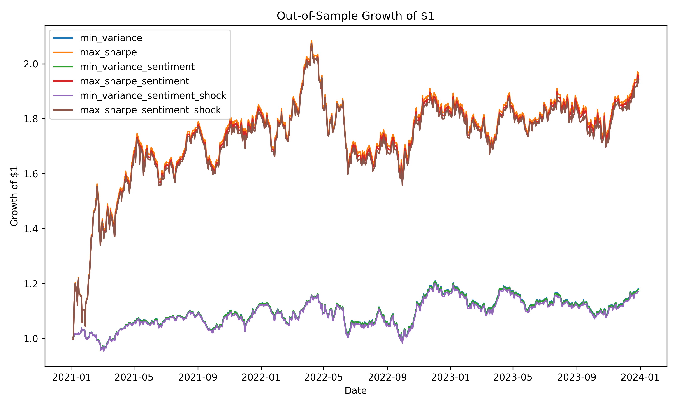
Figure A1. Growth of $1 for the base and basic sentiment-adjusted combined funds, 4 January 2021 - 29 December 2023. Unit: value of an initial $1 investment.
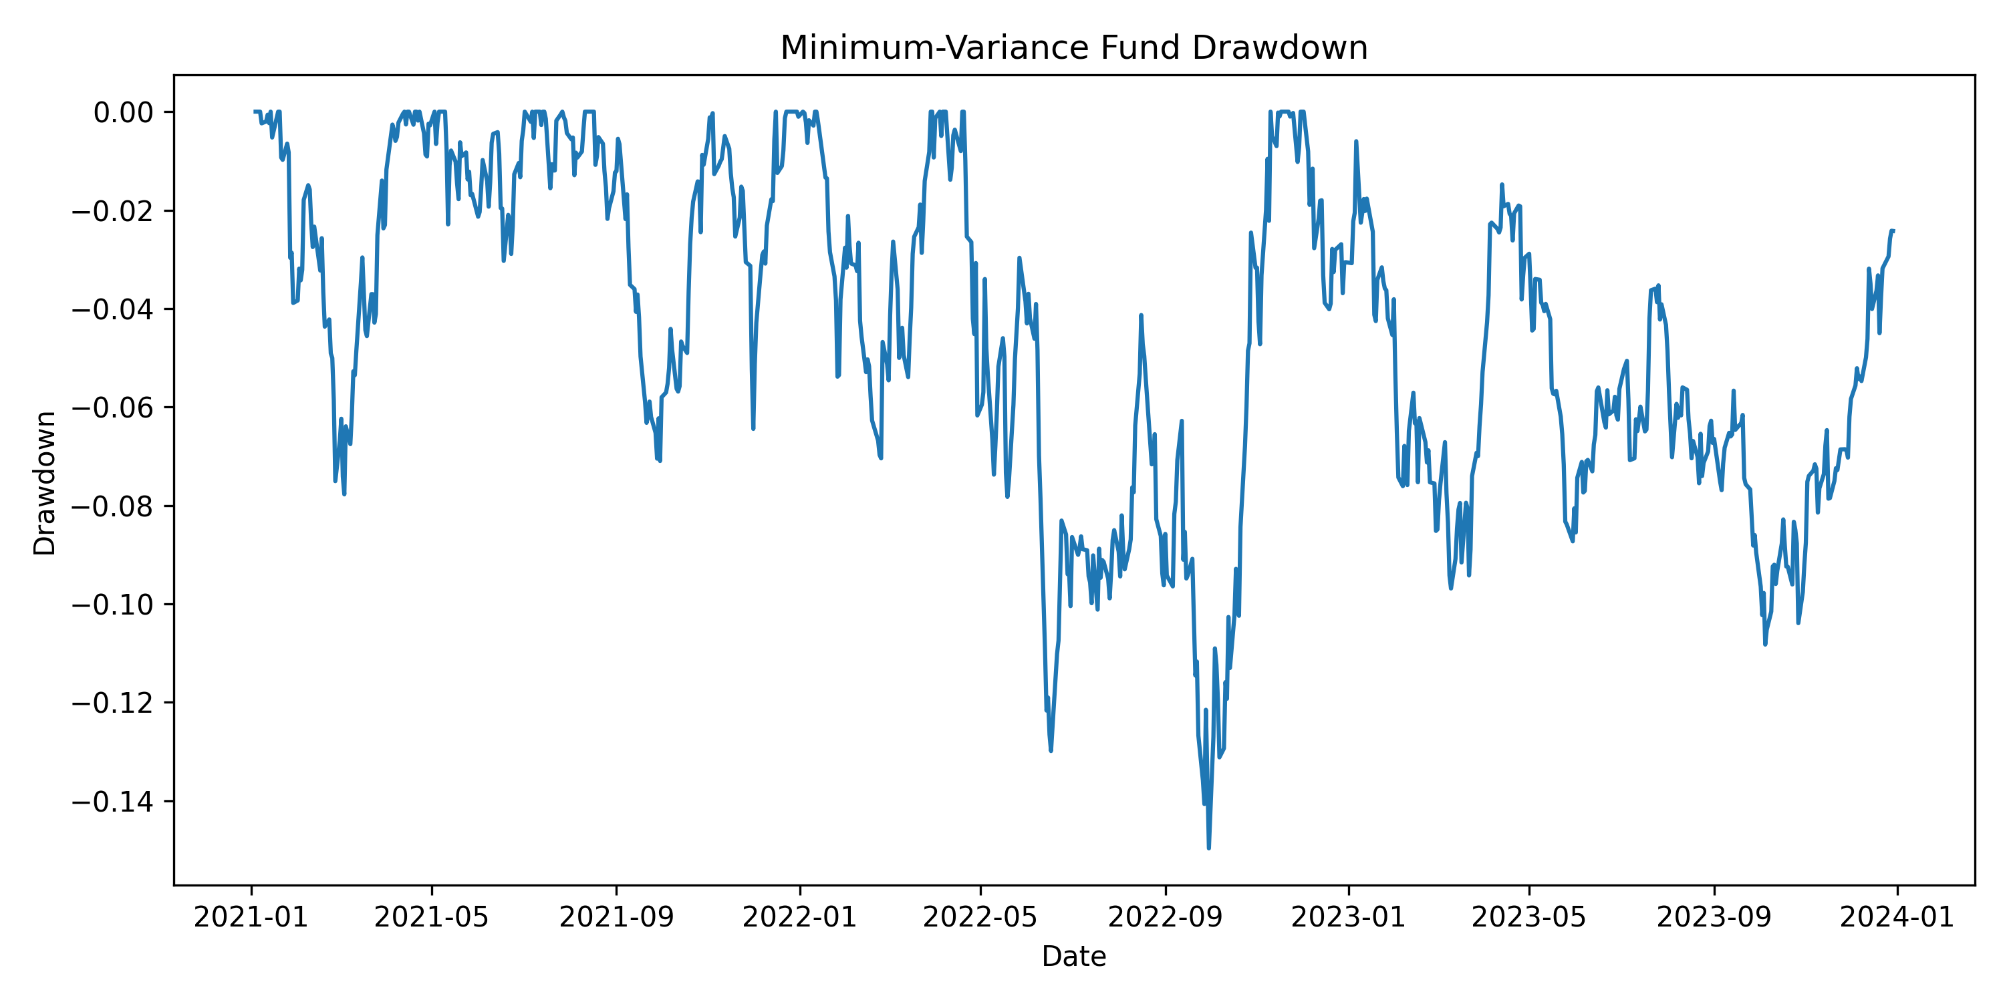
Figure A2. Drawdown of the Combined Minimum Variance fund, 4 January 2021 - 29 December 2023. Unit: percentage loss from the previous portfolio peak.
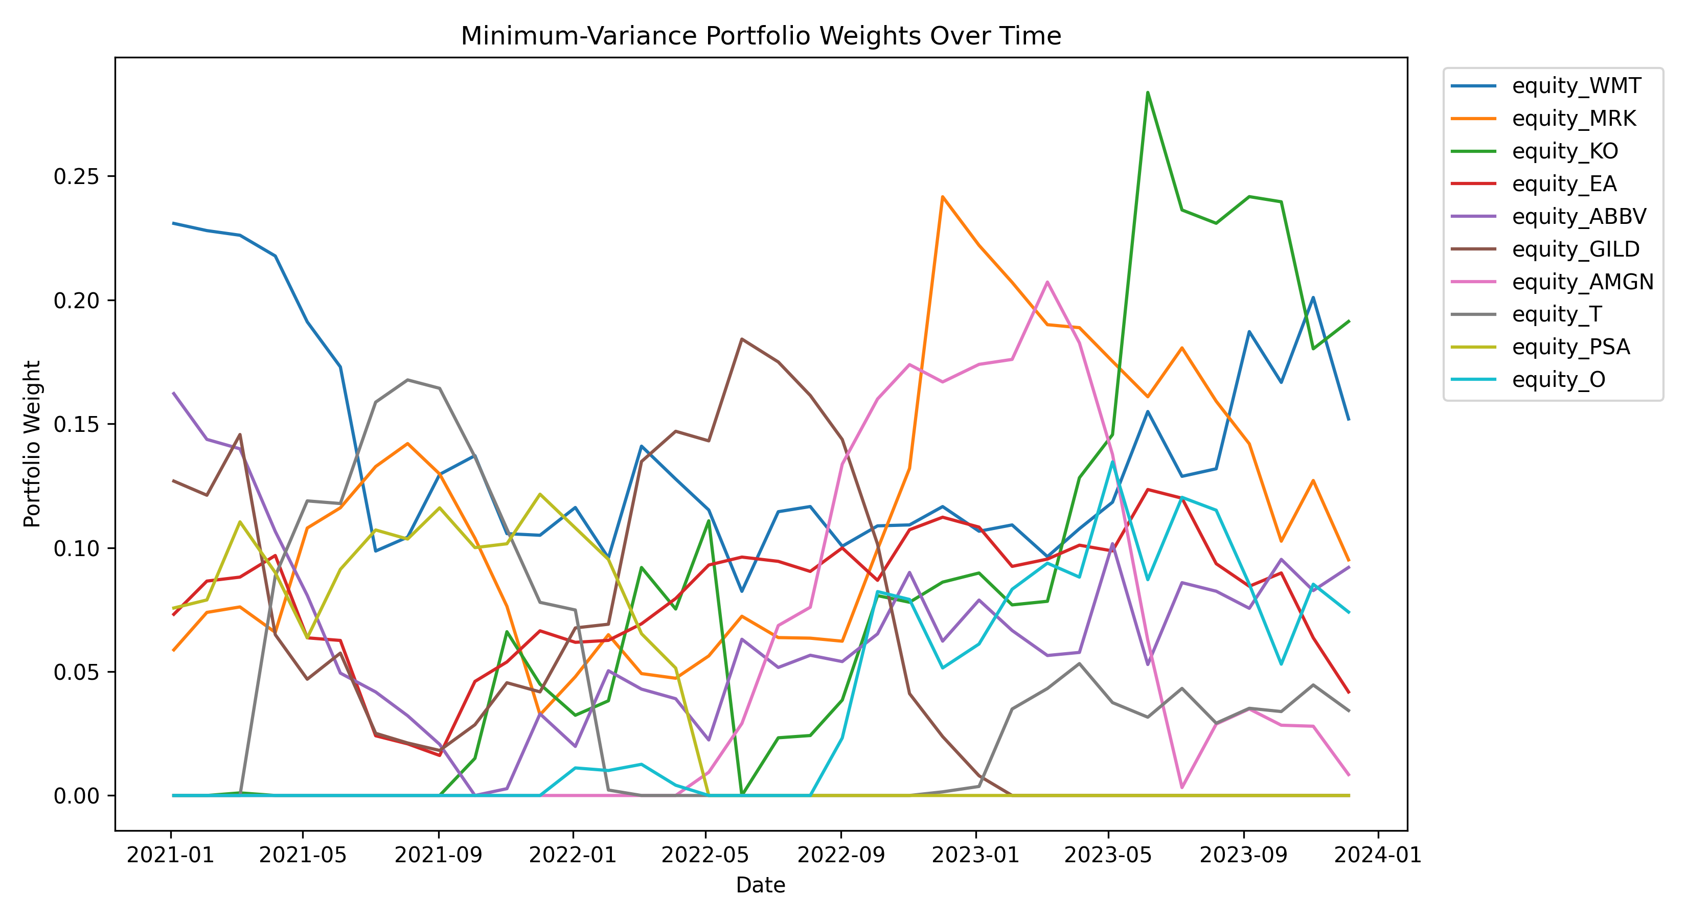
Figure A3. Top asset weights over time for the Combined Minimum Variance fund, 2021-2023. Unit: portfolio weight.
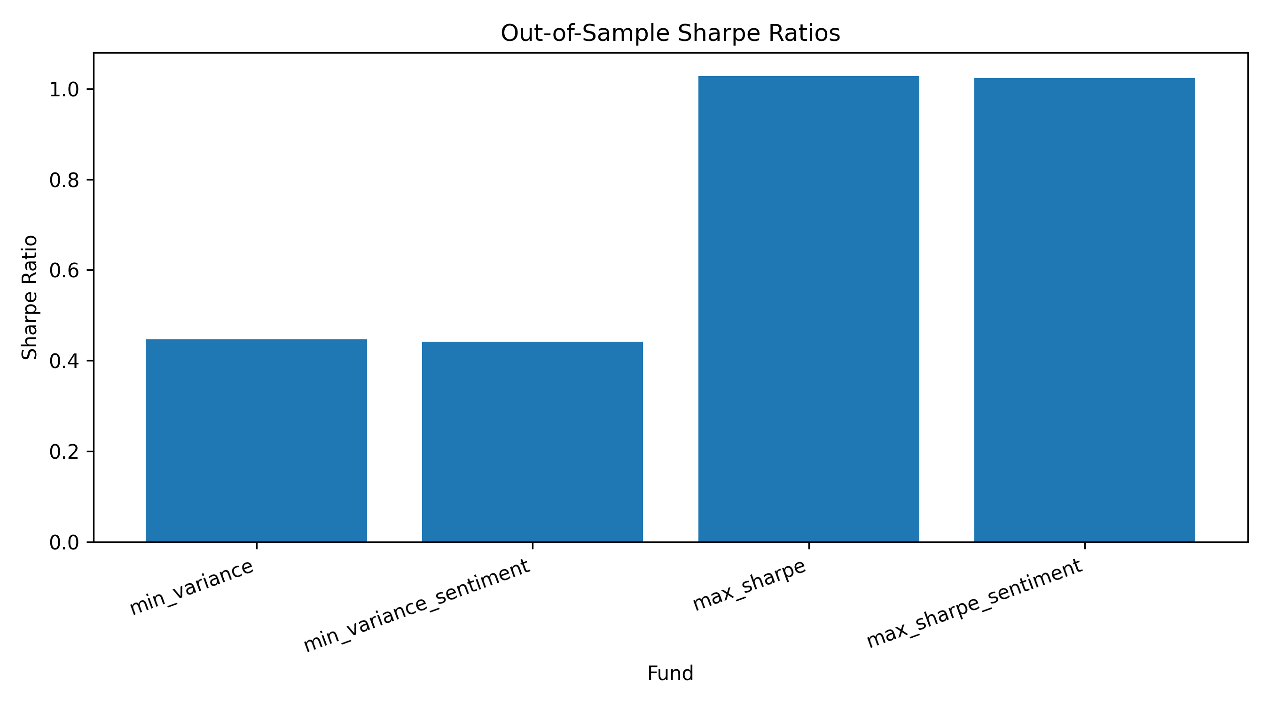
Figure A4. Out-of-sample Sharpe ratio comparison across the base and basic sentiment-adjusted funds, 2021-2023.
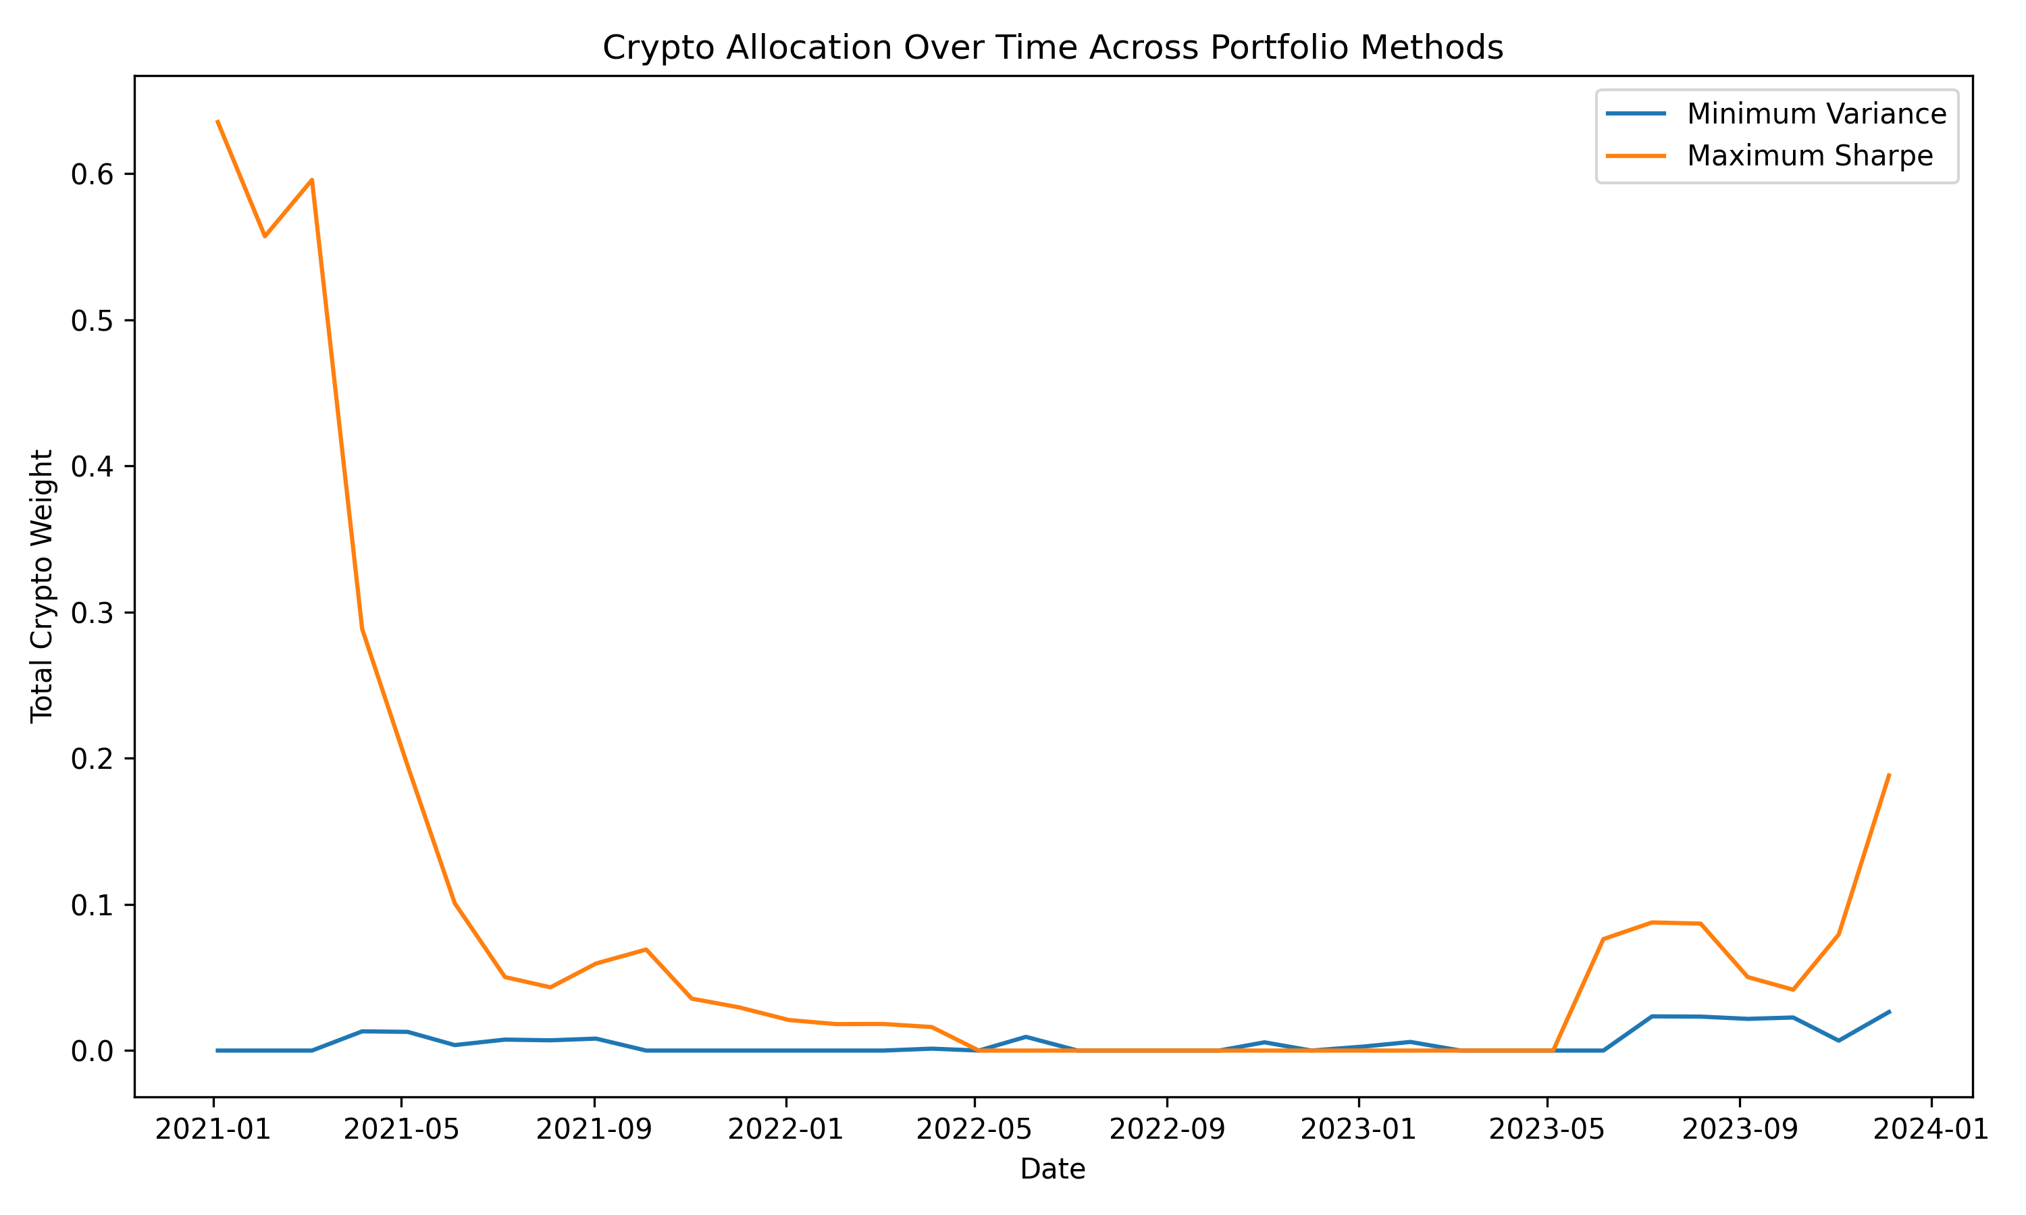
Figure A5. Total cryptocurrency allocation over time for Minimum Variance and Maximum Sharpe, 2021-2023. Unit: total portfolio weight allocated to crypto.
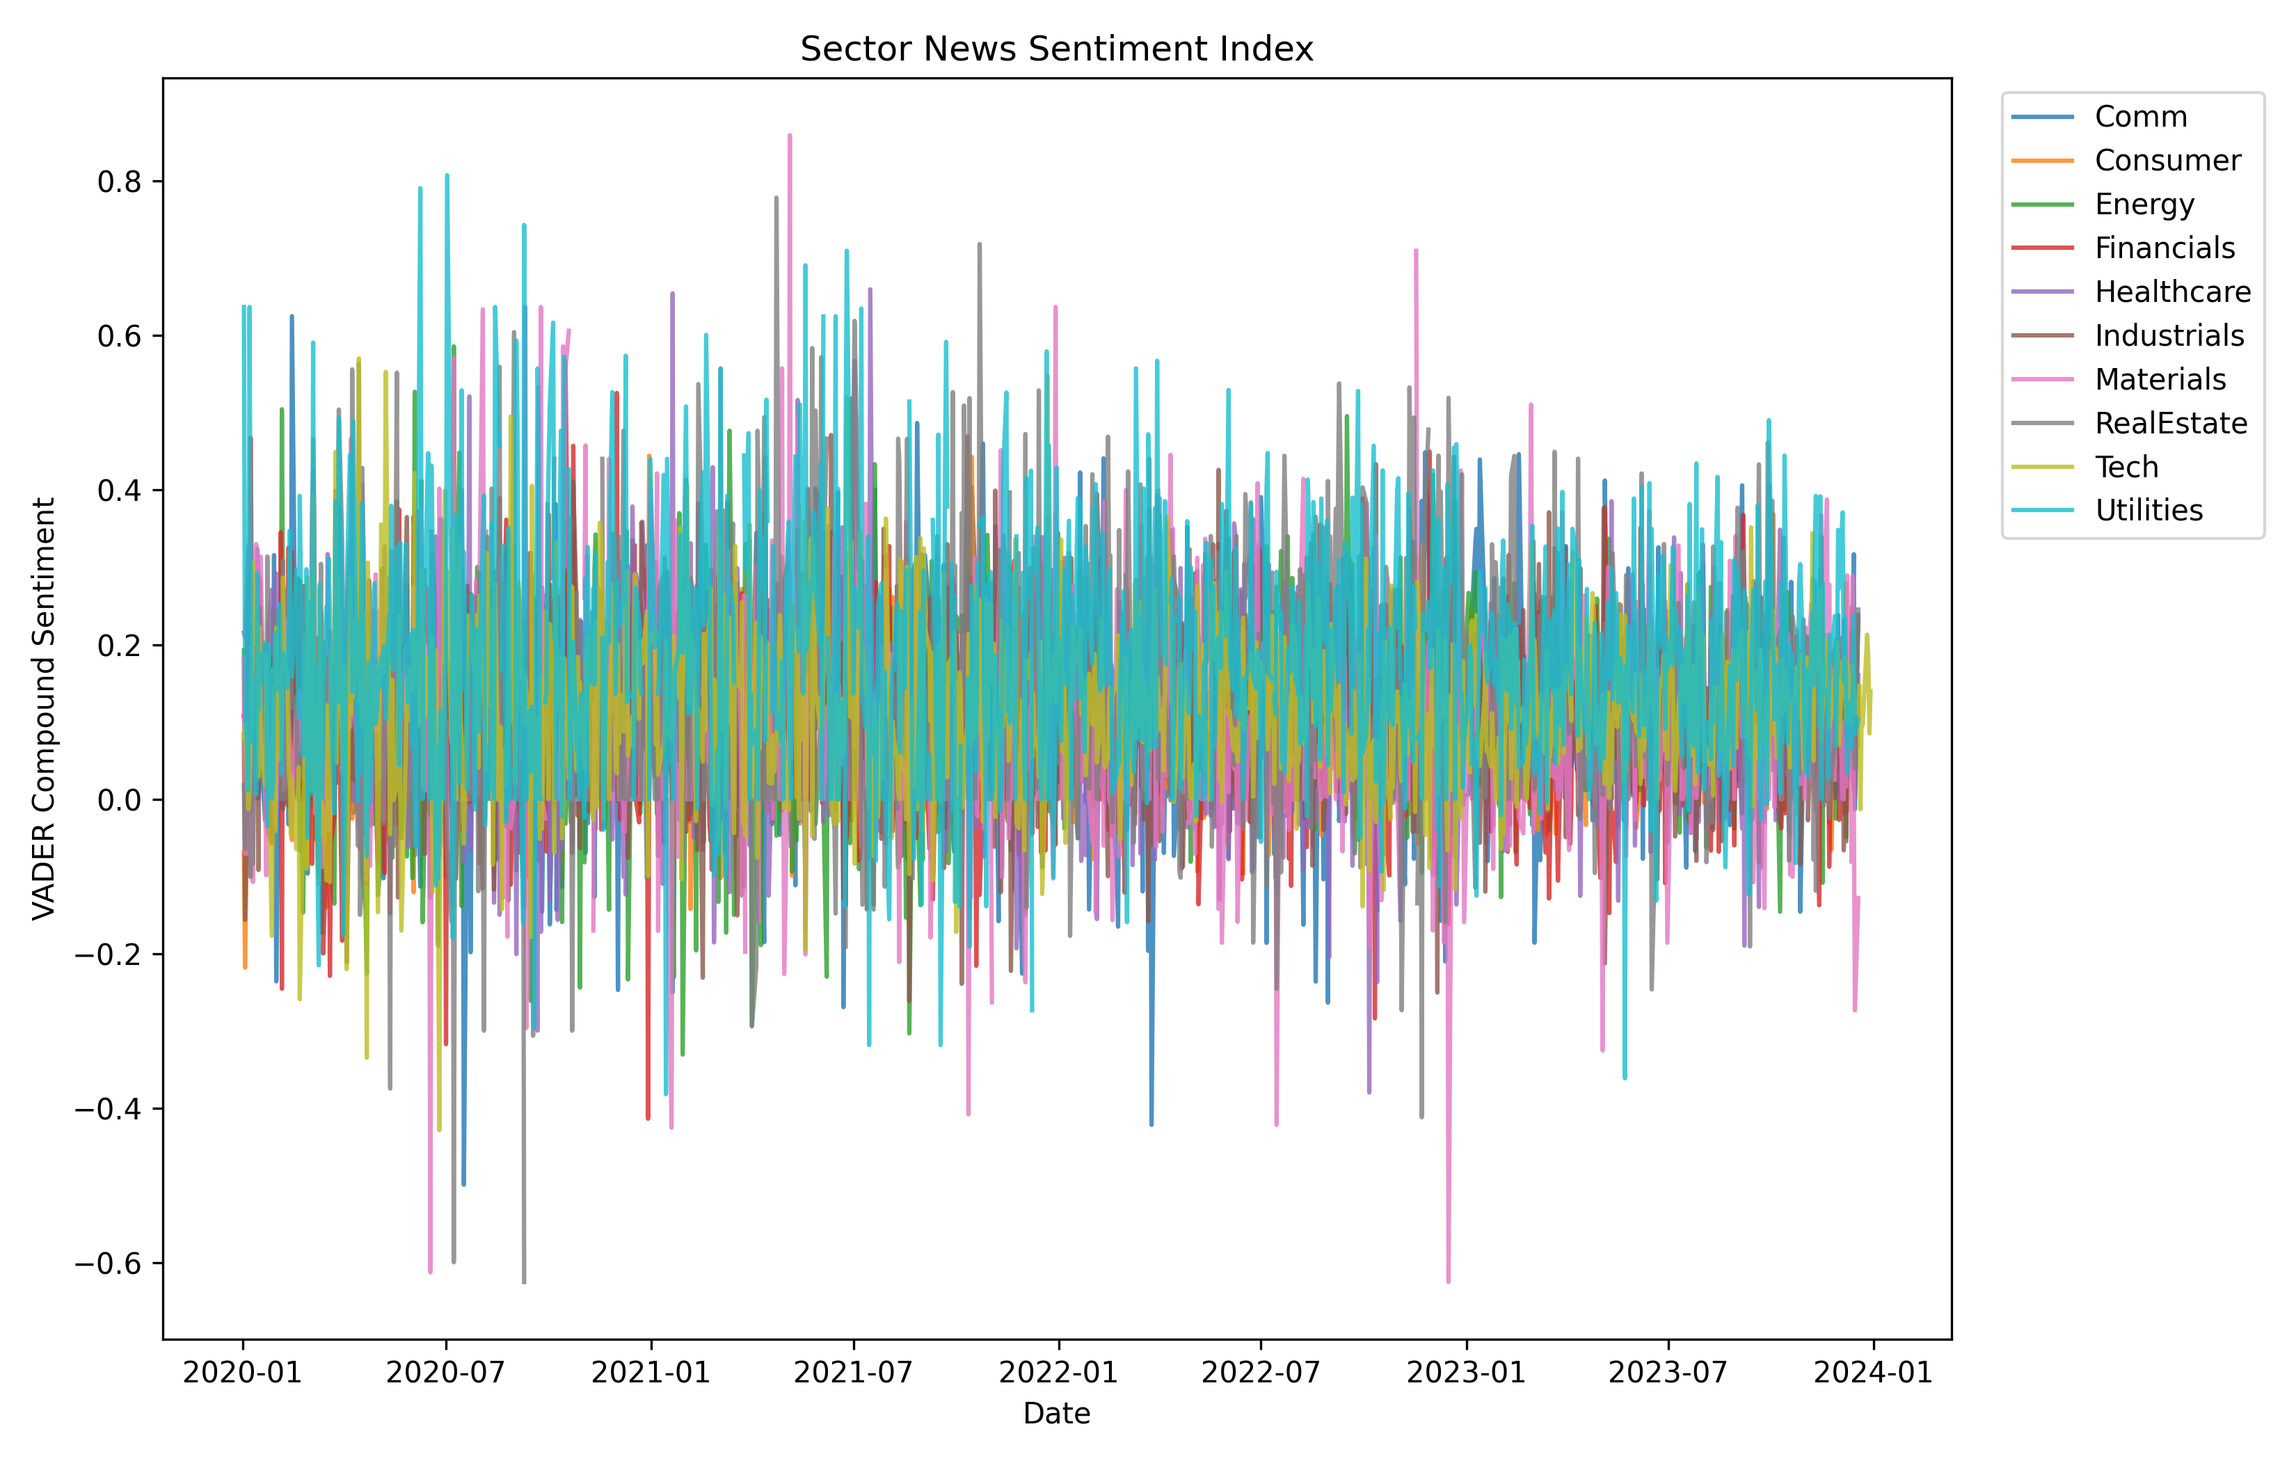
Figure A6. Daily VADER sector sentiment index for the equity sectors, 2020-2023. Unit: VADER compound sentiment score.
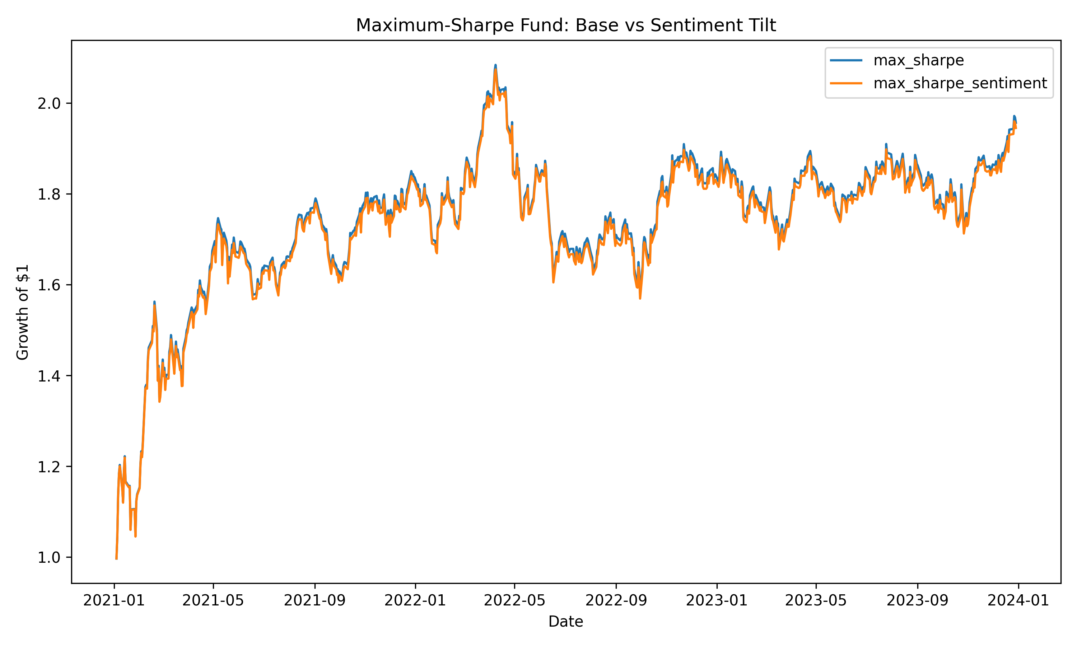
Figure A7. Maximum-Sharpe base fund versus the basic sector-sentiment tilt, 2021-2023. Unit: growth of an initial $1 investment.
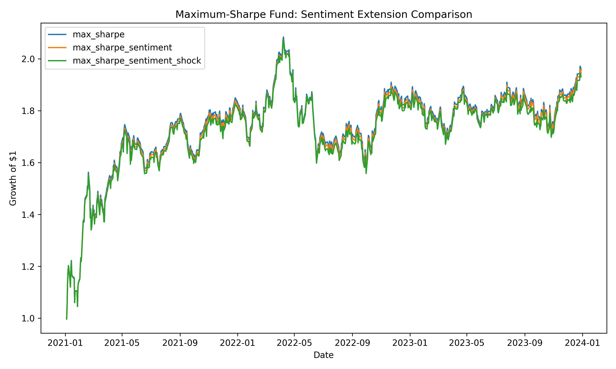
Figure A8. Maximum-Sharpe base, basic sentiment tilt and Sentiment Shock extension, 2021-2023. Unit: growth of an initial $1 investment.

