**Assignment #4. Responsive Web Design (Media Queries + Bootstrap Grid)**

Student: Faruza Saruar

Group: MT-2402

**Part 1. Media Queries**

**Task 0. Responsive Typography**

* Create a simple webpage with headings and paragraphs.
* Use media queries to change font sizes for mobile, tablet, and desktop.

Example: small font on mobile, medium on tablet, larger on desktop.

**Task 1. Responsive Layout with Media Queries**

* Create a webpage with three boxes in a row.
* On desktop: display all three side by side.
* On tablet: display two boxes in a row.
* On mobile: display boxes stacked vertically.
* Use only CSS media queries (no Bootstrap).

**Part 2. Bootstrap Grid System**

**Task 2. Bootstrap Responsive Columns**

* Build a responsive layout using Bootstrap’s **12-column grid**.
* Create three columns:
  + On **desktop**: each column takes 4 columns (3 equal parts).
  + On **tablet**: two columns on the first row and one on the second row.
  + On **mobile**: all columns stacked.

**Task 3. Bootstrap Navigation Bar**

* Create a responsive navigation bar using Bootstrap components.
* It should include: a logo on the left, links on the right, and collapse into a hamburger menu on smaller screens.

**Part 3. Combined Project**

**Task 4. Responsive Portfolio Page**

* Create a **portfolio page** using both Media Queries and Bootstrap Grid.
* Requirements:
  1. **Header** with a Bootstrap navbar.
  2. **Main section** divided into two parts:
     + Left side: portfolio projects (use Bootstrap grid to arrange cards).
     + Right side: sidebar with personal info and contact details.
  3. **Footer** across the bottom.
* Apply **custom media queries** to adjust font sizes, spacing, and element visibility for mobile, tablet, and desktop.
* Ensure that the page looks clean and usable across different screen sizes.

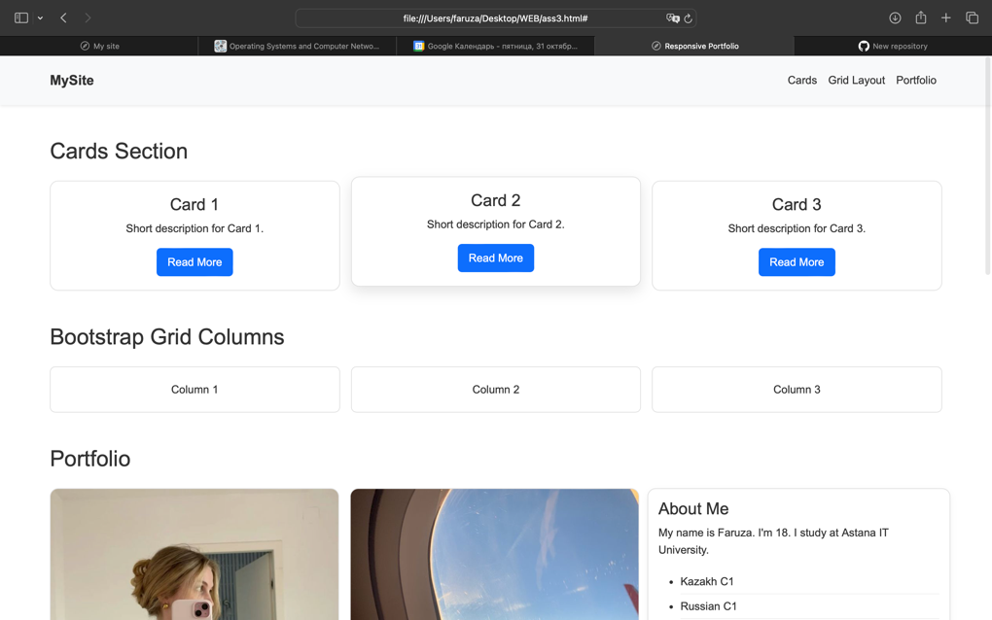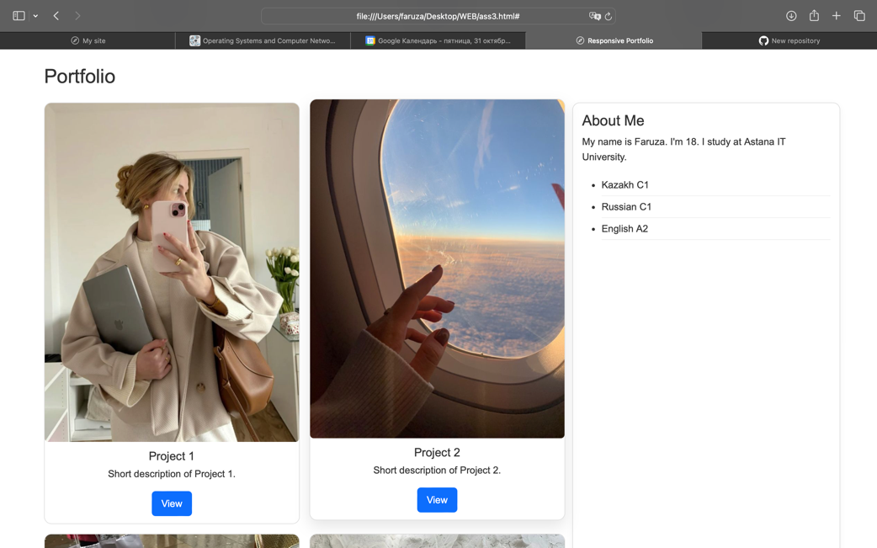

During this project, I learned how to create responsive web pages using CSS media queries and Bootstrap’s grid system. I practiced building adaptive layouts for desktop, tablet, and mobile screens, including responsive cards, grids, and portfolio sections. I also learned to implement a collapsible navigation bar, style buttons with hover effects, and organize a clean, user-friendly portfolio page. Overall, I improved my understanding of modern responsive design principles and practical front-end development skills.