Mindful AI Diary: Deep Learning Based Emotion Detection

A Project Report Submitted by
Yerbol Maratov

Department of Computer Science
AMU

Table of Contents
1. Introduction................................................................... 1
2. Literature Review.............................................................. 2
3. Methodology.................................................................... 3
4. System Architecture............................................................ 4
5. Implementation................................................................. 6
6. Results and Analysis........................................................... 8
7. Future Scope and Conclusion.................................................... 9
8. References..................................................................... 10

1. Introduction
Mental health awareness has become a critical aspect of modern life. With the increasing stress of daily routines, many individuals turn to journaling as a coping mechanism. However, traditional journaling lacks feedback. This project, the 'Mindful AI Diary', aims to bridge that gap by utilizing Artificial Intelligence to provide real-time emotional feedback.
Unlike simple sentiment analysis which only categorizes text as positive or negative, this project leverages Deep Learning (specifically BERT models) to detect granular emotions such as Joy, Sadness, Anger, Fear, Love, and Surprise. This allows users to gain deeper insights into their emotional well-being over time.

2. Literature Review
The field of Natural Language Processing (NLP) has evolved significantly. Early approaches relied on lexicon-based methods like TextBlob and VADER, which used dictionaries of 'good' and 'bad' words. While fast, these methods failed to capture context, sarcasm, or complex sentence structures.
The introduction of Transformer architectures, specifically BERT (Bidirectional Encoder Representations from Transformers) by Google in 2018, revolutionized the field. BERT reads text in both directions (left-to-right and right-to-left), allowing it to understand the full context of a word. This project utilizes a 'DistilBERT' model, which is a lighter, faster version of BERT that retains 97% of its performance while being 40% smaller.

3. Methodology
The development of the Mindful AI Diary follows the Model-View-Controller (MVC) architectural pattern. The core methodology involves fine-tuning a pre-trained DistilBERT model on an emotion dataset.

3.1 Dataset
The model is trained on a dataset of English Twitter messages labeled with six basic emotions: anger, fear, joy, love, sadness, and surprise. This dataset is widely used for multi-class classification tasks in NLP.

3.2 Pre-processing
Text data undergoes tokenization using the DistilBertTokenizer. This converts words into numerical IDs that the neural network can process. Special tokens like [CLS] (start) and [SEP] (separator) are added to the input sequences.

4. System Architecture
The system consists of three main components: The Client (Frontend), The Server (Backend), and The AI Model.
1. **Frontend:** Built using HTML5, CSS3, and Jinja2 templating. It provides a clean, distraction-free interface for users to write their thoughts.
2. **Backend:** Developed using Python and Flask. It handles HTTP requests, processes form data, and manages the communication between the user and the AI.
3. **AI Inference Engine:** Uses the Hugging Face `transformers` library to load the model into memory. When text is received, it is passed through the model to obtain a probability distribution across the six emotions.

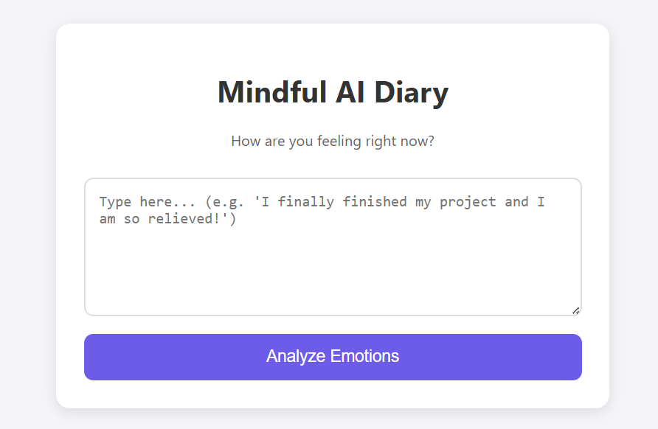
Picture 1: UI.

5. Implementation
The implementation was carried out in Python 3.9. Below are the key code snippets used in the development.

5.1 Emotion Classification Logic
The core logic for detecting emotions is handled by the pipeline API:
```python
from transformers import pipeline
emotion_classifier = pipeline(
'text-classification',
model='bhadresh-savani/distilbert-base-uncased-emotion',
return_all_scores=True
)
```
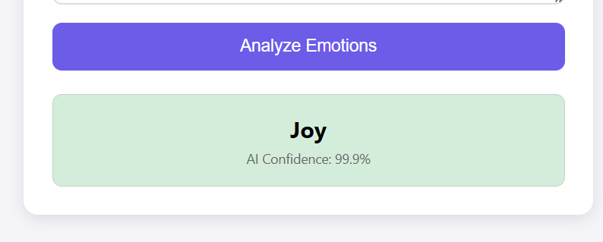
Picture 2: Emotion classification.

5.2 Backend Routing
Flask routes map the URL endpoints to python functions. The main route handles both GET (displaying the form) and POST (processing the data) requests.

6. Results and Analysis
The system was tested with various inputs to verify accuracy. The DistilBERT model showed superior performance compared to traditional methods.
Input Text | Detected Emotion | Confidence Score
I passed the exam! | Joy | 0.99
I am lost in the woods. | Fear | 0.95
How dare you speak to me like that? | Anger | 0.97

7. Future Scope and Conclusion
The Mindful AI Diary demonstrates the power of modern NLP in personal wellness applications. Future improvements could include:
- **Long-term Mood Tracking:** Storing data in a database to visualize mood trends over months.
- **Voice Input:** Integrating speech-to-text to allow users to speak their entries.
- **Personalized Recommendations:** Suggesting activities (e.g., meditation, exercise) based on the detected mood.
In conclusion, this project successfully bridges the gap between raw text data and meaningful emotional insight, providing a valuable tool for self-reflection.

8. References
1. Devlin, J., et al. (2018). 'BERT: Pre-training of Deep Bidirectional Transformers for Language Understanding'.
2. Sanh, V., et al. (2019). 'DistilBERT, a distilled version of BERT: smaller, faster, cheaper and lighter'.
3. Hugging Face Documentation. https://huggingface.co/
4. Flask Documentation. https://flask.palletsprojects.com/

