I find the primary meaning of vyasta to be "divided, separated" with secondary "spread, extended". This kind of comment is unusual and suggests that we have to make something of it. My first idea was that nak. number 7 on 2 jyestha is in advance of the norm where nak. 18 jyestha on the 15th leads back only to nak. 5 on the 2nd.

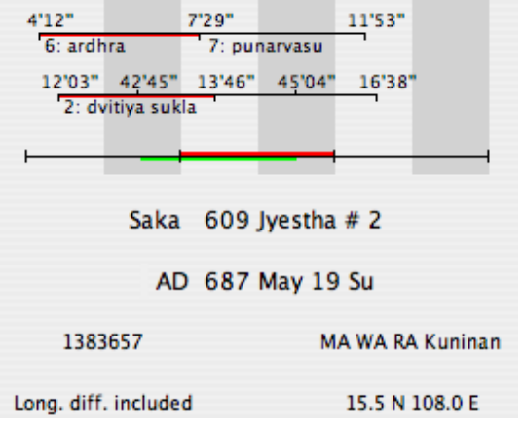

But: in the first week of the month the naks. begin, in nadis, at 4 7 11 17 23 29 and 35 of the day. In this sense the coverage on day 2 is well extended by comparison. So I will change my mind. It looks as though I will be better off saying that nak. 7 is in advance of the one usually in force on the 2nd but its coverage on the civil day is by comparison at the high end (very poor coverage of the tithi, we note).

