Dear Arlo.
The difficulties that the syntax presents you with suggest to me that there may be another way of hanging this together, which involves initially treating the second two lines on their own, as it were, as a way of finding another home for sthaapita.h.

"saakaabde rasa-loka-ma"ngala-yute jiive tu .sa.s.the bh.rgau |
me"sasthe pi ca bauddham eva ca bhavaan maahiindraloke"svaram |
candre kanyagate ca yo navani"saantaa.m sthaapita.h kiirttaye |
me"senaapi mahiindrapuura.napure vai"saakha"suklasya .sa.h |

If I was allowed to make the Skt say what it "ought" to be saying (in terms of its then presenting the horoscope details in an organised fashion) the two second lines would have the Latinate construction: "with the moon gone into Virgo, which (one) of end-nights is established in glory in Aries". Probably not legitimate--my Skt isn't good enough to say.

However, in defence of this as the intention, you may have heard me say that in horoscopes, even very bare ones, the main feature is first to define the moon, either by raa"si or by nak.satra, and then to say what lagna subsequently comes auspiciously into effect. The point being that the relevant nak.satra (here substituted by a raa"si as is common) has to come into play first.
The sequence on my reading reflects the process by which the auspicious moment is determined: the moon first gata in x and then the lagna sthaapita in y. The lagna is defined indirectly, i.e. it is dawn, therefore the sun must be on the horizon, and the lagna is by definition the raa"si on the horizon. The sun does not itself need to be named (and is not), since dawn is a sufficient indicator.
Two verifiers of this set-up (the whole system works on the principle of simultaneous constraint) are that it is vai"saakha, so the sun must be in Aries whether this is specified or not; and that Venus has already been placed in Aries, so the sun also cannot be far away from that position.

I suppose it comes down to whether the end of line 2 can't survive without the end of line 3 as its completion.

Less remotely: the 6th as regards Jupiter will be a house not a sign. The raa"si sequence begins with Aries as first sign, making Virgo the 6th; but the house sequence here incidentally begins with Aries because it is a dawn in vai"saakha, so Virgo is also the 6th house in the configuration.
Jupiter's position in Virgo makes this 638 not 618, but then there is a problem with Venus not being in Aries.

816: 836:
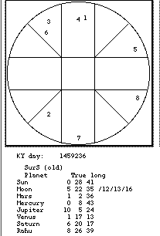
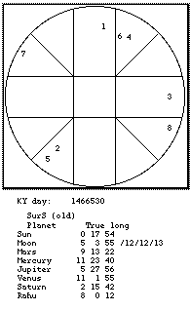

Venus (6) is almost one complete sign short of Aries, though Jupiter (5) is where we want it.

As for the quantième, it cannot be 6 waxing: if the sun (1) is in Aries and the moon (2) in Virgo, there are four intervening raa"si at three days a piece on average, so the date must be somewhere around the 12th of the month:

I find it a bit odd though not unaccountable that only Jupiter is defined by a numeral. How solid is the reading? The point with .sa.sthe (=house), if sound, would be that sense could be made of it even on its own: the position of an object in a house (any object in any house) carries with it a set of meanings: "my Saturn in the (Western) 8th" would mean the direst of the planets was in my house of death.
And the (Indian) 6th house is conventionally "ari"--which sounds a bit drastic, except that Jupiter is the Major Fortune, as opposed to Saturn the Major Infortune. The indication may be that at least the enemy territory in the horoscope is being governed by the most favourable of the planets.

The Champa horoscopes do have more technical stuff in them than the Cambodian. (The only known mention, for instance, of decans.)

PS. ** It wouldn't do me any good at all, but does jiive tu .sa.s.the bh.rgau
me"sasthe pi ca mean / have to mean "Jup. in 6th and Ven. also in Aries", i.e. the 6th house is Aries with Jup. and Ven. both there? Trouble, if so.

I look foward to doing more battle with this.
Yrs.

