VIII. [sragdharā]

yatra śrīśākarāje mvarakucatanubhiḥ prāptakāle vṛṣasthe
candrā(tharvārka)candrau pra(thama)bhavagate ketuke mīnaśukre
cāpārkkau taularāhau mṛgapatisamite (gīrath)e maithunair(e)

in 820, in Taurus the moon, in [Aquarius] sun and Mercury; Ketu gone to the first house; in Pisces Venus; Saturn in Sagittarius; in Libra, Rahu; in Leo, Jupiter; in Gemini, Mars

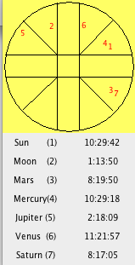
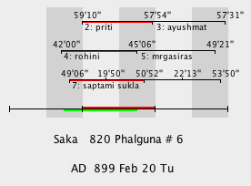
The constraints capable of being met are (1) Venus in Pisces (which requires the sun to be close by); (2) moon in Taurus; (3) sun and Mer together but not in Pis; (4) Sat in Sag.
The figure indicates that no planet can be occupying Leo. Jup was in Gem for the whole year.
By the time mṛgapatisamite (gīrath)e maithunair(e) is reached in the enumeration there are only Mar and Jup left to be placed. It may be no accident that Mars was in the sign exactly opposite to the one assigned to it. In the processing procedure all angles are brought to the 1st quadrant because the sine table runs from 0° to 90°. Failure to return Mars back to its correct quadrant would cause it to lie in Gemini rather than in Sagittarius. That would not, however, explain why Jupiter was dislodged from Gemini to Leo since it was in the 1st quadrant to begin with.
Because there are no means of deducing positions for Rahu (it is not treated as the diametric opposite of Rahu), we have no means of deducing what was considered to be the first house and hence the lagna (though Aries as the first sign in order is otherwise unoccupied).

[[ Looking at the sine table (bhāgamaurvikā) in Western notation and seeing what is involved:
sin 5= 0.0871
sin 175 ditto
sin 185 = -0.0871
sin 335 ditto
If you were processing a Mean longitude of Vir 25 (175), Lib 5 (185), or Pis 5 (335) to get a True long., you could end up in Aries if you neglected to go back to the correct quadrant. This might (might) explain Mars supposedly in Gem and not in Sag. ]]

I will not change this one in ChampaEade3 until I hear what has been settled. I take it that an Aquarius word is needed for sun and Mer. But a lagna word in the gīrathe position is too much to hope for.
Yrs

