|  |  |
| --- | --- |
| **Client** | ENB CREATIVE |
| **Project Name** | DEMO NOTE APP |
|  |  |

Table of Contents

1 Assumptions 3

2 Requirements 3

3 Solution 4

3.1 DemoNoteApp 4

3.2 Android Module 4

3.3 Web Module 5

3.4 Design Module 5

3.5 Error Handling 6

3.5.1 Android: 6

3.5.2 Web: 6

Appendix 7

Document Control 7

References 7

# Assumptions

|  |  |
| --- | --- |
| ID | Description |
| ASM-001 | App rotation will not be supported in first release. |
| ASM-002 | Supporting tablet devices and creating multiple layout files will not be added. |
| ASM-003 | App will be able to communicate with a database via API |
| ASM-004 | Users will be provided with a web user interface to use the app in web base too |

# Requirements

|  |  |
| --- | --- |
| Req. # | Short Description |
| REQ-001 | Synchronized content between web and android app should be in JSON format. |
| REQ-002 | A database |
| REQ-003 | Proper connection to db via API |

# Solution

## DemoNoteApp

Within CR001, a new native android application will be created. The main purpose of this demo application is visualizing communication between team members and improving it.

Application will be created in GitHub with 3 main modules which are;

1. Android
2. Web
3. Design

Android module will contain all native android codes, in-app database, application architecture patterns etc.

Similarly, Web module will contain web based development codes, database creation scripts, connection URLs, etc.

And finally, Design module will have web and android pre-screenshots, app navigation flow, UX and UI related drawings, etc.

## Android Module

A sample app will be created from scratch. Application package name will be “com.enbcreative.demonoteapp”. App will have splash screen which should contain ENB logo for a few seconds then Login Activity will be displayed which should have below characteristics;

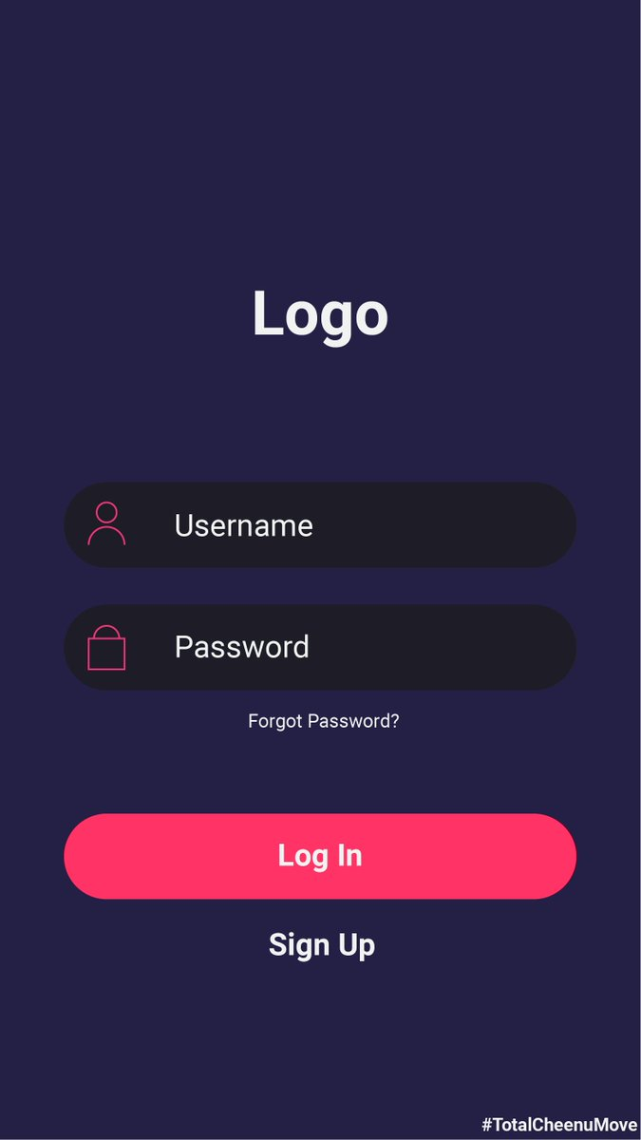

Figure 1: Example Login screen

(this sample screenshot downloaded from web)

User should be presented with login screen as shown above which has two editing fields for Email and Password.

However, “Forgot Password” and “Sign Up” options should be provided for unregistered users. Each option should have its own user interface (UI) if clicked.

After entering user’s credentials to login screen a progress bar should be displayed to indicate network connection.

When network connection is successful, a toast message should be displayed to user with content of “Login Success” and a new Main Activity should be started.

Main Activity is the main UI which all user interactions will be handled such as Listing all notes, adding new note, editing existing one or Deleting a note.

A rounded add button (+) will be available on main screen for adding new notes. After clicking add button a dialog will be displayed to user which may looks as below.

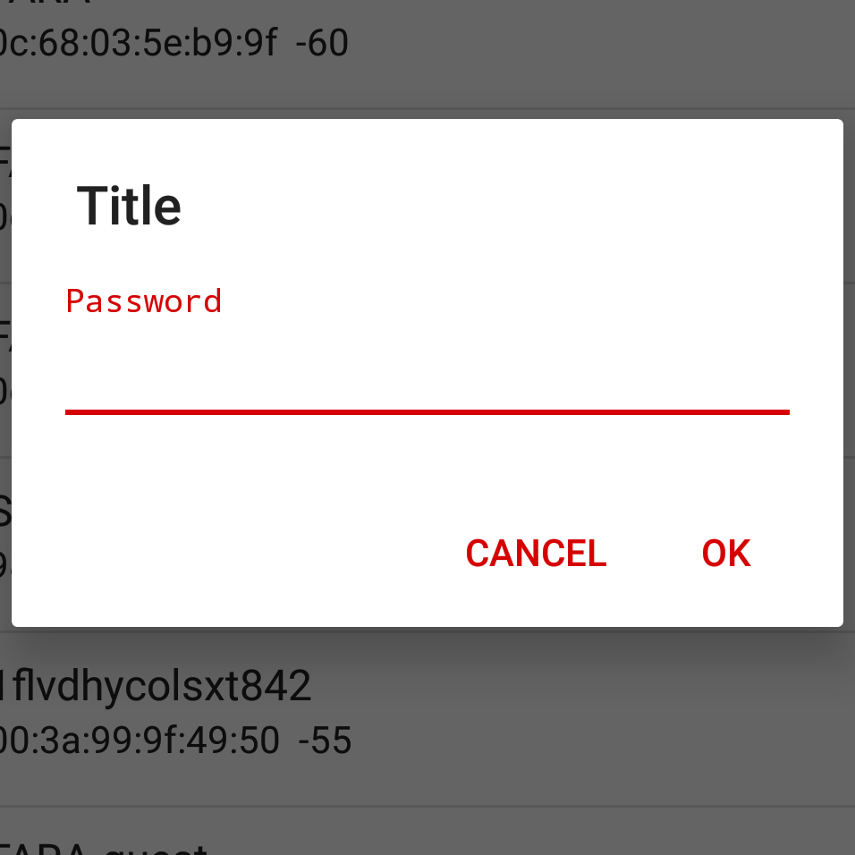

Figure 1: Example Adding Note

(“password” text will have no meaning for this screen)

Note object will be stored in database with id, content and date columns. All notes in main activity will be listed based on date by descending order.

“Swipe to delete” option will be provided as well.

Room library will be used for storing Notes locally. App will synchronize all data with web in background if network available. Thanks to this feature user will have smooth interactions with app.

## Web Module

A hosting service will be bought to host the databse. The databse is going to be preapred using relational databse like MySql-Not necessariliy MySql of course – .

Web and mobile app conneciton is going to be done using php PDO method. It is going to be secured via username and password only.

Web Interface is going to be developped using following technologies : PHP , JavaScript, HTML5, CSS3 , Bootstrap.

## Design Module

## Error Handling

### Android:

No network exceptions will be handled for already singed in users. Local data will be displayed while web content will be downloading in background during user interactions.

### Web:

User will be obligated to enter password and username.

# 

# Appendix

# Document Control

# References

1. CR_ENB_DemoNoteApp_CR001_v1.0.0.doc, Change Request, 17.05.2020, ENB CREATIVE

Change Control & Distribution

|  |  |
| --- | --- |
| **Owner** | Ercan Duman |
| **Reviewer** | Baris Ciftci, Sinan Erturk |
| **Approved By** |  |
| **Distribution** |  |
| **File Name** | SRS_ENB_CREATIVE_CR001_DEMO_NOTE_APP_v1.0.0.doc |

Version History

|  |  |  |  |
| --- | --- | --- | --- |
| **Version** | **Change Descriptions** | **Author** | **Date** |
| 1.0.0 | Initial Version | Ercan Duman | 17/05/2020 |

Approvals

This document requires the following approvals:

|  |  |  |  |  |
| --- | --- | --- | --- | --- |
| **Name** | **Title** | **Date** | **Signature** | **Version** |
|  |  |  |  |  |
|  |  |  |  |  |