Client | ENB CREATIVE
Project Name | DEMO NOTE APP

Table of Contents
1 Assumptions 3
2 Requirements 3
3 Solution 4
3.1 DemoNoteApp 4
3.2 Android Module 4
3.3 Web Module 5
3.4 Design Module 5
3.5 Error Handling 6
3.5.1 Android: 6
3.5.2 Web: 6
Appendix 7
Document Control 7
References 7

Assumptions

ID | Description
ASM-001 | App rotation will not be supported in first release.
ASM-002 | Supporting tablet devices and creating multiple layout files will not be added.

Requirements

Req. # | Short Description
REQ-001 | Synchronized content between web and android app should be in JSON format.

Solution

DemoNoteApp
Within CR001, a new native android application will be created. The main purpose of this demo application is visualizing communication between team members and improving it.

Application will be created in GitHub with 3 main modules which are;
- Android
- Web
- Design

Android module will contain all native android codes, in-app database, application architecture patterns etc.
Similarly, Web module will contain web based development codes, database creation scripts, connection URLs, etc.
And finally, Design module will have web and android pre-screenshots, app navigation flow, UX and UI related drawings, etc.

Android Module
A sample app will be created from scratch. Application package name will be “com.enbcreative.demonoteapp”. App will have splash screen which should contain ENB logo for a few seconds then Login Activity will be displayed which should have below characteristics;
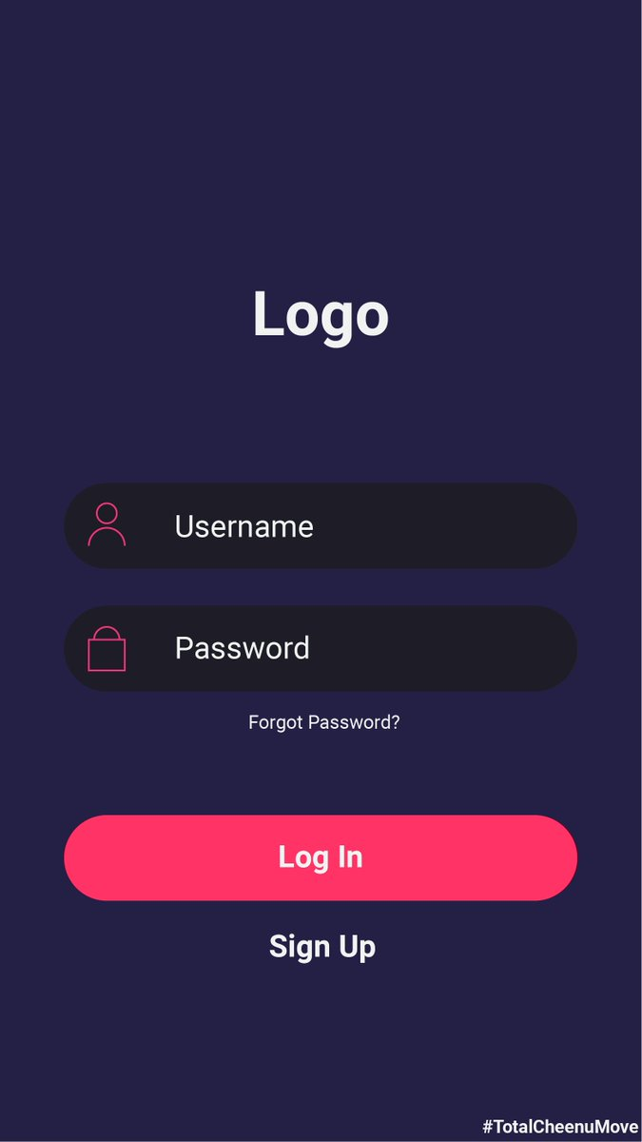
Figure 1: Example Login screen
(this sample screenshot downloaded from web)
User should be presented with login screen as shown above which has two editing fields for Email and Password.
However, “Forgot Password” and “Sign Up” options should be provided for unregistered users. Each option should have its own user interface (UI) if clicked.
After entering user’s credentials to login screen a progress bar should be displayed to indicate network connection.
When network connection is successful, a toast message should be displayed to user with content of “Login Success” and a new Main Activity should be started.
Main Activity is the main UI which all user interactions will be handled such as Listing all notes, adding new note, editing existing one or Deleting a note.
A rounded add button (+) will be available on main screen for adding new notes. After clicking add button a dialog will be displayed to user which may looks as below.
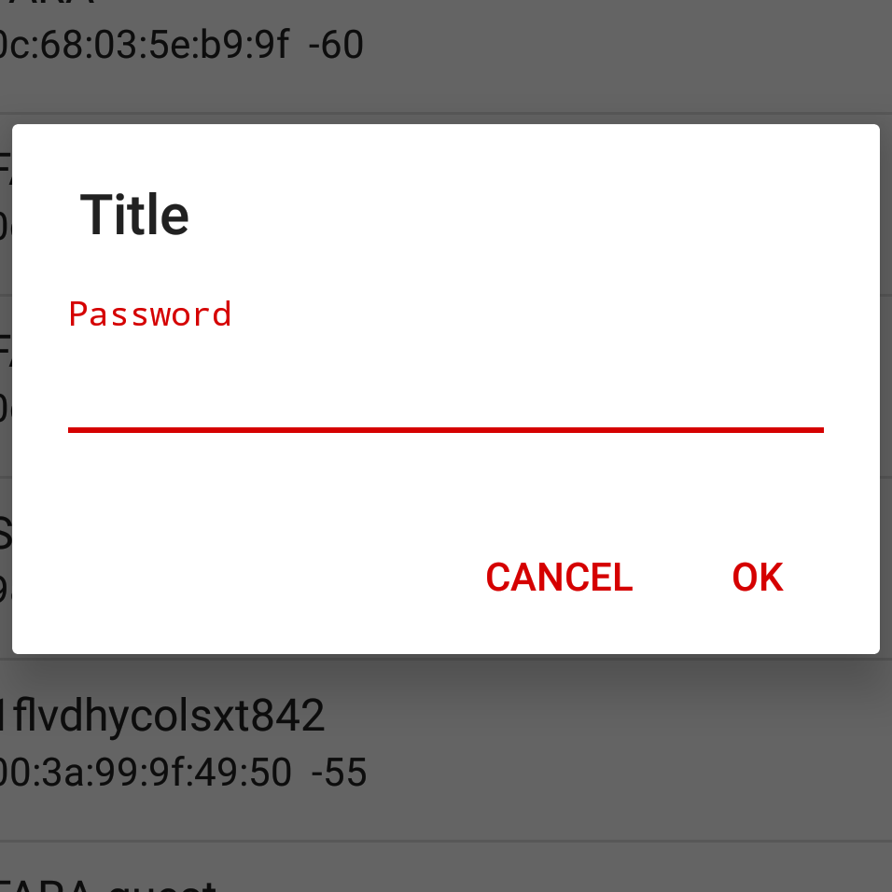
Figure 1: Example Adding Note
(“password” text will have no meaning for this screen)

Note object will be stored in database with id, content and date columns. All notes in main activity will be listed based on date by descending order.
“Swipe to delete” option will be provided as well.
Room library will be used for storing Notes locally. App will synchronize all data with web in background if network available. Thanks to this feature user will have smooth interactions with app.

Web Module

Design Module

Error Handling

Android:
No network exceptions will be handled for already singed in users. Local data will be displayed while web content will be downloading in background during user interactions.

Web:

Appendix

Document Control

References
- CR_ENB_DemoNoteApp_CR001_v1.0.0.doc, Change Request, 17.05.2020, ENB CREATIVE

Change Control & Distribution
Owner | Ercan Duman
Reviewer | Baris Ciftci, Sinan Erturk
Approved By
Distribution
File Name | 0000.doc

Version History
Version | Change Descriptions | Author | Date
1.0.0 | Initial Version | Ercan Duman | 17/05/2020

Approvals
This document requires the following approvals:

Name | Title | Date | Signature | Version

