**CSE222_HW03**

**ERCAN UCA 091044011**

* Specific List LinkedList Classından extends olmuştur.
* SpecificListin ek olarak 3 methodu vardır.
* **public boolean addAllAtHead(Collection<? extends E> c);**
* Bu metod için 2 tane spectList objesi olmalı s1,s2 gibi mesela,
* s1’de 1,3,4,5,5 add ile eklensin. S2’ye de 1,3,4,6,7 eklensin.
* Çağırılma şekli **s1.addAllAtHead(s2);** return true olursa.
* S1 de artık 1,3,4,6,7,1,3,4,5,5 şeklinde olur farklı durumlarda false ise
* Zaten excetion handle edilmiştir metodun içinde.
* **public List<E> getIntersectList (Collection<? extends E> c);**
* Bu metod iki listeden ortak olanları döndürüyor.
* Çağırılma şekli; **s3 = s1. getIntersectList(s2);**
* S3 de 1,3,4 şeklinde olur.
* public List<E> sortList(int sorting);
* sorting’in tipine göre (1 increasin, 0 decreasing)
* Cocktail sort algoritması uygulanmıştır.
* S1 de “ali”,”seda”,”can”, “bursa”,”seda” olsun ve sorting:0 olsun.
* Çağırılma şekli **s2=s1.sortList(0);**
* S2 de “seda”,”can”,”bursa”,”ali” olur.
* **Class Diagramı**

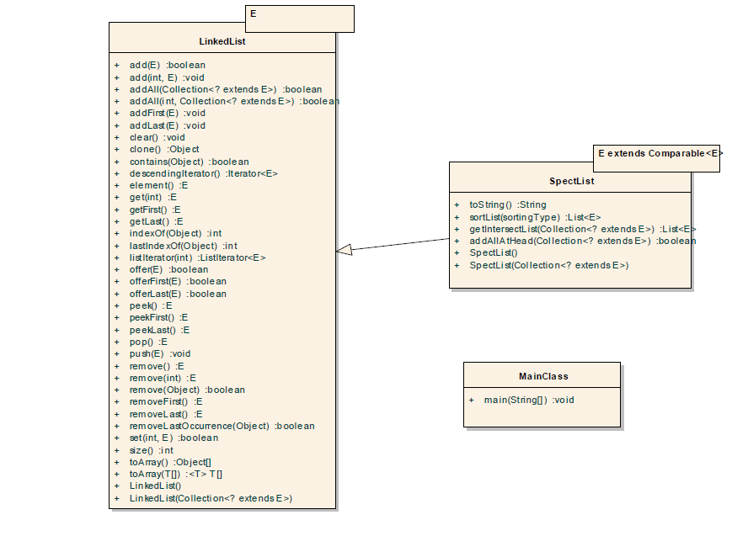

* **Use Case Diagrams**

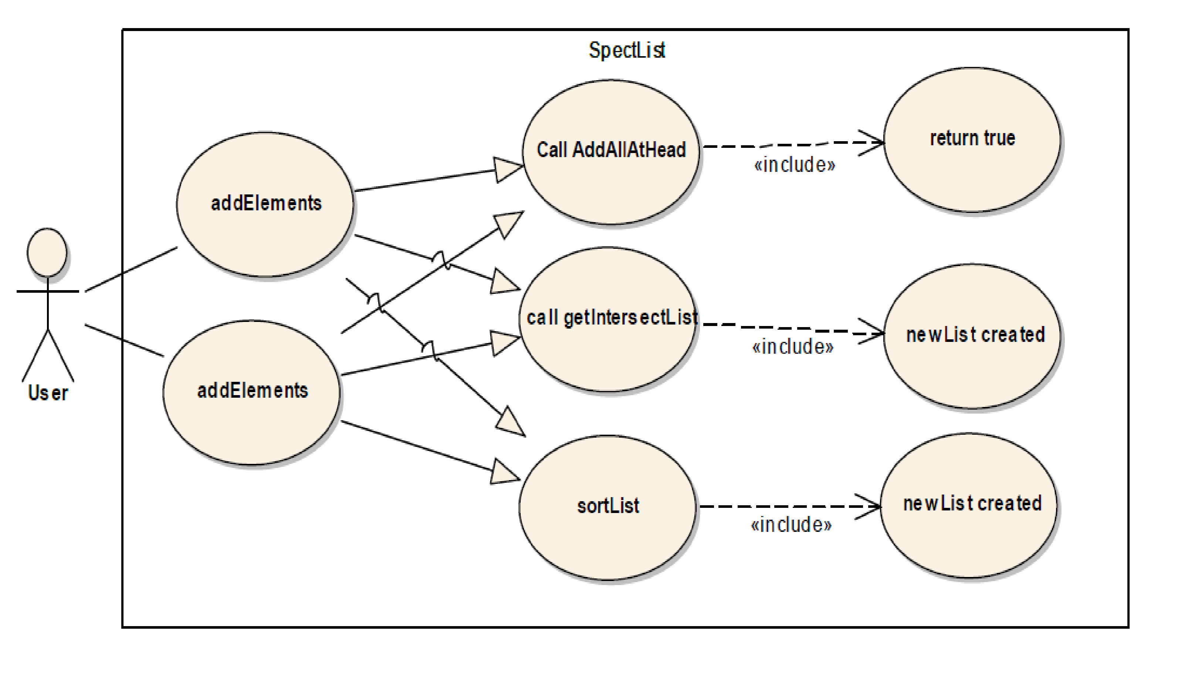

* **Complexity of Metods**

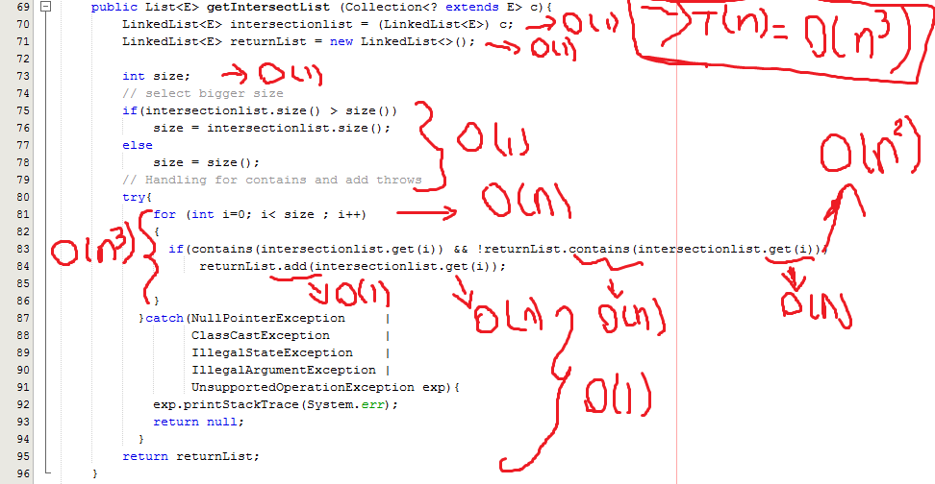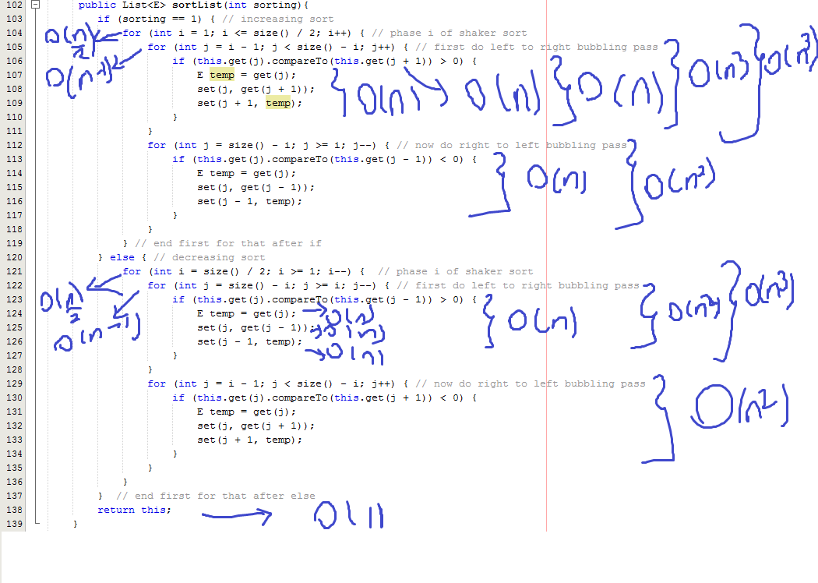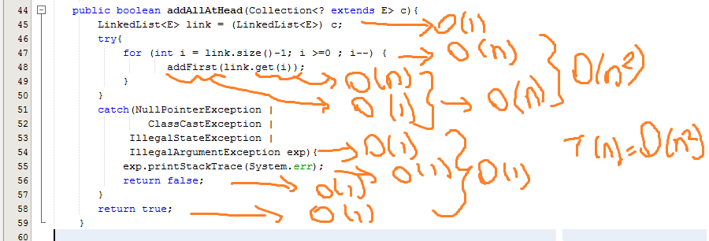

* **Tests**

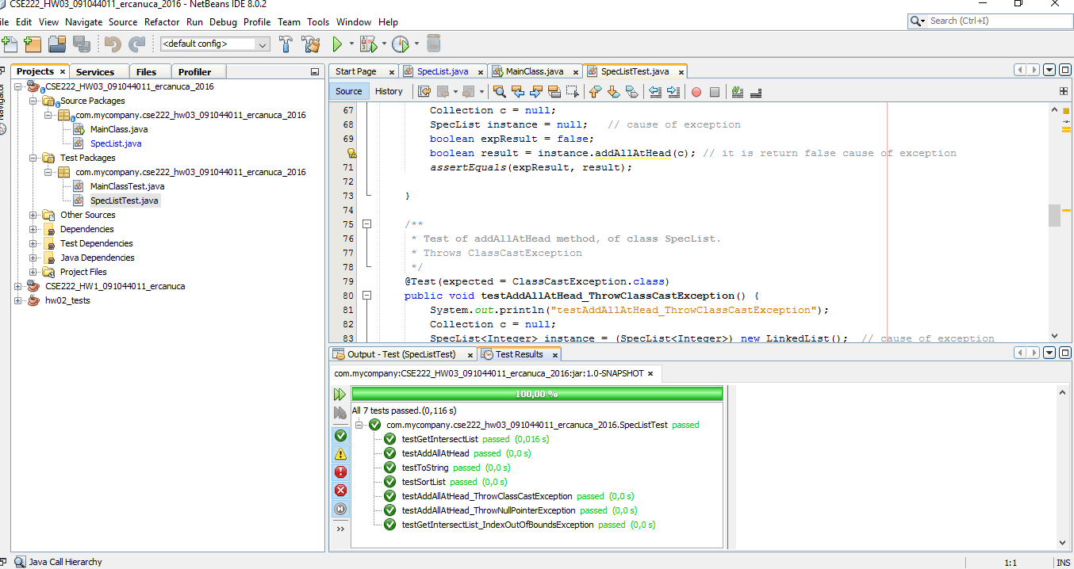

* **Main tests**

**----------------------Tester I--------------------**

**----------------------INTEGERS--------------------**

**Created specificList Class object type of Integer and add 7 elements like above.**

**SpecList<Integer> specific = new SpecList<>();**

**specific.add(1);**

**specific.add(2);**

**specific.add(5);**

**specific.add(4);**

**specific.add(0);**

**specific.add(2);**

**specific.add(3);**

**Created another specificList Class object type of Integer and add 5 elements like above.**

**SpecList<Integer> specific2 = new SpecList<>();**

**specific2.add(0);**

**specific2.add(10);**

**specific2.add(20);**

**specific2.add(30);**

**specific2.add(40);**

**Called addAllAtHead like specific2.addAllAtHead(specific); and show return value.**

**addAllAtHead returned value: true**

**Called specific2 toString method**

**SpecList{[1, 2, 5, 4, 0, 2, 3, 0, 10, 20, 30, 40]}**

**----------------------DOUBLES--------------------**

**Created specificList Class object type of Double and add 7 elements like above.**

**SpecList<Double> specific3 = new SpecList<>();**

**specific3.add(1.1);**

**specific3.add(2.5);**

**specific3.add(5.6);**

**specific3.add(4.5);**

**specific3.add(0.7);**

**specific3.add(2.8);**

**specific3.add(3.8);**

**Created another specificList Class object type of Double and add 5 elements like above.**

**SpecList<Double> specific4 = new SpecList<>();**

**specific4.add(1.0);**

**specific4.add(10.78);**

**specific4.add(20.77);**

**specific4.add(30.44);**

**specific4.add(40.99);**

**Called addAllAtHead like specific4.addAllAtHead(specific3); and show return value.**

**addAllAtHead returned value: true**

**Called specific4 toString method**

**SpecList{[1.1, 2.5, 5.6, 4.5, 0.7, 2.8, 3.8, 1.0, 10.78, 20.77, 30.44, 40.99]}**

**----------------------STRINGS--------------------**

**Created specificList Class object type of String and add 4 elements like above.**

**SpecList<String> specific5 = new SpecList<>();**

**specific5.add("ali");**

**specific5.add("can");**

**specific5.add("sardar");**

**specific5.add("kenan");**

**Created another specificList Class object type of String and add 3 elements like above.**

**SpecList<String> specific6 = new SpecList<>();**

**specific6.add("elif");**

**specific6.add("salih");**

**specific6.add("Yusuf");**

**Called addAllAtHead like specific6.addAllAtHead(specific5); and show return value.**

**addAllAtHead returned value: true**

**Called specific6 toString method**

**SpecList{[ali, can, serdar, kenan, elif, salih, yusuf]}**

**----------------------Tester I END--------------------**

**----------------------Tester II--------------------**

**----------------------INTEGERS--------------------**

**Created specificList Class object type of Integer and add 7 elements like above.**

**SpecList<Integer> specific = new SpecList<>();**

**specific.add(1);**

**specific.add(2);**

**specific.add(5);**

**specific.add(4);**

**specific.add(0);**

**specific.add(2);**

**specific.add(3);**

**Created another specificList Class object type of Integer and add 5 elements like above.**

**SpecList<Integer> specific2 = new SpecList<>();**

**specific2.add(0);**

**specific2.add(1);**

**specific2.add(2);**

**specific2.add(3);**

**specific2.add(4);**

**Initialzation to getIntersectList the List Class Object.**

**List<Integer> list1 = (LinkedList<Integer>) specific.getIntersectList(specific2);**

**Called list1 toString method**

**[0, 1, 2, 3, 4]**

**----------------------DOUBLES--------------------**

**Created specificList Class object type of Double and add 7 elements like above.**

**SpecList<Double> specific3 = new SpecList<>();**

**specific3.add(1.0);**

**specific3.add(2.5);**

**specific3.add(5.6);**

**specific3.add(4.5);**

**specific3.add(0.7);**

**specific3.add(20.7);**

**specific3.add(3.4);**

**Created another specificList Class object type of Double and add 5 elements like above.**

**SpecList<Double> specific4 = new SpecList<>();**

**specific4.add(1.0);**

**specific4.add(10.78);**

**specific4.add(20.7);**

**specific4.add(3.4);**

**specific4.add(40.99);**

**Initialzation to getIntersectList the List Class Object.**

**List<Double> list2 = (LinkedList<Double>) specific4.getIntersectList(specific3);**

**Called list2 toString method**

**[1.0, 20.7, 3.4]**

**----------------------STRINGS--------------------**

**Created specificList Class object type of String and add 4 elements like above.**

**SpecList<String> specific5 = new SpecList<>();**

**specific5.add("yusuf");**

**specific5.add("can");**

**specific5.add("elif");**

**specific5.add("kenan");**

**Created another specificList Class object type of String and add 3 elements like above.**

**SpecList<String> specific6 = new SpecList<>();**

**specific6.add("elif");**

**specific6.add("salih");**

**specific6.add("Yusuf");**

**Initialzation to getIntersectList the List Class Object.**

**List<String> list2 = (LinkedList<String>) specific5.getIntersectList(specific6);**

**Called list3 toString method**

**[elif, yusuf]**

**----------------------Tester II END--------------------**

**----------------------Tester III--------------------**

**----------------------INTEGERS--------------------**

**Created specificList Class object type of Integer and add 7 elements like above.**

**SpecList<Integer> specific = new SpecList<>();**

**specific.add(1);**

**specific.add(2);**

**specific.add(5);**

**specific.add(4);**

**specific.add(0);**

**specific.add(2);**

**specific.add(3);**

**Called specific toString method**

**SpecList{[1, 2, 5, 4, 0, 2, 3]}**

**Called specific sorting with decreasing method**

**SpecList{[5, 4, 3, 2, 2, 1, 0]}**

**Created another specificList Class object type of Integer and add 5 elements like above.**

**SpecList<Integer> specific2 = new SpecList<>();**

**specific2.add(55);**

**specific2.add(20);**

**specific2.add(24);**

**specific2.add(37);**

**specific2.add(40);**

**Called specific2 toString method**

**SpecList{[55, 20, 24, 37, 40]}**

**Called specific2 sorting with increasing method**

**SpecList{[20, 24, 37, 40, 55]}**

**----------------------DOUBLES--------------------**

**Created specificList Class object type of Double and add 7 elements like above.**

**SpecList<Double> specific3 = new SpecList<>();**

**specific3.add(1.1);**

**specific3.add(2.5);**

**specific3.add(5.6);**

**specific3.add(4.5);**

**specific3.add(0.7);**

**specific3.add(2.8);**

**specific3.add(3.8);**

**Called specific3 toString method**

**SpecList{[1.1, 2.5, 5.6, 4.5, 0.7, 2.8, 3.8]}**

**Called specific3 sorting with increasing method**

**SpecList{[0.7, 1.1, 2.5, 2.8, 3.8, 4.5, 5.6]}**

**Created another specificList Class object type of Double and add 5 elements like above.**

**SpecList<Double> specific4 = new SpecList<>();**

**specific4.add(1.0);**

**specific4.add(10.78);**

**specific4.add(20.77);**

**specific4.add(30.44);**

**specific4.add(40.99);**

**Called specific4 toString method**

**SpecList{[1.0, 10.78, 20.77, 30.44, 40.99]}**

**Called specific4 sorting with decreasing method**

**SpecList{[40.99, 30.44, 20.77, 10.78, 1.0]}**

**----------------------STRINGS--------------------**

**Created specificList Class object type of String and add 4 elements like above.**

**SpecList<String> specific5 = new SpecList<>();**

**specific5.add("ali");**

**specific5.add("can");**

**specific5.add("sardar");**

**specific5.add("kenan");**

**Called specific5 toString method**

**SpecList{[ali, can, serdar, kenan]}**

**Called specific5 sorting with decreasing method**

**SpecList{[serdar, kenan, can, ali]}**

**Created another specificList Class object type of String and add 4 elements like above.**

**SpecList<String> specific6 = new SpecList<>();**

**specific6.add("elif");**

**specific6.add("zeynep");**

**specific6.add("salih");**

**specific6.add("Yusuf");**

**Called specific6 toString method**

**SpecList{[elif, zeynep, salih, yusuf]}**

**Called specific6 sorting with increasing method**

**SpecList{[elif, salih, yusuf, zeynep]}**

**----------------------Tester III END--------------------**

* **Ödev githup linki**

**https://github.com/erccanuca/cse222_hw03.git**