Malabanan, Angelo Quim

Perez, Eric Gabriel

2ECE-A

**Machine Problem 1 (Python Solution)**

**Program Screenshots**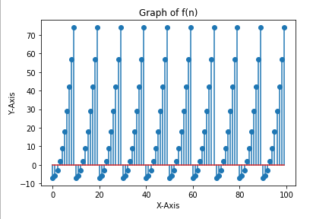

The graph of the function f(n) is one that reoccurs after every 10 increments on the values of x. This is because when the function reaches the values of n greater than 10, it shall get the output with index n-10. This would mean that after n = 10, the values of the function would return to where it started.