Malabanan, Angelo Quim C.  
Perez, Eric Gabriel  
2ECE-A

**Machine Problem 3 (MATLAB Solution)**

**Program:**

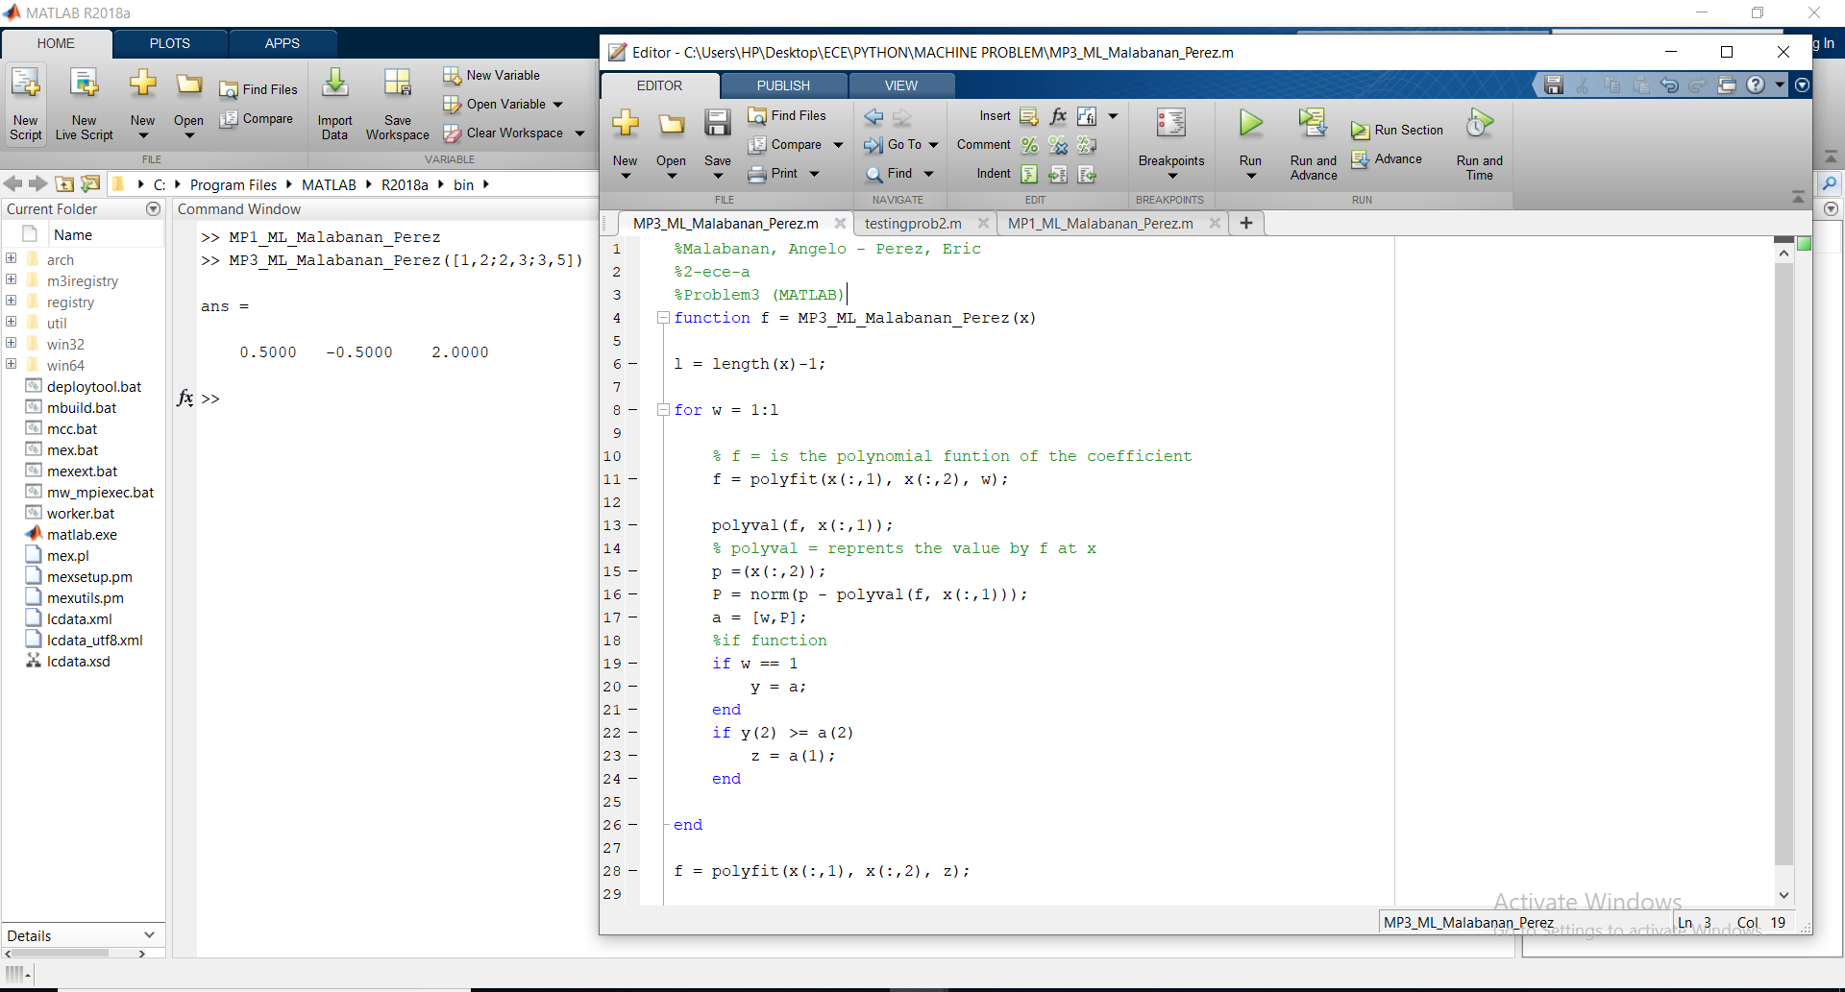

**Answer:**

