Malabanan, Angelo Quim C.  
Perez, Eric Gabriel  
2ECE-A

**Machine Problem 3 (Python Solution)**

**Program:**

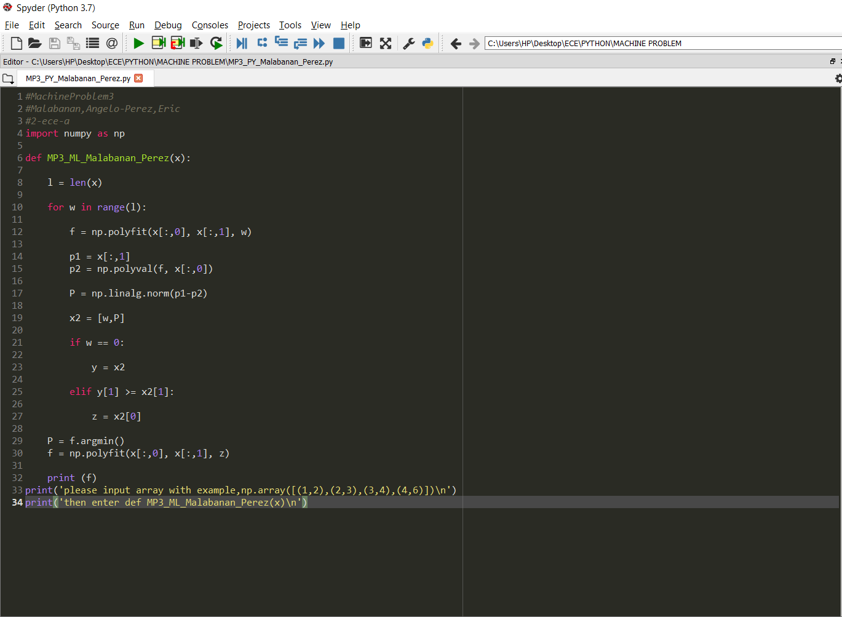

**Console:**

