Perez, Eric Gabriel L.

2ECE-A

**Experiment 8: Pandas**

**Program Screenshots**

**Problem 1:**

firstFive = cars.head()

lastFive = cars.tail()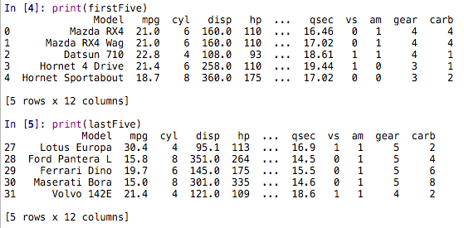

**Problem 2:**

1. displayed via variable QA
2. displayed via variable QB
3. displayed via variable QC
4. displayed via variable QD