Ecosphere
Subject Track: Vegetation Ecology
Submission Type: Article
Leaf litter quantity alters seed removal rates
Eric Minogue^{1,2,3,*}, M. Noelia Barrios-Garcia^{1,2,3}, Vegas Rockafeller^{1,2}, Karin Rand^{3,4}, Aimée T. Classen^{2,3,4}, Nathan J. Sanders⁴, Mariano A. Rodriguez-Cabal^{1,2,3}
Affiliations:
¹Rubenstein School of Environment and Natural Resources, University of Vermont, Burlington, VT 05405, USA
²Gund Institute for Environment, University of Vermont, Burlington, Vermont, USA
³University of Michigan Biological Station, University of Michigan,
Pellston, MI 49769, USA
⁴Department of Ecology and Evolutionary Biology, University of Michigan
Ann Arbor, MI 48109, USA

*Corresponding Author: eminogue@uvm.edu
Abstract
Seed removal is a key ecological process that shapes plant recruitment and community composition, which in turn shapes future plant communities and ecosystems. However, the physical drivers that regulate interactions between seeds and their removers are underexplored. Leaf litter is the major structural component of most forest floors. Leaf litter affects habitat complexity, microclimate, seed detectability, and seed remover foraging behavior. Here, we leveraged a 20-year leaf litter manipulation experiment in a northern temperate forest to test how litter quantity influences post-dispersal seed removal and the activity of dominant invertebrate seed removers including ants (primarily Aphaenogaster spp.) and the nonnative slug (Arion fuscus). Using experimental plots with three litter treatments (No Litter, Control (Single Litter) and Double Litter) we quantified seed removal and predator activity during the day and night. Seed removal was highest in No Litter plots. Seed removal was higher at night than during the day in all treatments except in the No Litter plots, where seed removal did not differ significantly in the day and night. Seed removal was highest during the early morning when slugs were most active. However, treatment effects were stronger when slugs were less active and ants were more active. Ant activity varied among litter treatments, measuring the highest in No Litter plots, however slug activity showed little response to litter treatments. Taken together, these results suggest that the reduced habitat complexity of litter-free environments enhances ant activity and by extension, seed removal.

Keywords: Seed removal, invasive species, myrmecochory, detrital inputs, seed dispersal, Aphaenogaster spp., Arion fuscus

Introduction
Seed removal is a key ecological process that regulates plant recruitment and community composition (Janzen 1971; Orrock et al. 2006; Worthy et al. 2006; Xu et al. 2015). Following dispersal from parent plants, seeds experience a range of fates that determine recruitment success, including mortality, persistence in the seed banks, germination or secondary dispersal by other animals (Larios et al. 2017; van Klinken and White 2014; Johnson and Zettlemoyer 2022; Lewis and Gripenberg 2008). Among these outcomes, post-dispersal seed predation reduces recruitment by eliminating seeds before germination (Anderegg et al. 2021). Conversely, secondary seed dispersal, disbursal by seed removers, can increase plant establishment by relocating seeds to more favorable microsites and by increasing seed dispersal distance from the mother plant, thereby influencing gene flow, population dynamics and community composition (Garant et al. 2007). The interaction between seeds and their dispersers and predators could shape plant populations and communities.
Seed removal is important, yet studies tend to focus on biological drivers such as seed traits, remover identity, and remover abundance. In forest ecosystems, leaf litter often provides structure to the forest floor and could change seed detectability, predator movement, foraging efficiency, and microclimatic conditions (Anderegg et al. 2021; Cintra 1997; Jessen et al. 2023; Sayer 2005). For example, Gallegos et al. (2014) found that ants frequently moved seeds under the leaf litter layer effectively lowering the detectability from other dispersers and predators. Similarly, Silva et al. (2026) found that leaf litter quantity altered ant-seed interactions, with deeper litter layers favoring smaller ant species adapted to foraging within structural complex environments. Higher habitat complexity allowed smaller ants to consume elaiosomes in situ, decreasing the likelihood of successful germination and gene flow (Silva et al. 2026). Together these studies suggest that variation in litter quantity may influence both the amount of seed removal and the identity of the seed removers. By changing forest-floor structure and microclimatic conditions, shifts in litter quantity may alter predator-seed interactions and rates of post-dispersal seed removal (Cintra 1997; Dias et al. 2017; Jessen et al. 2023; Prieto et al. 2019).
Invertebrates are major drivers of seed removal, accounting for nearly half (47%) of all seed removal events worldwide, (Peco et al. 2014). In Eastern North American temperate deciduous forests, ants in the genus Aphaenogaster (A. rudis and A. picea) are dominant dispersers of understory forbs, nearly one third of which are adapted for dispersal exclusively by ants (Buono et al. 2023; Kiel et al. 2020; Ness et al. 2009; Zelikova et al. 2011). Aphaneogaster picea and A. rudis facilitate secondary dispersal by relocating seeds from where they are released near their mother plant to specialized caches or middens located in close proximity to the colony nest (Wagner and Fleur Nicklen 2010). These discard piles are often rich in nutrients (Wagner and Fleur Nicklen 2010) and enhance successful germination and recruitment within the plant population (Câmara et al. 2025; Palfi et al. 2017).
The non-native slug Arion fuscus, unlike ants in the genus Aphaenogaster, consumes seeds preventing their dispersal and germination (Meadley Dunphy et al. 2016). These two invertebrate seed removers vary in foraging strategies and are likely to respond differently to changes in litter structure. Despite growing evidence that litter quantity and quality mediate the interactions that dictate seedling recruitment (Anderegg et al. 2021; Yuan et al. 2015; Wang et al. 2022), little research has focused specifically on the influence of leaf litter quantity on the foraging dynamics of invertebrate seed removers, and consequently, seed removal.
Here, we used a long-term manipulative experiment (Detrital Input and Removal Treatment, DIRT) that had been running for 20 years in a northern temperate forest. We tested how differences in litter input quantity influence post-dispersal seed removal and the activity of dominant invertebrate seed removers. Specifically, we asked: (1) Does leaf litter quantity influence rates of post-dispersal seed removal by invertebrates? (2) Does litter quantity alter the activity of dominant invertebrate removers? We hypothesized that reduced litter would increase seed removal by decreasing habitat complexity and enhancing seed detectability, with the strongest effects mediated by increased ant activity, whereas slug activity would increase in plots with higher quantities of leaf litter. By linking litter quantity and the identity and activity of the seed predators and dispersers this study provides a mechanistic framework for understanding how variation in forest floor conditions can influence seed fate processes.

Methods
Study Area
We conducted this work at the University of Michigan Biological Station (UMBS) in northern Michigan (45.55 N, 84.70 W) in the summer of 2023. The experimental plots used are part of the DIRT Network, a global collaboration of long-term experiments examining the impacts of litter and soil inputs on soil geochemistry (Lajtha et al. 2018). The UMBS DIRT site was established in 2004 within a northern temperate forest dominated by bigtooth aspen (Populus grandidentata) and characterized by coarse-textured sandy soils (Whalen et al. 2021).

Experimental design
There were three treatments in this experiment, each applied to 5 × 5 m plots: (1) Control (Single Litter) receiving natural litter inputs; (2) No Litter, in which annual aboveground litter inputs are removed; (3) Double Litter, receiving the litter from a litter removal plot (~twice the amount of litter inputs of the litter control plots). The understory vegetation was removed from all the plots to isolate the effects of leaf litter. There were three replicates of each treatment, and treatment plots were within 1km of one another. The experiment took place over a total of 8 days spread out over three weeks. Day time seed removal was successfully counted 8 times while nighttime removal was counted only 6 times, this variation being due to inclement weather.

Seed removal
We measured post-dispersal seed removal using standardized, shell-less sunflower seeds, which lack chemical and physical defenses and are edible to a broad range of granivores. The use of sunflower seeds is a widespread and well-established method studying post-dispersal seed removal (Hargreaves et al. 2019; Hargreaves et al. 2024).Within each 5 × 5 m plot, we placed one Petri dish containing 10 intact, undamaged sunflower seeds. Each depot was covered with a half-dome chicken wire cage to exclude vertebrates. Seeds were replaced twice daily (08:00–09:00 and 19:00–20:00). At each check, we counted seeds that were damaged or missing. After each observation period, seeds were discarded away from the experimental site and replaced with a fresh set of ten. In a small number of instances, chicken wire cages were overturned by mammals, and the seed depots were consumed. These observations were not included in the subsequent analyses.
Invertebrate surveys
We surveyed seed depots three times per day: morning (08:00-09:00), midday (13:00-14:00), and evening (19:00-20:00), morning and evening followed seed replacements, midday did not. Because midday did not follow seed replacement, it is not compared across time only between treatment withing midday. During these surveys, we checked each depot three times at 20-minute intervals, recorded the number of seeds removed, and identified invertebrates on each seed depot.

Data analysis
We analyzed seed removal rates using a negative-binomial generalized linear model, fitted with glm.nb in the MASS package (Venables and Ripley 2002). The model included treatment, time of day, and their interaction as fixed effects. We evaluated each fixed effect using type III likelihood-ratio χ² tests implemented with the car package (Fox and Weisberg 2019). Estimated marginal means (EMMs) were obtained on the response scale using emmeans. We used Tukey-adjusted contrasts to compare treatments within each time period and Dunnett-adjusted contrasts to compare each litter treatment against the Control plots. Figures display response-scale EMMs with +1 standard error bars. We analyzed slug and ant abundance separately using negative-binomial GLMs. We first assessed treatment effects with treatment-only models and then evaluated treatment, survey time, and their interaction with treatment-by-time models. We used type III likelihood-ratio χ² tests to assess fixed effects, and response-scale EMMs to visualize estimated abundance across treatments and survey times. All analyses were conducted in R (version 4.4.2) (R Core Team 2024).
Results
Seed removal, averaged across day and night, differed among leaf litter treatments, with the No Litter plots exhibiting a 39.1% (z = -2.942, p = 0.0172; Fig 2) higher seed removal rate than Control plots, while Double Litter plots did not differ significantly from Control or No Litter plots. Time of the day also strongly influenced seed removal rates (Figure 3). During the daytime period (08:00-19:00), seed removal varied among litter treatments, with No Litter plots exhibiting 91.7% (z = -4.078, p = 0.000265) greater seed removal than Control plots, other treatments did not differ significantly from one another. In contrast, nighttime seed removal increased by 71.5% across all treatments (z = -6.796, p < 0.0001) but did not vary among litter treatments (Fig. 3). The magnitude of the day-night difference varied among treatments. Control plots showed the largest increase in seed removal rates at night (153.3%, z = -5.593, p < 0.0001), followed by Double Litter plots (67.2%, z = -3.170, p = 0.0015. In contrast, No Litter plots showed only marginal increase in seed removal during the nighttime period (33.3%, z = -1.912, p = 0.0559; Fig. 3).

Surveys
Across all treatments seed removal was 248.6% (z = 4.918; p < 0.001) higher during the early morning surveys (08:00–09:00) compared to the evening surveys (19:00–20:00)(Fig 4). Slug abundance did not vary among litter treatments (Fig 5). However, averaged across treatments, the abundance of slugs during the early morning was 145.9% higher (z = 4.359, p < 0.001) than late evening slug abundances (Fig 6). Ant abundance showed the opposite temporal pattern. Averaged across treatments, late evening ant abundance was 162.6% (z = -2.501, p = 0.012) higher than abundance in the morning surveys. During the evening surveys, when ants were most active, ant abundance in the No Litter plots was 930.9% ($z=-2.879,p=0.021$) higher than Control (Fig 5). During the morning surveys, no significant difference in ant abundance was detected among treatments.

Discussion
We found that leaf litter quantity can affect post-dispersal seed removal by modifying the structure of the forest floor, and, in turn, altering invertebrate abundance and seed removal rates. In particular, seed removal rates were highest in No Litter plots followed by Double, and finally Control plots, with the strongest differences among treatments observed during the daytime. These observed patterns are closely linked to invertebrate activity, as native ant activity was highest in the No Litter plots. The activity of Invasive slugs, on the other hand, did not vary among litter treatments. Together, these findings suggest that litter quantity mediates seed removal not simply by affecting seed availability, but by structuring the foraging environment in ways that differentially influence the activities of key invertebrate taxa.
While treatment differences were significant during the day, seed removal rates did not differ at night. This pattern is likely driven by contrasting foraging behaviors of our two focal species, as both literature and our data show ants in the genus Aphaenogaster forage more during warmer and drier parts of the day, whereas the nonnative slugs are relatively more sensitive to light, temperature, and moisture and tend to forage primarily at night and in the early morning (Dainton 1954; Fellers 1989; Grognuz et al. 2025). The overall variation in total seed removal is likely driven by treatment effects on ants and, to a lesser extent, by responses of the nonnative slug. Overnight, when slugs are most active, seed removal did not differ among treatments, whereas significant treatment differences were observed during the day, when slug activity is reduced. This suggests that slugs are largely unaffected by litter treatments, whereas Aphaenogaster ants forage more effectively in No Litter plots than in control and Double Litter treatments. We propose that the absence of litter facilitates movement and seed detection by Aphaenogaster ants, whereas increased leaf litter increases habitat complexity and may impede foraging by forest-floor ants thereby altering key processes that regulate plant communities, including seedling recruitment and survival (Kenis et al. 2008; Brockerhoff and Liebhold 2017; Lau 2008). Nonnative invasive species can restructure plant communities by altering seedling recruitment and survival, outcompeting native species and disrupting critical mutualisms (Rodriguez-Cabal et al. 2013; Moyano et al. 2019; Meadley Dunphy et al. 2016; Allen et al. 2020). Although our current study does not explicitly track the final fate of individual seeds, observed patterns of consumer activity allow us to infer how differences in leaf litter structure likely mediate interactions between seeds and their removers. Given the well-established role of Aphaenogaster ants as dominant seed dispersers in eastern North American forests (Ness et al. 2009; Tamara Jane Zelikova et al. 2014; Rodriguez-Cabal et al. 2013; Buono et al. 2023; Tamara J. Zelikova et al. 2011), elevated seed removal rates observed in No Litter treatments are most likely explained by enhanced seed dispersal by ants rather than increased predation. In contrast to ants, the non-native slug Arion fuscus was frequently observed consuming seeds in situ, consistent with its function as a post-dispersal predator rather than a disperser ( Dainton 1954; Meadley Dunphy et al. 2016; Grognuz et al. 2025). Furthermore, Miczajka et al. (2019) demonstrated that seed predation increases with slug density, highlighting the strong negative impacts of invasive slugs on both ants and plants, and on the mutualisms they sustain. Together, these results suggest that reductions in leaf litter may alter the relative activity of dispersal and predation agents, favoring native myrmecochory and potentially increasing effective propagule movement and establishment.
Future studies should explicitly track how leaf litter quantity and quality respond to ongoing climate changes and how these changes influence seed removal, predation, and dispersal. Because environmental change is expected to modify litter quantity and structure in many forest ecosystems, understanding how changes influence seed-consumer interactions provides a mechanistic basis for predicting future patterns of plant recruitment and understory community composition. Our results highlight the potential for climate-driven changes in forests floor conditions to interact with biological invasion in shaping plant community dynamics. Such work will clarify how climate-driven shifts in litter inputs to mediate the balance between mutualists and antagonists on the forest floor. In addition, invasive slug species such as Arion Fuscus should be researched in more depth, as there is a gap in research on the ecological impacts of this non-native invasive opportunistic detritivore.

Acknowledgments
We would like to thank Karin Rand for the introduction to the field site as well as everyone at the University of Michigan Biological Station who helped make this project possible. AI models CodeX by ChatGPT and Claude were used to assist in writing large portions of the code for statistical analysis and in drafting the data analysis section of the Methods. All code was checked by author Vegas Rockafeller to ensure the quality of the statistical and coding methods.

Authors’ Contributions
EM conceived the initial idea, and subsequently, EM, MRC, and NBG collaboratively developed the methods and procedures. KR is responsible for maintaining DIRT plots year-round. EM was responsible for all data acquisition. EM and VR were responsible for statistical analysis. EM authored all drafts of the manuscript. MRC and NBG provided critical revisions, contributing to the substantial improvement of the final manuscript. NJS and ATC assisted in the validation and confirmation of the paper's central themes and specific details as well as providing feedback on the presentation and writing.
Conflict of Interest Statement
The authors declare no conflict of interests regarding the publication of this paper

References
Allen, Warwick J., Ralph Wainer, Jason M. Tylianakis, et al. 2020. “Community‐level Direct and Indirect Impacts of an Invasive Plant Favour Exotic over Native Species.” Journal of Ecology 108 (6): 2499–510. https://doi.org/10.1111/1365-2745.13433.
Anderegg, Genevieve C., Jonathan J. Henn, John L. Orrock, and Ellen I. Damschen. 2021. “Litter Removal Reduces Seed Predation in Restored Prairies during Times When Seed Predation Would Otherwise Be High.” Restoration Ecology 30 (4). https://doi.org/10.1111/rec.13550.
Brockerhoff, E. G., and A. M. Liebhold. 2017. “Ecology of Forest Insect Invasions.” Biological Invasions 19 (11): 3141–59. https://doi.org/10.1007/s10530-017-1514-1.
Buono, Carmela M., Jesse Lofaso, Will Smisko, Carly Gerth, John Santare, and Kirsten M. Prior. 2023. “Historical Forest Disturbance Results in Variation in Functional Resilience of Seed Dispersal Mutualisms.” Ecology 104 (4). https://doi.org/10.1002/ecy.3978.
Cintra, Renato. 1997. “Leaf Litter Effects on Seed and Seedling Predation of the Palm Astrocaryum Murumuru and the Legume Tree Dipteryx Micrantha in Amazonian Forest.” Journal of Tropical Ecology 13 (5): 709–25. https://doi.org/10.1017/s0266467400010889.
DAINTON, BARBARA H. 1954. “The Activity of Slugs.” Journal of Experimental Biology 31 (2): 188–97. https://doi.org/10.1242/jeb.31.2.188.
Dias, André Tavares Corrêa, Johannes H. C. Cornelissen, and Matty P. Berg. 2017. “Litter for Life: Assessing the Multifunctional Legacy of Plant Traits.” Journal of Ecology 105 (5): 1163–68. https://doi.org/10.1111/1365-2745.12763.
Fellers, Joan H. 1989. “Daily and Seasonal Activity in Woodland Ants.” Oecologia 78 (1): 69–76. https://doi.org/10.2307/4218832.
Fox, John, and Stephen Weisberg. 2019. An R Companion to Applied Regression. Sage. https://www.john-fox.ca/Companion/.
Gallegos, Silvia C., Isabell Hensen, and Matthias Schleuning. 2014. “Secondary Dispersal by Ants Promotes Forest Regeneration After Deforestation.” Journal of Ecology 102 (3): 659–66. https://doi.org/10.1111/1365-2745.12226.
GARANT, DANY, SAMANTHA E. FORDE, and ANDREW P. HENDRY. 2007. “The Multifarious Effects of Dispersal and Gene Flow on Contemporary Adaptation.” Functional Ecology 21 (3): 434–43. https://doi.org/10.1111/j.1365-2435.2006.01228.x.
Grognuz, Vincent, Flavienne Landolt, Julia Curty, and Eva Knop. 2025. “Slugs Hide in the Dark: Artificial Light at Night Alters Fitness and Activity of Dominant Herbivores with Consequences for Ecosystem Functioning.” iScience 28 (6): 112770. https://doi.org/10.1016/j.isci.2025.112770.
Hargreaves, A. L., Esteban Suárez, Klaus Mehltreter, et al. 2019. “Seed Predation Increases from the Arctic to the Equator and from High to Low Elevations.” Science Advances 5 (2): eaau4403. https://doi.org/10.1126/sciadv.aau4403.
Hargreaves, Anna L, John Ensing, Olivia Rahn, et al. 2024. “Latitudinal Gradients in Seed Predation Persist in Urbanized Environments.” Nature Ecology & Evolution 8 (10). https://doi.org/10.1038/s41559-024-02504-7.
Janzen, Daniel H. 1971. “Seed Predation by Animals.” Annual Review of Ecology and Systematics 2 (1): 465–92. https://doi.org/10.1146/annurev.es.02.110171.002341.
Jessen, Maria‐Theresa, Harald Auge, W. Stanley Harpole, and Anu Eskelinen. 2023. “Litter Accumulation, Not Light Limitation, Drives Early Plant Recruitment.” Journal of Ecology 111 (6): 1174–87. https://doi.org/10.1111/1365-2745.14099.
Johnson, Sarah E., and Meredith A. Zettlemoyer. 2022. “Seed Predator Preferences Are Associated with Seed Traits but an Unlikely Mechanism of Local Extinction.” Restoration Ecology 30 (7). https://doi.org/10.1111/rec.13627.
Kalejs, Jenny. 2019. “The Detrital Input and Removal Treatments (DIRT): Insights into Soil Carbon Stability from 15 Years of UMBS-Based Research | U-M LSA University of Michigan Biological Station (UMBS).” In Umich.Edu. Umich.edu. https://lsa.umich.edu/umbs/news-events/all-news/search-news/the-detrital-input-and-removal-experiment--dirt---insights-into-.html.
Kenis, Marc, Marie-Anne Auger-Rozenberg, Alain Roques, et al. 2008. “Ecological Effects of Invasive Alien Insects.” Biological Invasions 11 (1): 21–45. https://doi.org/10.1007/s10530-008-9318-y.
Kiel, Nathan G., Geoffrey R. Griffiths, and Gregory G. McGee. 2020. “Can Disruption of an Ant–Plant Mutualism Explain a Lack of Recovery of Forest Herbs in Post-Agricultural Forests of New York?” Northeastern Naturalist 27 (2): 215. https://doi.org/10.1656/045.027.0204.
Klinken, R. D. van, and A. J. White. 2014. “The Role of Pre- and Post-Dispersal Seed Predation in Determining Total Seed Loss.” Basic and Applied Ecology 15 (7): 581–89. https://doi.org/10.1016/j.baae.2014.08.012.
Lajtha, Kate, Richard Bowden, Susan E. Crow, et al. 2018. “The Detrital Input and Removal Treatment (DIRT) Network: Insights Into Soil Carbon Stabilization.” Science of The Total Environment 640–641 (November): 1112–20. https://doi.org/10.1016/j.scitotenv.2018.05.388.
Larios, Loralee, Dean E. Pearson, and John L. Maron. 2017. “Incorporating the Effects of Generalist Seed Predators into Plant Community Theory.” Functional Ecology 31 (10): 1856–67. https://doi.org/10.1111/1365-2435.12905.
Lau, Jennifer A. 2008. “BEYOND THE ECOLOGICAL: BIOLOGICAL INVASIONS ALTER NATURAL SELECTION ON A NATIVE PLANT SPECIES.” Ecology 89 (4): 1023–31. https://doi.org/10.1890/06-1999.1.
Lewis, Owen T., and Sofia Gripenberg. 2008. “Insect Seed Predators and Environmental Change.” Journal of Applied Ecology 45 (6): 1593–99. https://doi.org/10.1111/j.1365-2664.2008.01575.x.
Meadley Dunphy, Shannon A., Kirsten M. Prior, and Megan E. Frederickson. 2016. “An Invasive Slug Exploits an Ant-Seed Dispersal Mutualism.” Oecologia 181 (1): 149–59. https://doi.org/10.1007/s00442-015-3530-0.
Miczajka, Victoria L., Alexandra-Maria Klein, and Gesine Pufal. 2019. “Slug Activity Density Increases Seed Predation Independently of an Urban–Rural Gradient.” Basic and Applied Ecology 39 (39): 15–25. https://doi.org/10.1016/j.baae.2019.07.003.
Moyano, Jaime, Mariana C. Chiuffo, Martín A. Nuñez, and Mariano A. Rodriguez-Cabal. 2019. “Seed Predation Does Not Explain Pine Invasion Success.” Oecologia 189 (4): 981–91. https://doi.org/10.1007/s00442-019-04354-8.
Ness, J. H., D. F. Morin, and I. Giladi. 2009. “Uncommon Specialization in a Mutualism between a Temperate Herbaceous Plant Guild and an Ant: areAphaenogasterants Keystone Mutualists?” Oikos 118 (12): 1793–804. https://doi.org/10.1111/j.1600-0706.2009.17430.x.
Orrock, John L., Douglas J. Levey, Brent J. Danielson, and Ellen I. Damschen. 2006. “Seed Predation, Not Seed Dispersal, Explains the Landscape‐Level Abundance of an Early‐Successional Plant.” Journal of Ecology 94 (4): 838–45. https://doi.org/10.1111/j.1365-2745.2006.01125.x.
Palfi, Zsofia, Peter G. Spooner, and Wayne Robinson. 2017. “Seed Dispersal Distances by Ants Increase in Response to Anthropogenic Disturbances in Australian Roadside Environments.” Frontiers in Ecology and Evolution 5 (October). https://doi.org/10.3389/fevo.2017.00132.
Peco, Begoña, Shawn W. Laffan, and Angela T. Moles. 2014. “Global Patterns in Post-Dispersal Seed Removal by Invertebrates and Vertebrates.” PLoS ONE 9 (3): e91256. https://doi.org/10.1371/journal.pone.0091256.
Prieto, Iván, María Almagro, Felipe Bastida, and José Ignacio Querejeta. 2019. “Altered Leaf Litter Quality Exacerbates the Negative Impact of Climate Change on Decomposition.” Journal of Ecology 107 (5): 2364–82. https://doi.org/10.1111/1365-2745.13168.
Rodriguez-Cabal, M. A., M. N. Barrios-Garcia, G. C. Amico, M. A. Aizen, and N. J. Sanders. 2013. “Node-by-Node Disassembly of a Mutualistic Interaction Web Driven by Species Introductions.” Proceedings of the National Academy of Sciences 110 (41): 16503–7. https://doi.org/10.1073/pnas.1300131110.
Sayer, Emma J. 2005. “Using Experimental Manipulation to Assess the Roles of Leaf Litter in the Functioning of Forest Ecosystems.” Biological Reviews 81 (01): 1. https://doi.org/10.1017/s1464793105006846.
Silva, Jaiane Maria, Marília Bruzzi Lion, Rafaela Cândido de França, Bráulio Almeida Santos, Helder Farias P. Araujo, and José D. Ribeiro‐Neto. 2026. “Landscape Configuration and Soil Properties Shape Ant‐Mediated Seed Dispersal in Tropical Dry Forest Agricultural Landscapes.” Journal of Animal Ecology 95 (8): 1476–87. https://doi.org/10.1111/1365-2656.70313.
Talita Câmara, Luiza Eulália, Andressa Barros, Geraldo Nascimento, and Xavier Arnan. 2025. “Increased Temperatures Negatively Affect Ant-Mediated Seed Dispersal in a Seasonally Dry Tropical Forest.” Journal of Arid Environments 232 (November): 105521–105521. https://doi.org/10.1016/j.jaridenv.2025.105521.
Team, R. Core. 2024. R: A Language and Environment for Statistical Computing. R Foundation for Statistical Computing. https://www.R-project.org/.
Venables, W. N., and B. D. Ripley. 2002. Modern Applied Statistics With S. Springer.
Wagner, Diane, and E. Fleur Nicklen. 2010. “Ant Nest Location, Soil Nutrients and Nutrient Uptake by Ant-Associated Plants: Does Extrafloral Nectar Attract Ant Nests and Thereby Enhance Plant Nutrition?” Journal of Ecology 98 (3): 614–24. https://doi.org/10.1111/j.1365-2745.2010.01640.x.
Wang, Zhengning, Dayang Wang, Qingqing Liu, et al. 2022. “Meta-Analysis of Effects of Forest Litter on Seedling Establishment.” Forests 13 (5): 644. https://doi.org/10.3390/f13050644.
Whalen, Emily D., Natalie Lounsbury, Kevin Geyer, et al. 2021. “Root Control of Fungal Communities and Soil Carbon Stocks in a Temperate Forest.” Soil Biology and Biochemistry 161 (October): 108390. https://doi.org/10.1016/j.soilbio.2021.108390.
WORTHY, FIONA R., RICHARD LAW, and PHILIP E. HULME. 2006. “Modelling the Quantitative Effects of Pre‐ and Post‐Dispersal Seed Predation in<I>Pinus Sylvestris</I>L.” Journal of Ecology 94 (6): 1201–13. https://doi.org/10.1111/j.1365-2745.2006.01168.x.
Xu, Yue, Zehao Shen, Daoxin Li, and Qinfeng Guo. 2015. “Pre-Dispersal Seed Predation in a Species-Rich Forest Community: Patterns and the Interplay With Determinants.” PLOS ONE 10 (11): e0143040. https://doi.org/10.1371/journal.pone.0143040.
Yuan, Jianli, Defei Liang, and Shiting Zhang. 2015. “Litter and Its Interaction with Standing Vegetation Affect Seedling Recruitment in Tibetan Alpine Grasslands.” Plant Ecology & Diversity 9 (1): 89–95. https://doi.org/10.1080/17550874.2015.1073400.
Zelikova, Tamara J., Nathan J. Sanders, and Robert R. Dunn. 2011. “The Mixed Effects of Experimental Ant Removal on Seedling Distribution, Belowground Invertebrates, and Soil Nutrients.” Ecosphere 2 (5): art63. https://doi.org/10.1890/ES11-00073.1.
Zelikova, Tamara Jane, Dana M. Blumenthal, David G. Williams, et al. 2014. “Long-Term Exposure to Elevated CO ₂ Enhances Plant Community Stability by Suppressing Dominant Plant Species in a Mixed-Grass Prairie.” Proceedings of the National Academy of Sciences 111 (43): 15456–61. https://doi.org/10.1073/pnas.1414659111.

Figure 1. Experimental design showing the arrangement of treatments used to manipulate leaf litter depth in forest plots. No Litter (NL) has all leaf litter removed as well as any understory growth, it is completely barren soil. Control (C) has removed understory growth, and leaf litter is not altered. Double Litter (DL) has removed understory growth and has the removed leaf litter from NL along with the normal amount of litter allowing it to be double.
Figure 2. Mean number of seeds removed per survey across treatments. Letters indicate significant differences among treatments based on post-hoc comparisons accounting for time. Treatments: C = Control, DL = Double Litter, NL = No Litter. NL is significantly higher than Cand no other significance is present. Error bars represent +1 standard error.
Figure 3. Mean number of seeds removed by treatment and time of day. Yellow bars represent mean number of seed removed during the day (9:00-20:00). And dark blue bars represent mean number of seed removed at night (20:00-9:00). No significance between treatments exists at night but NL remains significantly higher than C during the day. Error bars represent +1 standard error.
Figure 4. Mean seed removed by time of day by treatments during surveys. Morning (08:00–09:00); Evening (19:00–20:00). Error bars show ±1 standard error; letters compare all treatment × time groups. Graph shows increased seed removal during early morning surveys. Significant difference in Double Litter treatments, not significant in Control and No Litter.
Figure 5. Relative activity of invertebrates during surveys shown by mean count by time of day per treatment. Graph shows relatively increased slug activity in the morning and decreased later at night. Ant activity remains low in E and N in both C and DL but increases during N in both REF and NL. Error bars represent +1 standard error. Letters show significance among the same species between each treatment, not the significance between species.

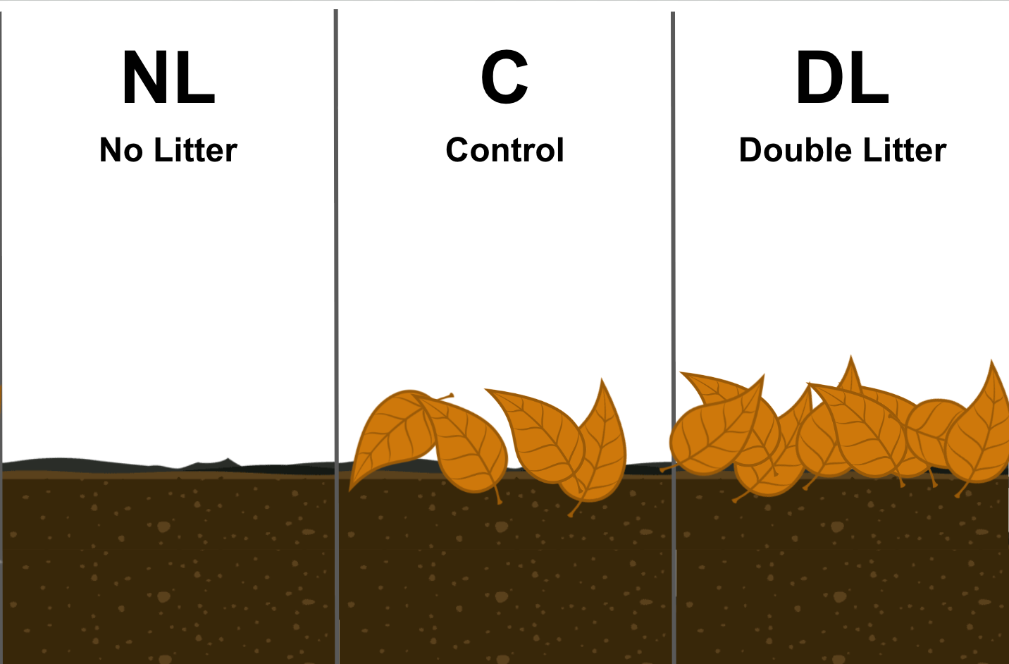
Figure 1

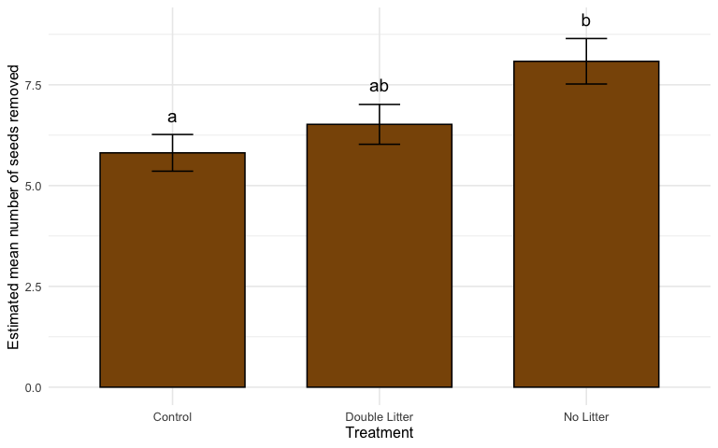
Figure 2

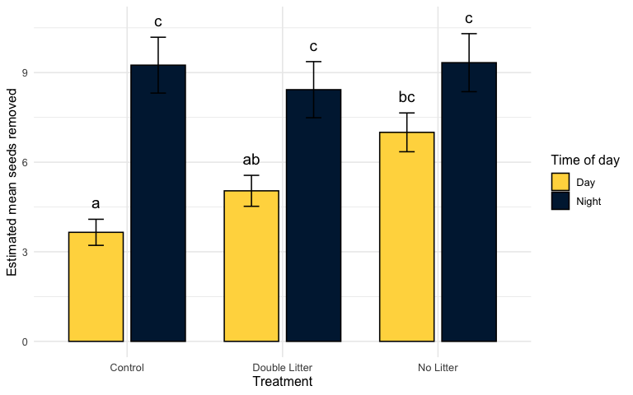
Figure 3

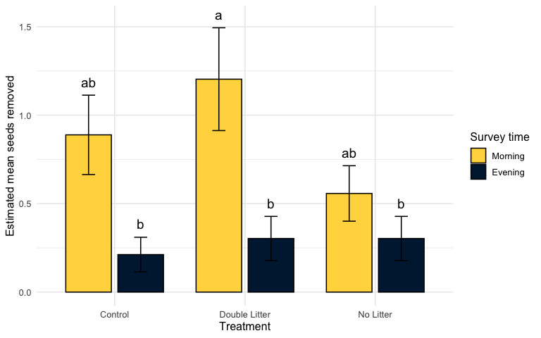
Figure 4

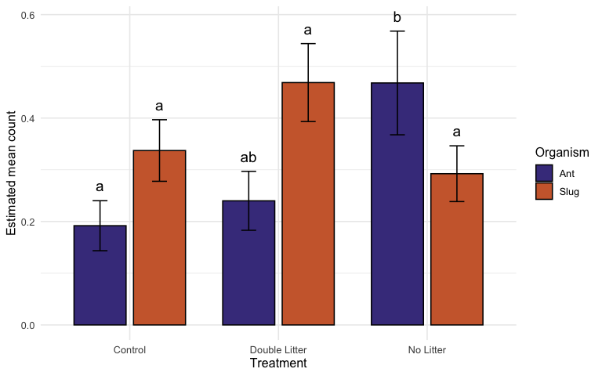
Figure 5

Fig 6

