SERISS 1A2 MULTILINE KSU MANUAL – REV-J5
OVERVIEW, INSTALLATION, TESTING, OPERATION, EXPANSION,
TROUBLESHOOTING, EQUIPMENT
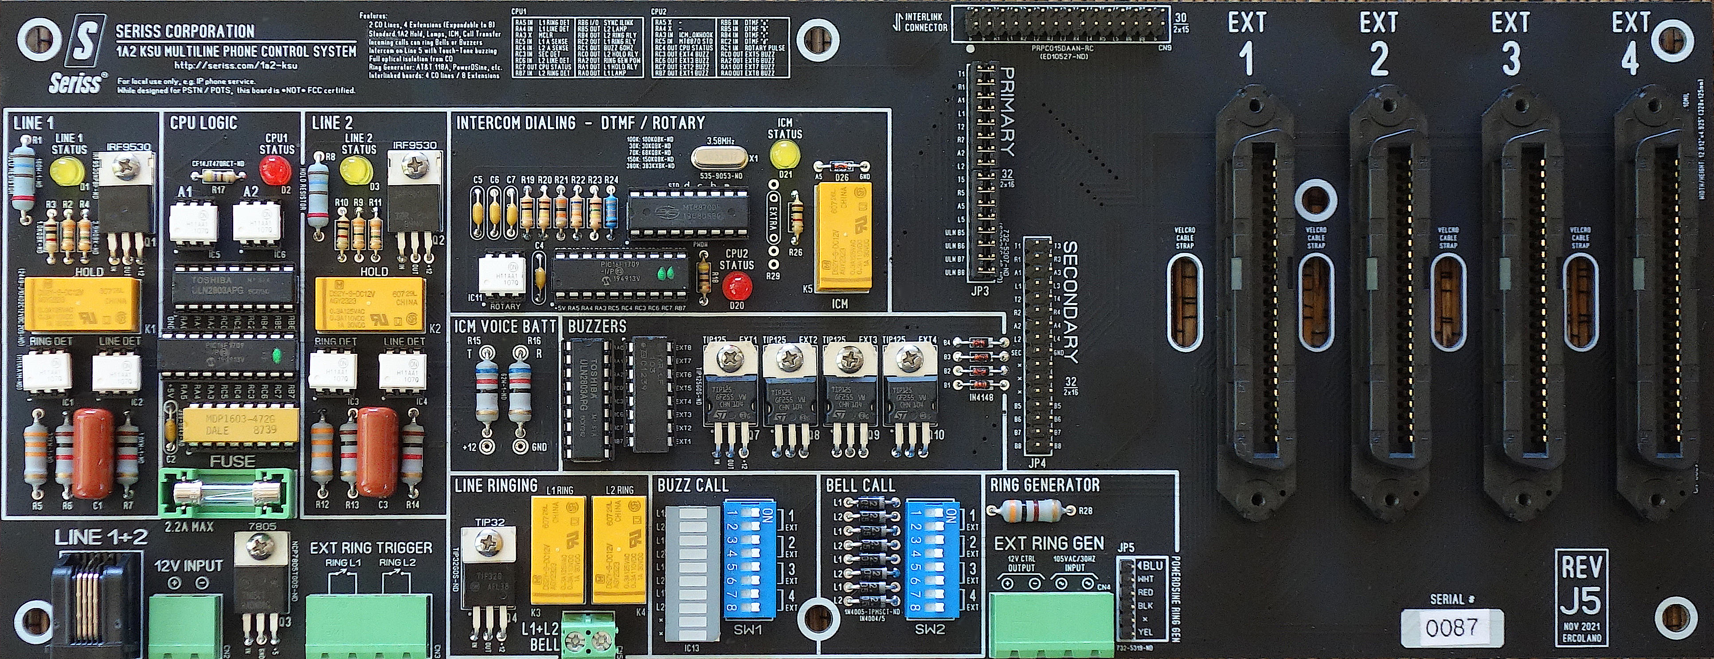
Fig. 1 ‒ Seriss 1A2 KSU (REV-J5) supports two lines / four extensions.
Two KSUs can be interlinked with a ribbon cable for four lines / eight extensions.

1. – GENERAL 3
2. – INSTALLATION 4
2.1 – Mounting 4
2.2 – Free Standing 4
2.3 – Mounting In Phone Closet 4
2.4 – Velcro Retaining Straps 5
2.5 – Mounting Enclosure (optional) 6
2.6 – Connecting Power 6
2.7 – Connect 1A2 Phone Extensions 6
2.8 – Internal Phone Wiring 7
2.9 – General Phone Bell Wiring 7
2.10 – General Phone Buzzer Wiring 8
2.11 – Wiring 2564/65 Phones 9
2.12 – Wiring 2830 Phones 9
2.13 – 2636 Call Director Buzzer Wiring 10
2.14 – ITT 2861 Phone Configuration 11
2.15 – NorTel LOGIC 10/20/30 Phones 12
2.16 – Telco Wiring 13
2.17 – Verify Line Polarity 13
2.18 – Connecting a Ring Generator 14
2.19 – The PowerDSINE Ring Generator 14
2.20 – “Black Magic” Ring Generator 15
2.21 – WE 118A 30Hz Ring Generator 15
2.22 – TelLabs 8101 Ring Generator 16
2.23 – Ring Programming 16
3. – TESTING 17
3.1 – Intercom Test 17
3.2 – Call Test 17
3.3 – Ring Test 17
3.4 – CPC Test 18
3.5 – Hold Test 18
4. – OPERATION 18
4.1 – Using Multiline Phones 18
4.2 – Line Buttons 1-5 18
4.3 – To Make A Call 18
4.4 – Putting Calls On Hold 19
4.5 – Incoming Calls 19
4.6 – Using The Intercom 19
5. – EXPANSION 19
5.1 – Interlinking Two Seriss KSUs 19
5.2 – Interlinked Bridged Ringing 20
5.3 – Interlink Testing 21
6. – TROUBLESHOOTING 22
6.1 – No Power, Status LED Off/Dim 22
6.2 – Status LED Flickers Instead of Blinks 22
6.3 – Touch-Tone Can’t Dial 22
6.4 – Can’t Rotary dial Intercom 22
6.5 – Line #1 works, Line #2 does not 23
6.6 – Lamps light but no dial tone 23
6.7 – Lamps don't light on line pickup 23
6.8 – No ringing 23
6.9 – Buzz-ringing not working. 24
6.10 – Cpu LED Not Flashing 24
6.11 – HOLD makes lamp turn off 24
6.12 – Line goes into Hold on pickup 24
7. – 1A2 EQUIPMENT 25
7.1 – Phones 25
7.2 – Buzzers 26
7.3 – 25 Pair Cables 26
7.4 – Connection Blocks 26
7.5 – Cable Terminology 26
7.6 – C-P-C Bridging Blocks 28
7.7 – 66E3-25 Connection Blocks 29
7.8 – Ring Generators 32
8. – Addendum 32
8.1 – Wire Color Terminology 32
8.2 – 50 Pin Connector Pin-Outs 34
8.3 – 2564 Caveats and Pin-Outs 34
8.4 – 2565 Caveats 34
8.5 – Terminology / Acronyms 35

GENERAL
The Seriss 1A2 KSU (Key System Unit) shown in Fig. 1 and Fig. 2 provides control of up to 2 CO (Central Office) telephone lines via an RJ11/4 jack at the lower left of the board, and can manage up to 4 multiline 1A2 key telephone extensions connected directly to the 4 Amphenol 50 pin connectors at the right hand side of the board.

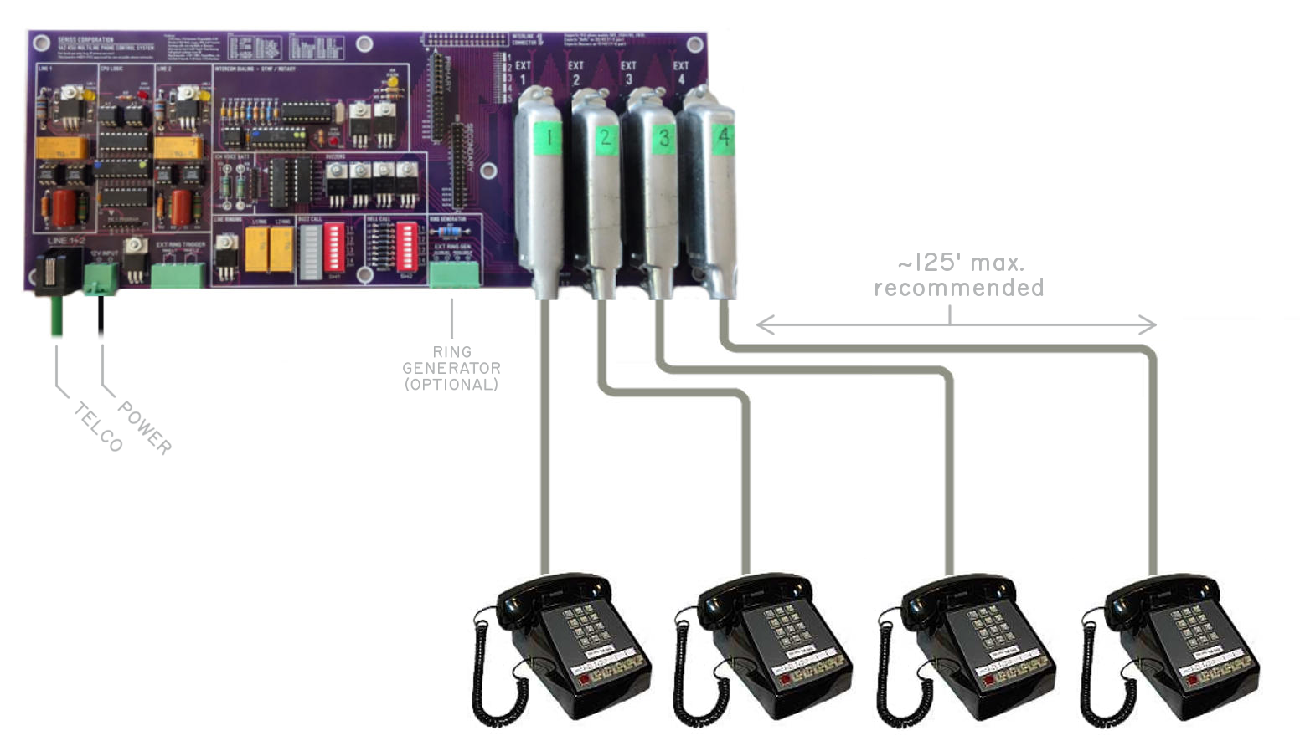Fig. 2 ‒ Seriss KSU supports 2 CO telco lines
and 4 extensions.
This is a single board design to control old Bell System 1A2 multiline phones (Fig. 3) to operate them as originally designed. A small enough board for demos, yet with sufficient features as a fully functional small business phone system for mounting in a phone closet. (See “Installation”)
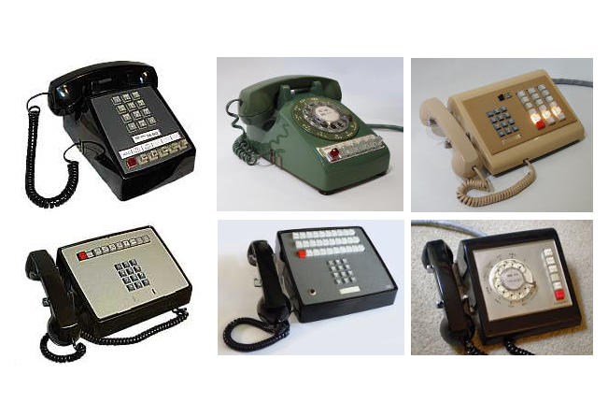Fig. 3 ‒ 1A2 multiline phones

Simple setup: connect 12VDC power to CN2 (Fig. 4), telco lines to CN1 (Fig. 4), and up to 4 phone extensions to connectors EXT-1 thru EXT-4 shown at the center right of Fig. 2.
The 12 Volt supply powers the control circuitry, lamps, buzzers, and intercom for Line #5. It must be a minimum of 2 Amps for single boards, and 2.5 Amps for powering two interlinked boards.

For bell ringing on the extensions under KSU control, an external Ring Generator must be provided at either CN4 or JP5 (Fig. 5).
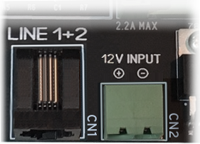
Fig. 4 ‒ RJ11 telco jack (CN1) and
12VDC power input (CN2).
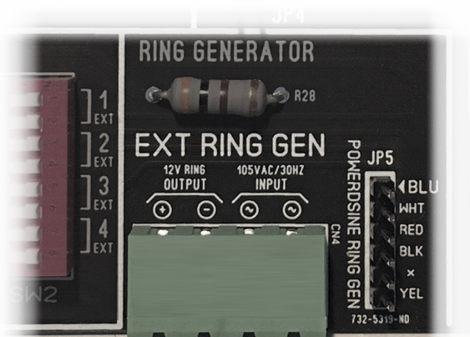
Fig. 5 ‒ External Ring Generator connections CN4 and JP5.
Features include:
- HOLD for Line #1 and Line #2
- Line Lamps Indication:
  - Off=Idle
  - Flash=Incoming Call (60 IPM)
  - On=Call In Progress
  - Wink=Call Hold (120 IPM / 80% duty)
- Intercom on Line #5
- Rotary or Touch-Tone Intercom dialing
- Expandable to 4 Lines / 8 Extensions (See “Interlinking Two Seriss KSUs”)
- Incoming Calls Ring Bells -or- Buzzers
- DIP switch Programmable Ringing for Extension Bells and Buzzers

◊ ◊ ◊

INSTALLATION

Mounting
When making connections to the board, connection order is not critical. While it is safe to to make changes while the board is powered, the safest way is to start with power disconnected.
 | Verify internal phone wiring before connecting phones to avoid accidental short circuits blowing the on-board fuse.  See “Connecting Extensions” below to verify per-phone wiring.

Free Standing
It is important the board isn’t lying on metal or conductive objects when powered up to prevent shorting out components on the back of the board.
Place the board on a non-conductive surface (wood, cardboard, newspaper) that is free of metal particles, e.g. no paper clips, staples, stray screws/nuts/wire clippings, etc.

Mounting In Phone Closet
When mounting the KSU board to a backboard for a permanent installation, use screws through all mounting holes with standoffs to keep the board elevated off the backboard’s surface to allow airflow for cooling components, and to prevent capturing metal particles behind, such as stray wire clippings from punch blocks during maintenance (Fig. 6).

In some areas, building code requires phone closet backboard material to have particular plywood fire rating, and may require the stamp for fire rating be visible at all times (unpainted and unobscured) for inspection. Consult local building codes.

If metal standoffs are used, make sure their diameter is not larger than the white markings on the bottom of the board, to prevent short circuiting traces on the rear of the board. Similarly, metal screw heads should not exceed these diameters.
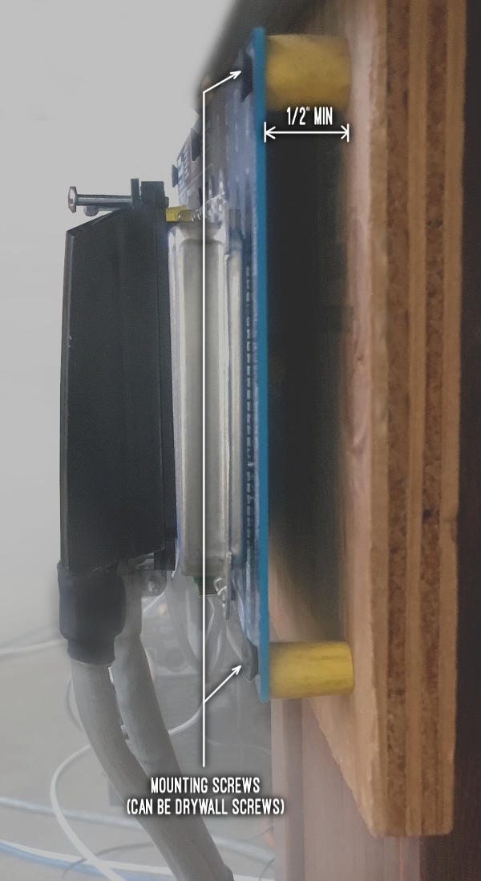
Fig. 6 ‒ KSU Mounted to backboard, office installation.

For rubber standoffs, insulation clippings from outdoor extension cords can even be used, as shown in Fig. 7.
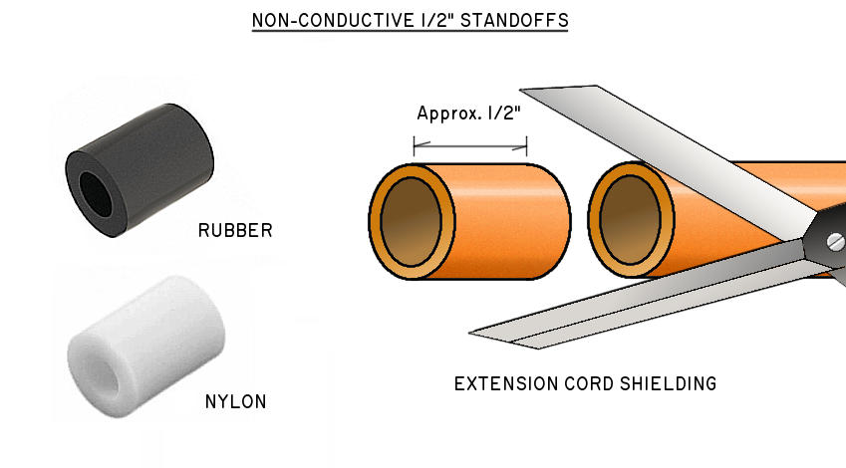Fig. 7 ‒ Backboard standoffs.

Use all 7 screw mounting holes, especially center mounting screws which prevent bending when plugging and unplugging the large 50 pin amphenol connectors.
Excessive bending mechanically stresses solder traces that can cause a fracture, leading to intermittent circuit behavior.

Velcro Retaining Straps
REV-J3 (and up) boards provide Velcro slots to allow strips of 1/2” velcro to be wrapped around the amphenol connectors to retain them tightly in place (Fig. 8 and Fig. 9). This is recommended for live systems and/or permanent installations where a connector popping out could mean a dropped call.
1/2” Velcro strips cut to approx. 5” will retain most amphenol connectors, depending on the connector type. It’s best to thread the Velcro through the slots before mounting the board to a backboard or enclosure. Straps can later be secured around the connectors after the board is mounted and cables have been seated.
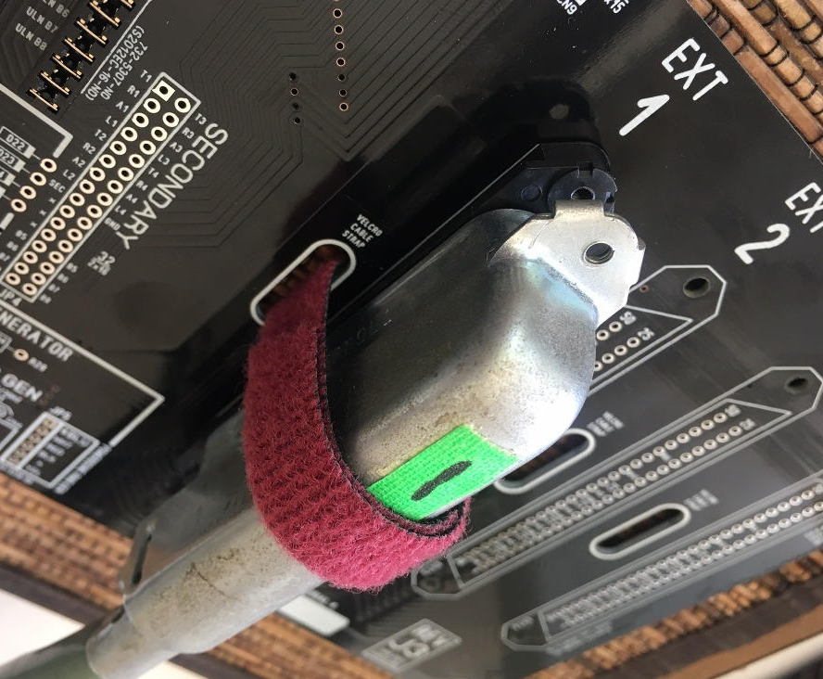Fig. 8 ‒ Velcro straps are optional but recommended for permanent installations.
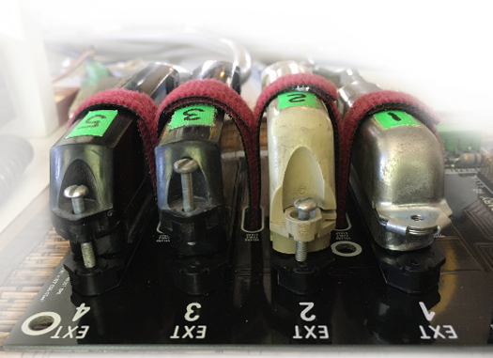
Fig. 9 ‒ Four amphenols restrained with Velcro strips.

At the date of this writing, 1/2” x 75 foot roll of Velcro (Fig. 10) can be sourced from Amazon for $22.50 USD, and cut to 5” lengths, or other required sizes.

Fig. 10 ‒ A 75’ reel of 1/2” Velcro can be cut into strips for use as amphenol retaining straps.

If a longer strap is needed (such as to retain an amphenol-to-RJ45 harmonica) a second Velcro strap can be appended to an existing one, without having to rethread a longer strap through the board. Appending a second strap avoids disrupting a live system where rethreading a longer single strap through an already mounted board can be difficult.

◊ ◊ ◊

Mounting Enclosure (optional)
Enclosures are optional and not provided by Seriss Corp. To use an enclosure, use metal or fire resistant plastic that allows bottom-up airflow, allowing hot components to induce airflow by heat convection. Air slots at the bottom and top should be sufficient without need for a fan. If fans are employed, use low speed fans – only mild airflow is necessary.
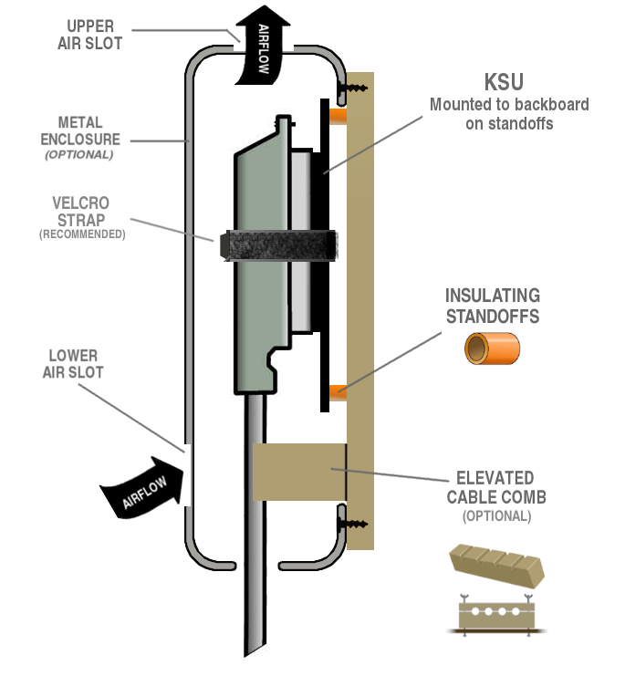
Fig. 11 ‒ Enclosure and cable tie-downs
Metal enclosures should be grounded.
Enclosures should allow for cable egress without cables rubbing against edges of enclosure. Strain relief is up to the installer; Velcro, zip ties, or similar soft materials are recommended.
Ensure strain relief/tie downs don’t dislodge the amphenol connectors.

Connecting Power
Connect the 12-volt DC power source to CN2:
- POSITIVE terminal is on the LEFT.
- Ground terminal is on the RIGHT.
Important: If you wire the power connector yourself, ensure correct polarity. There is NO PROTECTION against power reverse polarity! Reversed polarity will blow random board components.

With 12V power, the CPU1 STATUS LED should flash once per second. If intercom (Line #5) is in use, the CPU2 STATUS LED should flash 2 per second.
If the CPU1 status LED is NOT flashing, something is WRONG – disconnect power immediately, and refer to the “Troubleshooting” section.
It is advised to use the 12VDC power supplied with the board, rated 12VDC / 2 Amps, or higher.
If a custom DC power supply is used, input voltage can safely range from 11.25VDC to 12.75VDC.
For a single board, a 2 amp supply is recommended (1.5 amp minimum). For interlinked dual boards, a single 2.5 amp is recommended (2.0 amp min).

Connect 1A2 Phone Extensions
Connect the phone extensions to the large EXT-1 through EXT-4 amphenol connectors. If using Velcro straps, secure them tightly.
Phones must be 1A2 compatible, and can be either rotary or touch-tone dial pads. This includes, but is not limited to Bell System models:
- 565, 565, 2564, 2565 (5) button phones
- 2830 and 2831 (10/20) button phones
- 635, 2636 “Call Director” phones
- 2861 ITT 30 button phone
Phones that use Amphenol 50 pin connectors but are not 1A2 compatible and should never be directly connected to the Seriss 1A2 KSU board:

- 2832 Com Key (7A)
- Most “Autovon” phones
- Com Key 416/718 phones (4A)
- Northern Telecom LOGIC series phones *

(*) Northern Telecom LOGIC 10/20/30 series phones can be connected with rewiring using a 66 block; see section on “NorTel LOGIC 10/20/30 Phones”.
When connecting phones for the first time, verify each phone’s internal wiring before connecting to ensure proper operation. Refer to each phone’s recommended internal wiring for details in Table 1— 1A2 Phone Set Wiring.

◊ ◊ ◊

Internal Phone Wiring
In general 1A2 phones will “just work” when plugged into the KSU, however you should verify internal bell and buzzer wiring in each phone first.
Use the sections in this table to verify phone wiring BEFORE connecting to the KSU. Especially Northern Telecom sets, which require special connection block wiring for the buzzer wire pair.
Not all 1A2 phones are listed here, but may still be supported (e.g. 2851, 2852, 2853..). Generally, similar wiring techniques apply for all:
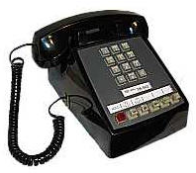 | 2564 · 2565 · 564· 565  Also known as 6 button sets. See:  ➤ 2.11 Wiring 2564/65 Phones
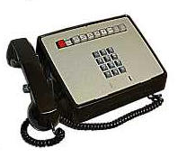 | 2830 · 2831  Also known as 10 button sets. See:  ➤ 2.12Wiring 2830 Phones
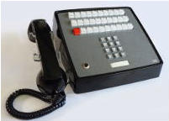 | ITT 2861  A 30 button set. See:  ➤ 2.14 ITT 2861 Phone Configuration
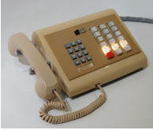 | 2636 · 5361  Also known as “Call Director”. See:  ➤ 2.13 2636 Call Director Buzzer Wiring
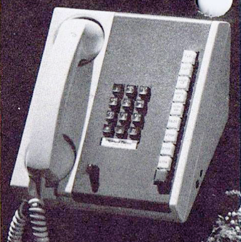 | Nortel LOGIC 10  The LOGIC 10/20/30 needs special wiring. See:  ➤ 2.15 NorTel LOGIC 10/20/30 Phones
Table 1— 1A2 Phone Set Wiring

General Phone Bell Wiring
For bells to ring, an external ring generator must be supplied at either the “EXT RING GEN” connector CN4, or “POWERDSINE RING GEN” connector JP5. (Fig. 5)
To enable ringing on extensions, the appropriate “BELL CALL” switches for SW2 must be set to “ON”, as shown in Fig. 12:

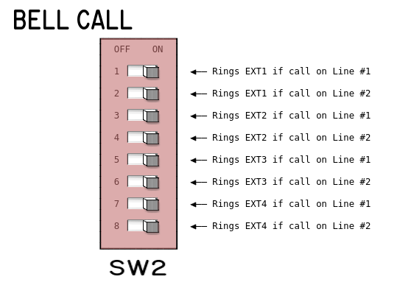Fig. 12 ‒ KSU Bell Call programming switches, or "SW2" on the KSU.
The KSU uses a diode matrix to program ringing, so one must bypass the ring capacitor between terminals K and A on all the 1A2 phone’s hybrid network, as shown in Fig. 13:
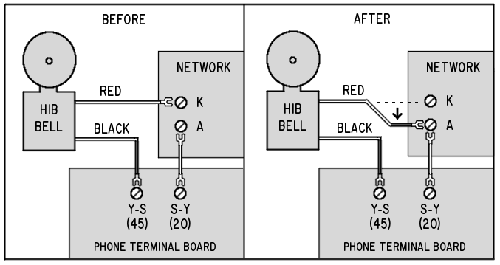Fig. 13 ‒ 1A2 bell bypass K → A wiring change.
Paraphrasing Ed from Sundance Communications:
“For any kind of diode ringing to work, the capacitor between hybrid network terminals A and K (inside the phone) has to be bypassed. Move the wire on terminal ‘K’ over to terminal ‘A’ along with the existing wire.”

There are two types of bells found in 1A2 phones (Fig. 14 and Fig. 15):
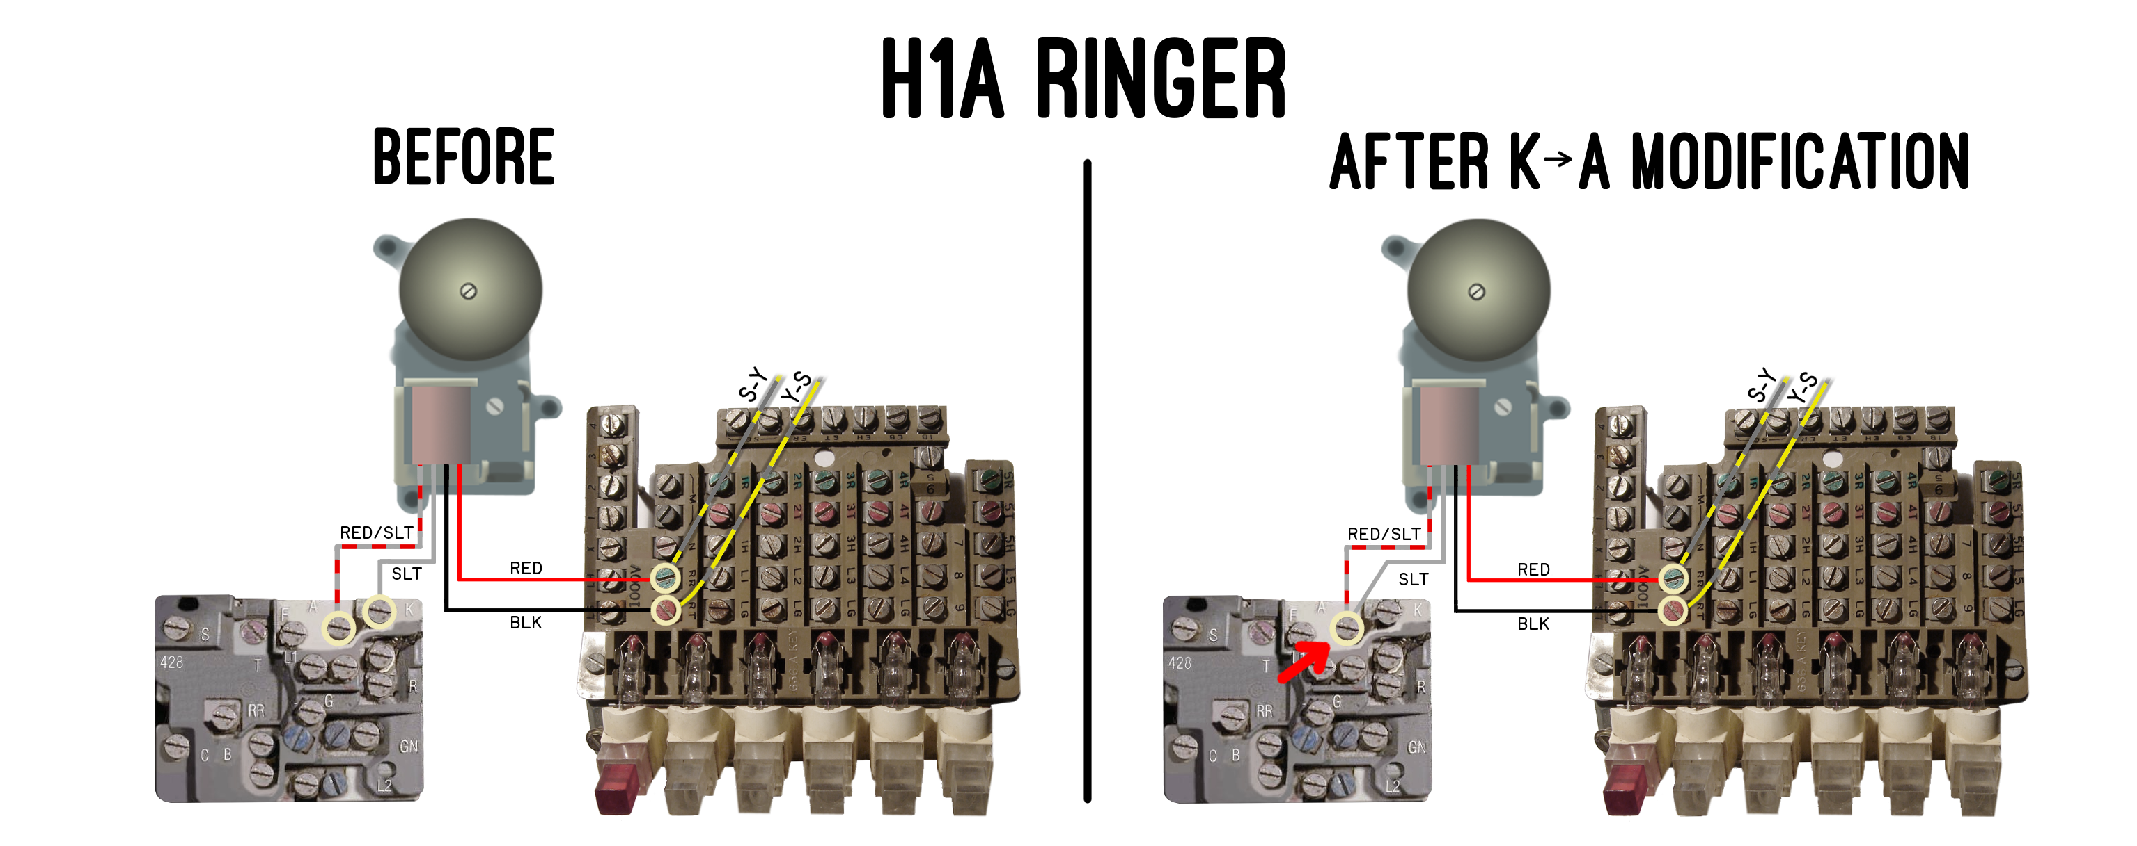
Fig. 14 ‒ H1A “4 wire” bell wiring for K→A modification.

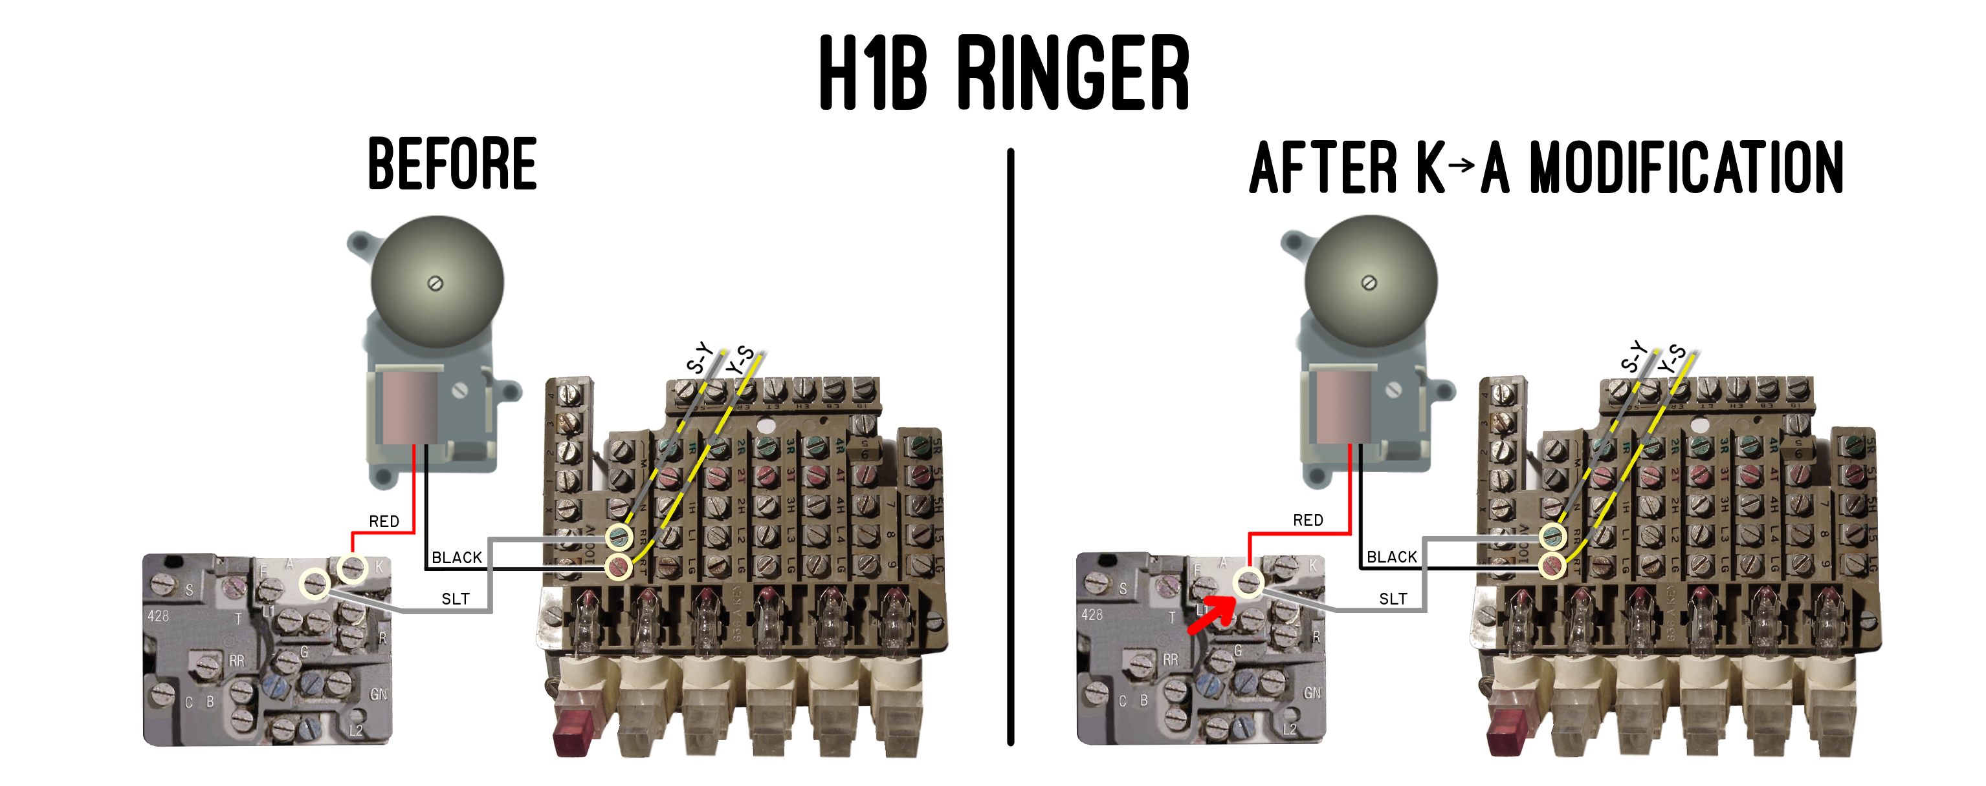Fig. 15 ‒ H1B “2 wire” bell wiring for K→A modification.
On terminal boards for the 2564/65, the S-Y and Y-S wires attach to terminal board screws RR and RT respectively as shown in Fig. 14 and Fig. 15. Labeling may be different on other phone sets.
If you’ve enabled bell ringing (SW1 on KSU) and supplied a ring generator, but don’t hear ringing on one or more phones, there are some things to check inside the phones themselves:

Tips: If You Don’t Hear Ringing:
- Swap Y-S and S-Y wires on network screws. Polarity matters for diode ringing.
- Try changing LOUDNESS (bottom of phone) to various settings.
- Confirm bell clapper moves freely and is not caught on other objects inside phone.
- Check bell bias spring.
For more info, see the “TROUBLESHOOTING” section 6.8 “No ringing”.

◊ ◊ ◊

General Phone Buzzer Wiring
Buzzer wiring is generally straightforward: connect the buzzer’s two wires to the Y-O pair using two available screws on the phone’s internal terminal board, as shown in Fig. 16.

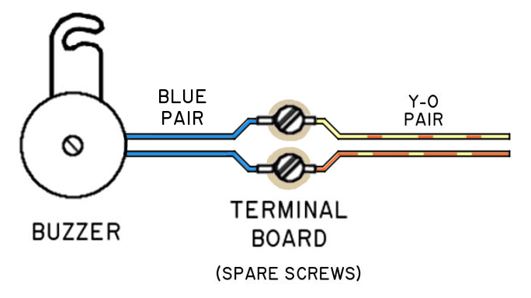
Fig. 16 ‒ Typical Buzzer Wiring Y-O Pair.
Some terminal boards (2636 and 2861) use bussed screws, allowing wires to be joined on separate screws (Fig. 17)
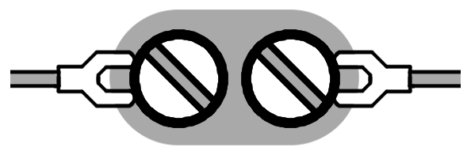
Fig. 17 ‒ Bussed terminal connection.
For other phones, such as the 2564/65, joining wires involves the sharing a screw (Fig. 18).
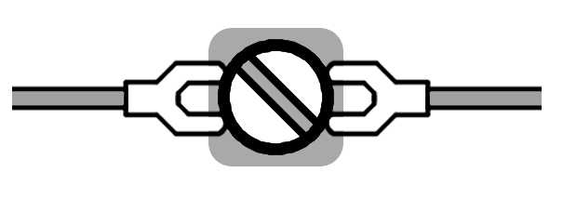Fig. 18 ‒ Shared terminal connection.
The buzzer sounds if that extension’s number is dialed on Line #5, or if that extension is programmed to buzz on an incoming call via the “BUZZ CALL” (SW1) Fig. 19.

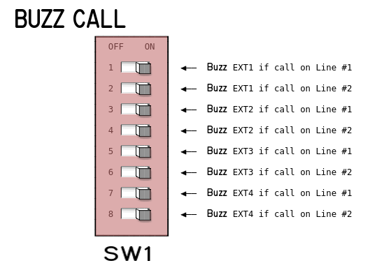
Fig. 19 ‒ Programming Buzzers for Incoming Calls.

Wiring 2564/65 Phones
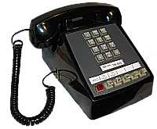
Verify your 256x phone’s bells and buzzers are properly wired for use with the Seriss KSU:

- For bell wiring , refer to section 2.9.
- For buzzer wiring, refer to section 2.10.

The buzzer can be wired to any spare screws on the terminal board inside the phone:
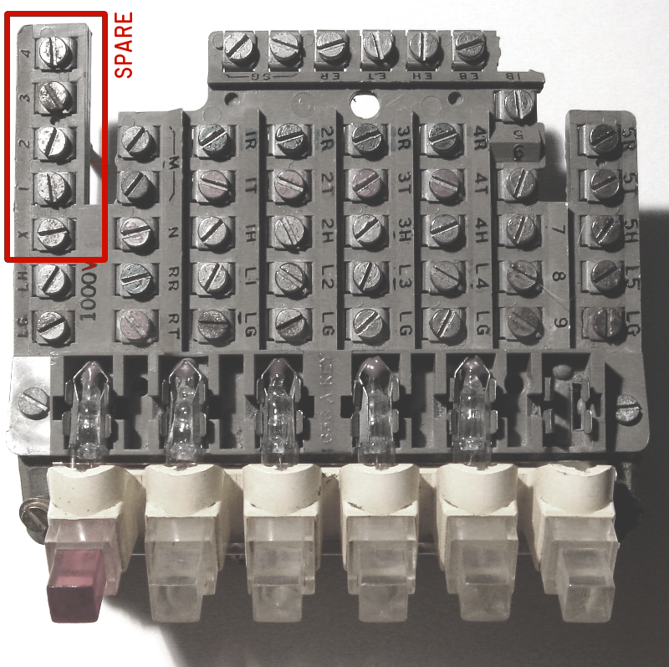
Fig. 20 ‒ Recommended buzzer wiring for 2564/65 and 564/65 phone sets.

Any two spare screws at the upper left of the terminal board can be used to join the buzzer wires with the Y-O pair from the phone’s mounting cord.
With the two blue buzzer wires mounted on spare screw terminals 1 and 2, locate the Y-O wire pair from the mounting cord, and wire them to join the blue wires on terminals 1 and 2 respectively.
To verify all buzzers operate correctly, pick up the intercom (on Line #5), and dial “0”. This will ring the buzzers on all extensions (EXT 1 – 4).

Spare screws used on the 636A terminal board used for wiring the buzzer are usually any two available screws at the upper left of the board, labeled “1” -- “4” and “X”.
To use any other screws, refer to the BSP schematics for your exact phone model to ensure you don’t interfere with terminals hardwired for other purposes.

◊ ◊ ◊

Wiring 2830 Phones

The 2830’s factory configuration for buzzer and bell wiring should already be correct.
The only change needed should be the K → A modification (see section 2.9 General Phone Bell Wiring) for the bell wiring.
However, used equipment may be configured differently, so you should also verify the buzzer is wired to the Y-O pair (see section 2.10 General Phone Buzzer Wiring).

◊ ◊ ◊

2636 Call Director Buzzer Wiring
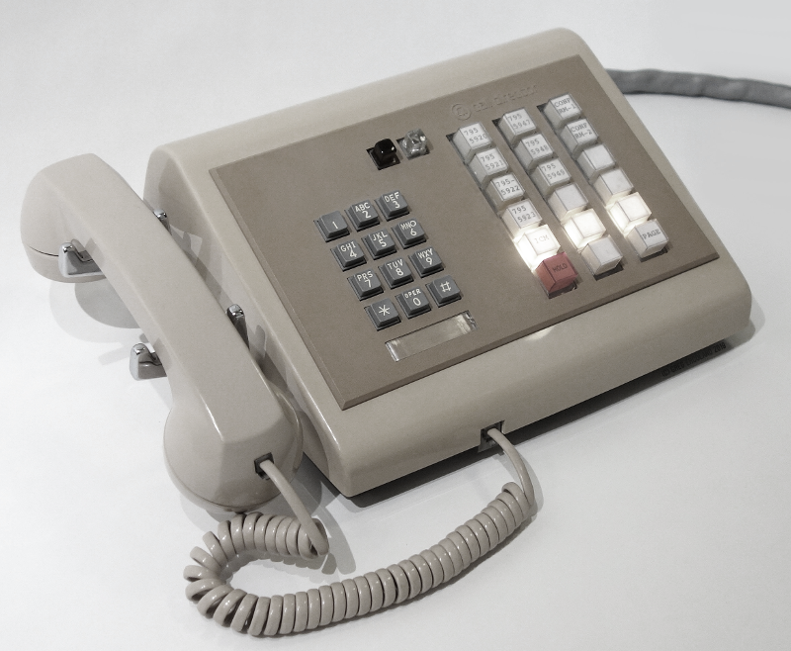

Proper buzzer wiring for Call Director phones is shown in Fig. 21; “Before” is the factory wiring, “After” is the proper wiring for the Seriss KSU:
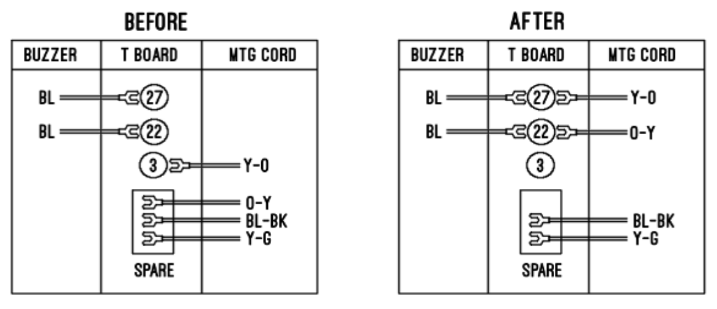Fig. 21 ‒ Buzzer Wiring for Call Director.
To make the necessary changes, identify the Y-O pair on the Connector I cable. With the blue buzzer wires attached to terminal screws 27 and 22:

- Remove Y-O wire from terminal screw 3, and move it over to join buzzer wire on terminal 27.

- Locate O-Y wire (usually spared off as shown in Fig. 21), and move it to join the wire on terminal 22.

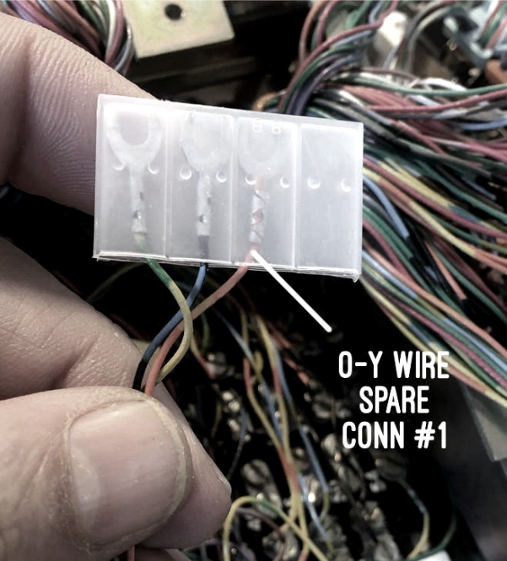Fig. 22 ‒ O-Y wire spared off in a Call Director.

◊ ◊ ◊

ITT 2861 Phone Configuration
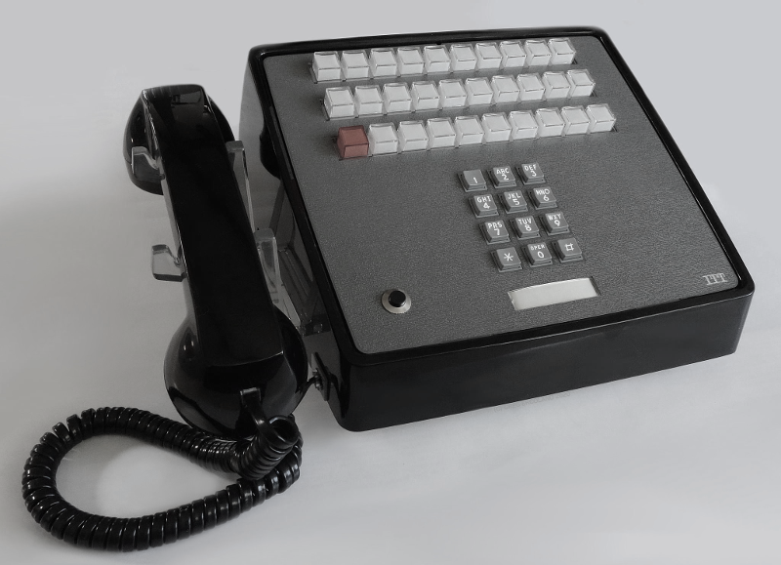
The ITT K-2861 (and rotary counterpart, K-861) is a 30 button (29 line) desk phone with 3 Amphenol connectors, named 1, 2 and 3 (Fig. 23):
There’s one connector per row of line buttons on the phone; Connector 1 is for the bottom row (with the Hold button), Connector 2 for the middle row, and Connector 3 for the top row.
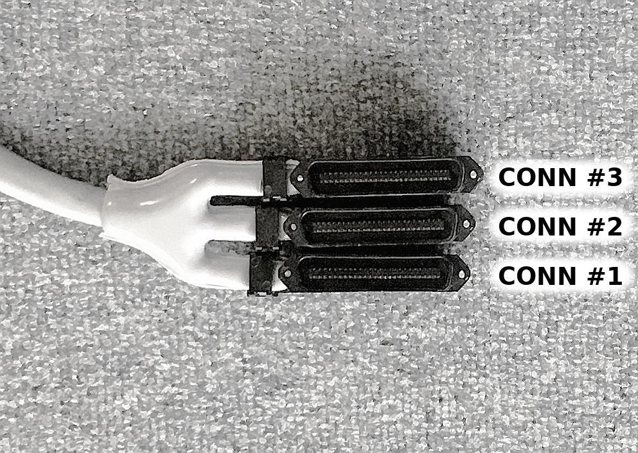Fig. 23 ‒ ITT 2861 mounting cord connectors.
Connector #1’s wire pairs should be used for bells and buzzers; the Y-S pair for bells, the Y-O pair for buzzer.
With this arrangement, the buzzer should operate normally with “Connector 1” plugged into any one of the EXT# connectors on the KSU.
If you connect all three 2861’s connectors 1,2 and 3 to the KSU’s EXT1, 2, 3 respectively, Lines #1, #2 and #5 (ICM) will appear duplicated on all three rows of the ITT’s line buttons; makes for a real “light show”.

2861 – Bell Ringing
To ensure proper KSU control of bell ringing, move the RED wire from terminal ‘K’ over to the ‘A’ terminal to join the SLT-YEL wire as shown in Fig. 24.
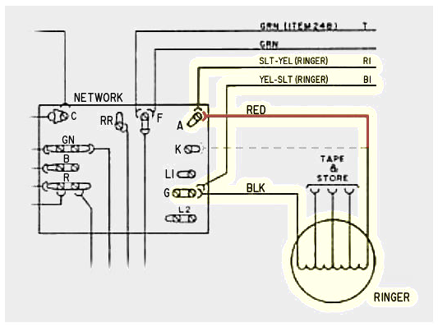Fig. 24 ‒ Recommended bell K→A wiring change in ITT 2861 30–button phone sets.

2861 – Buzzer
For buzzers to operate during intercom dialing and the optional “BUZZ CALL” feature, using the wiring described in Fig. 25 from the ITT “TIMM” practices.
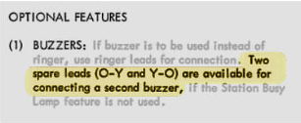
Fig. 25 ‒ Recommended buzzer wiring (as per ITT TIMM).

Identify the Y-O pair inside the phone from the mounting cord’s “Connector 1”, and wire them to any pair of unused screw terminals on the phone’s internal terminal board as shown in Fig. 26:
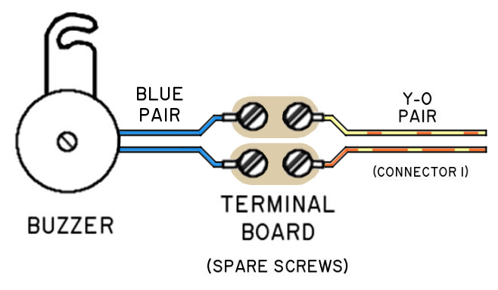Fig. 26 ‒ ITT buzzer wiring on spare bussed terminals.

NorTel LOGIC 10/20/30 Phones
This section covers special wiring for Northern Telecom LOGIC series phones with Seriss KSUs.
To do this properly, use an intermediate 66 or 66E3-25 connection block as shown in Fig. 27:
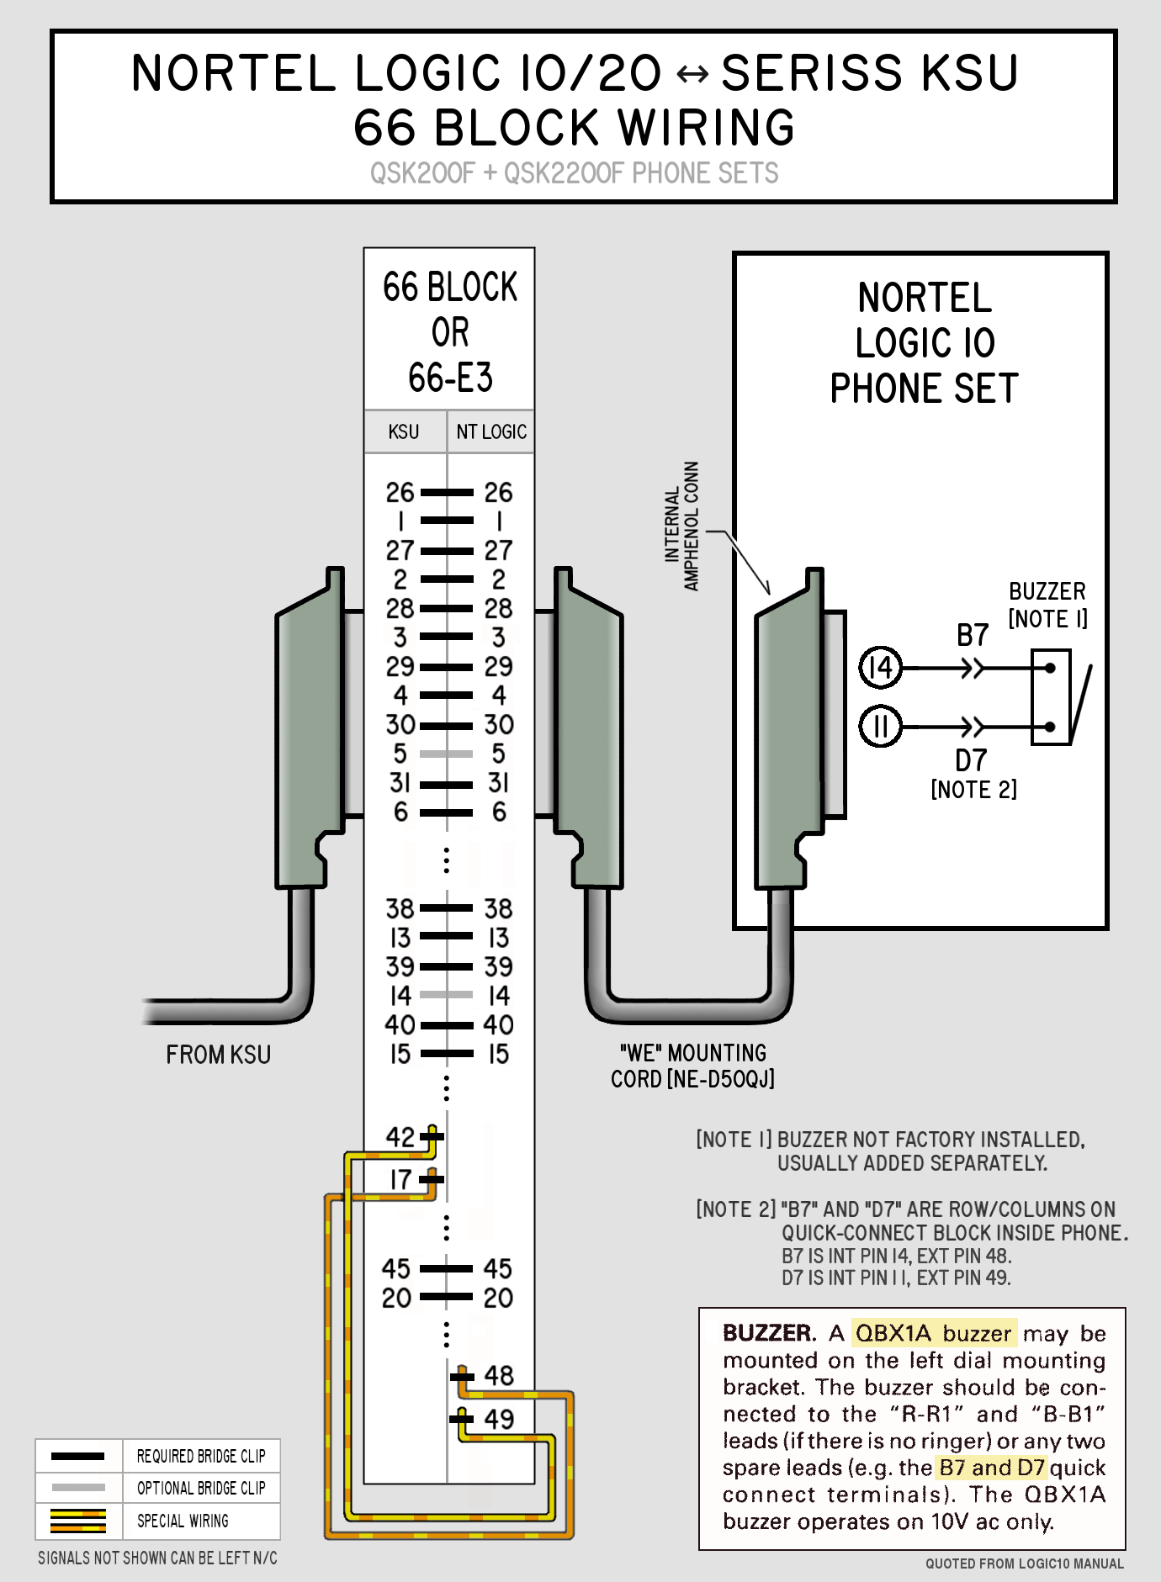
Fig. 27 ‒ Nortel LOGIC Phone 66 block wiring for WE mounting cord.

NorTel LOGIC series phones are only compatible with Seriss KSU “Rev J” (and higher) boards.
Within the Touch-Tone versions of these phones (QSK200F and QSK2200F) there’s a terminal block with numbered rows and letter columns.
The following photo shows the proper buzzer connections to terminals B7 and D7 (Fig. 28).
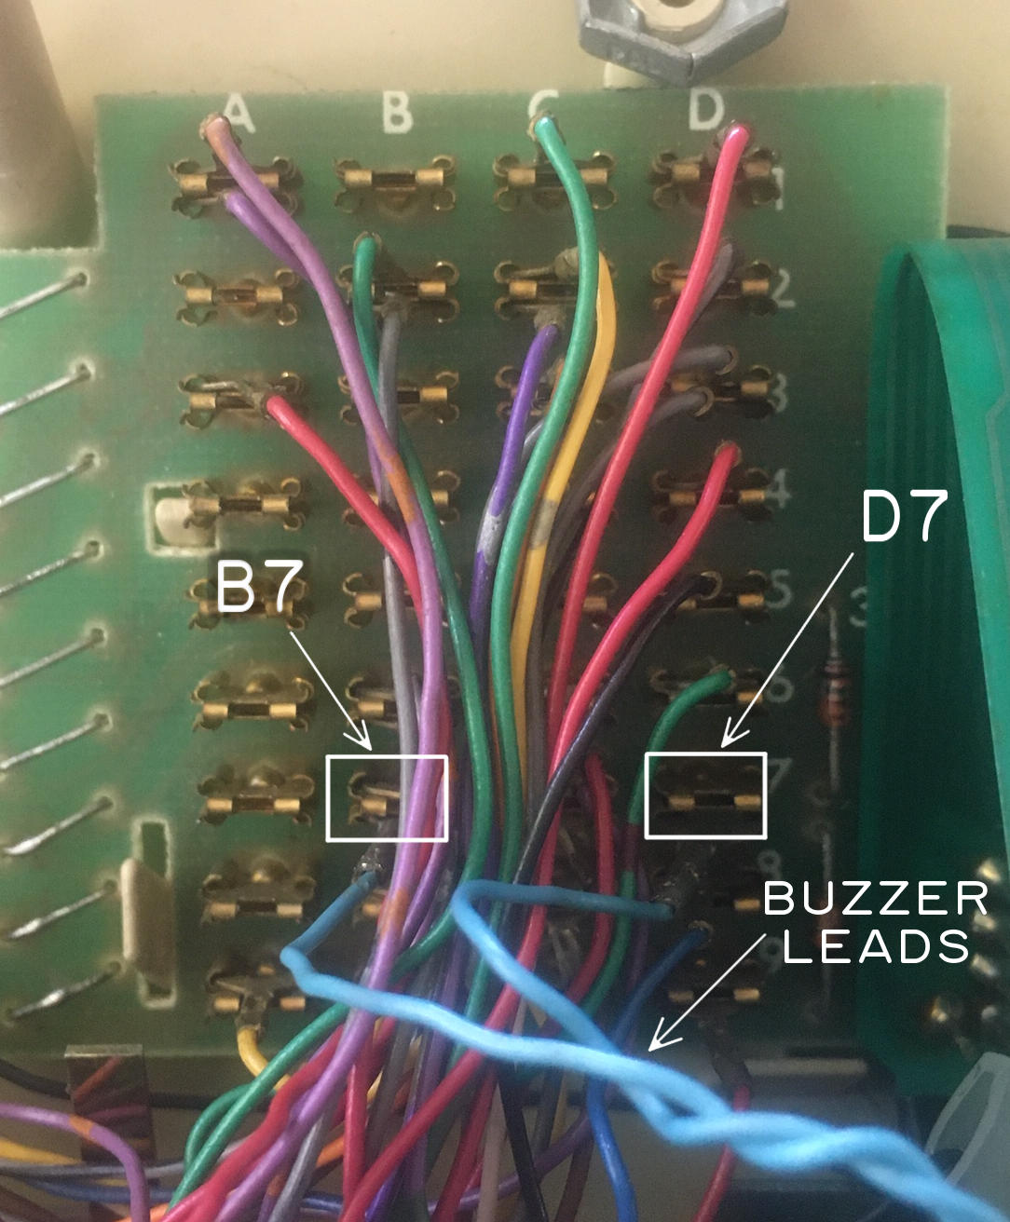Fig. 28 ‒ Buzzer lead attachment terminals for NT LOGIC 10 Touch-Tone set.
Wiring shown is for WE style mounting cords only. If you have an NT mounting cord, be careful with the rewiring. Refer to the Northern Telecom documentation’s wiring charts for details.
If you have Seriss KSU older than REV J, you can bypass the A lead diode in the phone by connecting the leads together to make it work, and doing some careful wiring with the buzzer leads, but it is not recommended.
Northern Telecom phones have special pinouts depending on the cable the phone was ordered with at the time of purchase.
These phones came with two possible mounting cords:
- Western Electric & ITT (NE-D50QJ)
- Northern Telecom KSU (NE-D50QE)
This manual only covers the Western Electric mounting cord (Fig. 27).
The pinout for the Western Electric (WE) and ITT cable is shown in the following table excerpted from the Northern Telecom documentation:
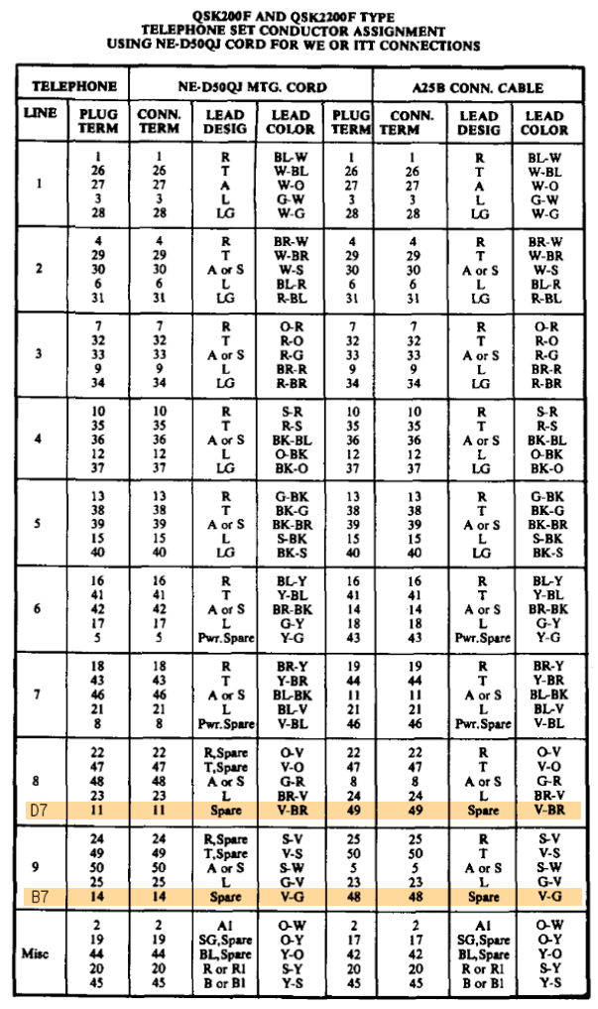
◊ ◊ ◊

Telco Wiring
Connect the card to your telephone service. The phone service can be VoIP, XLink, or other “plain old telephone” (POTS) compatible service.
It works fine to use that device as the CO source, so that your 1A2 phones can be used for receiving and originating calls.
Warning: This card is NOT approved by the FCC for use directly with analog PSTN (Public Switched Telephone Networks).
Legally it can only be attached to phone systems that use an interface of some kind, like VoIP or XLink.
While the board is designed to handle analog POTS lines, the responsibility is yours when connecting a non-FCC rated device to public switched networks. If you do, it is assumed you are a hobbyist or EE technician who understands the implications.

Verify Line Polarity
After connecting the live telco wiring (Section 2.06), It is best to verify line polarity, to avoid problems with e.g. Touch-Tone dialing not working due to swapped Tip/Ring pairs from the telco.
It’s easy to check Tip/Ring polarity for any of the lines with a digital volt meter on the KSU’s PRIMARY jumper (JP3):
Telco Line Voltmeter Polarity Check
- Set your voltmeter to read 100 VDC (min)
- Locate PRIMARY header (JP3) on the KSU
- Put RED probe to T1 (Tip for Line #1)
- Put BLACK probe to R1 (Ring for Line #1)
- Proper polarity should read positive voltage (approx. +48 Volts DC) on an idle phone line. (Fig. 29)

NOTE: If Tip/Ring polarity is wrong, you’ll instead see negative 48 Volts. If this happens, check your RJ11 cabling to ensure no intermediate devices are swapping polarity. See also TROUBLESHOOTING section 6.3 Touch-Tone Can’t Dial.
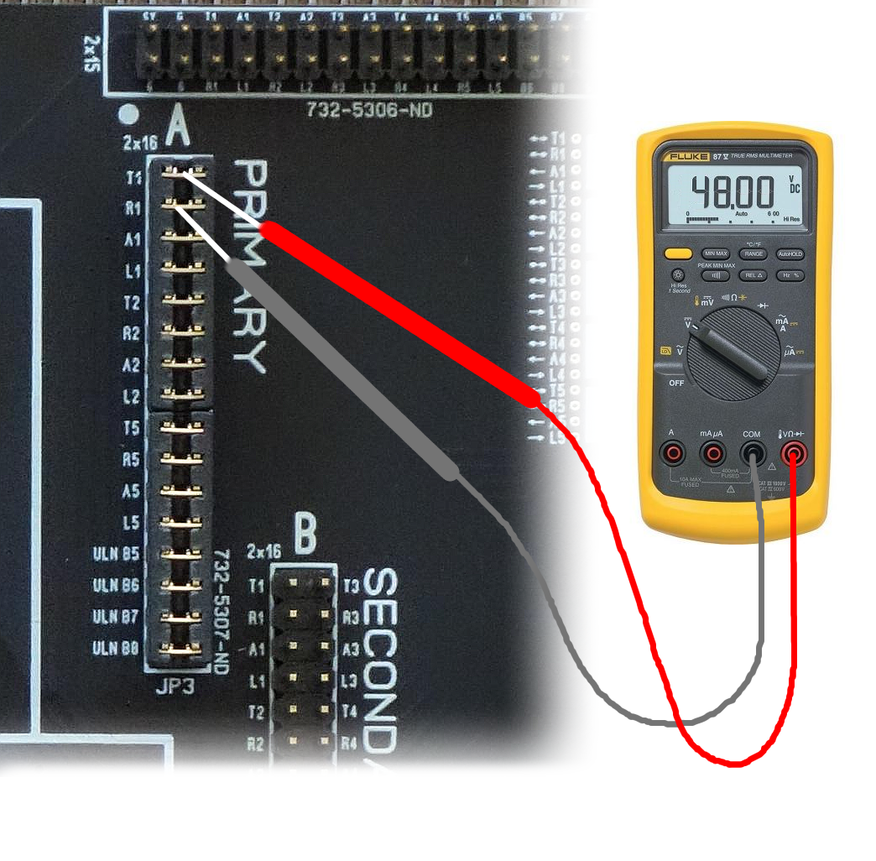Fig. 29 ‒ Checking for positive +48 VDC Tip/Ring polarity on the KSU.

◊ ◊ ◊

Connecting a Ring Generator
This step is optional. Skip this step if any of the following are true:
- You have no external Ring Generator
- You intend to use “Buzz Ringing” only
- You wired phones to ring off telco Tip/Ring
To configure a ring generator with the Seriss KSU, you can attach an 80 – 105VAC / 20Hz-30Hz external ring generator to enable bell ringing for the 1A2 phones on the Y-S wire pair.
There are several different ring generator options, any one of which can work with the Seriss KSU:
- The PowerDSINE Ring Generator
- “Black Magic” Ring Generator
- WE 118A 30Hz Ring Generator
- TelLabs 8101 Ring Generator

The PowerDSINE Ring Generator
The easiest, most common, cost effective ring generator is connecting a 12 volt PowerDSINE module (sometimes branded “Power Components”) directly to component position JP5 on the KSU board (Fig. 30).
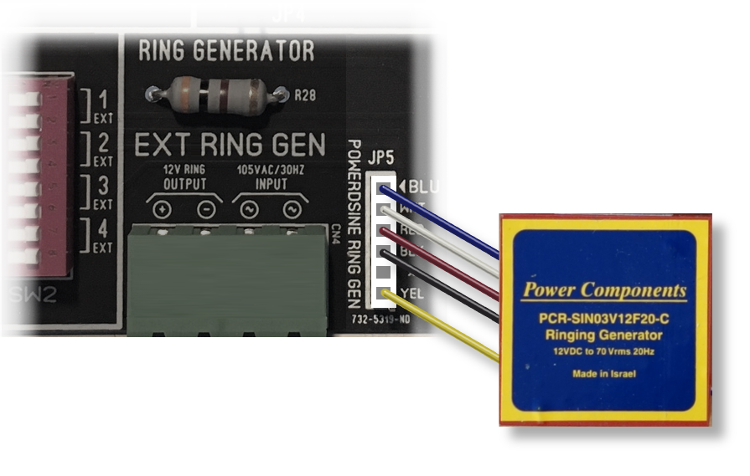Fig. 30 ‒ PowerDSINE, aka. “Power Components”, External Ring Generator attached to JP5.
Connected in this way, the module is powered by the KSU’s 12V power supply, powered only during ringing, ensuring the device is completely powered down when idle for energy efficiency.
Bell ringing is configured with the SW2 DIP switches – see section “Ring Programming”.
When mounting the PowerDSINE to a backboard, some suggested mounting techniques are shown in Fig. 31: sticky foam tape mounted to a separate small board (for easy relocation), or four drywall screws surrounding the module.

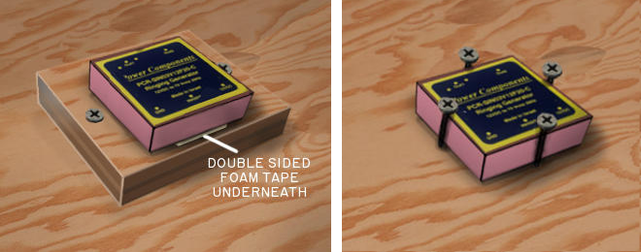Fig. 31 – PowerDSINE mounting techniques: foam tape (left), or screw constellation (right)
◊ ◊ ◊

“Black Magic” Ring Generator
This ring generator from Cambridge Electronics is similar to the PowerDSINE in that it’s a module, though its connector is typically not pin compatible with JP5.
But it can still be attached via the screw terminals on CN4, as shown in Fig. 32.
This device is meant to be installed on a PCB (Printed Circuit Board). You can either mount it to a PCB and solder wires to it, or solder wires directly to the pins with heat shrink, and mount it to the backboard with 3M foam stick tape.
The AC output wiring is not polarity sensitive, but the +12VDC provided by the KSU board is, so be sure to get the +/- connections correct.
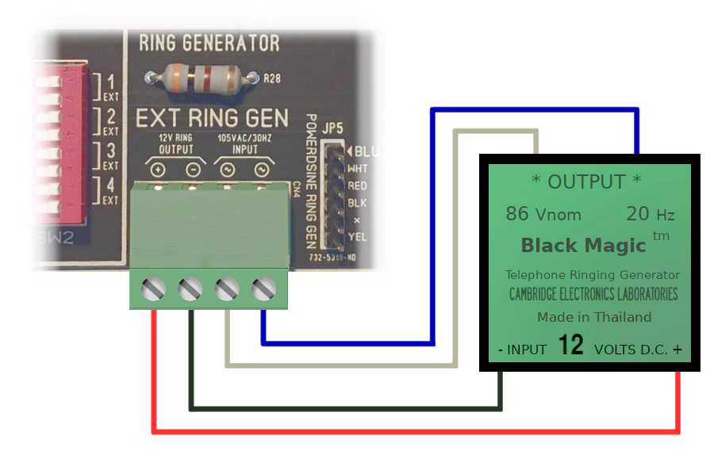Fig. 32 ‒ Cambridge Electronics “Black Magic” External Ring Generator attached to CN4.

Ringing will occur based on the programming of DIP switches SW2 on the Seriss KSU; see “Ring Programming”.

WE 118A 30Hz Ring Generator
This ring generator uses AC power, and provides a constant 105 VAC / 30 Hz ring voltage output on its two output terminal screws.
These outputs can be wired directly to the KSU’s CN4 “105 VAC/30HZ INPUT” terminals, as shown in Fig. 33 by the blue and white wires.
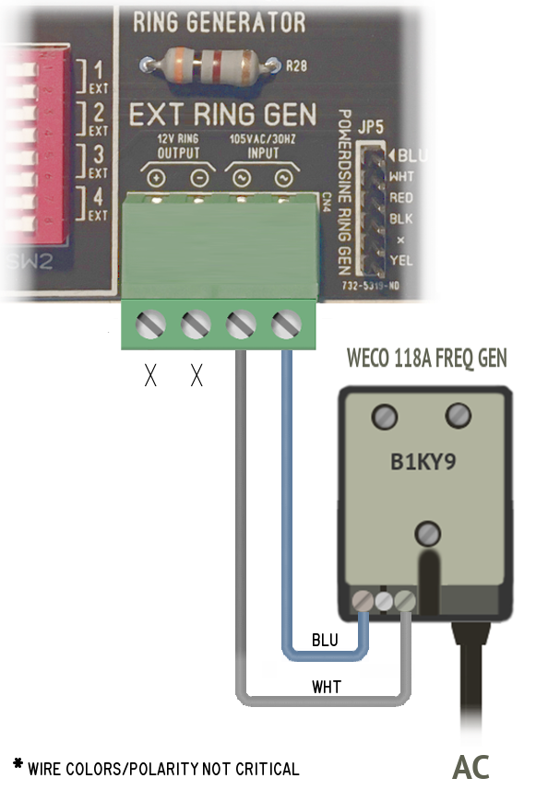
Fig. 33 ‒ WE 118A Frequency Generator (Ring Generator) wired to CN4.

Ringing will occur based on the programming of DIP switches SW2; see “Ring Programming”.
The 118A is an original Western Electric Company (WECO) device used in “Shoe Box” KSUs of the period, such as the 550-type and 551-type KSUs.
Proper WECO terminology for these devices is a “Frequency Generator”, but are more commonly referred to as “Ring Generators”.

TelLabs 8101 Ring Generator
Like the 118A, this ring generator uses AC power, and provides a constant 105 VAC / 30 Hz ring voltage output on its two output terminal screws.
These outputs can be wired directly to the KSU’s CN4 “105 VAC/30HZ INPUT” terminals, as shown in Fig. 34 by the white and blue wires.
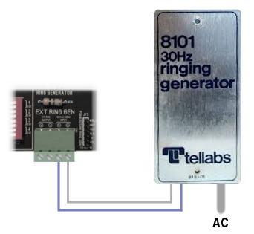Fig. 34 ‒ TelLabs 8101 30Hz External Ring Generator attached to CN4.

Ringing will occur based on the programming of DIP switches SW2; see “Ring Programming”.

◊ ◊ ◊

Ring Programming
Each extension can be programmed to ring when a call comes in on Line #1 or Line #2 via SW2 (Fig. 35) using the “BELL CALL” switches (SW2):
Fig. 35 ‒ Extension Bell Ring Programming for Incoming Calls.
Switches turned on (switch toggle moved to the right) will ring that extension when a call comes in on the specified line.
Similarly, extensions can be programmed to buzz phones for incoming calls by programming the “BUZZ CALL” switches (SW1). Setting of these switches does not affect intercom buzzing.
In the typical case with a Ring Generator, normally one wants extensions to ring; all “BUZZ CALL” switches (SW1) are set “off”, and only extensions desired to ring for incoming calls are selected on the “BELL CALL” switches (SW2).
If your system has no Ring Generator, it is advised you use the BUZZ CALL option (SW1).

◊ ◊ ◊

TESTING
With the above “Installation” steps completed and power applied, you should now be able to test the phones. Try these tests in order:

Intercom Test
- Pickup the handset on a phone extension, and press the Line #5 button.
On phones with a horizontal orientation of line buttons:
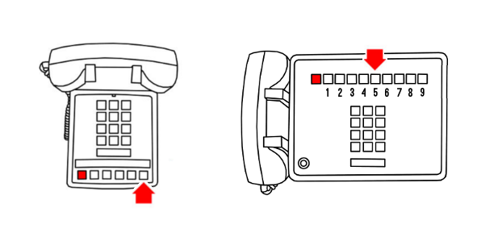
..Line #5’s button is the 5th to the right of the hold button.
On phones that have a vertical arrangement of line buttons:
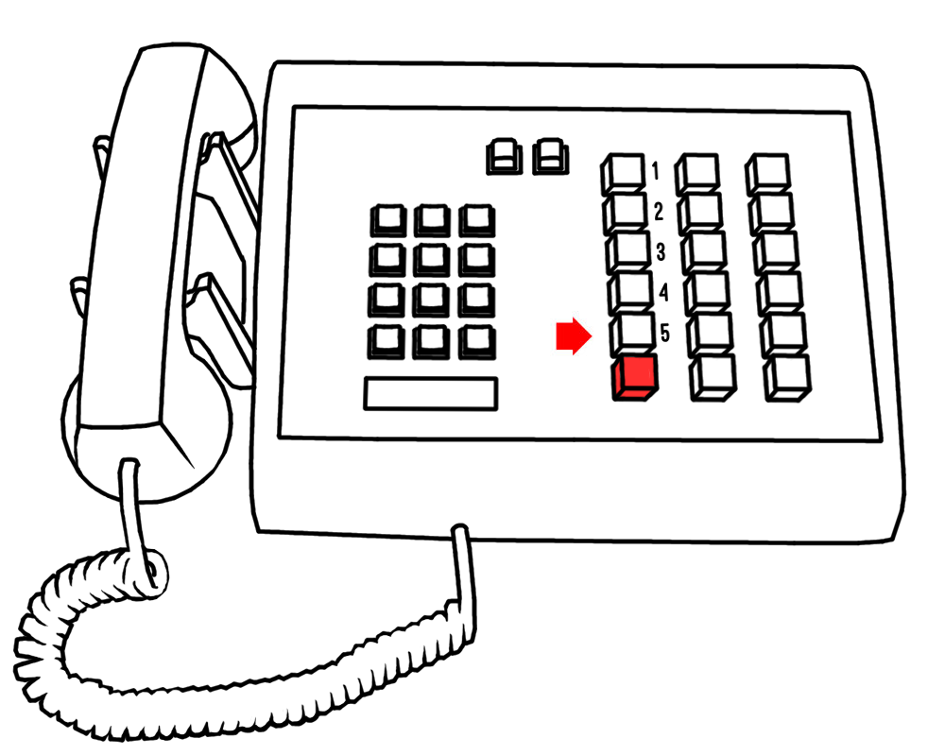
..Line #5’s button is the 5th down from the top in the left-most button column.

- The lamp for that line should light on ALL extensions.
- To test each extension’s buzzer, dial the number of each extension (e.g. Dial “1” to buzz EXT-1).
On Touch-Tone dials, the buzzer should sound for as long as you hold the button down. For Rotary dialing, the buzzer will sound for about 1 second.
Dial “0” to buzz all extensions at once.
- While you’re on the intercom line, have someone else pickup the same line on another extension, and verify the talk circuit works properly; both ends should be able to hear each other talking over the handset.

Call Test
- Try calling Line #1’s phone number from a separate phone (e.g. cell phone), or if you have two lines active, call from Line #2.
Line #1’s lamp should flash at 1 IPS on all extensions, and extensions programmed to ring (via SW1/SW2) should ring using a 1-second ring/3-second pause cadence.
If not, see “TROUBLESHOOTING”.
- Answer the call by selecting Line #1 on any extension, and pick up the handset. The lamp for Line #1 should stop blinking and stay on steady on all extensions.
- Put the call on Hold by pressing the red Hold button. Line #1’s lamp should flash at 2 IPS indicating the call is on Hold.
You can now hang up and retrieve the call on any extension.

Ring Test
If you don't have a live phone network configured, you can trigger ringing using the "Ring Trigger Connector"; briefly short the two left terminals to ring Line #1, or right two terminals to ring Line #2 (See Fig. 36).
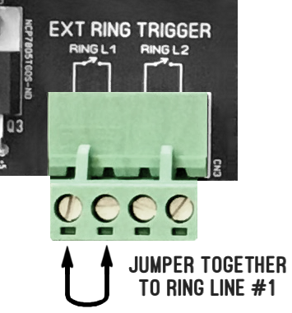Fig. 36 ‒ Test ringing by briefly connecting left two Terminals on “EXT RING TRIGGER” CN3.
Inducing ringing is also useful for demos, to trigger ringing without an actual phone line.
If you have trouble getting ringing to work, see the “Troubleshooting” section entitled “No Ringing”.

CPC Test
Calling Party Control (“CPC”), sometimes referred to as “Disconnect Supervision”, is a feature that frees up the line when someone on Hold hangs up.
The phone company (or your VoIP interface box, or other POTS interface) implements this by briefly opening the line on a hangup, making the line “go dead” briefly (for about ½ second).
To test this:
- Call Line #1 from another phone, answer, put the call on Hold. Line #1 should flash.
- Now hangup the call from the phone that initiated the call.
- Line #1’s lamp may continue to flash for several seconds, but eventually CPC should clear the line, releasing Hold.
If you find Line #1 remains on Hold indefinitely, CPC is not working. Consult the VoIP device documentation or telco provider to enable CPC.

Hold Test
Live telco service must be attached to the RJ11 connector (“LINE 1 + 2”) to test Hold.
Pick up the line and immediately put the line on Hold by pressing and releasing the Hold button. The line’s lamp should begin flashing. Retrieve the call from another extension.
If the call does not go on Hold, check that the telco line is live; you should hear dial tone, or some kind of audio indication that the line is not dead.
If you don’t have a POTS line, you can use a line simulator as shown in Fig. 37:
◊ ◊ ◊
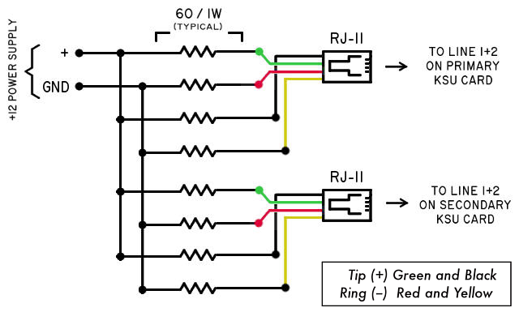Fig. 37 ‒ 4 line telephone line simulator using two RJ11 jacks.

OPERATION

Using Multiline Phones
Each multiline phone has “Line Select” buttons to let you pick which line to use when you lift the handset.
Depending on your phone set, these lines may be arranged horizontally or vertically:
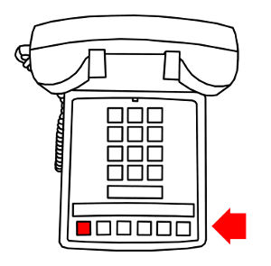  2564 / 2565 | 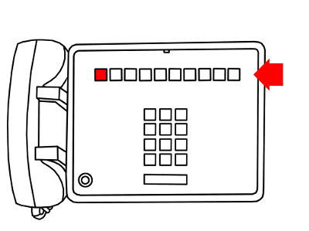  2830 / 2831 / 2861
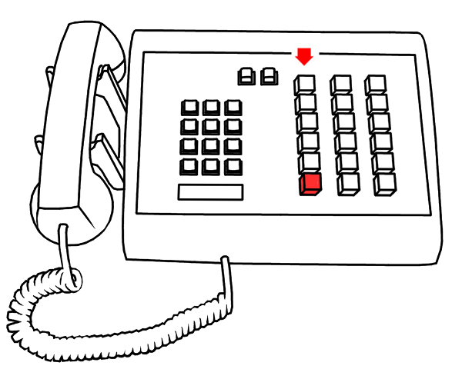
2636

Lines are preassigned:
- Single Board: Line #1+2 are the CO lines, and Line #5 is intercom.
- Interlinked Boards: Line #1+2 on PRIMARY board, Line #3+4 on SECONDARY board, and Line #5 is intercom.

Line Buttons 1-5
Next to the red Hold button are the line buttons; the first being Line #1, Line #2, and so on. Line #5 is the Intercom Line, described below.

To Make A Call
To make a call, push an available line button (that is not already lit). Choose the line button BEFORE picking up the handset, so you don't accidentally pick up a call that is in use.
Now lift the handset. The line's button should light up on all extensions, indicating you're using the line. You should hear dial tone.
Dial your call normally, and hang up when you're done. When you hang up, the line's light will go off on all extensions, indicating the line has freed up and can be used for new calls.

Putting Calls On Hold
You can put an active call on hold by pressing and releasing the red HOLD button. The line button pops up and the line’s lamp starts winking indicating to all extensions the line is on hold.
You can then hang up the phone and the call remains on hold. You can then answer calls on other lines, make new calls, use the intercom, etc.
Any extension can pick up the held call.
If the remote caller hangs up while on Hold, the Hold condition should automatically be released, and the line will be free for use again.

Incoming Calls
When a call comes in, extensions programmed to ring should do so, and the lamp for that line should flash indicating which line has the incoming call.
Phone extensions should either ring or buzz, depending on how the phones are programmed. (See "Ring Programming" in the "Installation" section).

Using The Intercom
The intercom lets people at different extensions inter-communicate, such as a receptionist notifying someone at another extension there's a call for them.
To use the intercom, push Line #5 and dial the number for the extension you want to talk to. Example: dialing "1" buzzes extension #1 (the phone plugged into the “EXT-1” connector). The person at that extension would hear the buzz and pick up the lit intercom line to answer.
Dialing "0" buzzes all extensions.

◊ ◊ ◊

EXPANSION

Interlinking Two Seriss KSUs
If you have two Seriss KSU boards, you can interlink them together with a 30 pin ribbon cable to create a single phone system supporting up to 4 Telco lines and up to 8 extensions that all can be individually buzzed on the intercom line (by dialing "1" through "8", or buzz all of them by dialing "0").
For info on how to configure two boards with the INTERLINK connector, refer to this diagram:
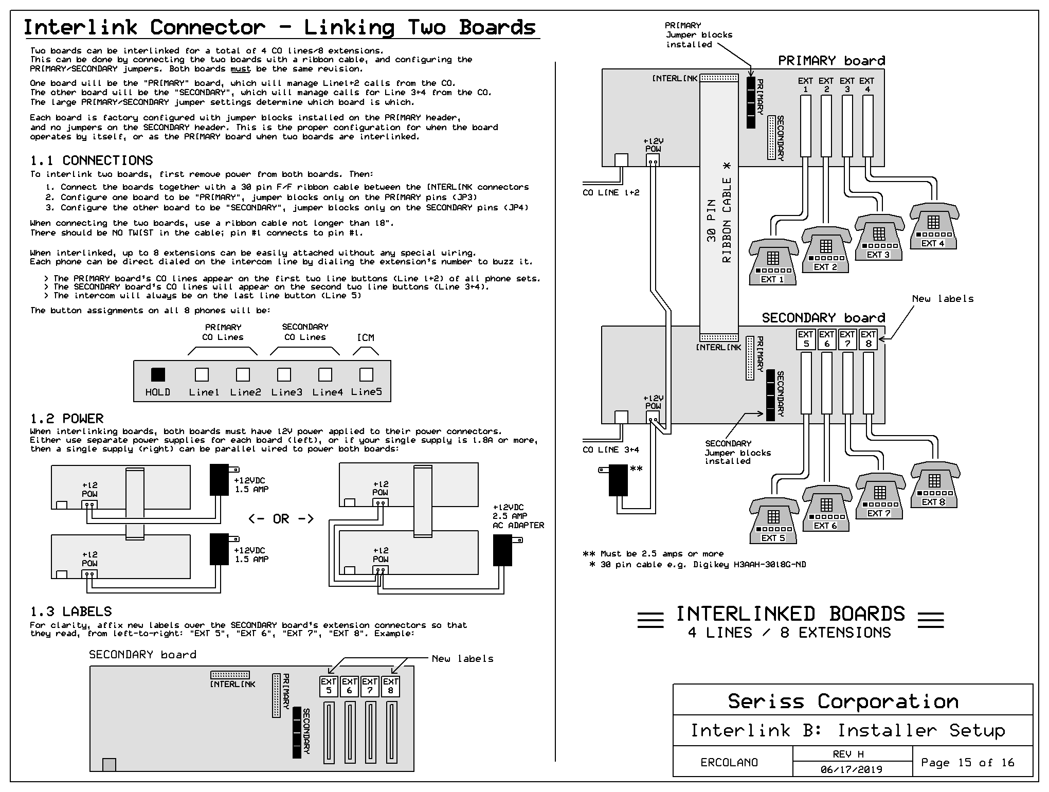
http://seriss.com/1a2-ksu/rev-j5/data/1a2-REV-J5-0015.png
One board should be configured using the “PRIMARY” jumper, the other using the “SECONDARY” jumper. Power both boards with a single 12V/2.5 amp power adapter.
Interconnect the two boards using a 30 pin ribbon cable between the INTERLINK connector on both boards (Fig. 38).

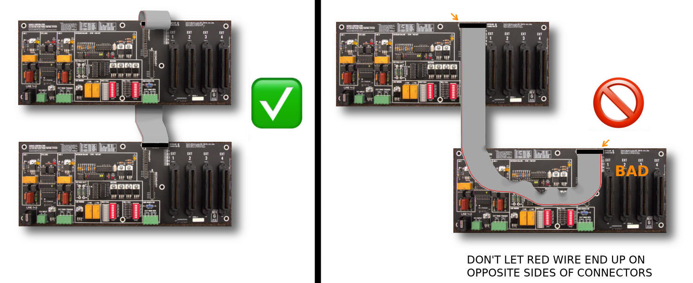
Fig. 38 ‒ Proper connection of the 30-pin INTERLINK ribbon cable.
This arrangement prevents obscuring the board, so one can easily see the DIP switch and jumper configurations. Note how the cable does a full 360 degree flip over itself, as shown in this side view:
One can also trivially route the cable straight across the top of the two boards as shown below without a twist, useful for quick/simple tests:
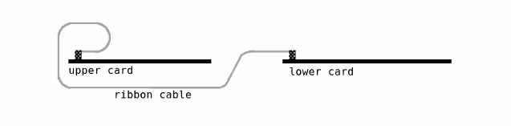Fig. 39 ‒ Recommended INTERLINK cable configuration for finished installations.
..but that blocks access to jumper and DIP switches, so the Fig. 39 arrangement is preferred.
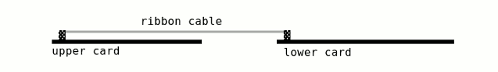Fig. 40 ‒ Simple cable arrangement OK for quick tests, but covers top board's components.
Configure one board as "PRIMARY"; that board's telco inputs will appear as Line #1+2 on extensions.
Configure other board as "SECONDARY"; that board's telco inputs will appear as Line #3+4 on all extensions.
The PRIMARY board's intercom circuit will manage the intercom on Line #5 for all 8 extensions.
To configure the PRIMARY board: ensure all jumper blocks are all installed on the PRIMARY jumper header (JP3), and none on the SECONDARY (JP4).
To configure the SECONDARY board: make sure all jumper blocks are installed on SECONDARY jumper (JP4), and none on PRIMARY jumper (JP3).
Plug telco lines 1+2 into the PRIMARY board.
Plug telco lines 3+4 into the SECONDARY board.
Attach up to 8 extensions to the EXT connectors.
◊ ◊ ◊

Interlinked Bridged Ringing
By default, incoming calls only ring extensions programmed to ring on the same board hosting those lines. Which is to say:
- Incoming calls on Lines #1 / #2 only ring the PRIMARY card’s extensions (EXT 1-4)
- Incoming calls on Lines #3 / #4 only ring the SECONDARY card’s extensions (EXT 5-8)
In REV-J3 (and up) the new “L1+L2 BELL” terminal screws allow bridging ringing across the two boards’ lines.
Note the “L1+L2 BELL” terminal block screws are only available on the REV-J3 (and higher) boards.
To operate properly, an external ring generator capable of ringing ALL THE LINES AT ONCE needs to be supplied. This means small ring generators like the PowerDSINE modules (only capable of ringing ~4 phones) cannot be used. More powerful AC ring generators such as the 118a, TelLabs 8101, or similar should be used instead as shown in Fig. 41.
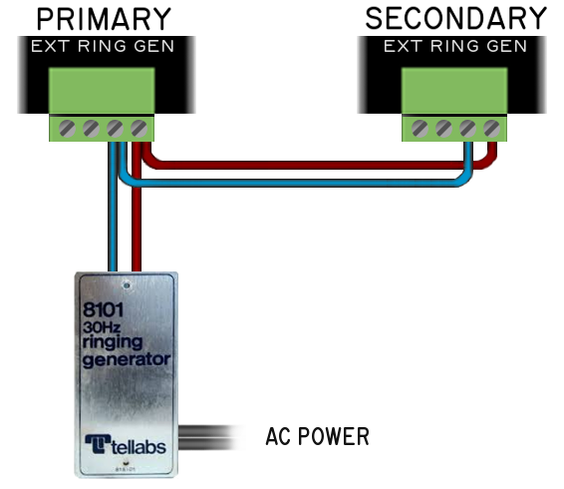
Fig. 41 ‒ Sharing single external ring generator.

Each of the two screws on the “L1+L2 BELL” terminal block is the ring generator’s output for ringing a single line:
- The LEFT screw is Line #1’s ring voltage
- The RIGHT screw is Line #2’s ring voltage
Example: To allow just Line #1 to ring extensions on both boards, connect the left screw on the PRIMARY board to the left screw on the SECONDARY board through a diode (1N4005 or similar) pointing towards the SECONDARY board, as shown below (Fig. 42).
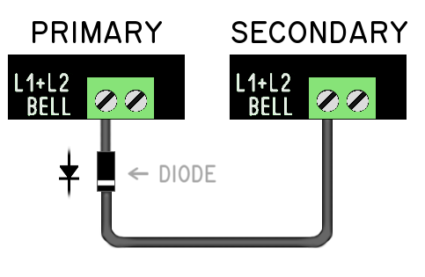
Fig. 42 ‒ Line #1 incoming calls also ring extensions programmed to ring for Line #3.

With the above configuration, an incoming call on Line #1 will also ring the bells configured to ring on Line #3 of the SECONDARY board. The diode prevents incoming calls on Line #3 from ringing the Line #1 programmed extensions.
If you interconnect the left screws on both boards without the diode, incoming calls on Line #1 or Line #3 will ring the same extensions on both boards.
Similar behavior is achieved with different interconnections at these terminals.
For all 4 lines to ring all extensions: interconnect all four screws on the “L1+L2 BELL” terminals as shown below (Fig. 43).
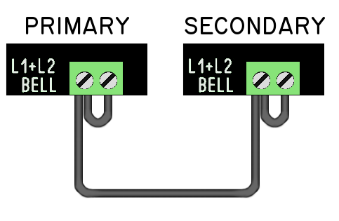
Fig. 43 ‒ Wiring all lines to ring all extensions programmed for bell ringing.

Interlink Testing
When boards are interlinked, the CPU STATUS led on both boards should blink in sequence, indicating both boards have power.
If four telco lines are connected, they should be accessible on Lines #1 through #4 on all extensions.
Any of the lines can be used on any extension, and calls can be put on hold and transferred to any other extension.
Line #5 is the shared intercom across all extensions, and each extension can be buzzed using the dial (rotary or touch tone).
Picking up the intercom (Line #5) and dialing 1 through 4 will buzz EXT 1-4 respectively on the PRIMARY board, and dialing 5 through 8 will buzz the corresponding extensions on the SECONDARY board. Dialing 0 will buzz all extensions.
For clarity it’s recommended to relabel EXT 1–4 on the SECONDARY board to EXT 5–8 instead using a custom label printer (such as a P-Touch or similar).
◊ ◊ ◊

TROUBLESHOOTING
This section should help you solve the various problems you can have during setup, or when things go wrong. Email erco@seriss.com if you encounter problems not defined here, esp. if you've found a solution and think others would benefit from it.

No Power, Status LED Off/Dim
When the AC wall adapter is plugged into the wall, the board's CPU1 STATUS LED should immediately start blinking. If not, things to check:

- Check Fuse
On all recent boards (REV-F and later), the fuse is a 250V/2AMP 5mm x 20mm glass cartridge type fuse rated on board above the power connector.
To remove the on-board cartridge fuse, just pop it out.
On REV-G1 and older, the fuse is inline on the power cord, between the “ferrite bead” and the green terminal screw plug that connects to the board.
To remove the in-line fuse type, push the two ends of the fuse holder together and twist; the two sides should come apart, revealing the glass cartridge fuse.
Test the fuse using an ohmmeter.
If the fuse is blown, before immediately replacing it with another (just to watch it blow again), unplug AC, remove all connections to the board except the power connector. Inspect the board (top and bottom) for small bits of metal that may be shorting out pins or components; stray wire clippings, fallen screws, paper clips, staples, bits of wire foil or metal shavings from drilling, etc. and remove them.
Then plug in AC power and see if the CPU1 STATUS LED starts blinking again. Then reconnect each phone ONE AT A TIME. Exercise all phone features for each until the bad phone is identified.
- Check AC Wall Adapter Power Output
Verify the 12 VDC power supply with a voltage tester. Unplug it from the board, and test for 12VDC on the terminal screws. Left screw should be “+”, right screw “-”.

Status LED Flickers Instead of Blinks
A flickering CPU1 STATUS LED on board revisions REV-J4 and up indicates the board is configured as a SECONDARY (at JP4) but is not properly connected to a PRIMARY configured board with an interlink cable. Check if the interlink cable is not connected properly or damaged.

Touch-Tone Can’t Dial
If dialing works for intercom, but not for telco Line #1 or Line #2, check if Tip/Ring are swapped by testing line polarity with a voltmeter as described in section 2.17 Verify Line Polarity.

A common problem with older model bell system Touch-Tone pads is sensitivity to line polarity reversal, which causes dial buttons to either generate no tones at all, or very low volume tones that aren’t sensed by the telco.
To solve, simply flop the Tip/Ring wires for that line and re-test. Rewire either at the jack, or if the jack can’t be rewired, use a Y-splitter and two RJ11 cables plugged into the female ends of the Y-splitter to effectively flop Tip/Ring.
Beware some female/female RJ11 adapters and/or RJ11 cables are wired to swap Tip/Ring. So even though the jack may be wired correctly, the wire or adapters between jack and KSU might be causing a line reversal.

Can’t Rotary dial Intercom
Rotary dialing doesn't work if other extensions are also off-hook during dialing. To buzz extensions with the intercom rotary dialing, only the dialing phone can be off-hook.
Board revisions REV-F and up (F/G/H/J) support both Touch-Tone and Rotary dialing on the intercom line.
Older board revisions REV-E and older do not support rotary dialing on the intercom lines, only Touch-Tone.
Rotary on the regular telco lines should work regardless of board versions, as long as your telco equipment supports it. Not all modern telco equipment supports rotary.

Line #1 works, Line #2 does not
Things to check:

- Verify the wire connected between telco jack and KSU is 4 conductor wire, and not just 2.
- Some phone wire only has 2 conductors (RED/GRN pair), and omit the YEL/BLK pair, which would cause this problem.
- Closely look at the RJ11 connectors on your wire and verify it has all four colors. If not, replace the cable with a proper 4 conductor cable.
- Verify telco source actually provides two lines. Use a volt meter to test for 48 VDC on both lines at the jack, or use a line checker (Fig. 44)
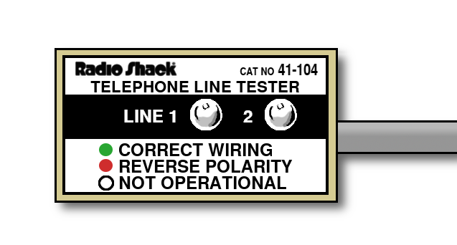Fig. 44 ‒ RadioShack telephone line tester.

Lamps light but no dial tone
Things to check:

- Verify telephone line connection.
Check Tip/Ring on the KSU for telco line voltage of 48 VDC using volt meter as shown in Fig. 29
- Make sure 50 pin amphenol connectors are fully seated, and not partially connected.

Lamps don't light on line pickup
Things to check:

- Verify telephone line connection.
Check Tip/Ring on the KSU for telco line voltage of 48VDC using volt meter as shown in Fig. 29

- Make sure 50 pin amphenol connectors are fully seated, and not partially connected.

- Verify CPU STATUS light is blinking. If not, try "rebooting" the card by turning it on and off again:

  - Pull the power connector from the board, wait a few seconds, and plug it back in again.
  - The CPU STATUS light should be blinking. If it's not, the board may need servicing.

  - If none of the above, see section 6.1 – No Power, Status LED Off/Dim

No ringing
One or all extensions aren't ringing with their bells during incoming calls, or when using the EXT RING TRIGGER connector (Fig. 36).
Things to check:

- Disconnect all extension phones, and test one extension at a time. Sometimes one phone can prevent the rest from working.

- For any extension that won’t ring bells, confirm bell wiring matches the wiring in section 2.9 General Phone Bell Wiring.

- Make sure amphenol connectors are fully seated. A partially seated connector can cause lack of ringing.

- Make sure the "BELL CALL" switches (SW2) are set to "on" for the lines/extensions you want to ring during incoming calls.

- An external ring generator must be attached to the card for the extensions to ring by their bells. See 2.18 Connecting a Ring Generator to verify proper connections, and verify AC ring voltage is present during the ring cycle.

- For bell ringing to work properly with the diode ring circuit on this KSU, verify all phones have K → A modification shown in Fig. 13.

- 1A2 phone ringers are sensitive to polarity when mixed with a diode ring circuit. If the ringer is not ringing or barely ringing / humming, try swapping the two wires from the bell at the screws where they attach on the terminal board inside the phone.

- Note that the 12V output on the "RING GEN POWER" connector only outputs 12V during actual ringing. This keeps the power off for the ring generator when the phones aren't ringing.
To test ringing without a PSTN network, see section 3.2 – Call Test using the EXT RING TRIGGER connector.

Buzz-ringing not working.
This card features "buzz ringing", where the buzzers operate during incoming calls, useful in the absence of a ring generator.
If there’s no buzzing during ringing, check:

- Buzzers inside phone are wired to the Y-O pair as shown in Fig. 16.

- The 1A2 connectors are all fully seated. A half-seated connector can prevent the buzzers from working, while other features work fine.

- The "BUZZ CALL" DIP switches (SW1) are set to "on" for the lines/extensions you want to buzz during incoming calls.

Cpu LED Not Flashing
Things to check:

- Verify power, see section 6.1 – No Power, Status LED Off/Dim.

- Check the fuse to see if it’s blown.

- Check the 7805 (at Q3) with a volt meter and verify +5V output: red probe to pin 3, black probe to pin 2 GND (See Fig. 45).
- Ensure the power is true DC, and not "lumpy DC"; put a scope on the terminal screws to verify 12VDC, and not AC voltage.

- Check temperature of Q3 by briefly touching it. If its hot, SOMETHING MIGHT BE SHORTED OUT – REMOVE POWER QUICKLY. Let it cool, then unplug everything except power. If that corrects the problem, plug things back in one at a time until the culprit is identified.
- Check for stray metal parts touching back of board, or lying across components. Stray screws/nuts, staples, metal drill shavings, wire clippings, etc.
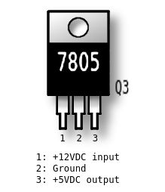Fig. 45 ‒ Check for +5V across pins 2 and 3 of 7805 (Q3).

HOLD makes lamp turn off
Check the CO line is live. Without talk battery from the CO, the line can't go into Hold.
In the v1.5b firmware, the line lamp comes on during pickup whether the line is alive or not. This is so that the line lamp doesn’t flash during rotary dialing, or when pressing RECALL (for phones that have this feature). But the line can’t go into Hold without talk battery on the CO line.

Line goes into Hold on pickup
This happens when something is wrong with the A lead circuit; it's staying open on pickup, instead of closing to ground.
Possible causes: Amphenol connector not fully seated, dirt in amphenol contacts, contacts corroded or broken, miswiring somewhere in the connector or phone for any signals involving the A lead (Pin 27 + 2 for Line #1, Pin 30 and 2 for Line #2, etc), switch contacts for the phone's Hold button, Hook Switch, or Line Buttons not making proper contact, or miswiring of any 66 block between phone and KSU.
If it’s one extension, check that the phone’s amphenol connector is fully seated.
Normally the A lead (e.g. Pin 27 for Line #1) is connected to ground (Pin 2) when a line is picked up. Switch closures inside the phone connect the A lead to ground in the off-hook state. When you press Hold, that opens the A lead causing a Hold condition.
If the A lead circuit isn't working at all, picking up a line simulates going directly into Hold as if someone immediately pressed the Hold button.
Example: If pin 2 (common ground for all A leads) is not connected, ALL lines may go into Hold on pickup. Look for a problem somewhere in the amphenol pin #2 circuit (O-W wire). It should be connected to GROUND on the KSU (right screw on CN2 power connector, see Fig. 50).
Test the A lead circuit in the phone:
- Using a test meter in continuity mode, disconnect amphenol from KSU
- Test across amphenol pin 2 (common) and pin 27 (A lead for Line #1)
It should tone on pickup of Line #1, and stop as soon as you press Hold, or hangup.
If A lead doesn't close during pickup, that's the problem to solve. Refer to the Bell System Practices document for your phone model, and verify wiring of Pin 27 (W-O wire) through hook switch contacts, hold button, and line button on back to Pin 2 (O-W wire) for a complete circuit.
If the A lead seems to work when testing the phone's connector, check any wiring between phone and KSU, such as 66 blocks, 66E3, etc.

◊ ◊ ◊

1A2 EQUIPMENT

Phones
1A2 phones are typically available on eBay, Amazon, or other surplus sources.
Phone models shown in Fig. 46 are all compatible with the Seriss KSU.
Other models may work as well.
 | Rotary | Touch-Tone
 | 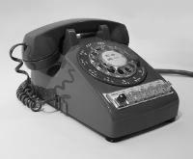  564, 565 | 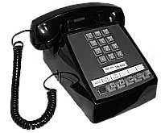  2564, 2565
Autodial | 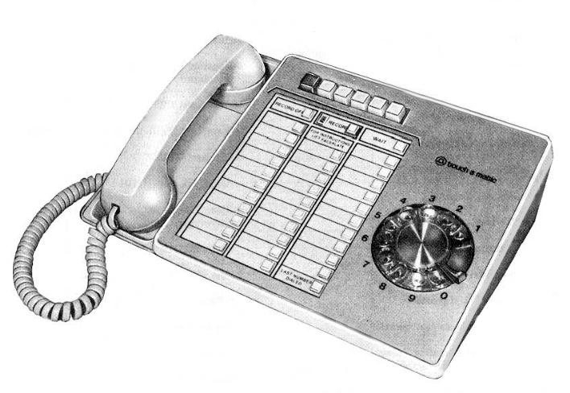  872 | 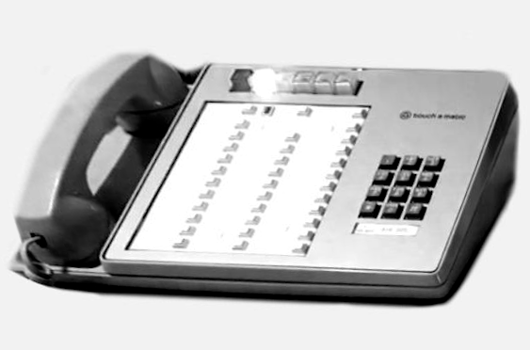  2872
 | 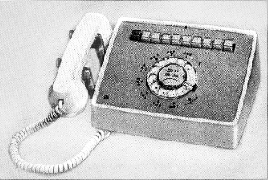  830 | 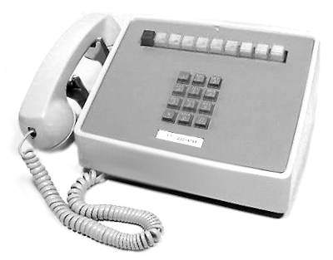  2830
 | 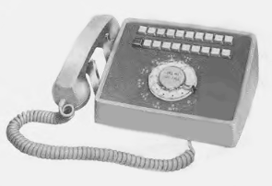  831 | 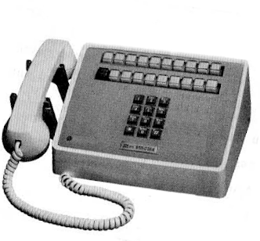  2831
 | 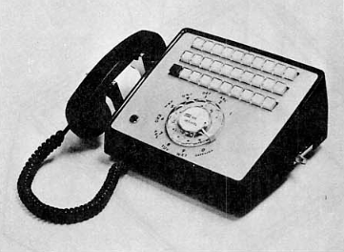  861 | 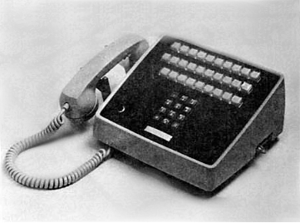  2861
Wall-Mount | 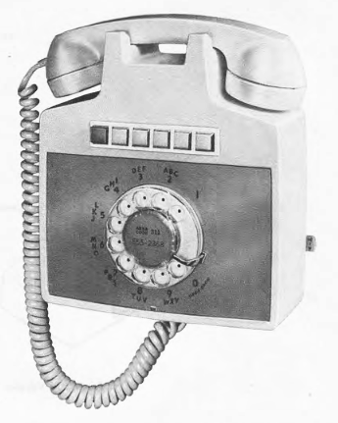  851 | 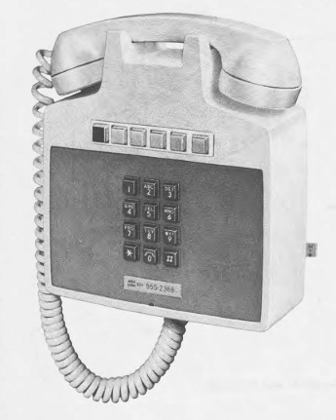  2851
Wall-Mount | 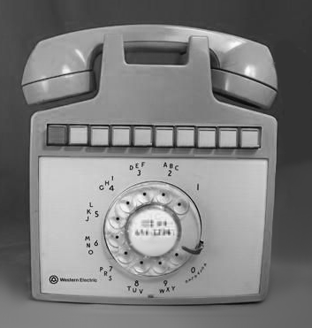  852 | 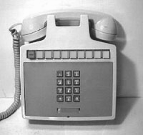  2852
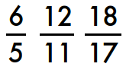  Call Director | 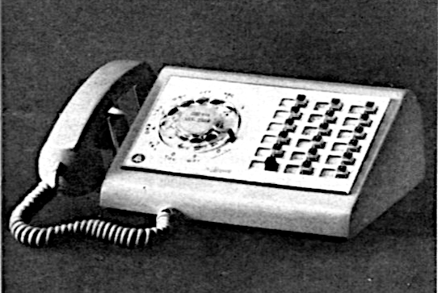  636 | 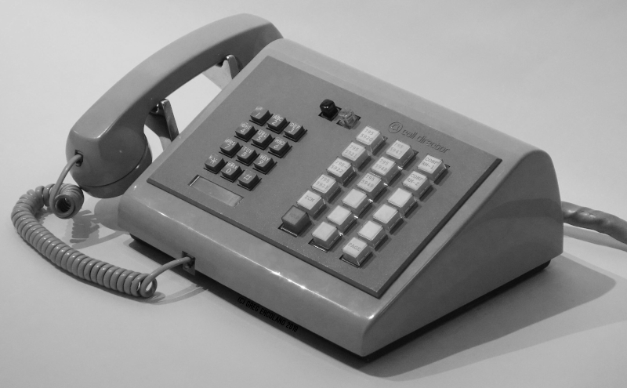  2636
Fig. 46‒ Common AT&T / ITT 1A2 phone sets.

Buzzers
For more info about Bell System 1A2 buzzers, refer to Bell System Practices section 501-120-100.
Many 1A2 phones, e.g. 2565’s, are factory equipped with a KS-20419L1 6-10 VAC buzzer (Fig. 47).
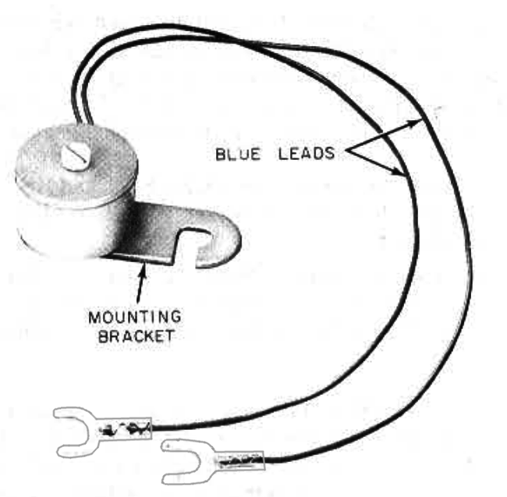
Fig. 47 ‒ KS-20419L1 buzzer, 6-10 VAC.

However, some 1A2 phones buzzers were a factory option which had to be ordered and added separately by the installer (Example: 2.14 ITT 2861 Phone Configuration).
If you have a 1A2 phone without a buzzer, you can purchase buzzers from various sources such as eBay to add them yourself.
Buzzers are typically mounted inside the phone by hooking the buzzer’s mounting bracket around the dial pad’s left mounting screw, and wiring to spare screws on the phone’s terminal board.
The most common 1A2 buzzer is the KS-20419L1 which operates at 6–10 VAC, and is compatible with the Seriss KSU.

25 Pair Cables
Cables for 1A2 phones are Cat3 UTP 25-pair, and are available in a large variety of lengths, from short extensions with amphenol ends, to raw 100 foot or 1000 foot reels of raw cable.
You can choose either raw cable, or ended cable.
Raw cable can be punched down onto 66 or 66E3 blocks, or crimped to amphenols with a butterfly crimping tool (AMP, TYCO, CHAMP).
Ended cable can be purchased in premade lengths, and gender of amphenol connectors at either end can be specified, e.g. M/F for a Male/Female cable.
With several 25' M/F cables, they can be easily chained together as needed to attain longer lengths.
Connect the male end at the KSU, female downstream towards the phone extensions.
These cables tend to be expensive, around $1/ft. So a 25' cable can be $30 – $40. (2018 prices).
Cables can be sourced new or used from e.g. eBay, Amazon, etc. Search terminology varies:
- RJ21 telco cable
- Amphenol telco cable
- Cat3 25 pair telco cable
- Cat3 50 conductor telco cable
- 24 - 26 AWG UTP Telco 25PR
- B25A Connection Cable (M/F)

Note: “B25A” is Bell System terminology for 25 pair cable with M/F ends.

Connection Blocks
There are a variety of connection blocks that can be used for installing/extending/distributing 1A2 equipment:
- 66 Blocks (Fig. 50 and Fig. 52)
- 66E3-25 Connection Blocks
- C-P-C Bridging Blocks
For more information on these, see the next section on “Cable Terminology”.

◊ ◊ ◊

Cable Terminology
The following is terminology typically used for referring to 25 pair cable and connections:

- "Cat3" or “Category 3” is the twisted pair rating for voice communications
- "UTP", or "Unshielded Twisted Pair", is typical of 25, 50, 100, 150, 200 pair cables used in telecom.
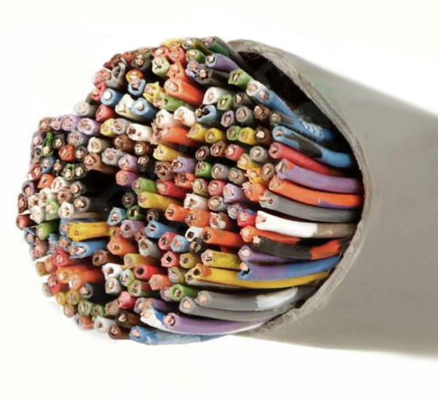Fig. 48 ‒ UTP 100 pair cable.
- "25PR" means "25 pair", or 50 conductors twisted in pairs.
- "Amphenol" is a company, but in the context of 1A2 generally refers to the RJ21 standard jack 50 pin connectors (Fig. 49):
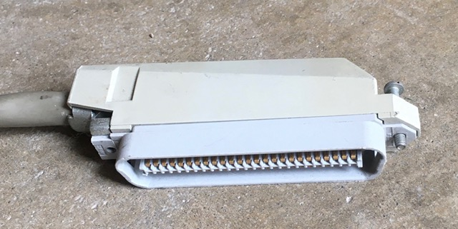Fig. 49 ‒ Amphenol connector.
- "RJ21" are 50 pin amphenol connectors.
- M/F, F/M, F/F, M/M all refer to the gender of connectors at either end of the cable. Example: F/M means Female at one end, Male at the other.
- “Solid Core” means each wire is a solid strand of copper. Solid core is stiff, used with punch blocks and permanent cabling such as in walls. Repeated bending of solid core wire will eventually cause metal fatigue.
- “Stranded” cable uses many thin strands of copper, giving cable flexibility. Used mainly for desk phone cords. Should not be used with punch blocks.
- 66 blocks are a type of punch block used to handle telco distribution wiring.
These blocks have 50 terminals. Solid core copper wire gauges 22 through 26 can be punched down on these blocks. Refer to BSP 461-604-100, -101, and -102 for more info.
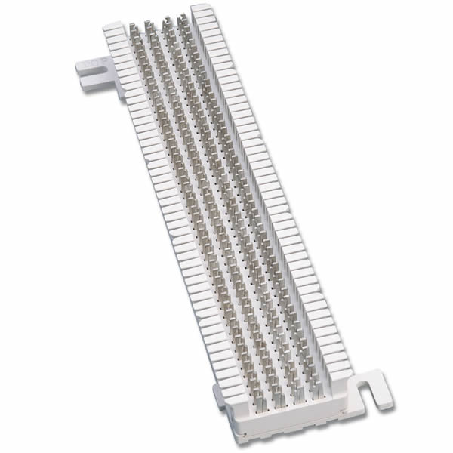
Fig. 50 ‒ A 66 Block
- “Bridge clips” are small spring metal clips that can be used to cross-connect the two sides of a 66 block (Fig. 51 and Fig. 52):
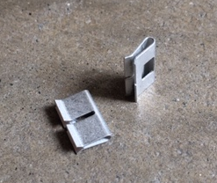Fig. 51 ‒ Bridge clips.
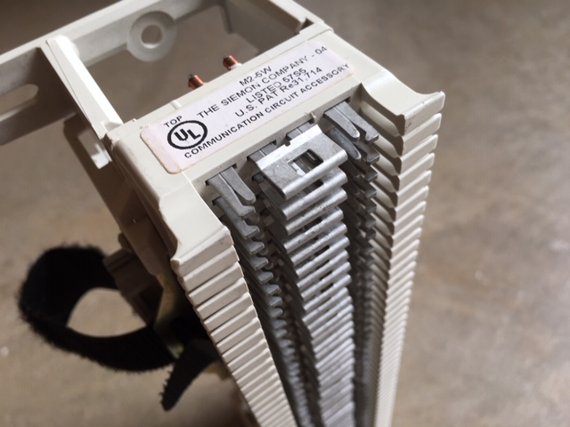Fig. 52 ‒ Bridge clips on a 66 block.

- 66E3-25 blocks are wall mount blocks with a decorative cover and built in Amphenol, basically a “wall jack” for 1A2 phones:

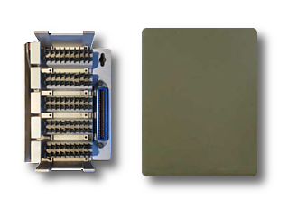Fig. 53 ‒ 66E3-25 Wall-Mount Connection Block and Cover.
These can be used to connect a single extension to a wall, and can also be used to create chains of phones on a single 25 pair cable run.
For more on how these flexible blocks can be used in an office or home environment, see section 7.7 66E3-25 Connection Blocks.
- “C-P-C” connection blocks are a 3-way splitter for amphenol connectors that has Female/Male/Female (F/M/F) connectors inside.
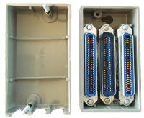
Fig. 54 ‒ KS-19252-L1 C-P-C Bridge/Splitter.

C-P-C, or Connector-Plug-Connector can be used to bridge two phones together to share a single 25 pair cable (Fig. 56).
For info, see 7.6 C-P-C Bridging Blocks.
◊ ◊ ◊

C-P-C Bridging Blocks

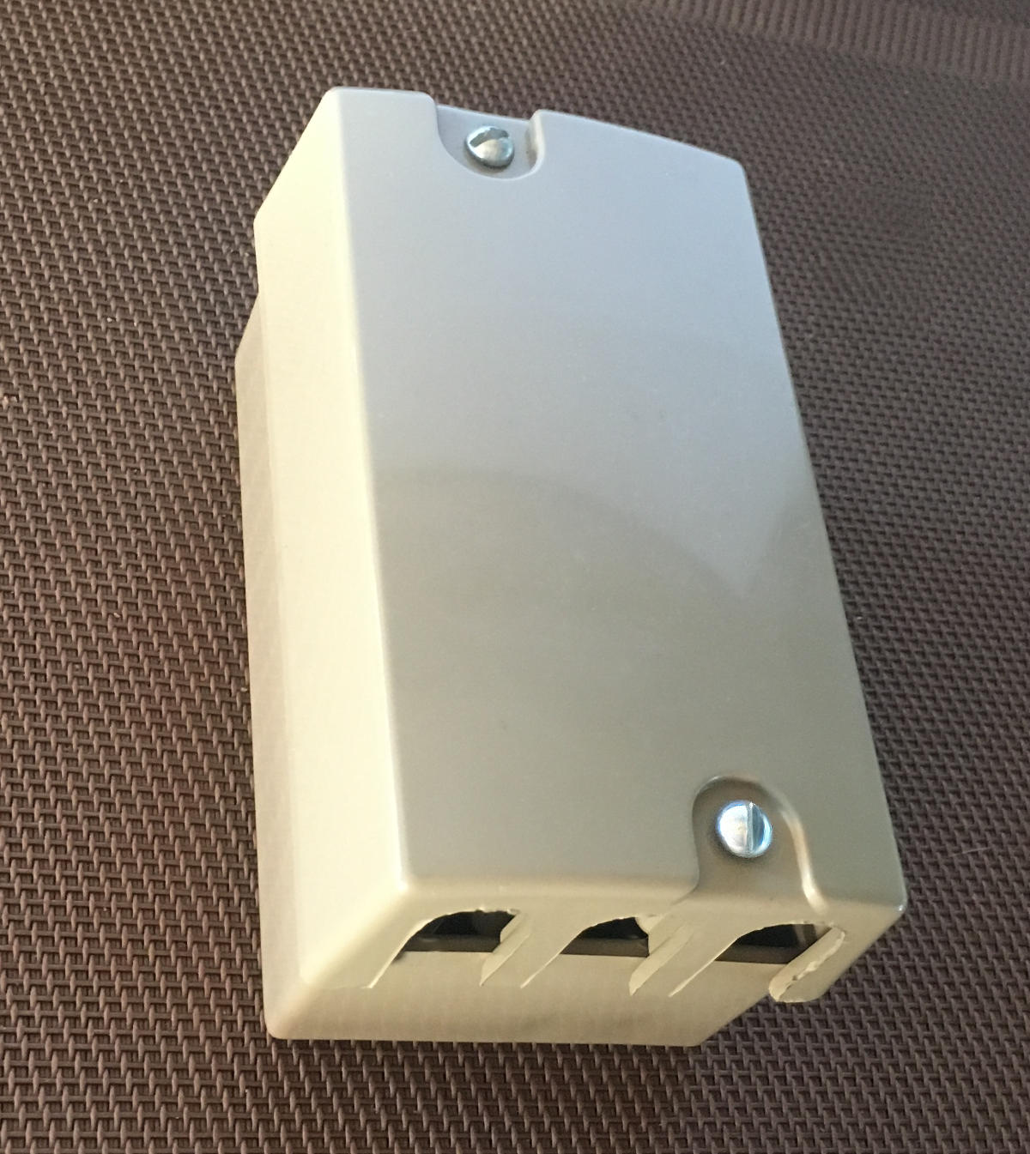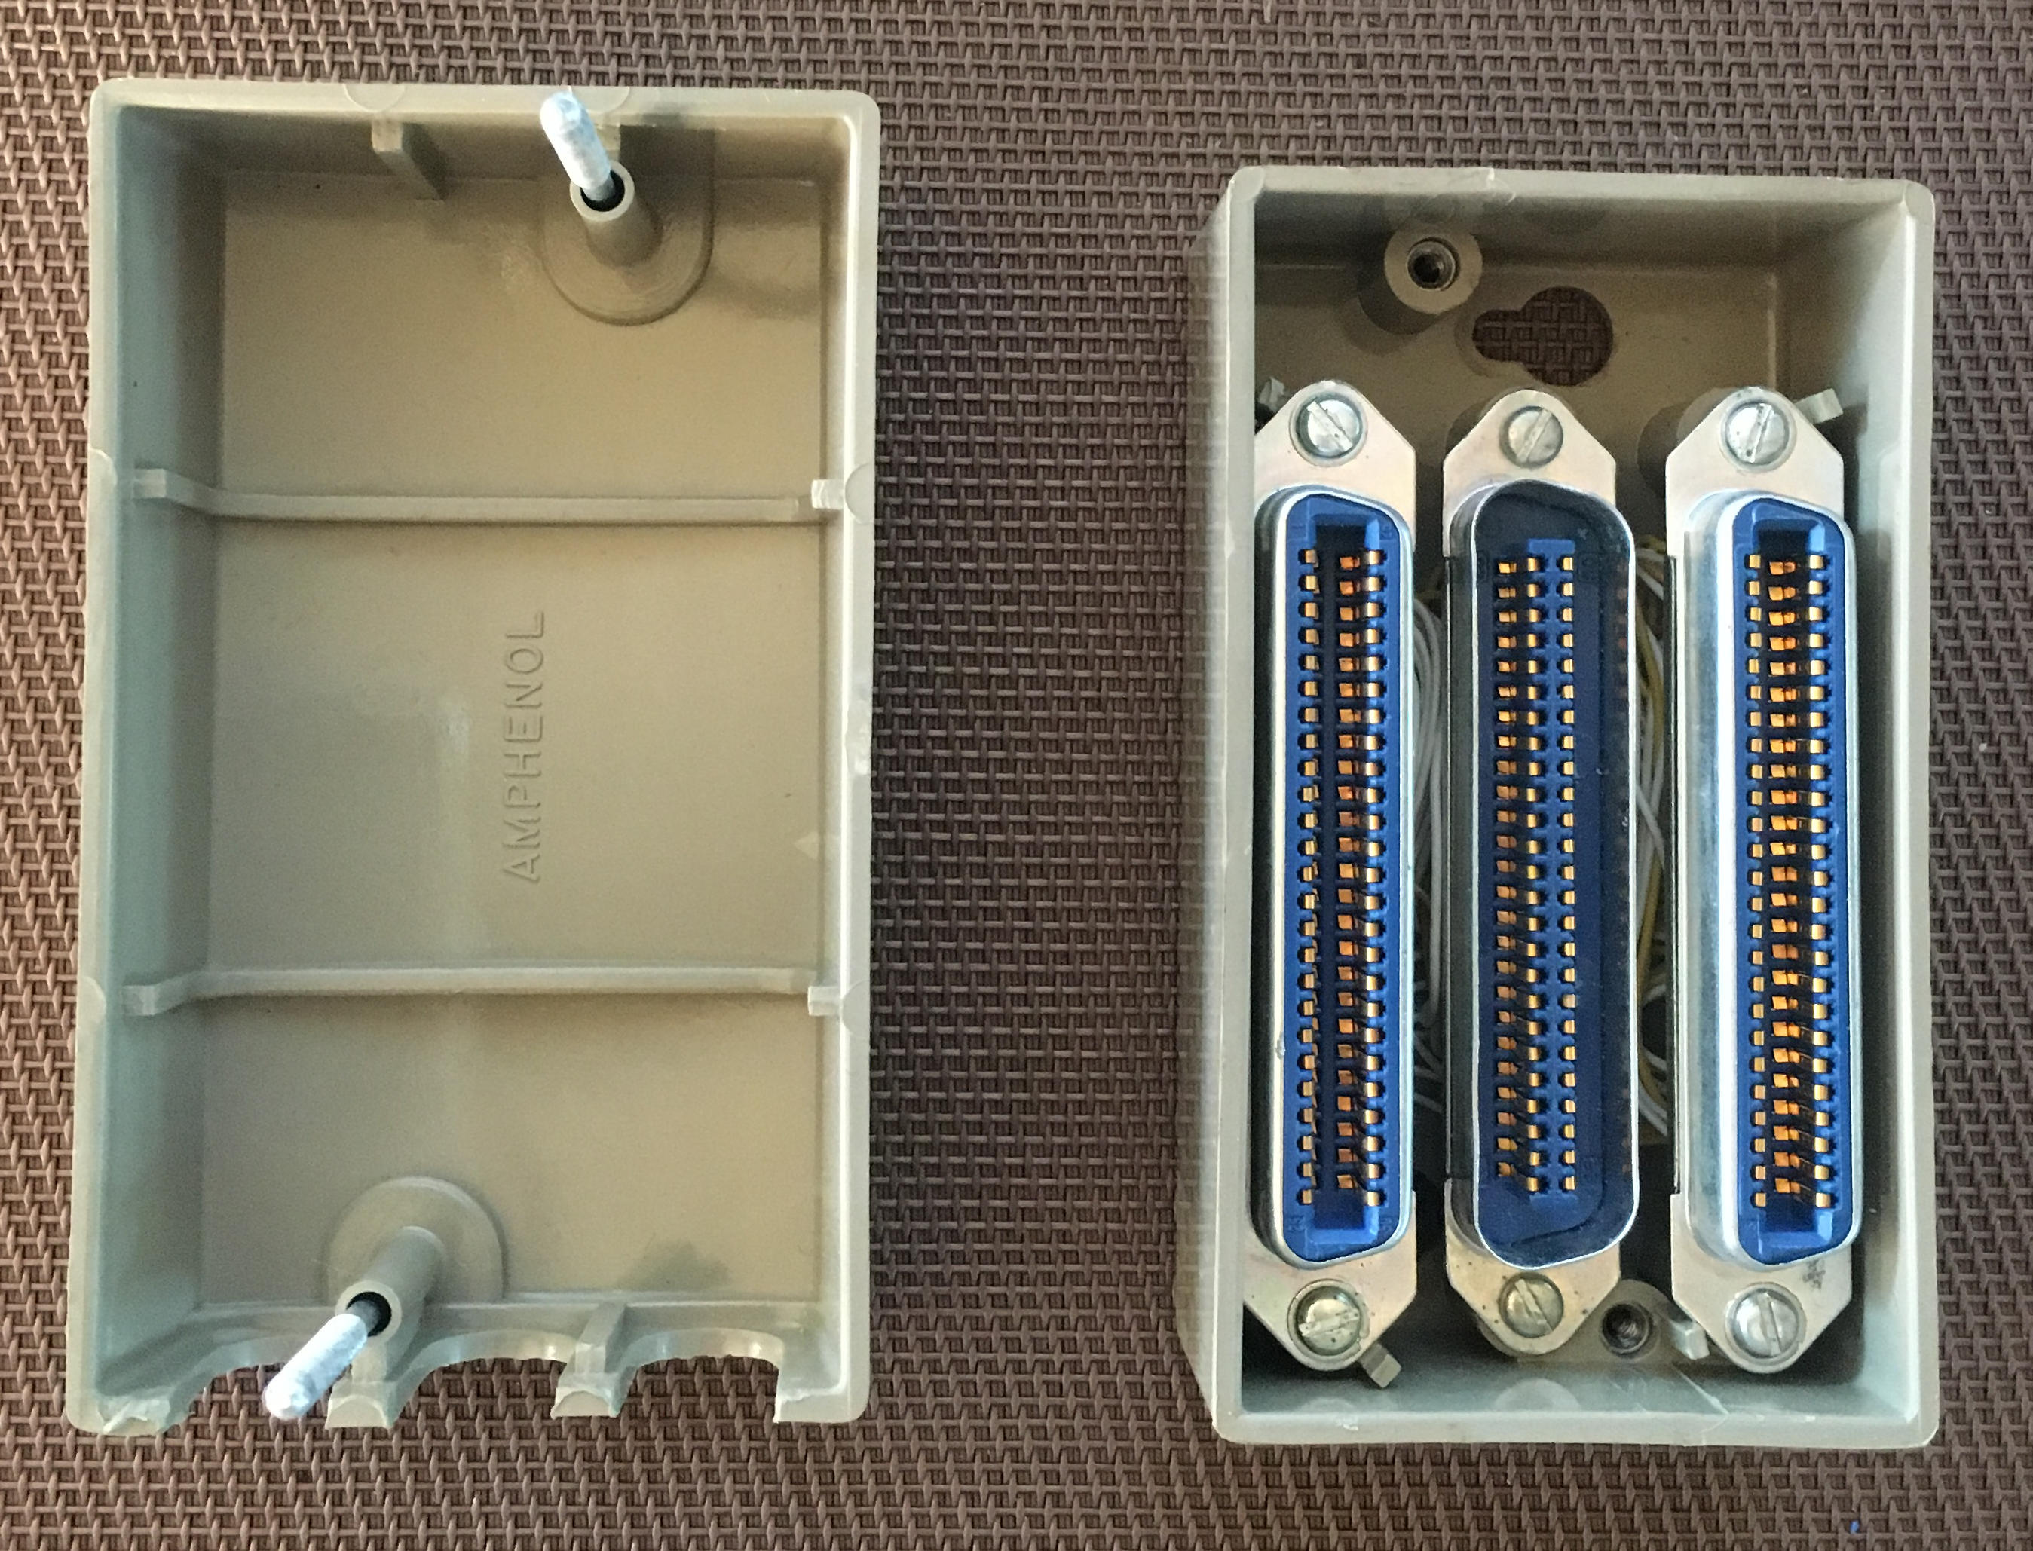
Fig. 55 ‒ C-P-C connection block KS-19252-L1.
C-P-C blocks contain Connector-Plug-Connector amphenol connectors (or Female-Male-Female) that are wired together (bridged) to create chains of extensions.
See Bell System Practices section 461-200-102 for more info about these, and other bridging blocks.
One can make large arrays of phone extensions without needing gender changers or same sex cables using only M/F ended cables 25-pair cables and a handful of C-P-C blocks, as shown in Fig. 56.

Care must be taken when bridging all 50 signal wires using C-P-C blocks. In particular, 2565 phones have some important signals on the violet wire pairs that cannot be bridged to another 2565 without first making some modifications inside the phones. Quoting the BSP 502-543-403:
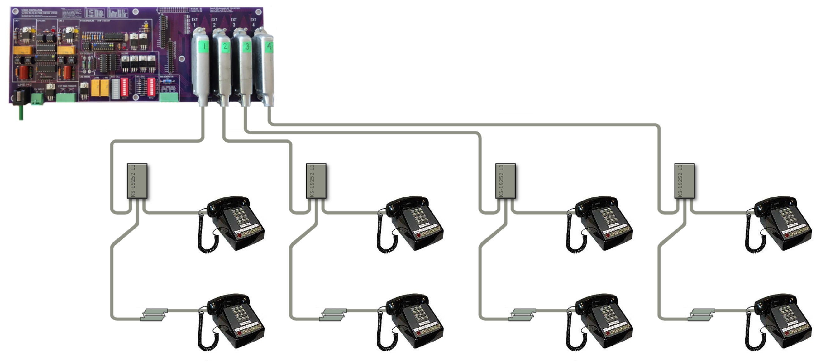Fig. 56 ‒ C-P-C connection blocks used to make extended chains of extensions.

2.05 When a 2565GK (MD) or 2565GKM telephone set is not used as a speakerphone set and is multipled with any other set furnishing speakerphone feature, speakerphone leads must be disconnected, insulated, and stored either at the telephone set or at the multipling point. If not disconnected, the speakerphone leads will provide a common path between the circuits of the multipled telephone sets. The leads to be removed are as follows: T1 (V-G), R1 (G-V), IT (V-BR), IR (BR-V), AG (V-S), and LK (S- V). Speakerphone connections are shown in Section 512-720-405.

So in short: spare off the violet pairs inside the phone before bridging two or more 2565 sets, or there’ll be trouble!

See also section “7.7 66E3-25 Connection Blocks”, which allows rewiring (instead of simple bridging), and are useful for terminating raw 25-pair cables without amphenol-ended cables.

66E3-25 Connection Blocks

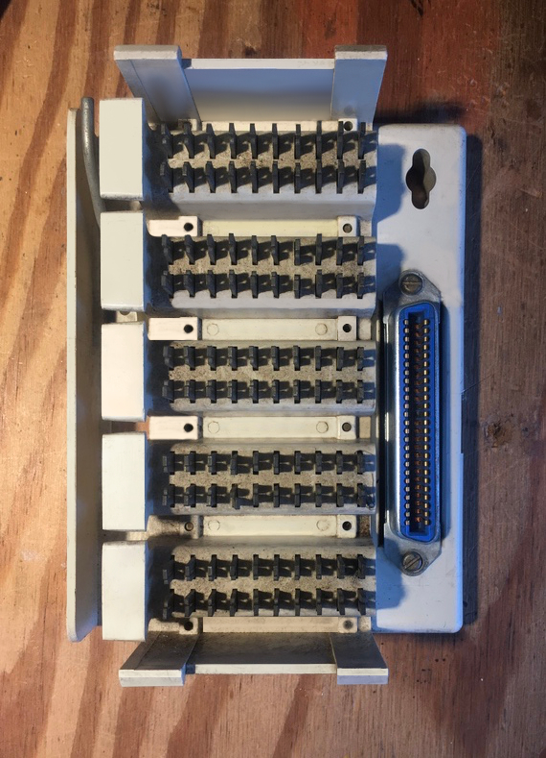Fig. 57 ‒ 66E3-25 block with cover removed.

66E3-25 blocks are 50 position (25 pair) punch blocks meant to be mounted on the wall where phone sets are installed. The block has a decorative cover making for a clean wall installation so that neither the block nor the phone’s amphenol connector is visible. (Fig. 58) The 25 pair feed cable comes into the block from behind through a hole in the drywall.

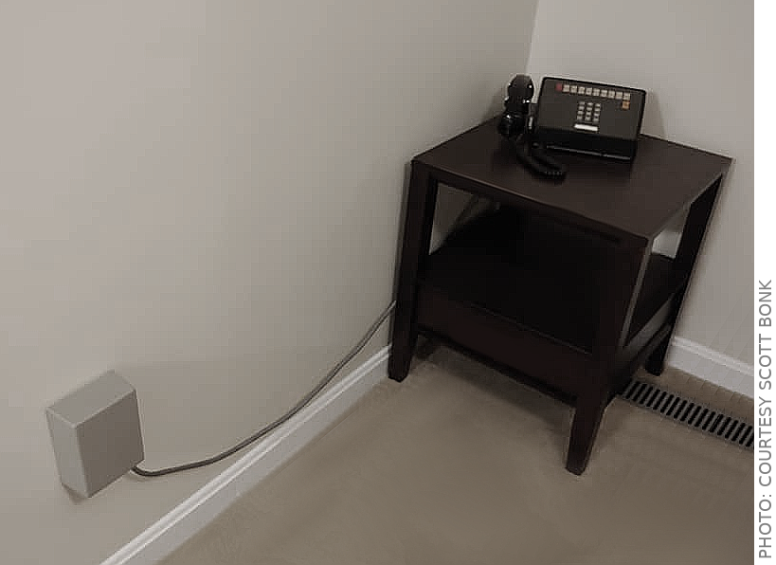Fig. 58 ‒ 66E3-25 wall installation with decorative cover for a 2830 desk set.
See Bell System Practices section 461-604-103 for more info about this type of connecting block.
The block is used as an end point for a raw 25 pair cable runs threaded through the walls, where the raw cable can be easily be cut and punched down on the block, as shown in (Fig. 59).
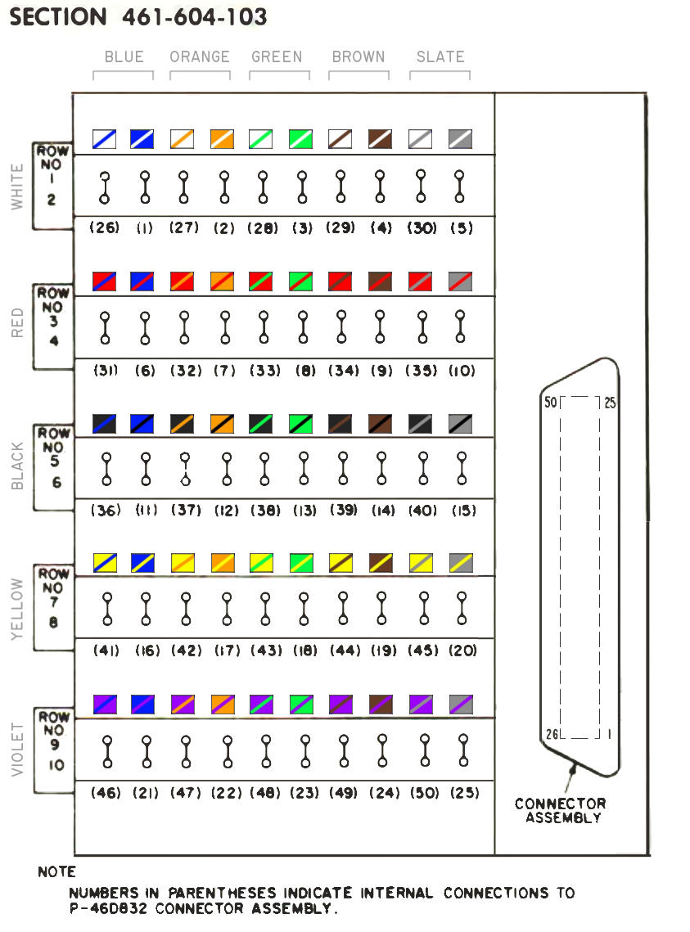
Fig. 59 ‒ Wiring for 66E3-25 Connecting Block, showing wire colors and color groups.
The single female amphenol on the block provides for a male ended phone cable’s connection, and dual rows of punch positions are provided to allow the block to be a point in a chain for a second cable to be punched down to extend to other phones, or a termination point for a single phone (Fig. 61).
Fig. 59 shows the wiring for a 25 pair cable. Note each row is a separate color group; row #1/2 is the white group, row #3/4 is the red group, etc.
It’s also possible to make special wiring changes on the punch block, such as swapping lines, or providing special wiring for phones such as the Northern Telecom LOGIC 10.

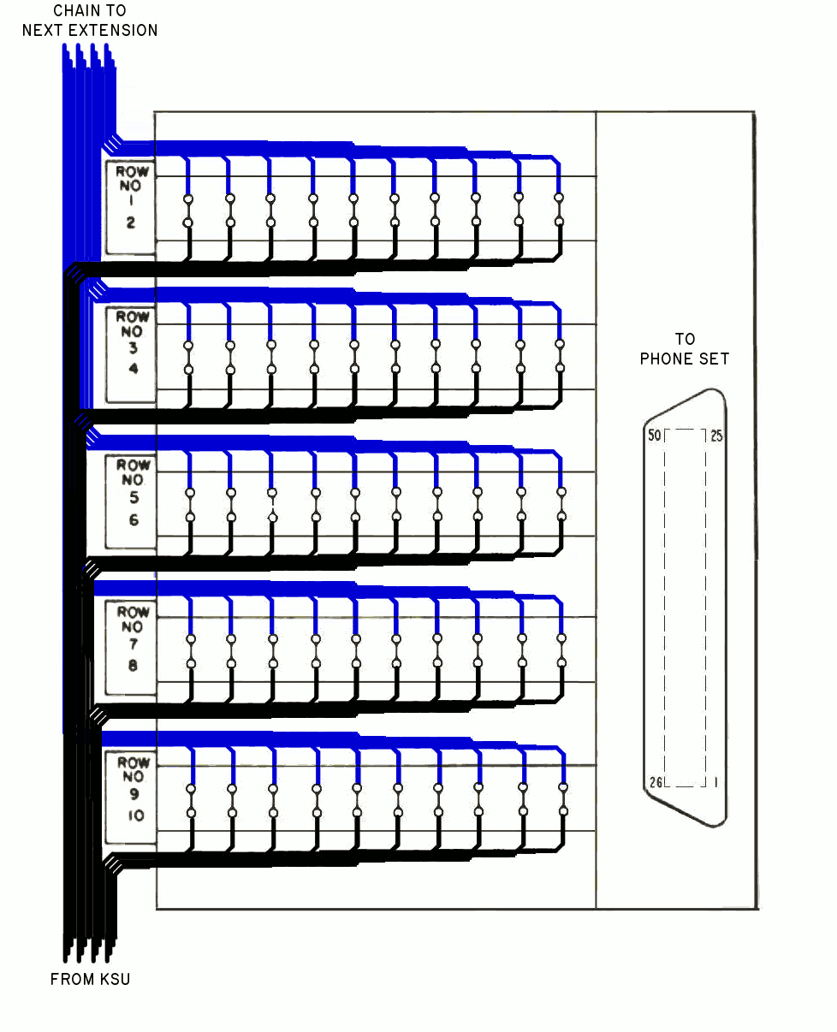Fig. 60 ‒ 66E3 block as a link in chain; cable from KSU (black) punched down to the lower rows, and an optional second cable (blue) goes out to the next block in the chain, punched down on the upper rows.
It’s recommended wiring practice for input wires from the KSU/CO (shown in black in Fig. 12) to arrive on the lower “even” rows #2,4,6,8,10. If the block is part of a chain, any output wires to further extensions leave on the upper “odd” rows #1,3,5,7,9 (shown in blue).
When wired as a termination point for a single desk set, only the bottom “even” numbered rows are used; the upper rows are left vacant.
For more info, see the following page: Fig. 61 ‒ A typical office using 66E3-25’s.
Fig. 61 shows a typical office wiring layout where 66E3-25 blocks are used at each desk phone point. 25 pair cables are threaded through the walls, and are punched down on each block near the phone’s
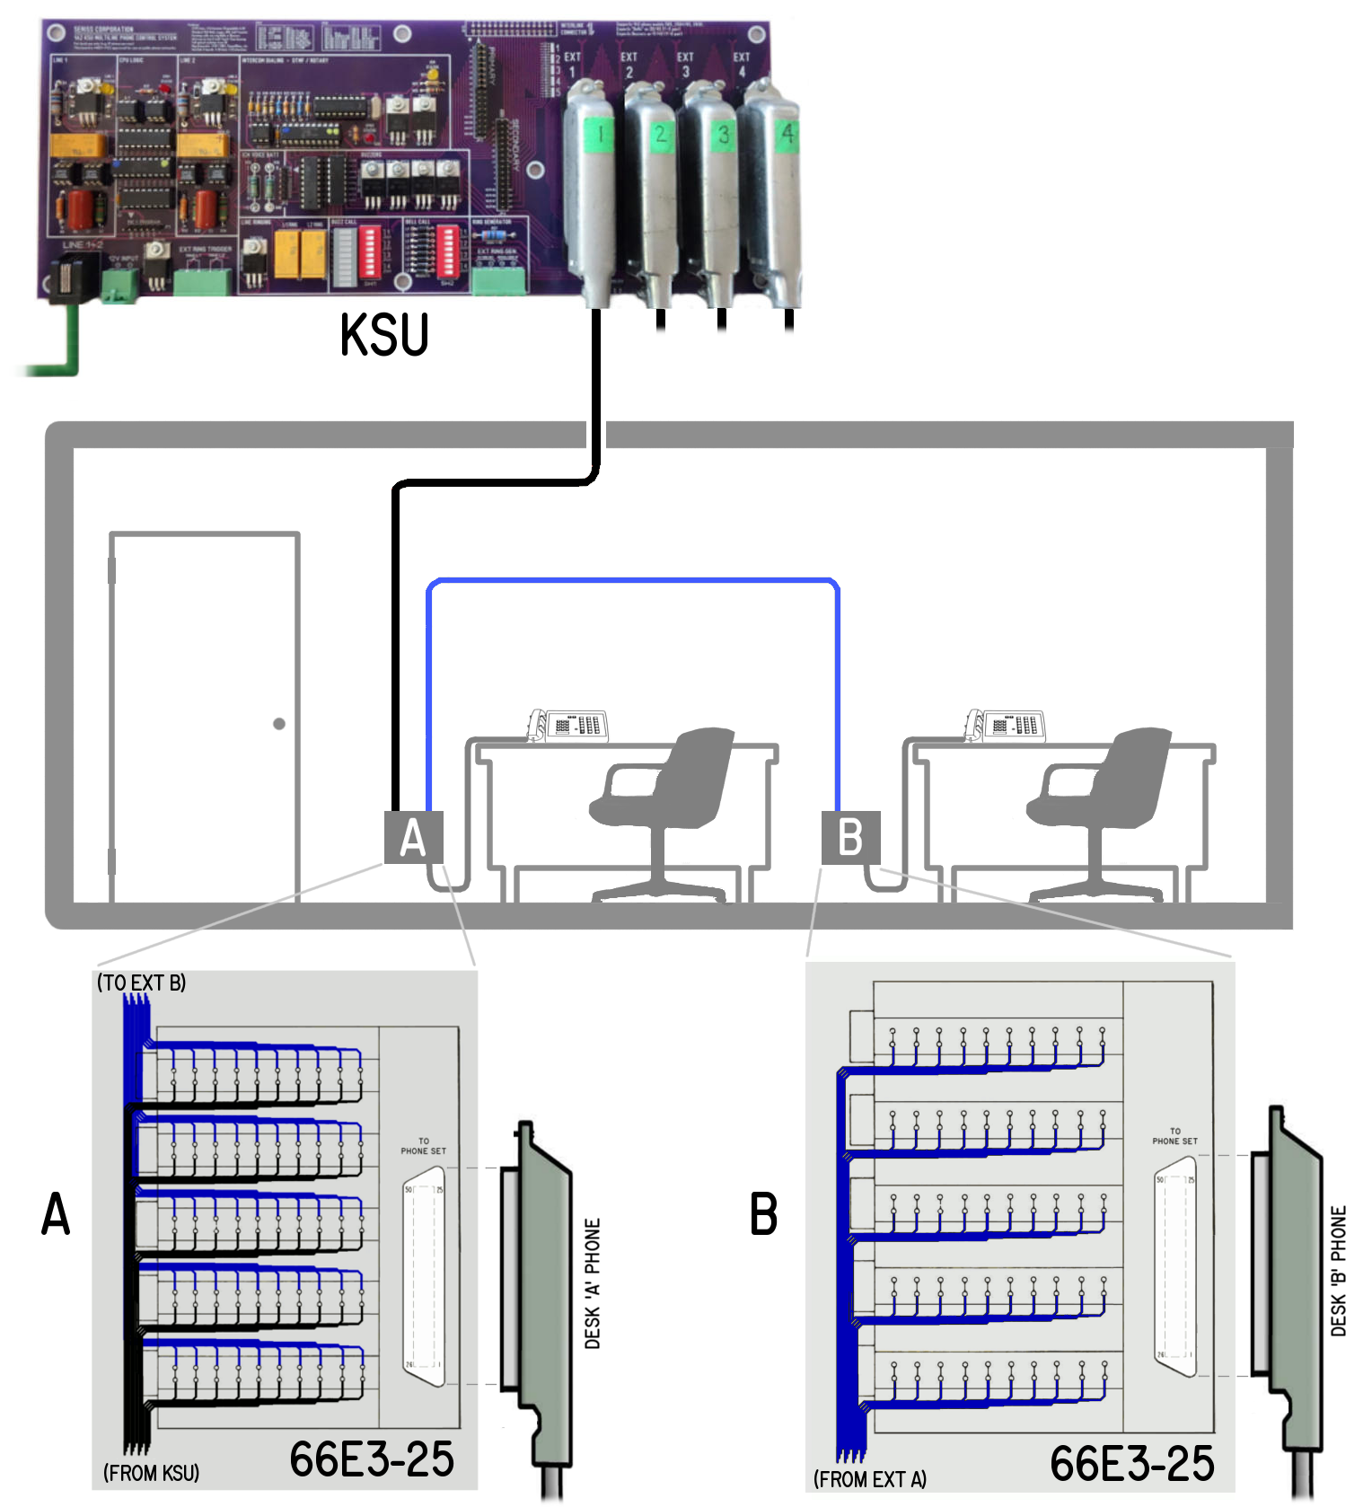Fig. 61 ‒ A typical office using 66E3-25’s.
(A) shows bridging two 25-pair cables, (B) shows a simple 25-pair termination.
location, so the phone set can simply be plugged into the 66E3’s connector, and the cover installed to complete the installation.

Ring Generators
An external ring generator is required to offer the option of ringing the bells in the 1A2 phones.
Note: Bell ringing is not required: phones can still be "rung" using buzzers with the "BUZZ CALL" option of the Seriss KSU, which can buzz whenever there’s an incoming call.
The "PowerDSINE" PCR-SIN03V12F20-C 12 volt ring generator module works off the KSU’s 12 VDC supply (see Fig. 30), so no external supply is needed.
While no longer manufactured, someone on eBay/Amazon seems to have a large stock and sells them in pairs for ~$15 each from Israel, the location of the original manufacturer, which was later purchased by Microsemi.
During ringing of 4 lines, these use about 500mA (0.5A), so make sure your 12vdc power supply can supply at least 1.5A, as the rest of the card uses less than 1 amp under full load of 4 extensions + 2 lines.
Another manufacturer of small “module” Ring Generators is Cambridge Electronics, which sells a similar 12volt ring generator called the "Black Magic" (Fig. 32).
Or, you can use any of the old telco ring generators that provide ~70-105 VAC, 20-30Hz ring voltage like the Western Electric 118A (section 2.21 WE 118A 30Hz Ring Generator) or TelLabs 8101 (section 2.22 TelLabs 8101 Ring Generator) which are both 30Hz ring generators.

◊ ◊ ◊

Addendum
This section covers special cases and generalized topics related to wiring of 1A2 phones in the context of the Seriss Multiline KSU.

Wire Color Terminology
This section describes the 50 pin connector wire colors and color groupings.
Bell System Practices wire color codes are used throughout this document, e.g. “Y-S” and “Y-O”. The color codes are (Fig. 62):
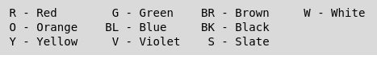Fig. 62 ‒ Bell System color codes for 25-pair cable.
Mostly single letters are used, but where confusion might arise, two letters are used (like BR for brown, BK for black, BL for blue). To avoid confusion with green (G), gray wires are always referred to as "slate" (S).
In telephone wiring, CAT-3 UTP cable (Category 3, "Unshielded Twisted Pair") is used to ensure long runs of signals have the best noise cancellation, such that each voice circuit is on its own pair of wires that are physically twisted together. Most 1A2 phones have 25 pair (50 conductor) CAT-3 UTP cables. (See “Cable Terminology”)
Each pair of wires twisted together share the same two colors, just swapping which is the "main" or "primary" color; The "Y-S pair" (yellow-slate) consists of two wires (Fig. 63):
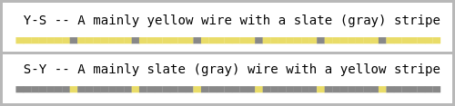Fig. 63 ‒ Y-S pair: separate Y-S and S-Y wires showing primary vs. stripe color patterns.
So it matters which color appears first; to refer to a single wire, the first of the two colors is the "primary" color, and the second is the “stripe” color.
So “Y-S” is a “yellow wire with a slate stripe”.
When referring to *wire pairs*, use the color group’s color as the first letter. So “the Y-S pair”, (and not the S-Y pair), because “yellow” is the color group, not “slate”.
In a 25 pair CAT3 UTP cable, wire pairs are broken into 5 color groups of 5 pairs each (Fig. 65).
These color groups are kept together on e.g. wiring blocks such as the 66 and 66E3-25 blocks, and on the amphenol connectors (Section 8.2).

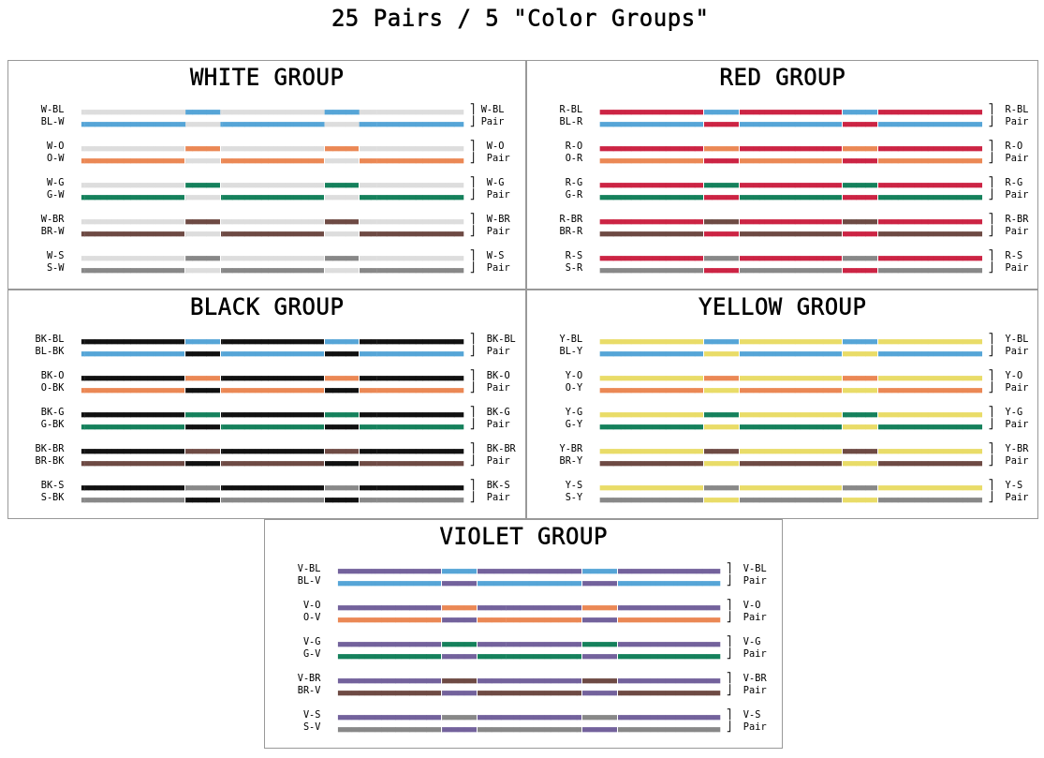Fig. 64 ‒ 25-pair five color groupings of wire pairs in amphenol pin# order.

50 Pin Connector Pin-Outs
This section covers the various connector pin-outs for common 1A2 model phone sets.

2564 Caveats and Pin-Outs
The 2564 Touch-Tone, and its older rotary counterpart, the 564, are common 1A2 phones.
Known as “6 button sets”, these phones have 5 lines and come factory configured with both a bell and KS-20419L1 type buzzer (see Fig. 47).
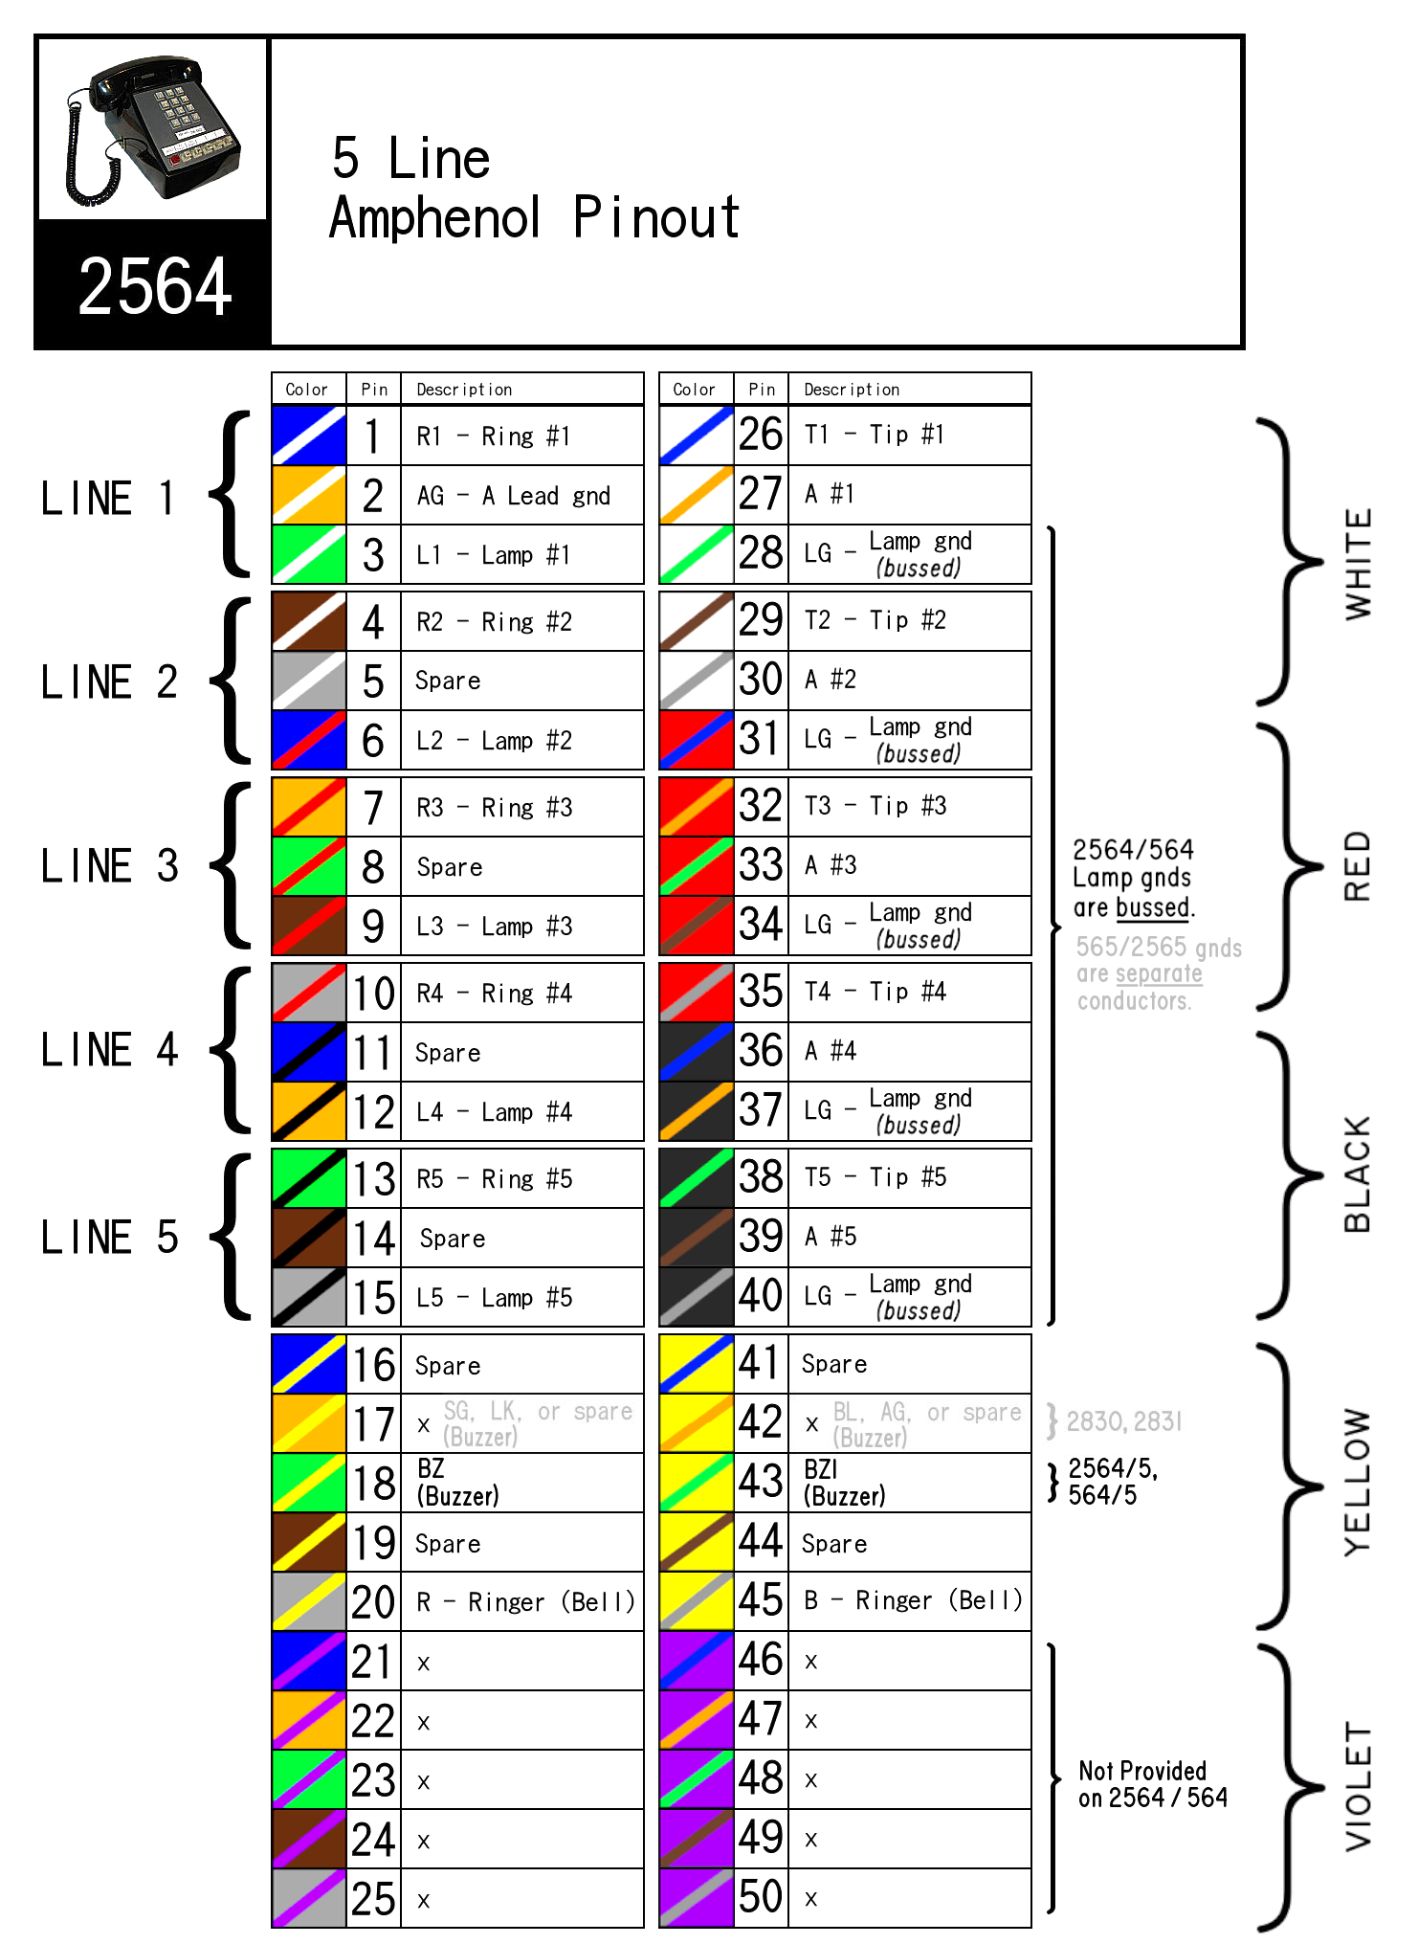Fig. 65 ‒ 2564 Amphenol Connector: proper wiring for the Seriss KSU. Shows wire colors, line groups, and color groups.
On this phone, the “lamp grounds” (pins 28, 31, 34, 37 and 40) are bussed together within the phone on a common bus bar.
The 2564’s amphenol connector wiring, showing signals relevant to the Seriss KSU. Note the Y-O pair is used for the buzzer.
Factory wiring for the 2564/564 has the buzzer wired to the Y-G pair.
To use this phone with the Seriss KSU, swap the Y-G pair out, and replace it with the Y-O pair.
Simply locate the two screws the Y-G wires are connected to and disconnect by unscrewing them. Then locate the Y-O pair, and wire them to those screws instead.
Spare off the now unused Y-G pair (put tape on the spades, and stow).

2565 Caveats
The 2565 Touch-Tone, and its older rotary counterpart, the 565, are common 1A2 phones.
These sets are similar to the 2564 in all aspects visually, except they are internally wired to allow attachment of a speakerphone, and therefore have extra signal paths (violet pairs) for that purpose. Info on this is best referenced by looking at the BSP documentation/wiring diagrams for the 2565.
While the Seriss KSU makes no use of the violet pairs, one has to be careful whenever bridging two or more 2565 phone sets together on the same 25 pair cable (such as with C-P-C Bridging Blocks) as the two phones will conflict each other over the violet pairs. Quoting BSP 502-543-405 for the 2565 HK, HKM, HKMS:

2.06 – When a 2565HK or 2565HKM (manufactured prior to July 20, 1979) telephone set is not used as a speakerphone set and is multipled with any other set capable of furnishing speakerphone feature, the T1 (V-G) and R1 (G-V) speakerphone leads must be disconnected, insulated and stored at the telephone set. If not disconnected, these speakerphone leads will provide a common path between the circuits of the multipled telephone sets.

Note in the above, “multipled” means “bridged” or “chained”, or “all signals wired together”, as shown in Fig. 61.
Similar to the 2564, the 2565’s buzzer is factory wired to the Y-G pair, so see the recommendations in the section on 2564 sets where it describes buzzer wiring changes to use the Y-O pair for the Seriss KSU (section 8.3 - 2564 Caveats and Pin-Outs).

Terminology / Acronyms
- ABR – Automatic Button Restore
- Amphenol – In telecom, the name of the 50-pin “Micro-Ribbon” connector used to interconnect 1A2 equipment.
- Amphenol Corporation – Founded in 1932 as American Phenolic Corporation, shorted to “Amphenol Electronics Corporation” when the company went public in 1957, this company invented the 50-pin “Micro-Ribbon” connector in 1956, patented in 1961.
- AMP, Inc. – Originally “Aircraft Marine Products”, shortened to AMP, Inc. in 1956 when incorporated as a public company. Competitor to Amphenol Corporation, AMP began manufacturing 50-pin micro-ribbon connectors when Amphenol’s patent expired.
- BSP – Bell System Practices
- C-C-C – Connector-Connector-Connector (Female-Female-Female) 3-way bridging adapter, WE part# KS-19252,L4
- CN – Connector (e.g. CN1 = Connector #1)
- CO – Central Office
- C-P-C – Connector-Plug-Connector
(Male-Female-Male) 3-way bridging adapter, WE part# KS-19252,L1.
- CPC - Calling Party Control (see also: DS)
- CPU – Central Processing Unit
- CV, CVW – Bell System pre-divestiture terms for single line phone, single line wall phone (See also: KV)
- DIP – Dual Inline Package
- DMARC, DEMARC – Demarcation Point
- DS – Disconnect Supervision (aka. CPC)
- DSS – Direct Station Selection
- DTMF – Dual Tone Multi Frequency
- EXT – Extension or External
- FCC – Federal Communcations Commission (USA)
- HFAI – Hands Free Answer on Intercom
- IPM – Impulses Per Minute
(e.g. 60 IPM = 1 on/off flash per second)
- ITT – International Telephone & Telegraph
- JP – Jumper (e.g. JP1 = Jumper #1)
- KS – Kearney System (WE parts numbering system, e.g. KS-19252,L1)
- KSU – Key System Unit
- KTS – Key Telephone System or Key System
- KTU – Key Telephone Unit
- KV, KVW – Bell System pre-divestiture terminology for Key phone, Key wall phone
- LED – Light Emitting Diode
- M/F, F/F, M/M – Male/Female,
Female/Female, Male/Male (connector sex)
- MOH – Music On Hold
- NE – Northern Electric (Canada)
- NorTel – Northern Telecom Ltd. (Canada)
- PBX – Private Branch Exchange
- PCB – Printed Circuit Board
- P-C-P – Plug-Connector-Plug (Male-Female-Male) 3-way bridging adapter, WE part# KS-19252,L2
- POTS – Plain Old Telephone Service
(See also: PTSN)
- P-P-P – Plug-Plug-Plug (Male-Male-Male) 3-way bridging adapter, WE part# KS-19252,L3
- PTSN – Public Switched Telephone Network
(See also: POTS)
- REV – Revision
- RJ – Registered Jack specification
(e.g. RJ-11, RJ-14, RJ-21, RJ-45, etc)
- SLT – Single Line Telephone
- SW – Switch (e.g. SW1 = Switch #1)
- TIMM – Telephone Instrument Maintenance Manual (ITT’s version of BSP)
- TT – Touch-Tone
- T/R – Tip and Ring (analog phone voice pair)
- USOC – Universal Service Ordering Code
- UTP – Unshielded Twisted Pair
- VAC, VDC – Volts AC, Volts DC
- VOIP – Voice Over IP (digital phone service)
- WE – Western Electric (USA)
- WECO – Western Electric Company (USA)

