# Try something

# Try something else

library(ggplot2)  
y <- rnorm(100)  
x <- rnorm(10)  
x

## [1] 0.73668316 1.17715015 -0.49635215 1.11464186 0.40498967  
## [6] -0.35760223 0.70252295 1.43648965 -0.05463809 -0.27982063

summary(x)

## Min. 1st Qu. Median Mean 3rd Qu. Max.   
## -0.4964 -0.2235 0.5538 0.4384 1.0202 1.4365

# Min. 1st Qu. Median Mean 3rd Qu. Max.   
# -1.4197 -1.0576 -0.3907 -0.2737 0.4970 0.9677   
print(y)

## [1] -0.089426688 -1.809303251 -0.635645659 1.564916729 0.918501075  
## [6] -0.181446613 0.493417965 -0.132991374 0.602995155 0.251056805  
## [11] -0.501488229 0.625065225 0.358943602 -1.062255703 -1.946374924  
## [16] -1.532103954 0.067408421 -0.660617660 -0.559040241 -0.121265916  
## [21] 0.654223256 0.123797712 -1.481497116 0.049716571 -0.014366584  
## [26] 0.857330525 0.476971871 -0.553478827 -0.956973820 -1.556787740  
## [31] 1.887079894 0.180462795 0.617170358 -0.080483461 -0.124765914  
## [36] -1.111424330 -0.391687372 -0.324264536 -0.733485705 -1.557271444  
## [41] -0.283571473 -0.342852979 0.530993533 0.680209252 1.153960707  
## [46] 0.265187899 1.178459636 0.346209676 -0.104753555 -1.773895650  
## [51] -0.202021993 -2.649953925 0.142945222 0.437112675 -0.386275491  
## [56] -1.838008618 0.245493580 0.723717035 -0.830500754 -1.227855260  
## [61] -0.187714790 -0.189360992 -1.258663261 0.991476000 -1.660530603  
## [66] 1.348347340 0.744561837 -0.569913094 -1.116482662 -0.402694026  
## [71] -1.784332921 1.122578927 1.861319825 -1.314106313 0.434908062  
## [76] 1.029503489 -0.293978718 -0.647027753 -0.758935013 0.779310849  
## [81] 0.576855074 0.275797498 0.864388825 -1.035132836 0.029366480  
## [86] -1.024233266 0.367081751 -0.794989416 0.226565885 -0.239092407  
## [91] -0.307344830 -0.005372356 -0.232916824 -0.443801087 1.457326953  
## [96] -0.237813270 -1.924076606 0.303957756 -0.688279211 -0.767748528

plot(x)

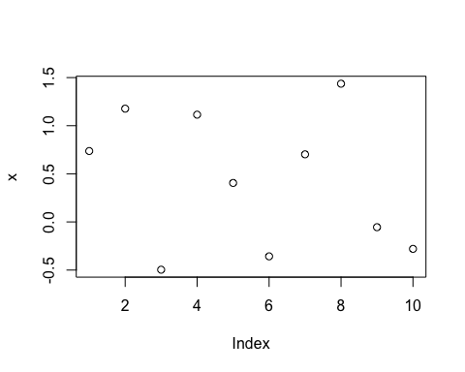

plot(y)

