**University of the Philippines**

**Open University**

# IS 226 Web Information Systems

# Software Requirements Specification

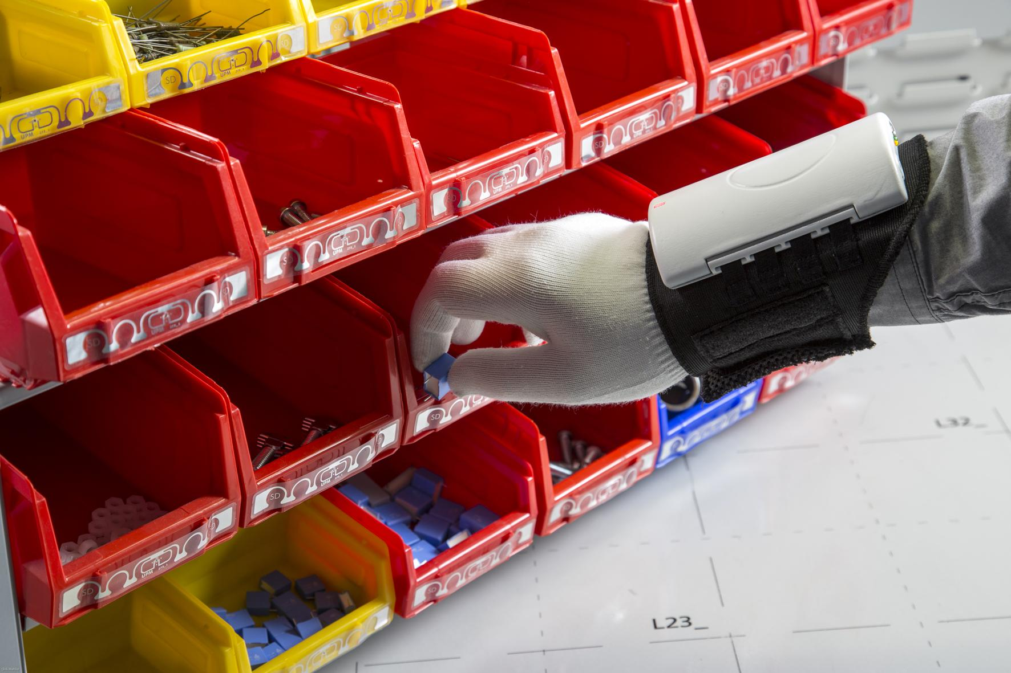

##### Ana Maria B. Pascual Ericson D. Billedo

##### *Team Bismillah*

##### 

Table of Contents

Release Information 2

Introduction 2

Use Cases 3

Use Cases by Functional Area 3

Use Cases by Business Object and Stakeholders/Actor 3

Functional Requirements 4

Features by Functional Area 5

Non-Functional Requirements 5

Usability requirements 6

Reliability and up-time requirements 6

Security requirements 6

Scalability and performance requirements requirements 7

Maintainability and upgradability requirements 7

Supportability requirements 7

Environmental Requirements 7

System hardware requirements 8

System software requirements 8

Data import and export requirements 8

# **Release Information**

|  |  |
| --- | --- |
| Project: | Simplified Inventory System |
| Internal Release Number: | 1.0.0 |
| Attached worksheets: | SRS > Use case suite  SRS > Feature set |
| Related Documents: | Project proposal > User needs  Glossary |

# **Introduction**

The Simplified Inventory System aims to modernize the ABC Technical College’s inventory process. The SIS geared towards providing a centralized web-based application that will cater to all the inventory needs of the Centre. With its “on-the-go” feature, every user will be able to conduct inventory transactions effortlessly. Report generation will be a breeze with a simple click of a button. This system will be accessible on virtually any device regardless of operating system.

The technology of choice for this project is HTML5 since this is a web-based application. Bootstrap will be the front-end framework and will make most of the users feel immediately comfortable as they will be using interface similar to that of Google’s, Facebook and Twitter.

PHP will be the back-end tool since the database will be implemented in MySQL. PHP can provide more than enough capabilities when working with MySQL database.

# **Use Cases**

The SIS is designed to be easy to use as it was based on the actual process in ABC Technical College’s inventory. The modules used in SIS are logically grouped mimic the manual process as close as possible.

**Use Cases by Functional Area**

|  |  |
| --- | --- |
| * User Account Management   + [UC-00](https://docs.google.com/document/d/1Wkols1NHCRC7tXVqhFwtgAsLvDTMOkxXzfPZDY-vr3g/edit#heading=h.ohrcaeg9ajwz) Login to system   + [UC-01](https://docs.google.com/document/d/1Wkols1NHCRC7tXVqhFwtgAsLvDTMOkxXzfPZDY-vr3g/edit#heading=h.3fhdztgt6w15) Register a user account   + UC-02 Request password   + UC-03 Edit user profile   + UC-04 View list of users   + UC-05 Delete user profile * Item Management   + [UC-06](https://docs.google.com/document/d/1Wkols1NHCRC7tXVqhFwtgAsLvDTMOkxXzfPZDY-vr3g/edit#heading=h.advw6hkbul9o) Add Item   + [UC-07](https://docs.google.com/document/d/1Wkols1NHCRC7tXVqhFwtgAsLvDTMOkxXzfPZDY-vr3g/edit#heading=h.f8hwr9hwo36l) View Item   + [UC-08](https://docs.google.com/document/d/1Wkols1NHCRC7tXVqhFwtgAsLvDTMOkxXzfPZDY-vr3g/edit#heading=h.vitveww31d7j) Edit Item | * Stocks Managements   + [UC-09](https://docs.google.com/document/d/1Wkols1NHCRC7tXVqhFwtgAsLvDTMOkxXzfPZDY-vr3g/edit#heading=h.jk3wo0q3sb17) Request Stocks   + [UC-10](https://docs.google.com/document/d/1Wkols1NHCRC7tXVqhFwtgAsLvDTMOkxXzfPZDY-vr3g/edit#heading=h.spl4yst036k8) Authorize Request   + [UC-11](https://docs.google.com/document/d/1Wkols1NHCRC7tXVqhFwtgAsLvDTMOkxXzfPZDY-vr3g/edit#heading=h.mmhy31vlz576) Issue Stocks   + [UC-12](https://docs.google.com/document/d/1Wkols1NHCRC7tXVqhFwtgAsLvDTMOkxXzfPZDY-vr3g/edit#heading=h.2xqhaq3ncolr) Receive Stocks   + [UC-13](https://docs.google.com/document/d/1Wkols1NHCRC7tXVqhFwtgAsLvDTMOkxXzfPZDY-vr3g/edit#heading=h.bbeepevderep) Search Stocks   + [UC-14](https://docs.google.com/document/d/1Wkols1NHCRC7tXVqhFwtgAsLvDTMOkxXzfPZDY-vr3g/edit#heading=h.ol67dggqnpg7) View Item History |

**Use Cases by Business Object and Stakeholders/Actor**

|  |  |  |  |  |  |
| --- | --- | --- | --- | --- | --- |
| BO \ Actor | All | Staff | Department Head | Store Manager / Administrator | Master Administrator |
| Items | View items and its related information    View item history information | Request for items currently not available in inventory | N/A | Add items  Edit items | N/A |
| Stocks | Request for stocks/supply  Search Stocks | N/A | Authorize or grant a request | Issue stocks  Receive Stocks | N/A |
| Users | View users | N/A | N/A | N/A | Elevate user rights |

# **Functional Requirements**

In developing the SIS, careful consideration was made regarding the client’s requirements. These requirements are then integrated in the overall design.

|  |  |
| --- | --- |
| Requirement | Description |
| REQ1 | The system shall allow the system administrator to add users and designate appropriate system usage rights. |
| REQ2 | The system shall allow users tagged as “store managers” to add items with details following their own formats |
| REQ3 | The system shall update available balance and stock balance of an item. Available balance reduces as requests are made. Stock balance will only be change when an item is received or issued. |
| REQ4 | The system shall allow all users to view stock balances. |
| REQ5 | The systems shall allow all users to make item request. |
| REQ6 | The system shall allow users tagged as “Head of Department” to authorize/grant or deny request, including his/her own. |
| REQ7 | The system shall allow users tagged as “store managers” to record item issued including his/her own. |
| REQ8 | The system shall allow users tagged as “store managers” to perform all functions available to “staff”. |
| REQ9 | The system shall allow users to generate a list of current inventory status. |
| REQ10 | The system shall allow users to generate list of transaction history. |
| REQ11 | The system shall allow users the system administrator to remove user/s from the system. |
| REQ12 | The system shall provide all users with a comprehensive (not lengthy) How-to guide. |
| REQ13 | The system shall provide all users a way to send feedback to the developers. |
| REQ14 | The system shall provide login and reset password feature. |

**Features by Functional Area**

|  |  |
| --- | --- |
| * User Account Management   + [F-00](https://docs.google.com/document/d/1Wkols1NHCRC7tXVqhFwtgAsLvDTMOkxXzfPZDY-vr3g/edit#heading=h.ohrcaeg9ajwz) Login to system   + [F-01](https://docs.google.com/document/d/1Wkols1NHCRC7tXVqhFwtgAsLvDTMOkxXzfPZDY-vr3g/edit#heading=h.3fhdztgt6w15) Register a user account   + F-02 Request password   + F-03 Edit user profile   + F-04 View list of users   + F-05 Delete user profile * Item Management   + [F-06](https://docs.google.com/document/d/1JpXRKOMnfwTg_pMbMDE16O3iziOAOuKJNU-R2mlc0bI/edit#heading=h.25nxhedb4d0m) Add Item   + [F-07](https://docs.google.com/document/d/1JpXRKOMnfwTg_pMbMDE16O3iziOAOuKJNU-R2mlc0bI/edit#heading=h.vrwemnvsau26) View Items   + [F-08](https://docs.google.com/document/d/1JpXRKOMnfwTg_pMbMDE16O3iziOAOuKJNU-R2mlc0bI/edit#heading=h.p407zn53qv45) Edit Item | * Stocks Managements   + [F-09](https://docs.google.com/document/d/1JpXRKOMnfwTg_pMbMDE16O3iziOAOuKJNU-R2mlc0bI/edit#heading=h.ncj3uamj3d4o) Request Stocks   + [F-10](https://docs.google.com/document/d/1JpXRKOMnfwTg_pMbMDE16O3iziOAOuKJNU-R2mlc0bI/edit#heading=h.xeieado5xayr) Issue Stocks   + [F-11](https://docs.google.com/document/d/1JpXRKOMnfwTg_pMbMDE16O3iziOAOuKJNU-R2mlc0bI/edit#heading=h.kdmel8gbe9od) Receive Stocks   + [F-12](https://docs.google.com/document/d/1JpXRKOMnfwTg_pMbMDE16O3iziOAOuKJNU-R2mlc0bI/edit#heading=h.huf0wr7ibe4y) Search Stocks   + [F-13](https://docs.google.com/document/d/1JpXRKOMnfwTg_pMbMDE16O3iziOAOuKJNU-R2mlc0bI/edit#heading=h.ivv2xufpa1mw) View Item History |

# **Non-Functional Requirements**

**Usability requirements**

Change is accepted differently by different people but a great major are receptive to this. This is why the main requirement considered in building the SIS is understandability. The system interface design was built on top of Bootstrap framework which provides intuitive interface that common to major website nowadays. This will more likely soften the blow and make users feel quick comfortable using the system.

Efficiency of use is the next requirement considered. The SIS provides easy to use functionalities such granting a stock request with just a click of a button. View item’s transaction history can be down in many way allowing users to accomplish the task faster and more efficient.

Aside from these, users will be able to do their work even on their mobile devices. The search feature of the system is not restricted to specific type (field or column in a table) of data. It searches the whole table so users won't need to remember where to search for keyword. Lastly, the client would like to have an interface that doesn’t look like a “system” per se. The SIS uses the SB Admin Bootstrap template which displays information in a “big” format. Much information is displayed in large panels and buttons used are large as well creating an impression that deviates from the old concept of a system where one needs to navigate through a series of submenus to locate a particular command or function.

**Reliability and up-time requirements**

The client requires that the system should be up and running during office hours and should only be accessible from within the vicinity. The SIS is designed to be running 24/7 and can be setup either in a LAN environment or it could be run from the Internet.

**Security requirements**

The SIS takes system security seriously without compromising efficiency. Although, a user may register his/her account, a newly created account is set to a limited privilege. It would take a “master administrator” to elevate a user’s right. A user may only be elevated to having a role of a “department head”, “administrator/store manager” or “master administrator”. The design of SIS provides a mechanism that prevents a single user to manipulate its transactions and the database credibility. These once again simulate the actual model the college is following. Passwords registered by the users are not stored in plain text. Instead, it follows the industry standard of hashing it before storing in a table using the one stand-out option in PHP called Bcrypt.

**Scalability and performance requirements**

The ABC College currently employs a little less than a hundred of teaching and non-teaching staff. Although it is unlikely, at most, the SIS should be able to concurrently allow this number of users to use the system. These will exceed the requirement set by the client to just about sixty (60) or 60% which comprises the teaching staff. The SIS is also expected be able to query or search the inventory in less than a second. Other requirement of the client like the page loading will somehow depend also on their existing network infrastructure.

The SIS database will likely grow over time as it will be recording all transactions per item in its inventory and having it installed on a legitimate server machine which is regularly managed will help the system scale up with this anticipated growth.

**Maintainability and upgradability requirements**

Although the client is clear about its requirement, it would also be safe to assume that this will change especially when they started using the system. They might require additional functionalities they might have overlooked at the beginning of the project. One option to resolve this foreseeable scenario is by preparation a provision for an automatic update feature. In this way, downtime may even be reduced to zero and the cost of doing upgrade would likely be far less than without this feature.

**Supportability requirements**

The client requires support especially during the first few months of system deployment. The SIS will feature a “contact me” function that will enable the client to reach out and seek technical support. Provision for system’s automatic upgrade will be considered once the product is deployed and when the client requires for it. With this feature installed, support cost will be minimized.

# 

# **Environmental Requirements**

**System hardware requirements**

The SIS is a web-based application and as such would require a web server. The client is required to produce a standard PC with an updated OS to act as a web server although a rack/tower server like the Dell PowerEdge would enhance the performance of the system.

A networking infrastructure is also required to access the system. Wired or wireless connection, it will work just fine. Aside from these, a stable internet connection is required since some plugins and application frameworks are fetching from CDN. In this, way when an update is available to these plugins the client won’t need to do anything as they will automatically be using the latest version of the plugins. However, to increase the SIS performance the plugins may also be stored on the web server side by side with the SIS.

**System software requirements**

A web server is required to run the SIS. NGINX is the ideal web server application for this system but it can also run on other web servers like Apache. Other software requirements include PHP for the back-end server side application, MySQL for its database and plugins like Bootstrap, JQuery and DataTables.

For users to be able to access and use the SIS, a web browser is required. It can be used on any device and on any OS.

**Data import and export requirements**

Existing inventory data of ABC College can be imported to the SIS using the SQL format saves in a “.sql” file. The SIS database can also be exported to SQL file, Text or even Excel file format.