[1]

Simplified Inventory System

System Usability Scale

Ana Maria B. Pascual, *Student, MIS*, and Ericson D. Billedo, Student, MIS

*Abstract*— The ABC Technical College has been growing over the years. With only less than a hundred students when it started, it now has more than five hundred. With this, change is bound to happen. Preparation of inventory has been done manually per se. Although reports are prepared using office automation software, the manner of requesting and approving request as well updating the inventory are all manually processed. It is tedious, time-consuming and prone to errors.

The Simplified Inventory System aims to provide one centralize web-based application that will cater to all the inventory needs of the College. With its “on-the-go” feature, every user will be able to conduct inventory transactions effortlessly. Report generation will be a breeze with a simple click of a button.

All these efforts in the end is directed toward its ultimate goal which is to provide quality services to its clientele, the students.

# INTRODUCTION

T

HE Simplified Inventory System was designed to address the ABC Technical College’s aims to modernize its inventory process.

Huge amount of effort was put into the design and implementation of this project. Considerable amount of requirements was considered and served as the guiding principle in developing this system.

Now that the system is on its first release, we would like to take in feedback that would be used to upgrade the system and improve its performance. This was done through casual interview and online survey using the SUS. The survey is accessible on the system’s landing page.

# The Survey

The survey was conducted when the system was fully functional. The participants used the system as a “staff” user. They were also shown how the entire process work by demonstrating what will usually happen after a stocks request was made.

The participants’ common expressed that this could possibly be used in their place of work for reasons that it was simple to use and so easy for them to understand and adapt.

Some participants also commented that the more they use it the more it becomes familiar to them. The result of this survey is shown below.

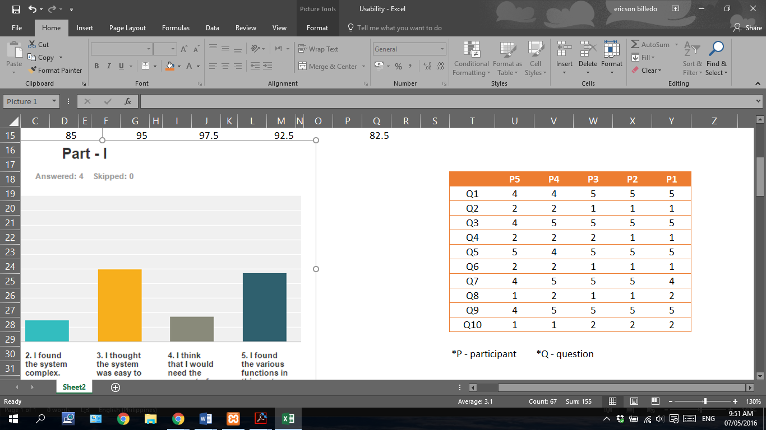

Figure 1- Raw Survey Result

The chart below shows a clearer idea of the survey. We can see that the participants share common idea about the SIS.

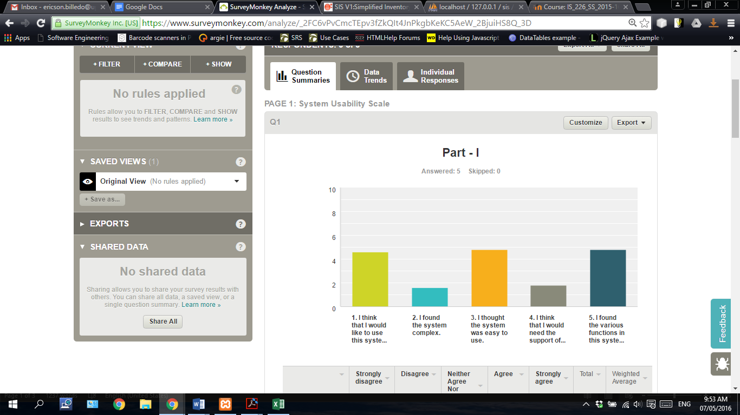

Figure 2 - Survey Chart Part-I

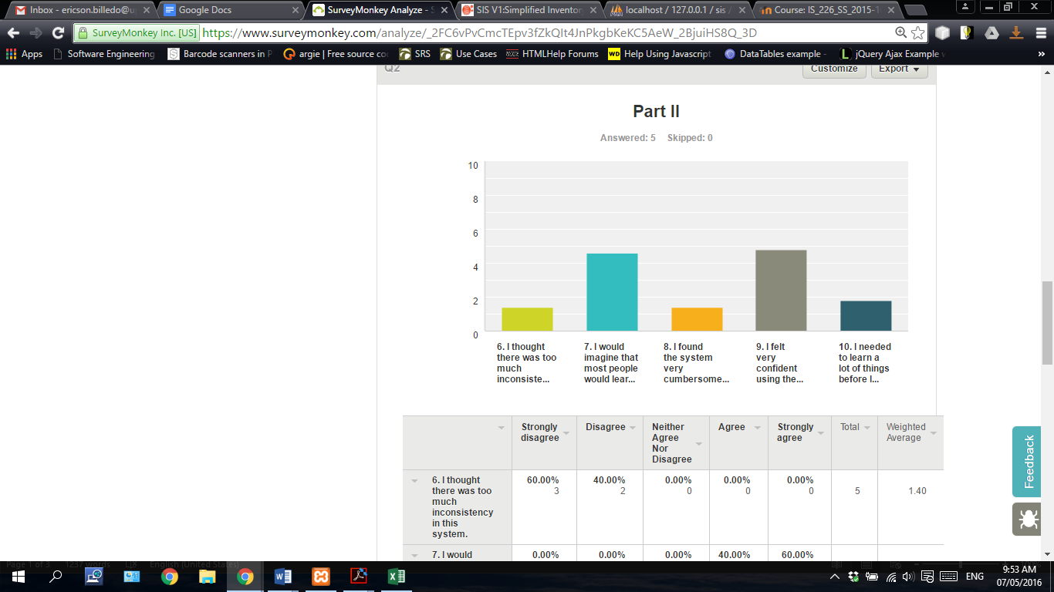

Figure 3- Survey Chart Part-II

The bars in the charts represent the weighted average for each item. The weighted average for each item was not used for calculating the SUS score.

# The Result

*“To calculate the SUS score, first sum the score contributions from each item. Each item's score contribution will range from 0 to 4. For items 1,3,5,7 and 9 the score contribution is the scale position minus 1. For items 2,4,6,8 and 10, the contribution is 5 minus the scale position. Multiply the sum of the scores by 2.5 to obtain the overall value of SU”.*

|  |  |  |
| --- | --- | --- |
| Participants | Score Contribution | Overall SU value |
| P1 | 35 | 85 |
| P2 | 38 | 95 |
| P3 | 39 | 97.5 |
| P4 | 37 | 92.5 |
| P5 | 33 | 83 |
| **Average** |  | **90.5** |

SUS scores have a range of 0 to 100. Based on research, a SUS score above a 68 would be considered above average and anything below 68 is below average.

Although the sample size for this survey is a little below of what is deemed adequate, it provides nonetheless to the developers an insight of what is still possible to add to make the system more efficient yet stays user friendly.

The five survey participants are as follows:

1. Mr. William L. Caniedo, ECE – He is an electronics instructor at Shinas Vocational Training Centre. He has been work at the Centre for more than five years now. Prior to working at the VTC, he was a college instructor at De La Salle University Batangas City for more than ten years.
2. Mr. Julius T. Dabon – a Refrigeration and Air Condition instructor at Shinas VTC for more than 8 years now. Prior to joining the Centre, he was working various companies in Manila then went out to work in Dubai for some three in an RAC company.
3. Mr. Jenier T. Galarpe – TESDA accredited welding instructor. He is teaching the same course at Shinas VTC for more than five years now. Prior to joining the Centre, he worked in South Korea.
4. Mr. Euclid R. Santiago – Professional Teacher. He is an Electrical instructor at Shinas VTC for more than five years. Prior to joining the Centre, He was with Bulacan State University then move to Saudi as a Safety Officer.
5. Mr. Norman P. De Ocampo – He is an RAC instructor at Shinas VTC for more than eight years now. Prior to joining the Centre, he was with Condura-Carrier Phil.

# Conclusion

The SIS is a step towards a modernize, efficient and reliable inventory system ABC Technical College take advantage of. Based on their existing inventory model, users of the system would likely become familiar with the SIS in a short span of time. The System Usability Scale use as the basis for the survey for this project show initially that the objectives set were all met pending upgrade that would make the SIS even more efficient system.

References

1. DIGITAL COMMUNICATIONS DIVISION. System Usability Scale (SUS) [Online]. Available: http://www.usability.gov/how-to-and-tools/methods/system-usability-scale.html
2. J. Brooke (1986). SUS - A quick and dirty usability scale*.* [Online]. Available e-mail: [JOHN.BROOKE@REDHATCH.CO.UK](mailto:HUMANIST@NYVM.ORG)

**Ana Maria B. Pascual** was born in Sampaloc Manila. She got her degree in Bachelor of Science in Computer Science from Central Colleges of the Philippines in the year 2007.

She was a Web Developer from her previous jobs but now she is currently a full-time mom and a student.

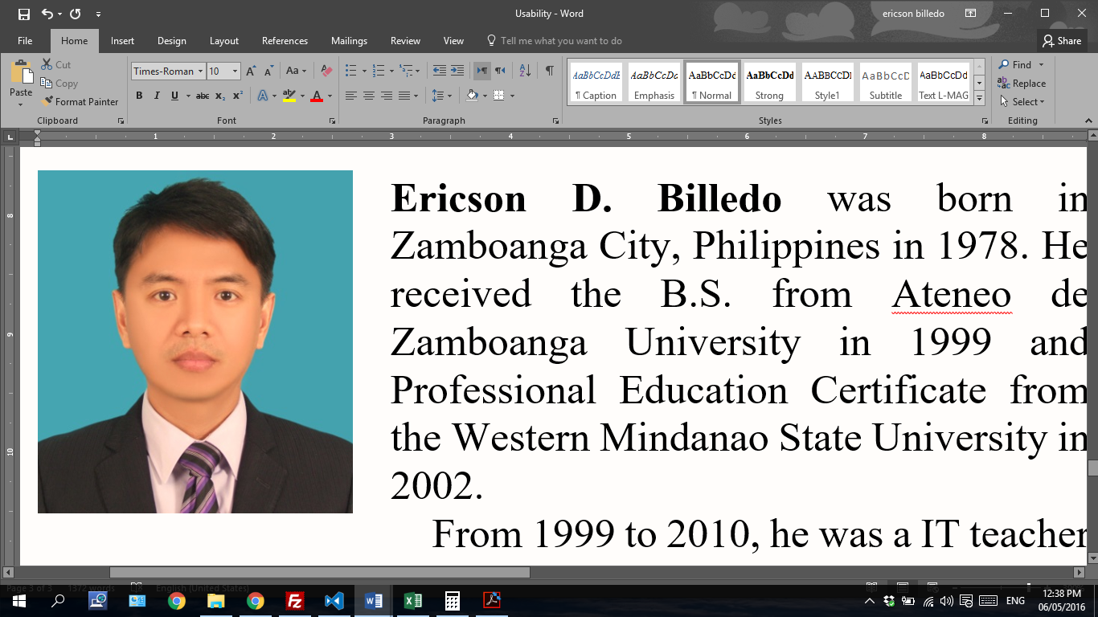 **Ericson D. Billedo** was born in Zamboanga City, Philippines in 1978. He received his B.S. in Management Information System from Ateneo de Zamboanga University in 1999 and Professional Education Certificate from the Western Mindanao State University in 2002.

From 1999 to 2010, he was an IT teacher with Claret School of Zamboanga City prior to joining Bahwan CyberTek LLC. He was also with St. Augustine School of Nursing Zamboanga Branch teaching the same subject from 2002 to 2004.

1. This work was submitted on 07 May 2016. It was sponsored solely by the authors.

   Ana Maria B. Pascual was a Web Developer from her previous job but now she is currently a full-time mom and a student.

   Ericson D. Billedo is with Bahwan CyberTek LCC, Muscat, Oman. He is currently working as an IT Instructor for Shinas Vocational Training Centre. (ericson.billedo@upou.edu.ph)