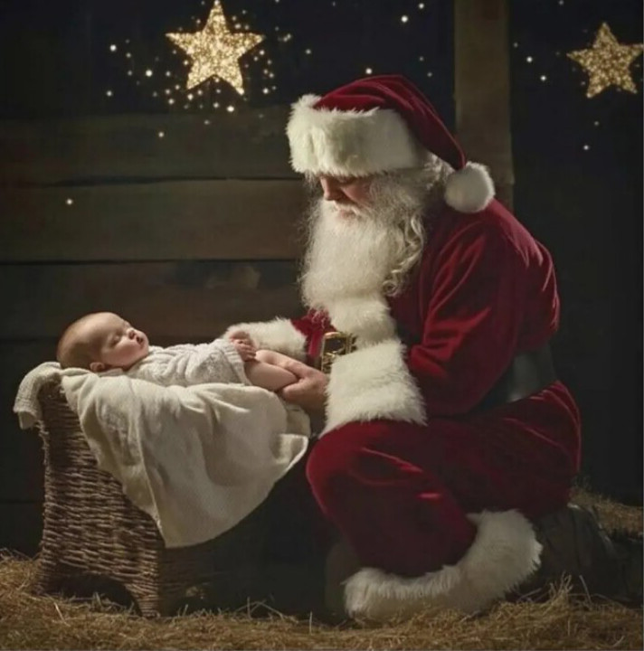
My dear precious Jesus, I did not mean to take your place,
I only bring toys and things and You bring love and grace.
People give me lists of wishes and hope that they come true,
But You hear prayers of the heart and promise Your will to do.
Children try to be good and not to cry when I am coming to town,
But You love them unconditionally and that love will abound.
I leave only a bag of toys and temporary joy for a season,
But You leave a heart of love, full of purpose and reasons.
I have a lot of believers and what one might call fame,
But I never healed the blind or tried to help the lame.
I have rosy cheeks and a voice full of laughter;
But no nail–scarred hands or a promise of the hereafter.
You may find several of me in town or at a mall;
But there is only one omnipotent You, to answer a sinner’s call.
And so, my dear precious Jesus, I kneel here to pray;
To worship and adore You on this, Your holy birthday.

