
Moringa: Nature’s Superfood

Moringa: All the good stuff
with no side effects.

Moringa: More nutritional power than kale, spinish, Swiss Chard, and broccoli.

Moringa: Clean Energy

Moringa: The most vitamin dense
plant on Earth
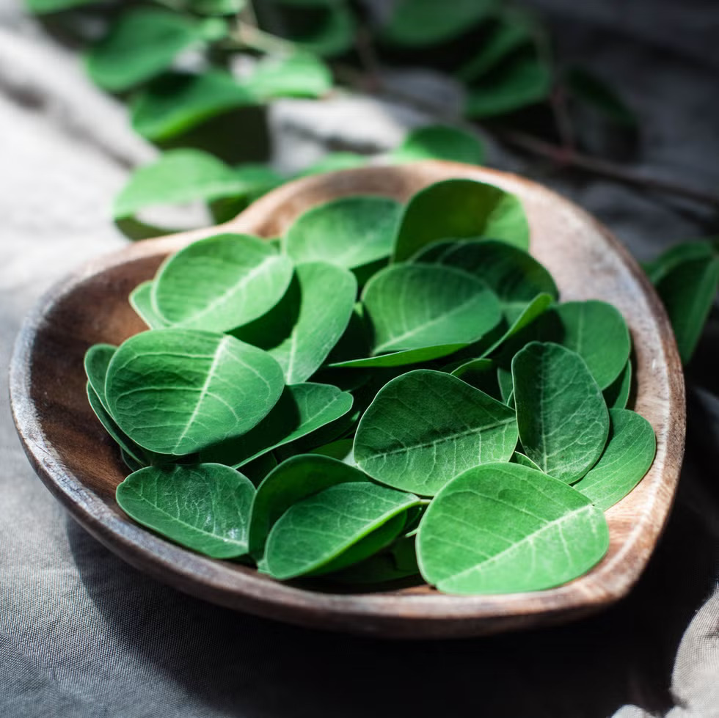
Moringa is often called a ‘Miracle Tree’ because it is considered effective in combating global warming due to its growth and ability to absorb carbon dioxide at 50 times faster than cedar trees. Moringa can be consumed in many forms including:

- Powder
- Extra-Fine Powder
- Raw Leaves
- Dried Leaves
- Course Shredded Dried Leaves
- Oil
- Seeds
- Tea Leaves
- Stems

Moringa is exceptionally nutritious:
  - 92 nutrients including
    - vitamins
    - minerals
    - amino acids
  - 46 antioxidants
    - High protein content
    - All essential amino acids
    - Rich in vitamins: A, C, E, and B-complex
    - Mineral-rich:
      - Calcium
      - Iron
      - Magnesium
      - Zinc
      - Potassium
    - Anti-inflammatory compounds:
      - Isothiocyanates
      - Flavonoids

According to Dr. Bill Messer, Moringa is the most vitamin dense plant on Earth. Among its benefits:
• Used to feed starving children in Africa.
• Protects and nourishes skin and hair.
• Treats Edema.
• Protects the Liver.
• Prevents and Treats Cancer.
• Treats Intestinal Discomfort.
• Fights Bacterial Diseases.
• Improves Bone Health.
• Treats Mood Disoders.
• Protects the Cardiovascular System.
• Treats Diabetes by Lowering Blood Sugar Levels.
• Improves Asthma Symptoms.
• Gives Energy—don’t take before bed

Other benefits attributed to Moringa consuption include:
- anti-diabetic
- anti-cancer
- anti-ulcer
- anti-microbial
- anti-oxidant
- curbing malnutrition
- energises elderly

People are more aware about health-related issues than ever before and they are very much interested in taking healthy, nutritious food. Food which has a wide range of health benefits may prevent or cure various chronic diseases are also desired. This kind of extraordinary food is also termed as super food. Scientists worldwide have identified Moringa a source of healthy and nutritious food properties.

Our Farm
• 100 hectare (250 acre) farm in Indonesia.
• Washing by Ozone Water before drying
• Certification by USDA
• Organic Certification
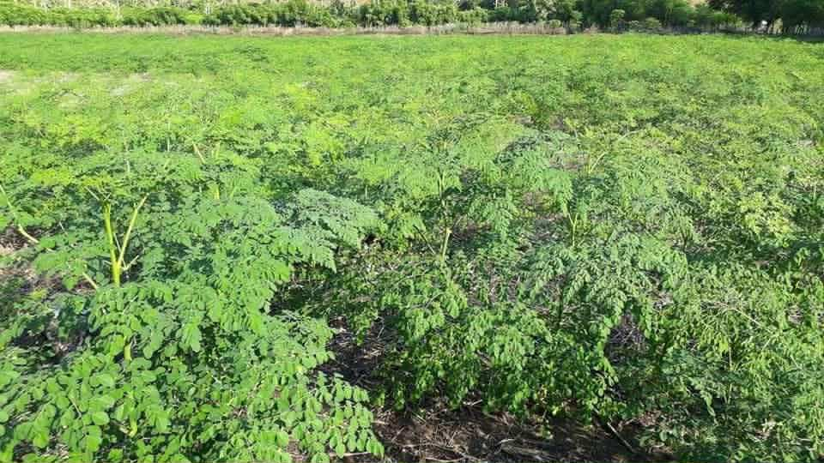
Moringa and Malnutrition:
According to The World Hunger Project, 815 million people do not have food to sustain themselves out of 7.6 billion people of the world. Moringa is a fast growing drought-resistant tree. It is widely cultivated for the diversified use of its young seed pods and green leaves as vegetables and for medicine. It is considered as a very good supplement because of its high protein value.
Moringa and Cholesterol:
Acccording to the National Institues of Health, Moringa leaf extract of Moringa oleifera decreased the high-fat diet-induced increases in serum, liver, and kidney cholesterol levels.
Moringa and Obesity:
Obesity constitutes a grave health problem and rises the hazard of chronic diseases such as diabetes mellitus and cardiovascular disease. Moringa holds saponins, tannins, flavonoids, glycosides and terpenoids, all of which possess medicinal belongings. The later compounds display effective anti-oxidants, anti-carcinogenic and anti-microbial potential and they can also boost the immune system.

Using Moringa in your home:
- Powder can be mixed into any sauce
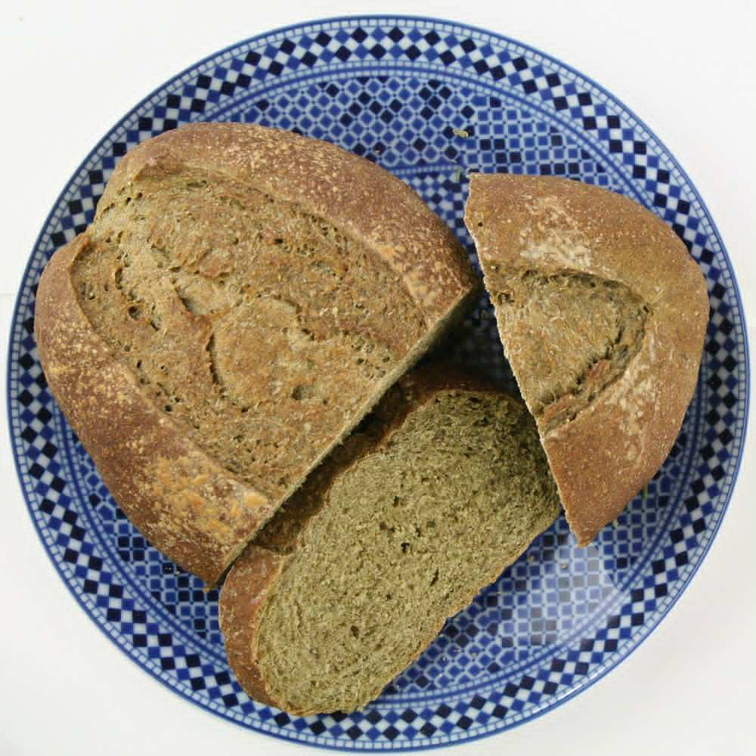
- Tea leaves can replace green tea for a no caffine hot beverage
- Powder can be substituted for 20% of the wheat in bread or pizza crust recipes
- Curry: fresh Moringa leaves, onion, tomato, curry, coconut milk, vegetables, chicken, rice
- Egg Scramble: eggs, Moringa powder, butter, salt
- Energy Balls: oats, peanut butter, honey, Moringa powder, nuts, raisins

Moringa in the food industry:
- Moringa can replace 20% of wheat flour in breads and pastas
- Moringa can be added to many sauces
- Course Shredded Dried Leaves can be substituted for tobacco for a healthy smoke

Industrial uses of Moringa:
- Seeds are used in water treatment plants to clean contaminents
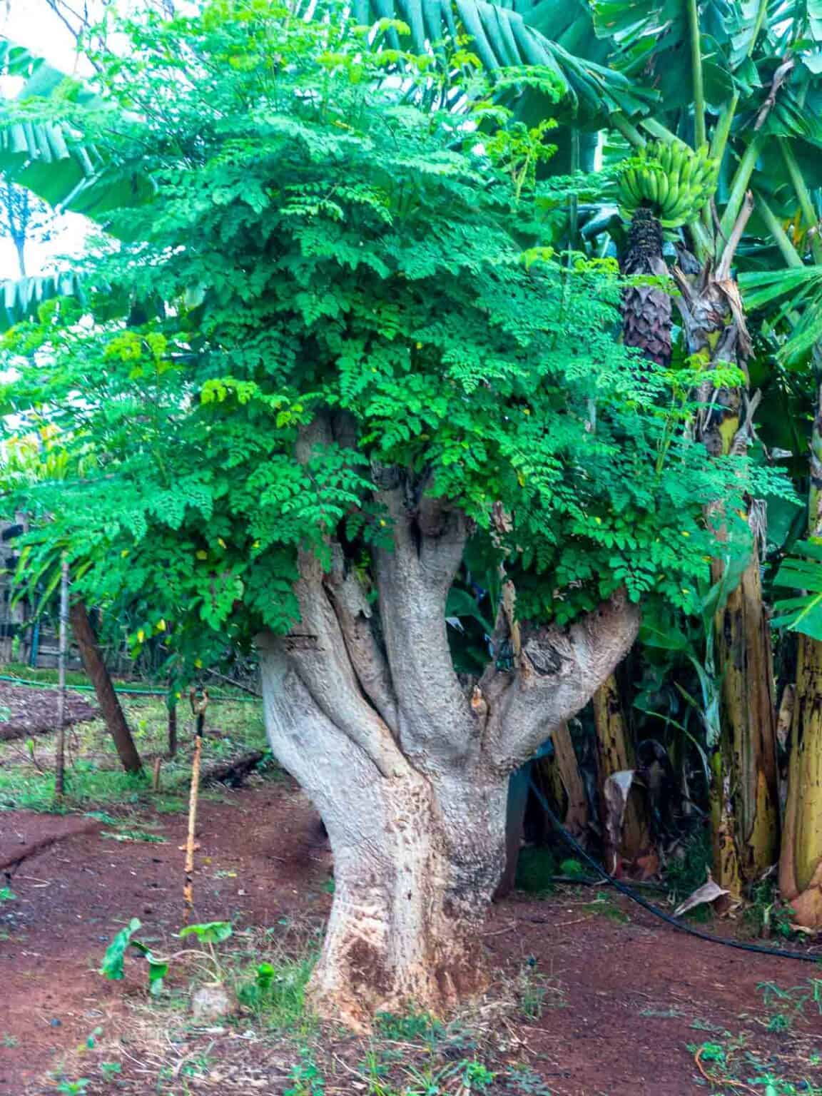
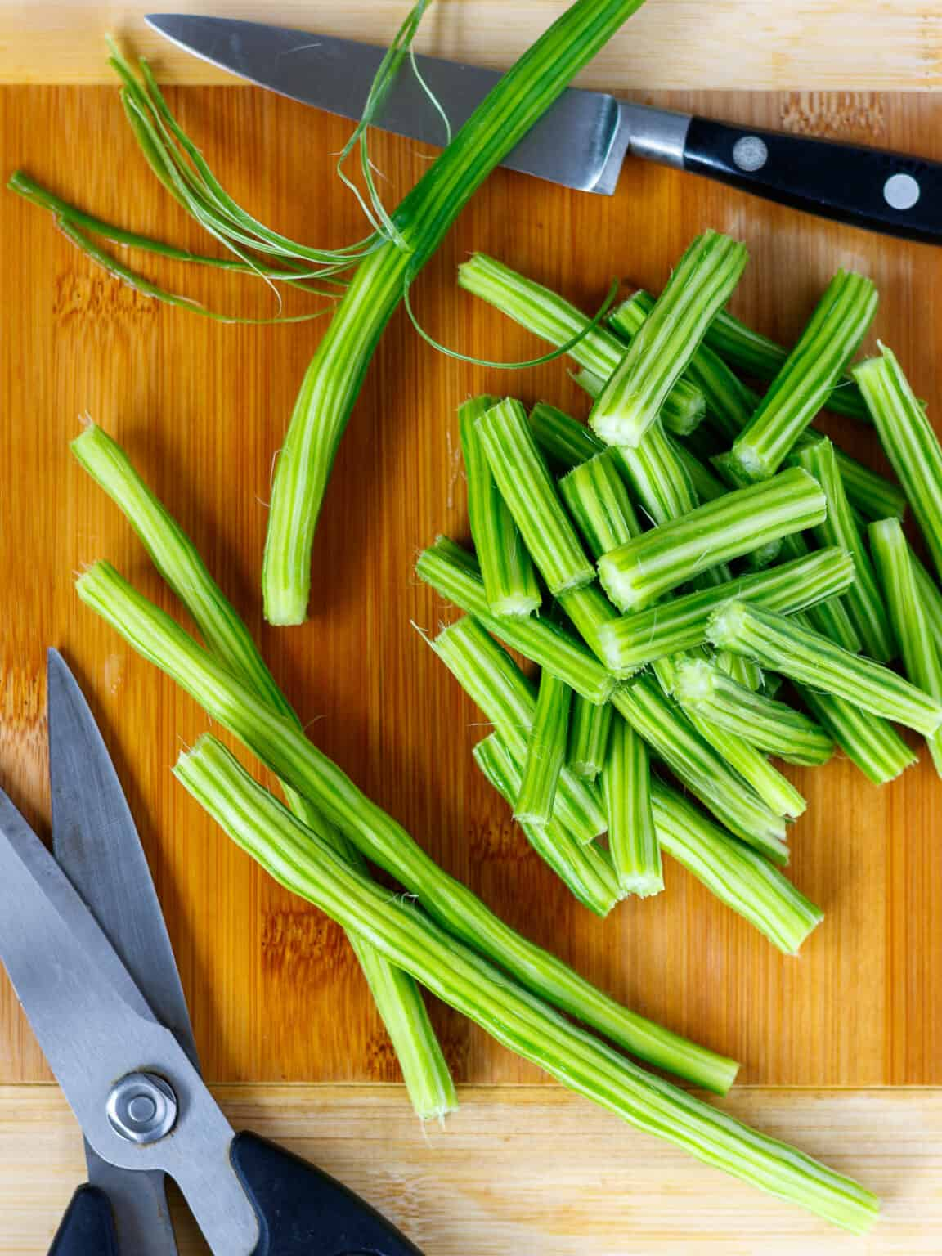
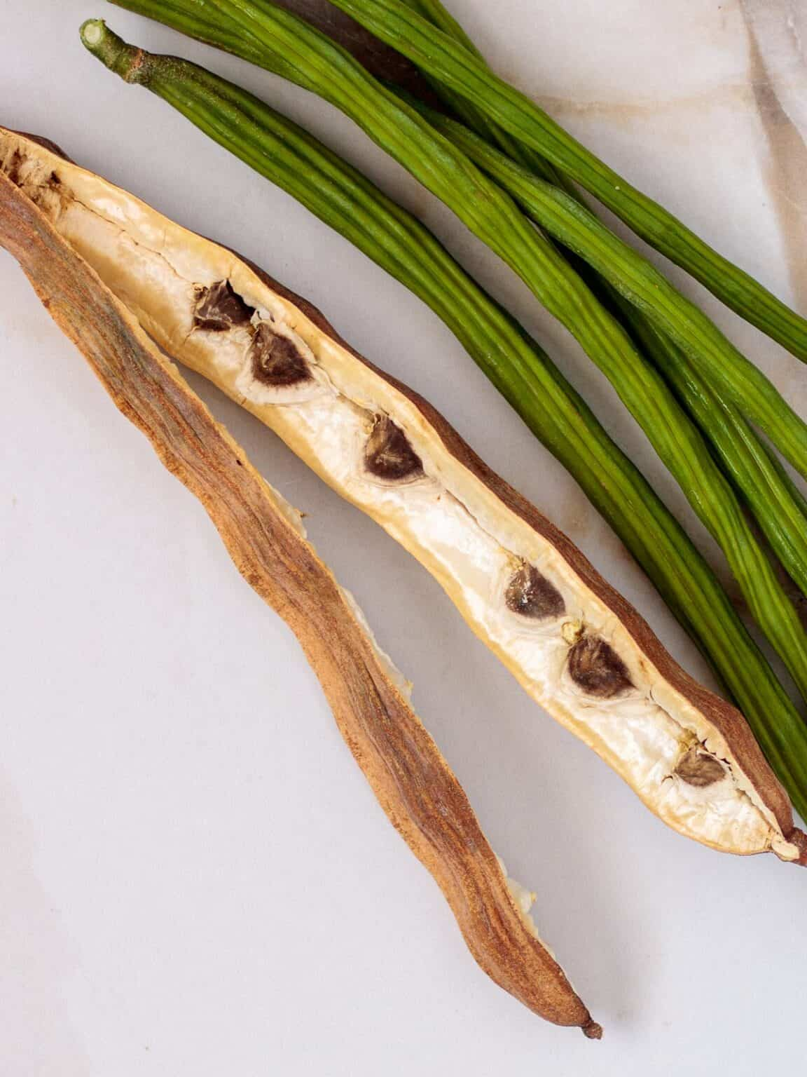
Benefits of Moringa:
- Food products are very dense in vitamins for malnourished areas
- Protect and Nourish skin and hair
- Treats Edema
- Protects the Liver
- Prevents and Treats Cancer
- Treats Intestinal Discomfort.
- Fights Bacterial Diseases.
- Improves Bone Health.
- Treats Mood Disoders.
- Protects the Cardiovascular System.
- Treats Diabetes by Lowering Blood Sugar Levels.
- Improves Asthma Symptoms.
- Prevents Obesity with Densely Packed Vitamins
- Promotes Sexual Health
- Strong Anti-Oxidant
- Prevents Ulcers
- Releives Lower GI Distress
- Protects cells from damage
- Prevents inflamation
- Relieves pain
- Antimicrobial
- Gives Energy—don’t take at night.

Cautions:
- Avoid Moringa from India which may be GMO treated (non Organic) and inconsitent quality.
- Pregnant women should consult their doctor.
- Persons using medications for high blood pressure should not combine with Moringa
- Beware of non-organic and products with additives. Some green powders have very little or no actual Moringa.

Published March 24, 2026
Copyright © 2026 CIRCco, All rights reserved worldwide,

