Moringa Steam Treatment

Moringa: "The Miracle Tree"
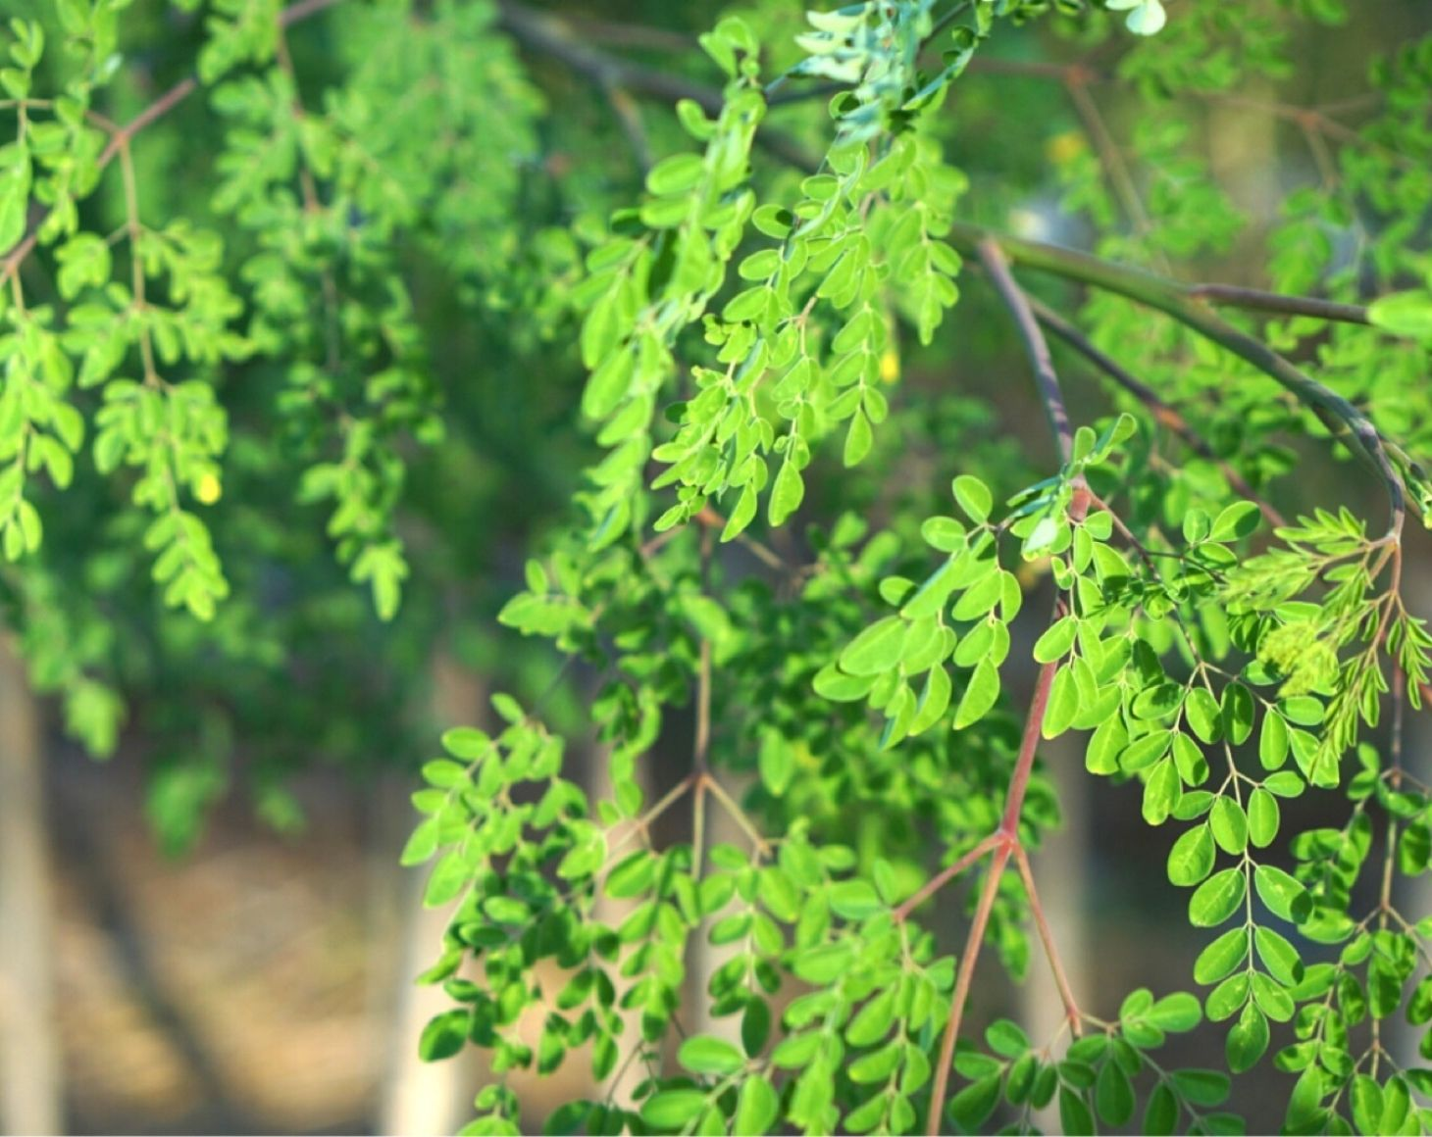
Moringa Oleifera is a plant native to subtropical regions that contains over 90 essential nutrients in a well-balanced manner. It is also called the "Miracle Tree," "Tree of Life," and "Medicine Box Tree." It is the ultimate superfood left to humanity to supplement modern nutritional deficiencies.
The ancient Indian medical text "Ayurveda" states that it is effective in preventing over 300 types of diseases. Useful components are contained in all parts of the plant: leaves, flowers, pods, seeds, bark, and stems.

Spreading the Power of The Miracle Tree:

Moringa × Hot Bath Therapy Nationwide
I am Mizuguchi, the Representative Director of the Japan Moringa Steaming Association.

Although the superfood "Moringa" has gradually become known in Japan in recent years, I became captivated by its charm even before it became famous and went to study in America and the Philippines.
I want to spread nationwide the message that it is necessary in modern society to absorb Moringa's nutrition not only internally but also externally.
Furthermore, I chose the association format because I wanted to energize the entire industry through Moringa steaming by connecting with salon owners who previously had almost no horizontal connections.
If you would like to experience Moringa steaming, please contact our certified salons nationwide.
We are still recruiting salons for introduction.
Let's expand the circle of Moringa together!

What is Moringa Steaming?
Moringa steaming is a hot bath therapy using steam from steamed leaves of the "Miracle Tree" Moringa. In contrast to its aromatic green tea-like scent that creates a relaxed and calm atmosphere, you can experience amazing effects in less than 5 minutes: sweat pouring from your pores, incredible detoxification, skincare benefits, diet support, relief from gynecological concerns, fertility support, and increased basal body temperature.
Moringa steaming is recommended for everyone who wants to improve their constitution, but our association's original Moringa steaming menu "JMSA Moringa Steam" is especially recommended for the following people:
- For Those Trying to Conceive: While mugwort steaming is famous for fertility support, it can actually only be offered for half the month to those trying to conceive. Moringa steaming can be safely offered anytime - even during pregnancy. Some clients have come for warming treatments until the day before delivery!
- For Those with Hay Fever or Atopy: The most common feedback from customers who have continued Moringa steaming for several years is: "I feel like my hay fever symptoms have eased compared to last year!" You can detox thoroughly and achieve smooth, beautiful skin. It's also popular among those with atopy.
- Diet Support: Although you're just sitting during Moringa steaming, you can actually burn calories equivalent to 3 hours of aerobics. If you're troubled by swelling, please try it right away. The amino acid power contained in Moringa may also help?!

Those Who Experienced Moringa Steam
Better than any herb I've tried before!!
This is amazing! Even though my body was cold, I immediately broke into a heavy sweat, and after about 20-30 minutes, my skin started to become smooth. Even after finishing, the sweat wouldn't stop and changing clothes was difficult (laughs). Better than any herb I've tried before!!

Introduction to Certified Salons
Our association's Moringa steaming can be experienced at certified esthetic salons, relaxation salons, chiropractic clinics, and acupuncture clinics nationwide. Please find a store near you.
(Some salons are still being prepared for listing. If there are no nearby stores, please contact us.)
• aesthetic salon Laguna
• Lymph & Detox Salon Lu・cuore
• Esthetic Salon Celestia
• Total Healthcare salon Nilufa
• Yomogi & Moringa Steam Warming Salon Ananta
• Organic & Detox salon Beloved
• EMIE
Furthermore, our association's direct "JMSA Moringa Steam®" can be experienced at salons with Moringa Steam Therapists

For Those Considering Introducing Moringa Steaming
Fortunately, in recent years, awareness of Moringa steaming has increased in the industry, and it has become easier to obtain Moringa as a seat bath agent than before.
However, learning at our association, which started Moringa steaming for the first time in Japan, and introducing Moringa steaming ensures overwhelming specialized knowledge and continuous after-sales support. Above all, we provide food-grade Moringa leaves that have obtained organic certifications both domestically and internationally, so we guarantee that you can confidently offer it to your customers.
We have prepared four courses optimal for your purpose, from courses that can be easily introduced to business opening schools.

