
Moringa: Nature’s Superfood

Moringa: All the good stuff
with no side effects.

Moringa: More nutritional power than kale, spinish, Swiss Chard, and broccoli.

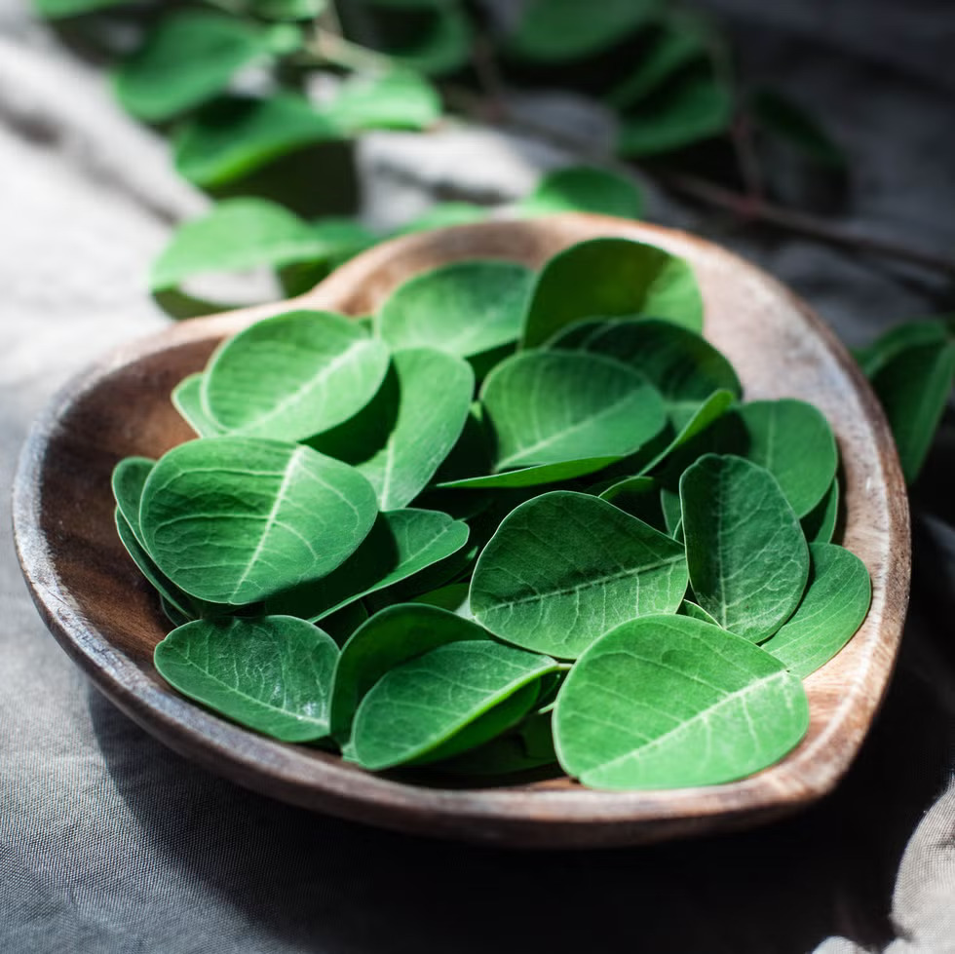
Moringa: The most vitamin dense
plant on Earth

People are more aware about health-related issues than ever before and they are very much interested in taking healthy, nutritious food. Food which has a wide range of health benefits may prevent or cure various chronic diseases are also desired. This kind of extraordinary food is also termed as super food. Scientests worldwide have identified Moringa as such a source of healthy and nutritious food properties.
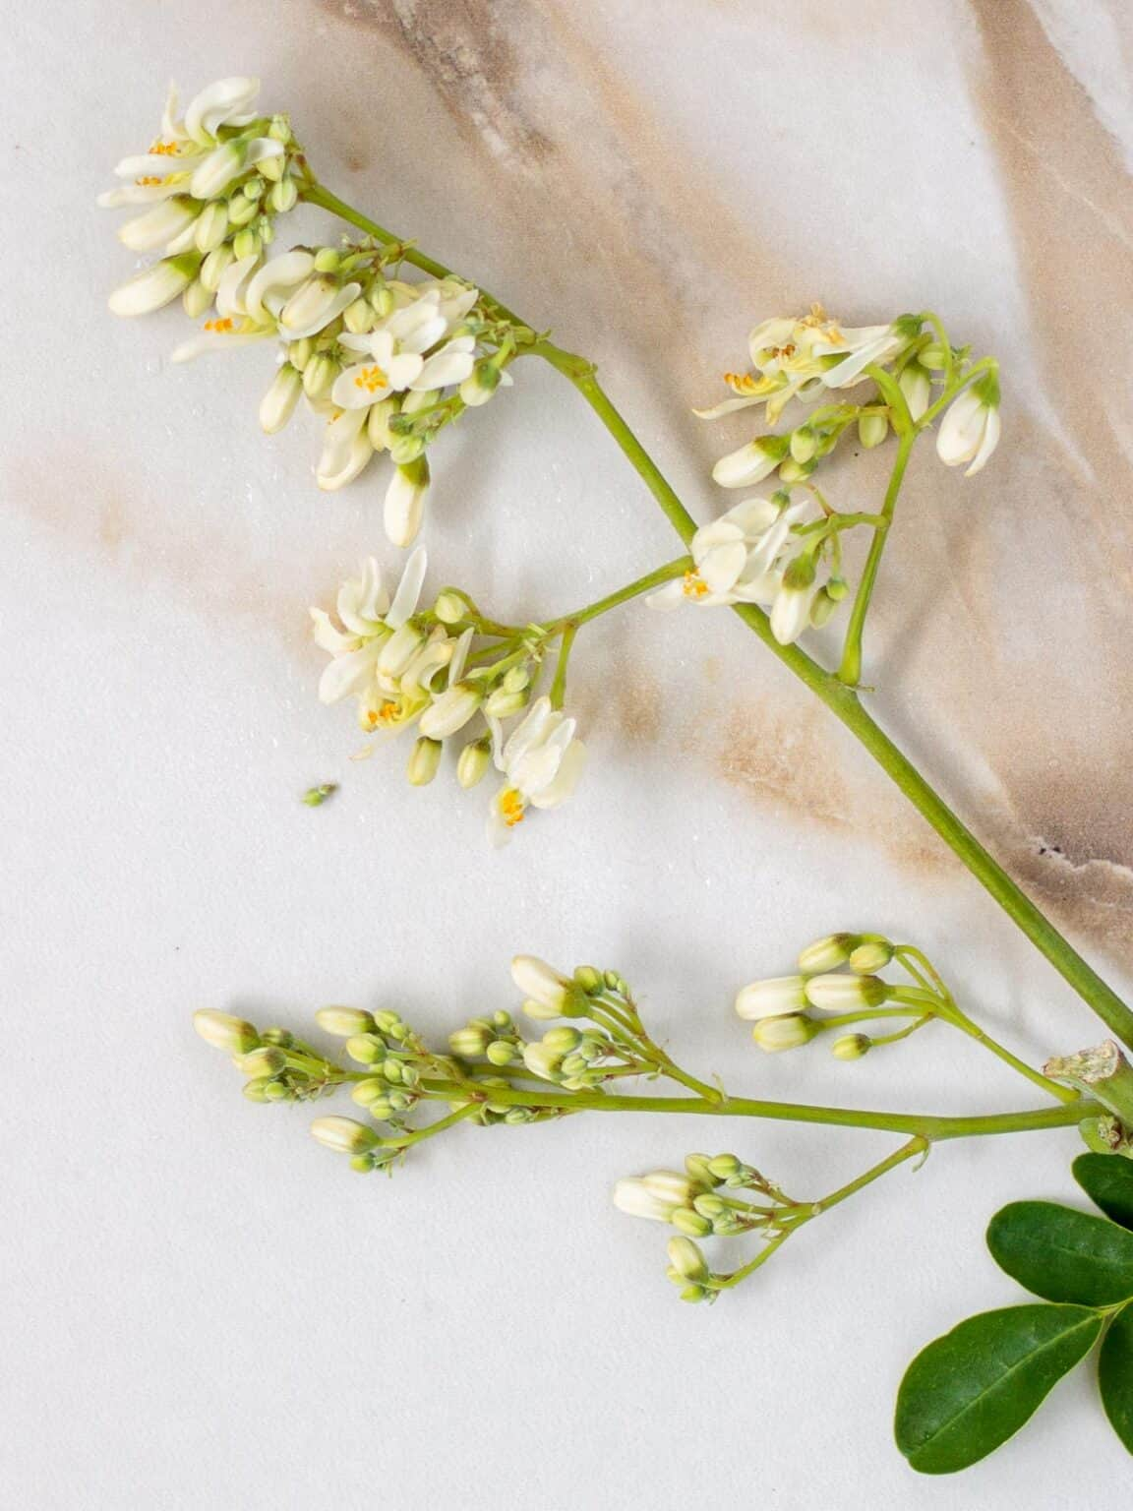
Moringa is exceptionally nutritious:
• 92 nutrients including vitamins, minerals, and amino acids
• 46 antioxidants
• High protein content with all essential amino acids
• Rich in vitamins: A, C, E, and B-complex vitamins
• Mineral-rich: Calcium, iron, magnesium, zinc, and potassium
• Anti-inflammatory compounds: Isothiocyanates and flavonoids

Utilization of natural products of plant origin having fewer side effects has gained popularity over the years. There is immense scope for natural products that can intimate health benefits beyond traditional nutrients. Moringa oleifera is one such tree having tremendous nutritional and medicinal benefits. It is rich in macro- and micro-nutrients and other bio-active compounds which are important for normal functioning of the body and prevention of certain diseases. Leaves, flowers, seeds, and almost all parts of this tree are edible and have immense therapeutic properties including anti-diabetic, anti-cancer, anti-ulcer, anti-microbial, and anti-oxidant. Most of the recent studies suggested that Moringa should be used as a functional ingredient in food.
Moringa is a prominent source of nutrients and antioxidants. Like other vegetables such as spinach and fenugreek, Moringa leaves are not as popular all over the world, but currently, it is used as substitutes in soups, lentils, and other preparations in Southeast Asia. Still there is a knowledge gap in potential uses of Moringa as a food supplement and food fortification. Moringa has enormous potential uses but is very less explored. It can be utilized to make foods that could be a step towards curbing malnutrition. The published literature gives the total scenario of the chemical constituents, nutritional content, potential uses, and pharmacological activities of the plant. The identification, isolation, and standardization of plant extracts may be considered for detailed studies which can be useful for the further development of the promising food products with health benefits and nutrients to cure different life style-related diseases as well as malnutrition.

Moringa can be consumed in many forms including:
- Powder
- Extra-Fine Powder
- Raw Leaves
- Dried Leaves
- Course Shredded Dried Leaves
- Oil
- Seeds
- Tea Leaves
- Stems

According to Dr. Bill Messer, Moringa is the most vitamin dense plant on Earth. Among its benefits:
• Used to feed starving children in Africa.
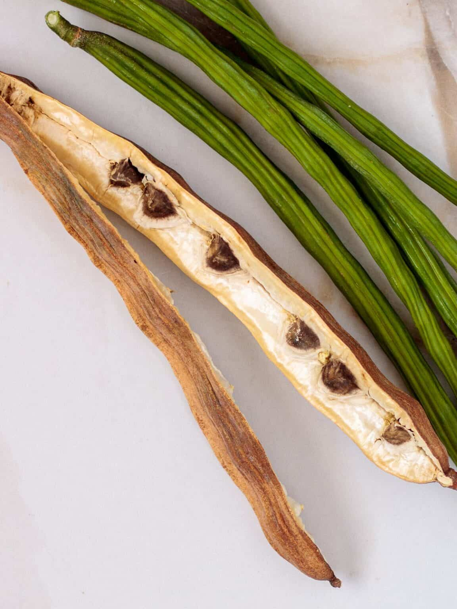
• Protects and nourishes skin and hair.
• Treats Edema.
• Protects the Liver.
• Prevents and Treats Cancer.
• Treats Intestinal Discomfort.
• Fights Bacterial Diseases.
• Improves Bone Health.
• Treats Mood Disoders.
• Protects the Cardiovascular System.
• Treats Diabetes by Lowering Blood Sugar Levels.
• Improves Asthma Symptoms.
• Gives Energy—don’t take at night.

Other benefits attributed to Moringa consuption:
- anti-diabetic, anti-cancer, anti-ulcer, anti-microbial, and anti-oxidan curbing malnutrition

Our Farm

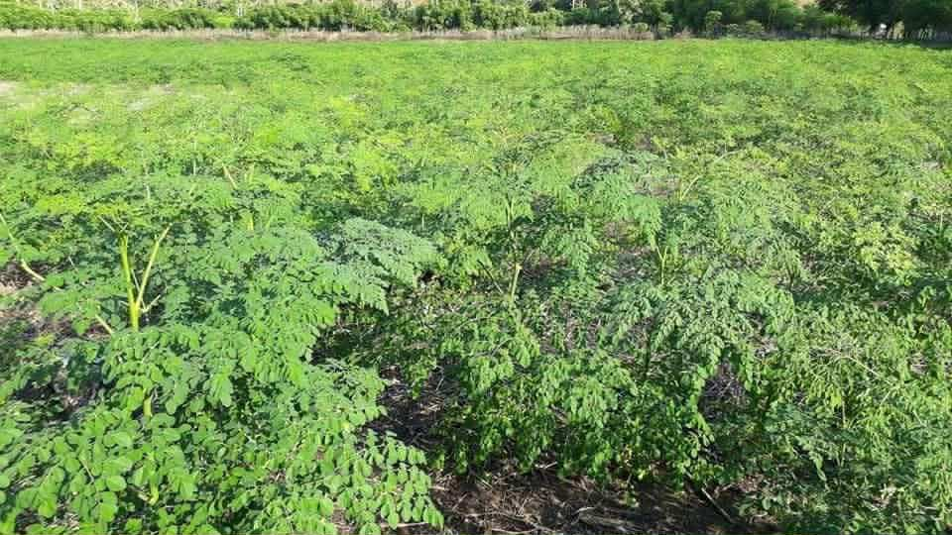
• ?? hectare (?? acre) farm in Indonesia.
• Washing by Ozone Water before drying
• Certification by USDA
• Organic Certification (certificate photo)

