Moringa Powder Raw Info

WebMD

Overview
Moringa is a plant native to India and other countries. It contains proteins, vitamins, and minerals, making it useful to fight malnutrition.
Moringa is an important food source in some parts of the world. It can be grown cheaply and easily, and retains much of its nutritional value when dried. As an antioxidant, it seems to help protect cells from damage. Moringa might also help decrease inflammation and reduce pain.
Moringa is used for asthma, diabetes, breast-feeding, and many other purposes, but there is no good scientific evidence to support these uses.

Uses & Effectiveness

Insufficient Evidence for
- Asthma. Early research shows that taking 3 grams of moringa twice daily for 3 weeks reduces the severity of asthma symptoms and improves lung function in adults with mild to moderate asthma.
- Diabetes. The effect of moringa on diabetes control is unclear. Some early research shows that taking moringa tablets along with a type medicine called sulfonylureas does not improve blood sugar control as measured by hemoglobin A1C levels. But it does seem to reduce fasting and post-meal blood sugar levels compared to taking sulfonylureas alone in people with diabetes. Other research also shows that ttaking moringa drumstick leaves with meals might also reduce post-meal blood sugar levels in people with diabetes not taking medications for diabetes.


How CFOs can get ahead in 2025
Sponsored By SAP Concur
Learn more
- HIV/AIDS. Early research shows that taking moringa leaf powder with each meal for 6 months might increase body mass index (BMI) but does not appear to improve immune function.
- High levels of cholesterol or other fats (lipids) in the blood (hyperlipidemia). The effect of moringa on lowering cholesterol levels is not clear. Early research of poor quality shows mixed results. Additional research is needed.
- Breast-feeding. Research regarding the effects of moringa for increasing breast milk production is mixed. Some early research shows that moringa increases milk production after one week of use, while other early research shows no benefit. It's also not clear if moringa is beneficial when used for longer periods of time.
- A condition caused by a poor diet or the body's inability to absorb nutrients. Early research shows that adding moringa powder to food for 2 months helps improve weight in malnourished children.
- Symptoms of menopause. Early research shows that adding fresh moringa leaves to food for 3 months improves menopausal symptoms such as hot flashes and sleeping problems in healthy, postmenopausal women.
- Vitamin A deficiency. Early research shows that adding moringa powder to infant cereal doesn't improve vitamin A levels in infants with low levels of vitamin A.
- A mild form of gum disease (gingivitis).
- Athlete's foot (Tinea pedis).
- Birth control.
- Cancer.
- Certain infections (opportunistic infections) in people with HIV/AIDS.
- Constipation.
- Dandruff.
- Diarrhea.
- Headache.
- Heart disease.
- Heart failure and fluid build up in the body (congestive heart failure or CHF).
- High blood pressure.
- Increasing sexual desire in healthy people.
- Infection of the intestines by parasites.
- Kidney stones.
- Low levels of red blood cells in people with a long-term illness.
- Obesity.
- Osteoarthritis.
- Overactive thyroid (hyperthyroidism).
- Seizure disorder (epilepsy).
- Skin infections.
- Snakebites.
- Stomach ulcers.
- Swelling (inflammation) of the stomach (gastritis).
- Warts.
- Wound healing.
- Other conditions.
More evidence is needed to rate moringa for these uses.

Side Effects
When taken by mouth: Moringa is likely safe when the leaves, fruit, and seeds are eaten as food. Moringa leaf and seeds are possibly safe when used as medicine, short term. Products containing moringa leaf have been used for up to 6 months. Products containing moringa seed have been used for up to 3 weeks. Moringa root and root bark are possibly unsafe. The roots and root bark contain toxic substances.
When applied to the skin: Moringa leaf is possibly safe when used on the skin, short term. A product containing moringa leaf extract has been used for up to 3 months.

Special Precautions and Warnings
When taken by mouth: Moringa is likely safe when the leaves, fruit, and seeds are eaten as food. Moringa leaf and seeds are possibly safe when used as medicine, short term. Products containing moringa leaf have been used for up to 6 months. Products containing moringa seed have been used for up to 3 weeks. Moringa root and root bark are possibly unsafe. The roots and root bark contain toxic substances.
When applied to the skin: Moringa leaf is possibly safe when used on the skin, short term. A product containing moringa leaf extract has been used for up to 3 months.

Pregnancy: It is possibly safe to use moringa leaves in pregnancy during the second or third trimester. But it's possibly unsafe to use the root, bark, or flowers of moringa when pregnant. Chemicals in the root, bark, and flowers might make the uterus contract. In traditional medicine, the root and bark were used to cause miscarriages. There isn't enough reliable information to know if other parts of moringa are safe to use when pregnant. Stay on the safe side and avoid use.
Breast-feeding: Moringa leaf is possibly safe to use while breastfeeding for up to 4 months. There isn't enough reliable information to know if other parts of moringa are safe to use when breast-feeding. Stay on the safe side and avoid use.
Children: Moringa leaf is possibly safe when taken by mouth, short-term. Moringa leaf has been used with apparent safety in children for up to 2 months.
Hypothyroidism: Using moringa might make this condition worse.

Interactions

Moderate Interaction
Be cautious with this combination

Medications changed by the liver (Cytochrome P450 3A4 (CYP3A4) substrates) interacts with Moringa
Some medications are changed and broken down by the liver. Moringa might change how quickly the liver breaks down these medications. This could change the effects and side effects of these medications.

Levothyroxine (Synthroid, others) interacts with Moringa
Moringa might decrease how much levothyroxine the body absorbs. Taking moringa along with levothyroxine might decrease the effects of levothyroxine.

Medications moved by pumps in cells (P-glycoprotein substrates) interacts with Moringa
Some medications are moved in and out of cells by pumps. Moringa might change how these pumps work and change how much medication stays in the body. In some cases, this might change the effects and side effects of a medication.

Minor Interaction
Be watchful with this combination

Medications for diabetes (Antidiabetes drugs) interacts with Moringa
Moringa might lower blood sugar levels. Taking moringa along with diabetes medications might cause blood sugar to drop too low. Monitor your blood sugar closely.

Medications changed by the liver (Cytochrome P450 1A2 (CYP1A2) substrates) interacts with Moringa
Some medications are changed and broken down by the liver. Moringa might change how quickly the liver breaks down these medications. This could change the effects and side effects of these medications.

Nevirapine (Viramune) interacts with Moringa
Moringa might decrease how quickly the liver breaks nevirapine. This might increase the effects and side effects of nevirapine. But it's not clear if this is a real concern.

Dosing
Moringa is an important food source in some parts of the world. The immature green pods (drumsticks) are prepared similarly to green beans, while the seeds are removed from more mature pods and cooked like peas or roasted like nuts. The leaves are cooked and used like spinach, and they are also dried and powdered for use as a condiment.
Moringa is also available in supplements. Moringa leaves and seeds have most often been used by adults in powders or extracts, in doses of 6-10 grams by mouth daily. Speak with a healthcare provider to find out what dose might be best for a specific condition.

Good Housekeeping

10 Surprising Research-Backed Health Benefits of Moringa
It has anti-aging properties, but that's just the beginning of what it can do for your body.
By Valerie Agyeman, R.D. Nov 4, 2025
Medically reviewed by Stefani Sassos, M.S., R.D.N., NASM-CPTNutrition & Fitness Lab Director
Save Article

fcafotodigital//Getty Images
We've been independently researching and testing products for over 120 years. If you buy through our links, we may earn a commission. Learn more about our review process.

Jump to:
- What is moringa?
- Benefits of moringa
- FAQ
- The bottom line
Moringa oleifera — often called the “drumstick tree,” “tree of life,” or even the “miracle tree,” has earned a reputation as one of the most nutrient-dense plants in the world. Packed with essential amino acids, fiber, vitamins, minerals, and phytonutrients, it’s a plant that offers both nutrition and versatility.
Though native to Northern India and East Africa, Moringa has 13 species in total, with only a few studied in modern research. “Among the 13 species, current studies focus on Moringa oleifera, Moringa stenopetala, Moringa concanensis, and Moringa peregrina,” explains Jerlyn Jones, M.S., M.P.A., R.D.N., certified LEAP therapist and owner of The Lifestyle Dietitian.
Moringa’s history stretches back thousands of years. “Its benefits were recognized long ago when it was used in Ayurveda over 4,000 years ago,” says Isabel Smith, M.S., R.D., C.D.N., Integrative Dietitian and Founder of Isabel Smith Nutrition. From ancient Greeks and Romans to the Mauryan warriors of India, moringa leaves were consumed to boost energy, strength, and vitality.
Today, Moringa oleifera is grown and consumed around the globe, its remarkable nutritional profile and storied history making it a plant that bridges tradition and modern wellness. While scientists are still studying exactly how moringa affects our health, it’s easy to see why this nutrient-packed plant has everyone talking. Here’s what you should know before adding it to your routine.
Advertisement - Continue Reading Below

More From Good HousekeepingSunscreen | Good to Know | Good Housekeeping
Watch: Sunscreen | Good to Know | Good Housekeeping
UNMUTE

What is moringa?
Every part of the Moringa plant is edible. “Moringa oleifera leaves, seeds, bark, roots, sap and flowers are widely used in traditional medicine and the leaves and immature seed pods are used as food products,” says Jones. The most used part of the plant is the edible leaves and in the United States, the dried leaves are sold as dietary supplements either in a powdered or capsule form.

Benefits of moringa
Modern medicine continues to confirm many of its nutritional and health benefits. Below are the top health benefits of moringa and creative ways to use it. Just keep in mind that the benefits may depend on how much moringa you consume.

1. It's extremely nutritious
“Moringa leaves are one of the most nutrient-dense greens on the planet, packed with protein, essential amino acids, vitamins and antioxidants,” says Lisa Curtis, Founder and CEO of Kuli Kuli Foods. That includes key nutrients like calcium, iron, B vitamins, potassium, magnesium and vitamin C. Overall, "moringa is rich in macro- and micronutrients and other bioactive compounds"which are important for the normal functioning of the body and prevention of many diseases," according to research.

2. It helps fight inflammation
Inflammation is a physiological response that happens in the body to protect against infection and restore body tissue injury, but chronic inflammation can contribute to health issues like heart disease. “Moringa contains inflammation-fighting nutrients including phytonutrients, antioxidants and antibacterial compounds,” says Smith. Together, these powerful compounds fight inflammation in the body by targeting free radicals (compounds that damage cells) and as a result reduces oxidative stress, inflammation and fights disease. “Two compounds of note are quercetin, a potent antioxidant and anti-inflammatory agent, and isothiocyanates, which aid in detoxification and have anti-inflammatory effects,” Smith says. One study suggests that these specific compounds found in moringa may help alleviate low-grade inflammation associated with chronic diseases.

Related Stories

3. It might enhance your sex drive
Did you know that stress can negatively impact sexual function? It can throw libido out of whack by increasing cortisol and decreasing the feel-good hormone, dopamine. Sexual function is a very complex process that involves the brain, hormones, emotions, nerves and muscles, which are very sensitive to stress. Many herbs known to be considered aphrodisiacs have long been used to enhance libido — and moringa might be one of them. “Animal studies found that moringa may boost testosterone and reduce cortisol, thereby supporting libido,” says Smith. According to one animal study, moringa leaves may have beneficial effects on male sexual dysfunction induced by stress. However, experts caution that these findings are preliminary, and human studies are still needed before drawing firm conclusions, notes Jones.
Advertisement - Continue Reading Below

4. You’ll may feel more energized
If you’re looking for an energy boost that is caffeine-free, you might want to consider moringa in your morning routine. “It’s rich in vitamins and minerals, especially iron and vitamins C and D, nutrients involved in energy-yielding metabolism,” Jones says. Moringa also contains B vitamins which helps sustain long-term energy and supports healthy metabolic processes. In fact, one investigation found that moringa helps regulate mitochondria (a part of many of our cells that is involved in energy production) by regulating calcium levels and bolstering the mitochondrial membrane. And the great news is you won’t be left with energy crashes, jitters or anxious feelings, which are common side effects of caffeinated beverages.

5. It could support cognition and mood
The extract of plants like moringa and its effect on enhancing cognition and mood continues to be studied in animals. Moringa may boost cognition given its amino acid and vitamin profile. “It contains tryptophan, a precursor to serotonin, aka the happiness hormone,” Smith says. This feel-good hormone works in the reward centers of your brain and “improves learning, motor function and memory,” Curtis says. You’ll find both vitamins C and E in moringa, potent antioxidants that help reduce oxidative damage to the brain, a major player in the development of some cognitive disorders. While these findings are promising, more human studies are needed to confirm the effects.

6. It helps balance blood sugar
This edible plant might keep your blood sugars stable for the better. “Moringa is believed to aid in blood sugar balance thanks to its chlorogenic acid and isothiocyanates,” Smith says. Chlorogenic acid can potentially control blood sugar levels by regulating the cells uptake or release of glucose (sugar) following a meal. Smith adds that “studies have supported the use of moringa to aid in blood sugar balance with positive effects on fasting blood sugar levels, insulin levels, HbA1c and overall blood glucose control in those that consume moringa powder."
Getty Images
Advertisement - Continue Reading Below

7. It has anti-aging properties
Although there’s no shame in aging, moringa is packed with antioxidants like flavonoids and polyphenols, which may combat premature wrinkles and keep your skin looking youthful when it's applied topically, according to early research. “Its compounds have powerful anti-inflammatory effects and its anti-aging benefits on skincare are promising but additional research is needed,” Jones says. However, current evidence is still preliminary and mostly based on lab studies, so human trials are needed to confirm these effects.

8. It may reduce blood pressure
If you struggle with high blood pressure, early research including a small study suggests that adding moringa to your diet regularly might make a difference, especially when your routine includes exercise and a nutrient-rich diet. Moringa powder has anti-hypertensive properties because it contains quercetin. “This antioxidant decreases oxidative stress on the heart and helps to stabilize blood pressure management systems in the body,” says Curtis. If you are taking blood pressure medications, you’ll want to speak to your healthcare provider before considering moringa as it may result in your blood pressure becoming too low.

9. It could help with digestion
If you struggle with digestive problems like constipation, the fiber found in moringa may help keep you regular, research on animals suggests. “It contains soluble fibers as well as insoluble fibers,” Curtis says. Both forms of fiber have many health benefits, especially for digestion. Soluble fiber dissolves in water and turns to gel, slowing digestion and keeping you fuller for longer, while insoluble fiber adds bulk to the stool, making it much easier to pass through the digestive tract, therefore reducing constipation. Not only that, moringa’s nutrition profile contains compounds that help promote the beneficial bacteria in the gut.

10. It might improve cholesterol
Having healthy cholesterol levels is crucial in preventing heart disease. The good news is that “moringa has the potential to decrease cholesterol,” Smith says. According to one animal study, a high-fat diet combined with daily moringa leaf extract for 30 days resulted in a 14% drop in serum cholesterol, with smaller reductions in liver and kidney cholesterol. While these findings suggest moringa has hypocholesterolemic (cholesterol-lowering) properties, more research is needed to confirm its effects in humans, Smith notes."

FAQ

Can moringa help with weight loss?
Currently, there is no solid research showing that supplementing with moringa is a surefire way for humans to lose weight. However, one study found that Moringa oleifera seed extract may prevent weight gain in rats who are fed a high-fat diet while another research review found that it helped regulate satiety hormones in animals. Lab research like this can be difficult to replicate in humans so although morgina is called the "miracle tree," it's way too early to consider it a miracle supplement for weight loss.

Does moringa have side effects?
Moringa is a powerful plant and when consumed in large quantities, some people may experience stomach upset, abdominal pain or other digestive issues. “If you're pregnant or nursing, avoid consuming moringa as the chemicals found in the root, bark and flowers can be harmful,” Smith says.
Advertisement - Continue Reading Below

Additionally, moringa may have interactions with some medications. If you’re interested in giving moringa a try, it's best to consult with your healthcare provider before adding it to your everyday routine. Some experts recommend starting with a small dose, like half to one teaspoon per day. Jones adds that research shows, “over 70 grams of moringa daily may cause vitamin and mineral toxicity.”

How to shop for moringa
In the U.S., moringa is commonly found in a powder or supplement form. It’s always best to read the instructions on the food package on how to safely use moringa. If you want to experiment with the leaves and pods you’ll likely find it at an international market. Here are some tips to consider when buying and using moringa:
- Look for organic, 100% pure moringa leaves.
- Choose brands that have been third-party tested (by organizations like USP or NSF) to ensure purity and accurate labeling.
- Moringa leaf powder should be stored in an air-tight container in a cool and dark environment.
- Look at the expiration date and shelf-life; it's best used within six months of harvesting.

How to use moringa powder
Moringa is versatile and can be added to a variety of recipes, from meals to snacks and beverages, too. Moringa has a similar taste to matcha (green tea ground into a powdered form). It’s tough to characterize, but it has been described as having an earthy, grassy or green flavor. “Some folks enjoy the taste of moringa while others prefer to combine it with stronger and sweeter flavors, allowing the moringa to take on a more complementary role,” says Curtis. Here are a few ideas to try out:
- Add to your morning smoothie
- Sprinkle in hummus
- Add to guacamole or your favorite dip
- Add to soups and salads
- Stir into a pasta sauce or pesto
- Bake into cookies and cakes
- Make tea by adding the leaves to hot water, steep and add your favorite sweetener

Related Stories

The bottom line
Overall, moringa is a nutrient-dense plant that offers many health benefits when consumed regularly. It's versatile, making it a great addition to numerous recipes. Research is limited and more human studies are needed to support the health claims. Talk to your healthcare provider before adding moringa to your daily regimen.

Live It Up Blog

What Is Moringa Powder, and What Does It Do?
Moringa powder has been used as a remedy for centuries. Filled with vitamins and antioxidants, here are its potential benefits and how to use it in your daily life.

By Rachel Rodek Gargano, MS, RD, CSSD, CBS
— On
In this article:
Share Tweet Pin it
Share on Facebook
Tweet on Twitter
Pin on Pinterest
It may seem like new healthy foods are everywhere these days. And though many of these foods and supplements can help you feel healthier, there are also a lot of false claims to sort through.
Moringa leaf powder is one of these trendy health foods that has become popular in the wellness world. The moringa tree is native to Asia, Africa, and Latin America and has been used for thousands of years in ayurvedic and herbal medicine. There are so many possible health benefits attributed to Moringa oleifera that the tree has earned the nickname "miracle tree." Other names for this tree include the drumstick tree and the horseradish tree.
Antioxidant-filled, nutrient-dense, and a plant-based source of protein, there is a seemingly endless list of ways moringa leaf supplements may help you feel your best. Here’s a closer look at what moringa could do for you, its purported benefits, how to use it, and possible side effects. We will also cover the importance of finding a superfood dietary supplement to get your daily moringa and other supplements.
"I have tried a lot of greens but this is by far the best. I drink mine with milk every Morning using a hand mixer so it's frothy and cold. I see a difference in my digestive system since I started drinking it. I highly recommend the product and get it on the subscription as it sells out fast and you have to wait. Well worth the money."
Debra S, United States, September 2022
Verified review
Try Super Greens today →

The Bottom Line
- What is moringa powder? Moringa oleifera contains essential vitamins and nutrients, has been used for centuries as an herbal supplement, and is emerging as one of many dietary plant compounds.
- What are the benefits of moringa powder? The possible health benefits include regulating hormone levels, alleviating stress, assisting digestion, supporting immunity, defending against free radicals, and strengthening hair and nails.
- What are the side effects of moringa powder? Since there is not much research on moringa leaf, experts recommend consulting your physician before adding it to your diet.
- How to use moringa powder. Moringa powder can be taken in a capsule or as part of a dietary powder.
- Why we recommend Live it Up Super Greens. Live it Up Super Greens is a dietary supplement with moringa leaf and other nutritionally dense superfoods that was created to help make getting your essential vitamins and minerals easy.

What Is Moringa Leaf?
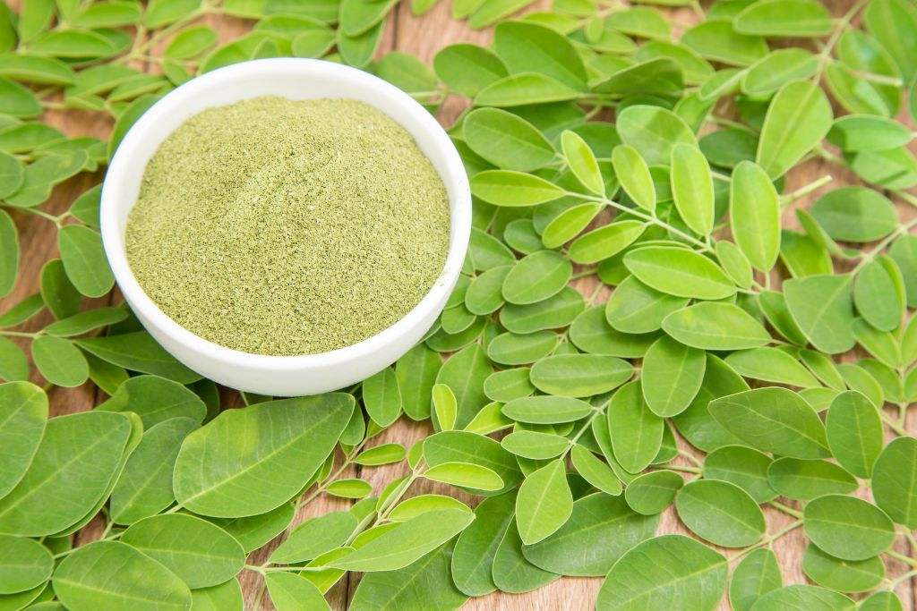
This health food powder comes from the leaves of Moringa oleifera, also known as the Moringa oleifera tree, drumstick tree, miracle tree, or horseradish tree. Native to Asia, Africa, and South America, the moringa tree has been used as an herbal remedy in Ayurvedic medicine for thousands of years.
Though more research is needed on the health claims of moringa leaf and its uses in traditional medicine, many scientists and dietitians agree that it could harness incredible nutritional value and host a number of potential health benefits.
Every part of this miracle tree is edible, but the moringa leaves are most frequently made into a superfood powder after being dried. Depending on whether you opt for capsule supplements or a dietary powder, moringa leaf powder does not need to be refrigerated and can last on a shelf for months. Other parts of the drumstick tree that have historically been used in herbal medicine include Moringa oleifera seeds and Moringa oleifera root extract.
In recent years, the many possible nutritional benefits of moringa powder have made it a popular supplement for its high concentration of antioxidants, vitamins, minerals, and macro and micro-nutrients.

What Does Moringa Powder Do?
Since all parts of the moringa tree have many of the essential vitamins and nutrients needed to support the body’s functioning, moringa is used in different ways around the world.
Perhaps the most common form is moringa leaf powder. Studies have shown that the powder is the most nutritionally dense form of Moringa oleifera. Just 100 grams of the powerhouse moringa leaf powder provides vitamins C, B, E, and riboflavin, plus essential minerals to help with the body’s functioning. These minerals include zinc, magnesium, potassium, and iron.
A recent study even showed that Moringa oleifera contains a higher concentration of vitamins C, E, and iron than oranges and other nutrient-dense foods. These vitamins and minerals may help with improving immune function, sleep, fighting off infections, and hormone regulation.
If the high concentration of vitamins isn’t enough benefit, moringa leaf powder is also an ample source of antioxidants. These substances may help the body neutralize free radicals that can lead to oxidative stress, which can be harmful to cells and hinder body function.
Since the body is exposed to free radicals every day (think air pollution, alcohol, and sun exposure), Moringa oleifera may be a useful addition to your diet.

What Is Moringa Powder Used for?
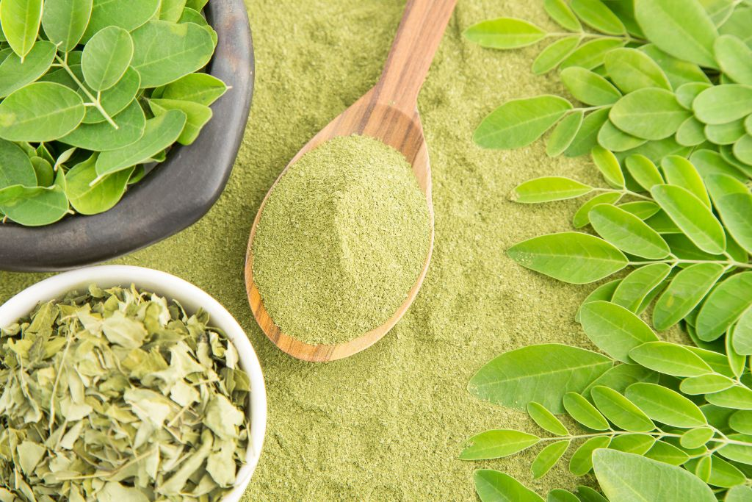
Because of its high concentration of vitamins and minerals, moringa has been employed to help with a range of health challenges. In Senegal and Benin, moringa extract was used to help with malnutrition in children because of the plant’s powerful nutritional and antioxidant properties.
Aside from being used as an herbal therapy for malnutrition, moringa leaf may be helpful against inflammation caused by infections or injuries. Moringa also contains isothiocyanates, compounds that may assist the body’s recovery processes. Just 100 grams of the powder also provides 27 grams of plant-based protein, equal to nine times the protein found in yogurt.
Although the many possible uses of moringa leaves are far-reaching, there is little scientific data supporting their effectiveness in humans compared to animals. Further study is required to substantiate these claims. So, it’s important to know that even with its many potential nutritional benefits, moringa powder cannot be used as a tried-and-true remedy for serious illnesses and health challenges.

What Are the Potential Benefits of Moringa Powder?
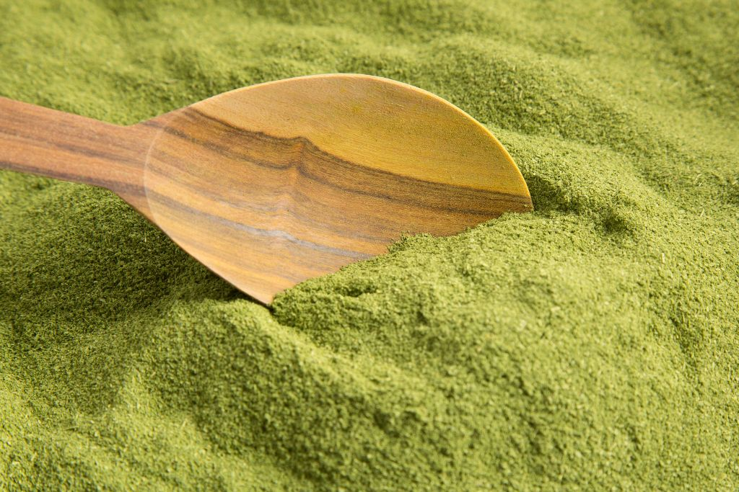
Because of the many vitamins, minerals, and antioxidants in the moringa tree, moringa leaves offer a wide range of possible benefits to your body's wellness. Remember that Moringa oleifera is not a single solution for many health challenges and should accompany advice from your doctor.

Here’s a look at some possible health benefits of taking moringa powder:
- Moringa powder may help reduce inflammation because of its high antioxidant properties and vitamin C concentration.
- Moringa leaf extract is rich in vitamin C, which may support immune function and aid in maintaining your body’s defenses against free radicals.
- Some experts link moringa leaves to assist with brain function and memory.
- Moringa powder also has antibacterial properties, which may help support the body’s natural defenses.
- Studies link moringa leaf powder to aiding respiratory function.
- Protein-dense moringa leaves may support the growth of strong hair and nails.
- Moringa powder may support liver health by helping with liver damage.
Moringa may help balance hormones linked to women’s health, thyroid health, digestion, and sleep.

What Are the Possible Side Effects of Moringa Powder?
Even though Moringa oleifera has an endless number of potential benefits, that doesn’t mean it is perfect. Like all things, there are some side effects you may experience with this superfood supplement. Here’s what you should be aware of before adding moringa leaf into your daily routine:
- Moringa may contain chemical compounds harmful to pregnant women or people who are nursing.
- Large quantities of moringa leaf may have a laxative effect on the body or cause an upset stomach.
- Some experts warn against taking moringa leaf if you’re also taking thyroid medication. Be sure to check if moringa may negatively interact with any medications you’re taking.

How to Use Moringa Powder
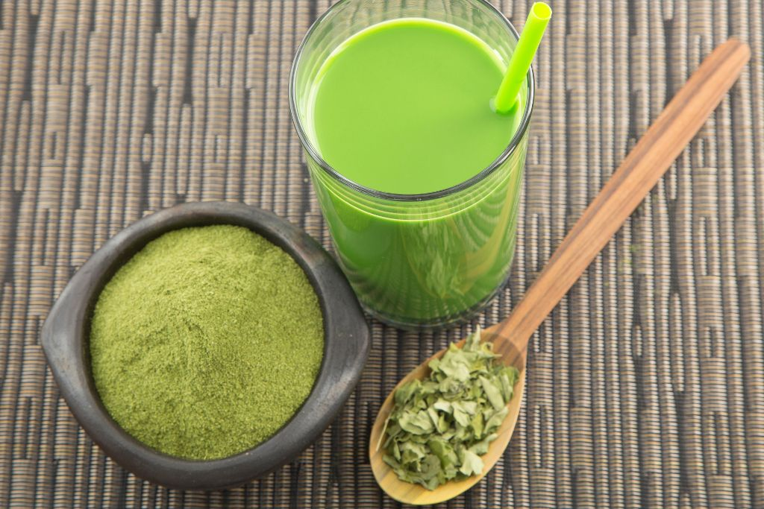
Moringa oleifera is easy to incorporate into your diet. Some people opt for moringa extract capsules that you take as a vitamin or try moringa powder—this form can be blended into smoothies, stirred into juice, or sprinkled on top of your meal.
One of the easiest ways to get the proper amount of moringa powder is by opting for a dietary supplement. You could opt for tableted supplements or a supergreens powder that contains moringa alongside other superfoods that can support your physical and mental wellness.
10% OFF with code:

Try Super Greens today →

Why We Recommended Live it Up
Finding ways to incorporate superfoods into your daily diet can be difficult, especially if you want to eat lesser-known health foods like Moringa oleifera. That’s why some people opt for superfood powders like Live it Up Super Greens.
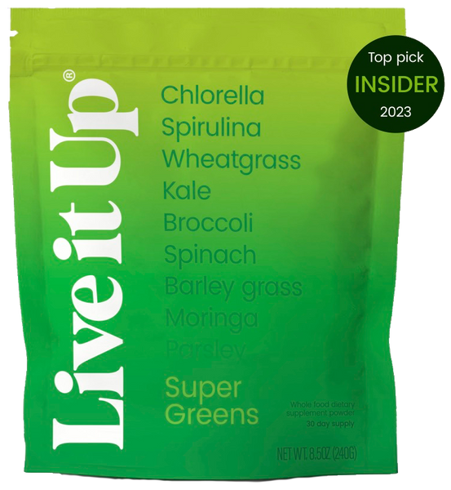
Moringa is nutritionally dense by itself, but when paired with probiotics and other essential nutrients, this plant-based supplement becomes a nutritional powerhouse. Live it Up's unique green supplement blend makes it easy to get essential nutrients without any of the added sugars or preservatives that are often found in other dietary supplements—just add one scoop to your daily smoothie or juice.
What’s more, the brand demystifies common wellness lingo. Every ingredient in the natural dietary supplement is stated on the label. Or, visit their website for a deeper look at the possible health benefits of the selected greens and superfoods.
Opting for Live it Up Super Greens also makes getting your greens delicious. Whether you are kale-adverse, can’t stand the smell of nutritional supplements, or don't want to worry about finding moringa powder at your local store, Live it Up’s powder packs delicious flavor so that eating healthy isn’t a chore.

Frequently Asked Questions
Moringa oleifera is popular in the health food world but still relatively unknown on a larger scale. To help you decide if moringa leaf is right for you, here are the answers to the most frequently asked questions we hear.

What does moringa powder do?
Moringa leaves are filled with essential vitamins, minerals, antioxidants, and protein to support everyday health functions. Experts have linked the superfood to assisting immune function, reducing inflammation, and fighting free radicals.

What is moringa powder used for?
For thousands of years, Moringa oleifera has been used traditionally to aid malnutrition, support the immune system, hormone regulation, sleep, digestion, and more.

Is moringa powder good for you?
Moringa oleifera is generally considered safe for most people and has nutrients that are essential for keeping your body healthy. One tablespoon of the superfood powder contains three grams of protein, 120 mg of potassium, 182 mg of calcium, and 20.5 mg of iron.
This superfood also has antioxidant properties and other essential vitamins, including high levels of vitamin C.

How much moringa powder should you take per day?
Depending on which form you choose, experts recommend a daily serving of two to six grams of moringa leaf. Try not to exceed this limit, since high doses of Moringa oleifera can have laxative side effects or lead to an upset stomach.

References
- https://www.ncbi.nlm.nih.gov/pmc/articles/PMC8373516/
- https://www.sciencedirect.com/science/article/pii/S2213453016300362#:~:text=In%20fact%2C%20moringa%20is%20said%20to%20provide%207%20times%20more%20vitamin%20C%20than%20oranges%2C%2010%20times%20more%20vitamin%20A%20than%20carrots%2C%2017%20times%20more%20calcium%20than%20milk%2C%209%20times%20more%20protein%20than%20yoghurt%2C%2015%20times%20more%20potassium%20than%20bananas%20and%2025%20times%20more%20iron%20than%20spinach
- https://www.ncbi.nlm.nih.gov/pmc/articles/PMC4944358/
- https://www.sciencedirect.com/science/article/pii/S2213453016300362#bbib0360
- https://www.ncbi.nlm.nih.gov/pmc/articles/PMC8373516/#B14:~:text=9%20times%20more%20protein%20than%20yoghurt
- https://oamjms.eu/index.php/mjms/article/view/8381#:~:text=Moringa%20oleifera%20leaf%20extract%20showed%20the%20anti%2Dinflammatory%20effect%20on%20inflammation%20induced%20by%20the%20bacterium%C2%A0P.%20gingivalis.%C2%A0M.%20oleifera%20extract%20can%20reduce%20the%20production%20of%20the%20pro%2Dinflammatory%20cytokine%20IL%2D6%20induced%20by%C2%A0P.%20gingivalis%20bacteria%20in%20periodontitis.
- https://journals.humankinetics.com/view/journals/ijsnem/7/1/article-p1.xml
- https://www.ncbi.nlm.nih.gov/pmc/articles/PMC3884855/#:~:text=The%20current%20results%20suggest%20that%20M.%20oleifera%20leaves%20extract%20possesses%20the%20neuroprotective%20and%20memory%20enhancing%20effects.
- https://www.sciencedirect.com/science/article/pii/S0254629922005117#sec0003
- https://www.ncbi.nlm.nih.gov/pmc/articles/PMC3023118/
- https://www.internationaltreefoundation.org/news/moringa-the-miracle-tree
- https://www.medicalnewstoday.com/articles/319916#:~:text=Protecting%20the%20liver,less%20inflammation%20in%20their%20liver.
- https://www.ncbi.nlm.nih.gov/pmc/articles/PMC3336641/pdf/ASL-7-172.pdf
About the author:
Rachel Rodek Gargano, MS, RD, CSSD, CBS
Rachel is a registered dietitian based in Contra Costa County, California, with over 15 years experience. She specializes in whole-body wellness and plant-based nutrition, helping people understand the dynamic interplay between food and health so they can live life to the fullest. When not helping others, she enjoys spending time with her kids, being physically active, and tending to her abundant household plants.
Learn more

