Food Manufacturers for Moringa | Green Power US White Paper

Manufacturers’ Representatives
- Herspring-Gibbs LLC, 368 Earhart Way, Livermore, CA 94551, (925) 552-0220, Home, About, Contact

Food Manufacturers

Pizza
- International Pizza Expo, Las Vegas, March 24-26, 2026 Web, Exhibitors

Pasta
- USA
  - RP's Pasta Co: Emphasizes using high-quality ingredients and traditional methods to create artisan pasta. Known for making fresh, artisan pasta with unique flavors and high-quality ingredients. About RP Madison, Wisconsin Products include spinach fettuccine and linguini.
  - Flour Pasta Company: An artisan pasta producer that focuses on creating high-quality pasta from various flours. Located in Moreland Hills, Ohio. About FPC.
  - Ronzoni: A company with a long history in the US (it is a division of Post, the largest cereal manufacturer); it has a wide range of pasta products. Some that may be considered boutique-style. About Ronzoni.
  - Medallion Foods, a division of Nisshin Seifun Welna Inc, manufacturers pasta and tempura mix in Tacoma (Frederickson) Washington.
- Canada
  - Italpasta: Offers custom private label solutions and a range of pasta shapes, catering to both large and small-scale needs. Facilities located in Brampton, Ontario, are certified SQF Food Safety Code: Food Manufacturing Edition 9 and Storage and Distribution Edition 9. About Italpasta.
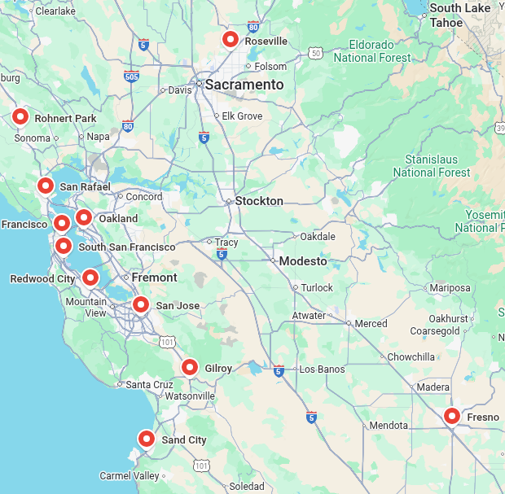
- Northern California
  - Pasta Sonoma, Rohnert Park: Since 1987, Pasta Sonoma now crafts high-quality pasta for leading retailers, small specialty stores, gift baskets and private label customers. Consistently using only the freshest American-grown wheat, highest grade premium flour, and time-honored Italian production and drying methods. About Pasta Sonoma.
  - Eduardo’s Pasta Company, San Francisco
  - Fiore Di Pasta, Fresno, 4774 E Jensen Ave, Fresno, CA 93725, (559) 558-8233, Spinach Pasta
  - Mill Valley Pasta Company Factory Store, San Rafael, Way in Back Next to Pho Viet, 555 Francisco Blvd E suite 24, San Rafael, CA 94901, (415) 755-4186, Contact, Yelp: Mill Valley Pasta Co. is a small artisan pasta producer specializing in dried pastas, pasta sauces, non-dried (fresh) pastas, and pasta-adjacent provisions.
  - Bigoli Fresh Pasta, Sand City, 426 Orange Ave, Sand City, CA 93955 (Monterey NE), (831) 899-4422, Wholesale
  - Pasta Shop (Wholesale), Oakland, 6050 Lowell St, Oakland, CA 94608, (510) 547-1423, About
  - Pasta Supply Co, San Francisco, Contact
  - Home Maid Ravioli, 360 Shaw Rd, South San Francisco, CA 94080, (650) 588-0600, Yelp (No Website)
  - Saporito Pasta, 1020 Hansen Way Ste C, Redwood City, (650) 361-1325, Web: Dating back to 1900 in Lucca, Italy, operations moved to the San Jose area in 1938. They offer nineteen pasta shapes in four formulations, including Whole Wheat Fettuccine to the pro-sumer market. Contact
  - Il Pastaio Foods, 1266 E Julian St, San Jose, (408) 753-9220, About, Wholesale only
  - Nate’s Fine Foods, 8880 Industrial Ave Suite 100,Roseville, 916-742-7612, Contact, Industrial Supply
  - Monterey Gourmet Foods, 5755 Rossi Ln A, Gilroy, (831) 753-6262, Contact (No Pasta)
  - Pastabiz, San Francisco About, Equipment Manufacfturer
- Southern California
  - Pasta Piccinini, Pasadena
  - Florentyna’s Fresh Pasta Factory, Inglewood
  - Virginia Park Foods, Riverside

