Green Power

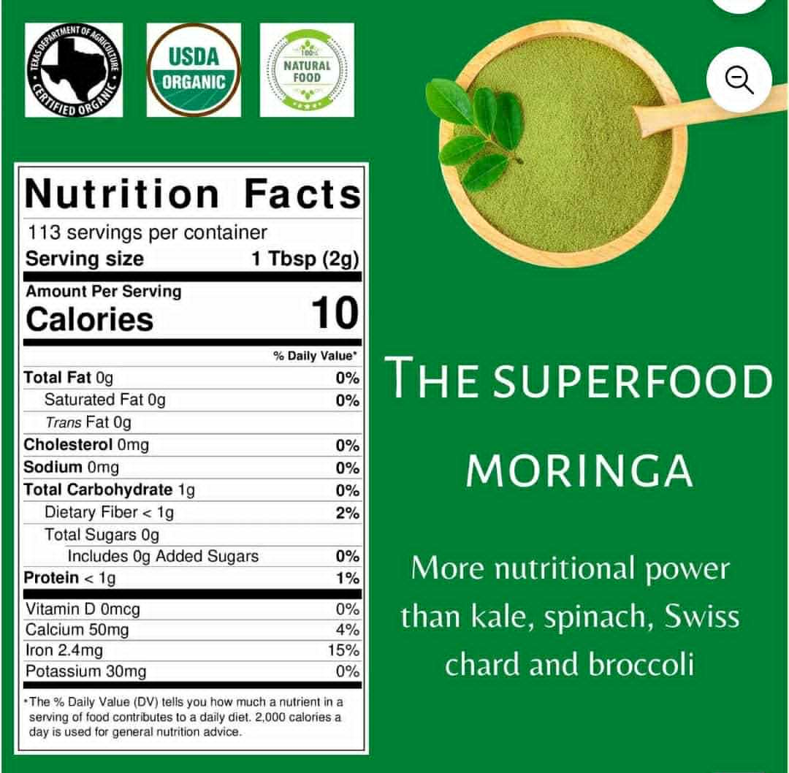
Moringa

Overview & Market Analysis

Author: Tony Otto
Seventh Draft in Progress: January 17, 2026

Introduction
According to Dr. Bill Messer, Moringa is the most vitamin dense plamt on Earth. Among its benefits:
- Used to feed starving children in Africa, see below.
- Protects and nourishes skin and hair.
- Treats Edema (swelling caused by excess fluid trapped in the body's tissues, commonly in the legs, feet, ankles, or hands).

- Protects the Liver.
- Prevents and Treats Cancer.
- Treats Intestinal Discomfort.
- Fights Bacterial Diseases.
- Improves Bone Health.
- Treats Mood Disoders.
- Protects the Cardiovascular System.
- Treats Diabetes by Lowering Blood Sugar Levels.
- Improves Asthma Symptoms.
- Gives Energy—don’t take at night.
Utilization of natural products of plant origin having fewer side effects has gained popularity over the years. There is immense scope for natural products that can intimate health benefits beyond traditional nutrients. Moringa oleifera is one such tree having tremendous nutritional and medicinal benefits. It is rich in macro- and micro-nutrients and other bio-active compounds which are important for normal functioning of the body and prevention of certain diseases. Leaves, flowers, seeds, and almost all parts of this tree are edible and have immense therapeutic properties including anti-diabetic, anti-cancer, anti-ulcer, anti-microbial, and anti-oxidant. Most of the recent studies suggested that Moringa should be used as a functional ingredient in food.
Moringa oleifera is a prominent source of nutrients and antioxidants. Like other vegetables such as spinach and fenugreek, Moringa leaves are not as popular all over the world, but currently, it is used as substitutes in soups, lentils, and other preparations in Southeast Asia. Still there is a knowledge gap in potential uses of Moringa as a food supplement and food fortification. Moringa has enormous potential uses but is very less explored. It can be utilized to make foods that could be a step towards curbing malnutrition. The published literature gives the total scenario of the chemical constituents, nutritional content, potential uses, and pharmacological activities of the plant. The identification, isolation, and standardization of plant extracts may be considered for detailed studies which can be useful for the further development of the promising food products with health benefits and nutrients to cure different life style-related diseases as well as malnutrition.
Moringa oleifera (MO) has started to focus the attention of many researchers, especially in the last decade, due to its rich nutrient content and bioactive compounds that have numerous pharmaceutical potentials.

US Market
US National Institutes of Health estimates world market for Moringa powder to be $10 Billion in 2025 with a growth rate of nearly 10% per year. Plus dietary supplements (food) at $4 Billion and 8%, oil and seed at $8 Billion and 8%, and tea at $9 Billion at 7½%. Approximately half of the world total to North America, primarily US with 30% to Europe and 20% to Asia.
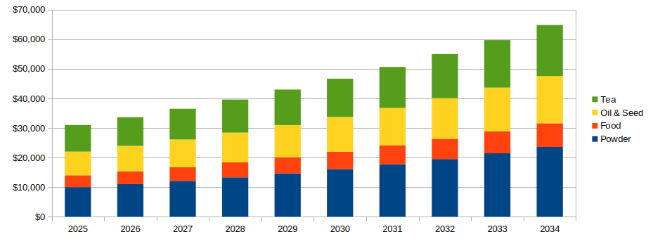Figure 1: World Wide Market 2025-34 (In Millions USD)

Moringa has enormous potential uses but is very less explored.

Trends
In recent times, people are aware about health-related issues, and they are very much interested in taking healthy and nutritious food. For instance, food which has a wide range of health benefits may prevent or cure various chronic diseases. This kind of extraordinary food is also termed as super food. It is a new field of research to identify such sources of healthy and nutritious foods. The global Moringa markets are expected to increase significantly within the near future. According to MRFR analysis report, the global Moringa product field is expected to reach 9.3% which is USD 7902.9 million by 2025. Moringa products such as oils, capsules, leaf powder, and soaps are extracted from different parts of the tree. In contrast to the global contribution, the Asia Pacific contributed the largest share of 35.30% of the Moringa product market in 2018. Australia, China, India, and New Zealand are key countries which are contributing in the growth. Asia Pacific is the largest producer of Moringa. The production in the region is mostly consumed locally due to the traditional use of Moringa in wellness, skincare, and hair care. The market in North America is expected to register a CAGR of 10.0% by 2025.

Formulations
Powder
Fine Powder
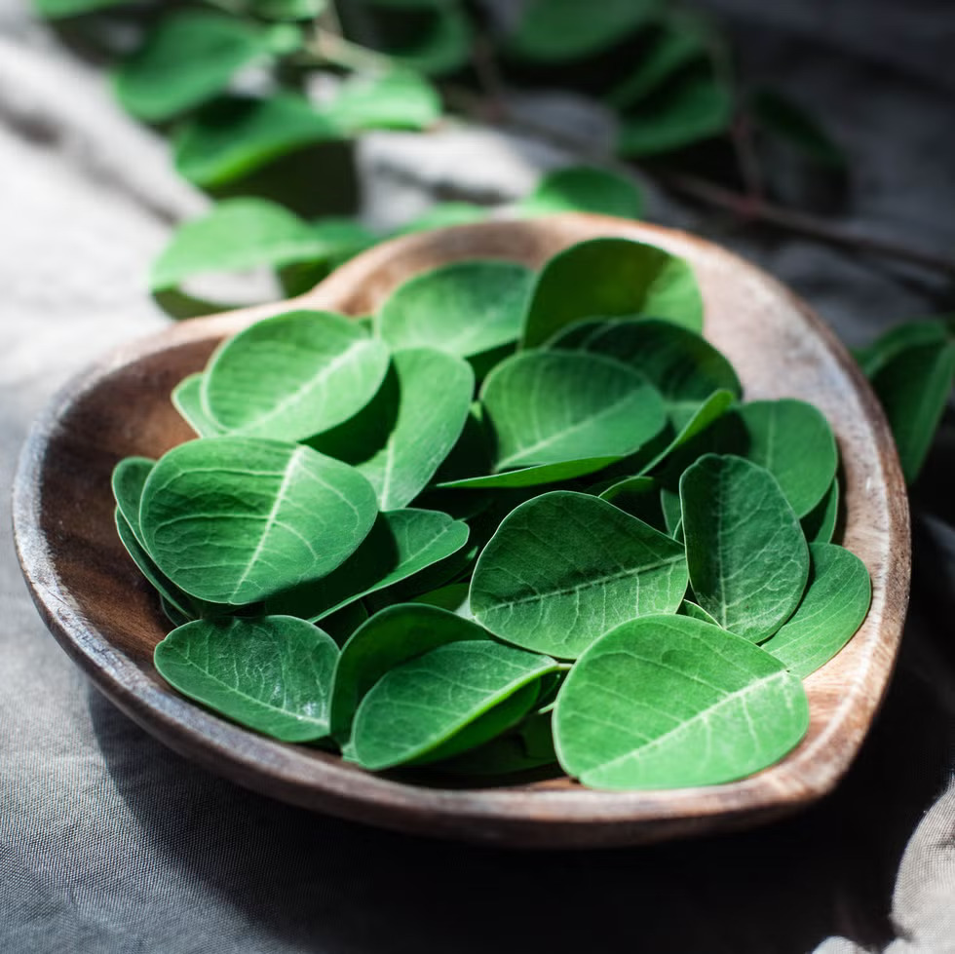
Raw Leaves
Dried Leaves
Course Shredded Dried Leaves
Oil
Seeds
Stems

Logistics
- ?? hectare (?? acre) farm in Indonesia.
  - (snap shots from video)
- Washing by Ozone Water before drying
- Certification by USDA
- Organic Certification (certificate photo)
- Export Specification (snap from PDF)
- Dealer sales units Box Size, Weight
- Wholesaler shipping container
- Boxes per 40’ standard shipping container
- No tariff on import to USA from Indonesia.1

Nutrition
Moringa is exceptionally nutritious:
- 92 nutrients including vitamins, minerals, and amino acids
- 46 antioxidants
- High protein content with all essential amino acids
- Rich in vitamins: A, C, E, and B-complex vitamins
- Mineral-rich: Calcium, iron, magnesium, zinc, and potassium
- Anti-inflammatory compounds: Isothiocyanates and flavonoids

Products

Food Recipes
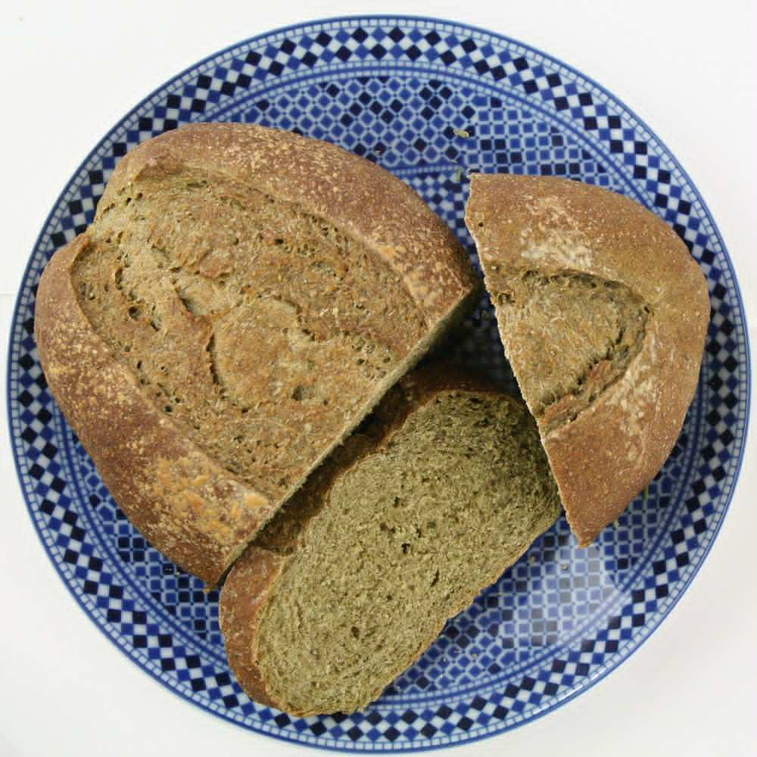
- Moringa Smoothie: banana or mango, Moringa powder, milk, honey
- Moringa Tea: Moringa powder, hot water, lemon or honey
- Moringa Leaf Soup: fresh Moringa leaves, chopped onion, garlic, tomato, broth, spices
- Moringa Curry: fresh Moringa leaves, onion, tomato, curry, coconut milk, vegetables, chicken, rice
- Moringa Egg Scramble: eggs, Moringa powder, butter, salt
- Moringa Stew: Moringa pod pieces, onion, garlic, tomato, spices (such as tumeric)
- Moringa Energy Balls: oats, peanut butter, honey, Moringa powder, nuts, raisins
- Moringa Bread or Pancakes: mix Moringa powder into batter

Health & Beauty

Recreational

Healthcare

Water Treatment

Potential US Partners

Food Producers

Pasta
- USA
  - RP's Pasta Co: Emphasizes using high-quality ingredients and traditional methods to create artisan pasta. Known for making fresh, artisan pasta with unique flavors and high-quality ingredients. About RP Madison, Wisconsin Products include spinach fettuccine and linguini.
  - Flour Pasta Company: An artisan pasta producer that focuses on creating high-quality pasta from various flours. Located in Moreland Hills, Ohio. About FPC.
  - Ronzoni: A company with a long history in the US (it is a division of Post, the largest cereal manufacturer); it has a wide range of pasta products. Some that may be considered boutique-style. About Ronzoni.
  - Medallion Foods, a division of Nisshin Seifun Welna Inc, manufacturers pasta and tempura mix in Tacoma (Frederickson) Washington.
- Canada
  - Italpasta: Offers custom private label solutions and a range of pasta shapes, catering to both large and small-scale needs. Facilities located in Brampton, Ontario, are certified SQF Food Safety Code: Food Manufacturing Edition 9 and Storage and Distribution Edition 9. About Italpasta.
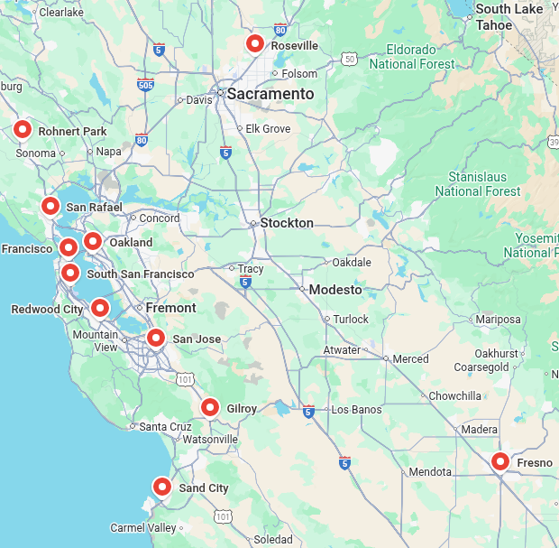
- Northern California
  - Pasta Sonoma, Rohnert Park: Since 1987, Pasta Sonoma now crafts high-quality pasta for leading retailers, small specialty stores, gift baskets and private label customers. Consistently using only the freshest American-grown wheat, highest grade premium flour, and time-honored Italian production and drying methods. About Pasta Sonoma.
  - Eduardo’s Pasta Company, San Francisco
  - Fiore Di Pasta, Fresno
  - Mill Valley Pasta Company, San Rafael
  - Bigoli Fresh Pasta, Sand City
  - Pasta Shop, Oakland
  - Pasta Supply Co, San Francisco
  - Home Maid Ravioli, SSF
  - Saporito Pasta, Redwood City: Dating back to 1900 in Lucca, Italy, operations moved to the San Jose area in 1938. They offer nineteen pasta shapes in four formulations, including Whole Wheat Fettuccine to the pro-sumer market.
  - Il Pastaio Foods, San Jose
  - Nate’s Fine Foods, Roseville
  - Monterey Gourmet Foods, Gilroy
  - Pastabiz, San Francisco
- Southern California
  - Pasta Piccinini, Pasadena
  - Florentyna’s Fresh Pasta Factory, Inglewood
  - Virginia Park Foods, Riverside
  - Pasta Mia, Fullerton
  - Pasta Straw, Gardena
  - Cucina Della Cucina, San Fernando

Benefits

Childhood Malnutrition
Malnutrition refers lack of quality food which is insufficient to support proper development and health. According to the report of the hunger project, in November 2017, 815 million people do not have food to sustain themselves out of 7.6 billion people of the world (Know Your World, The World Hunger Project). Moreover the exponential population growth threatens the margins of food security as time progresses. According to a report by the UN's Food and Agriculture Organization, earth is capable of ensuring the food security, where the agricultural sector needs a major transformation to reach its full potential. Moringa oleifera, a native species of the Indian subcontinent, is a fast growing drought-resistant tree belonging to the family Moringaceae. It is widely cultivated for the diversified use of its young seed pods and green leaves as vegetables and for medicine. It is considered as a very good supplement because of its high protein value. Without that, it is known as the miracle tree because of its diversified beneficial features, such as 10 times more vitamins than carrots, 7 times more Vitamin C than oranges, 17 times more Calcium than milk, and 15 times more Potassium than bananas In addition, it helps to increase the blood antioxidant level and reduce the blood sugar level and sustained inflammation.

Inflammation

Cholesterol Management
Leaf extract of Moringa oleifera decreased the high-fat diet-induced increases in serum, liver, and kidney cholesterol levels.

Obesity
The prevalence of obesity is increasing worldwide, and has already reached alarming levels particularly in the Middle East and North Africa region. Obesity constitutes a grave health problem and rises the hazard of chronic diseases such as diabetes mellitus and cardiovascular disease. Obesity is defined as abnormal excessive fat buildup that is accompanied by disproportion in energy intake and expenditure. In addition, world Health organization defined obesity and overweight as abnormal or excessive fat accumulation that presents a risk to health.
Moringa olifera holds saponins, tannins, flavonoids, glycosides and terpenoids, all of which possess medicinal belongings. The later compounds display effective anti-oxidants, anti-carcinogenic and anti-microbial potential and they can also boost the immune system. These effects are mediated via quenching singlet or triplet oxygens, neutralizing free radicals or decomposing peroxides. Moreover, Saponins and tannins also have been associated with a reduced energy requirement for protein and lipid biosynthesis, leading to lower body lipid, nutrient utilization, energy retention and growth performance. Therefore, such compounds have been demonstrated to have an efficient anti-obesity potential.
Moringa oleifera is a common highly nutritious herb that has been widely used in folk medicine, due to its numerous pharmacological potentials, it is known as “the miracle tree”. It contains high amounts of proteins, carbohydrates, oils, vitamins, minerals (such as potassium and calcium), amino acids, and phenolic compounds. An important pharmacological activity of Moringa oleifera is its anti-obesity potential.
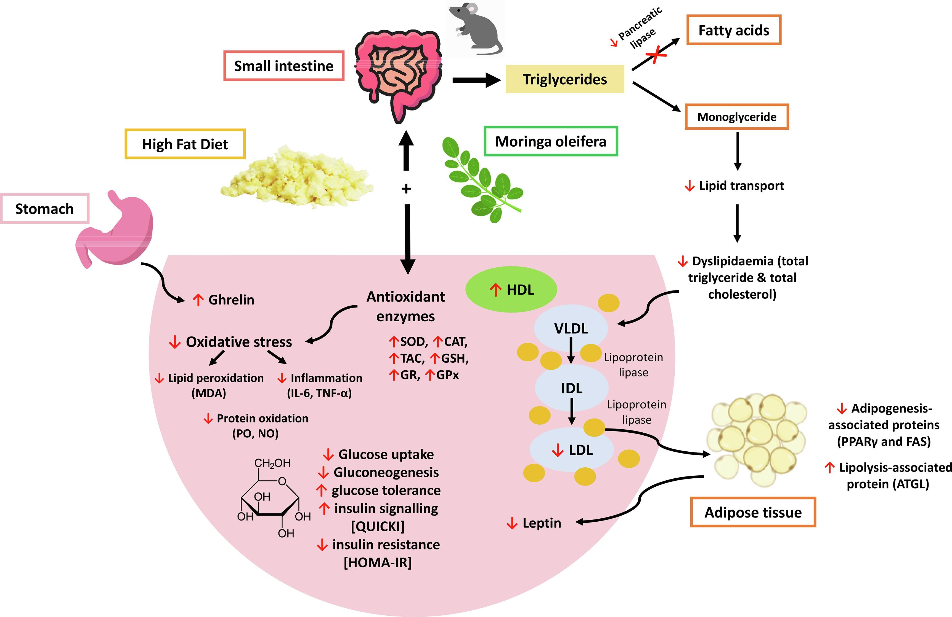Figure 2: Source: Science Direct
Supplementation of Moringa oleifera could have caused an inhibition in the pancreatic lipase decreasing the breakdown of triglycerides into fatty acids. Strong evidence has been reported regarding the potential of Moringa oleifera in improving the lipid profile (decreasing total cholesterol, triglycerides, low-density lipoprotein, very low-density lipoprotein, and enhancing high-density lipoprotein levels). Moringa oleifera extracts have regulated fat storage by downregulating the expression of adipogenesis-associated proteins and upregulation of expression of lipolysis-associated protein. Moringa oleifera was also effective in improving the levels of antioxidant enzymes and thus decreasing oxidative stress, lipid peroxidation, protein oxidation, and inflammation. In addition, Moringa oleifera was effective in decreasing glucose uptake, gluconeogenesis, and glucose tolerance, while improving insulin signaling and resistance. Besides, Moringa oleifera also influenced satiety hormones in which it decreased levels of leptin, while increasing the levels of ghrelin.

Sexual Health
Scientific Evidence for Sexual Health Benefits
Sexual Behavior and Reproductive Function

Male Subjects

The journal Plants found that Moringa leaf tea significantly enhanced sexual behavior in male subjects:

- Courtship behavior increased significantly at all tested doses (0.55, 1.10, and 2.20 mg/kg).
- Reproductive improvements included increased seminiferous tubule diameter, epithelium height, and type A spermatogonia.
- Sertoli cells increased at higher doses (1.10 and 2.20 mg/kg).
- Total spermatogenic cells increased at the lowest dose (0.55 mg/kg)
- Mechanisms of Action - The researchers attributed these benefits to:
  - Rich antioxidant content: High levels of total phenols (34.44 µg/mg) and flavonoids (13.45 µg/mg).
  - Specific compounds identified: Gallic acid, chlorogenic acid, caffeic acid, ferulic acid, quercetin, and kaempferol.
  - Oxidative stress reduction: The plant scavenged DPPH radicals, ABTS radicals, and hydrogen peroxide.
  - Anti-inflammatory effects: Inhibited lipid peroxidation and advanced glycation end products (AGEs)
- General Male Health Benefits - Research suggests Moringa may also:
  - Support prostate health: Glucosinolates in seeds may have anticancer properties.
  - Improve erectile function: Polyphenols may enhance blood flow by increasing nitric oxide production.
  - Enhance fertility: Antioxidants protect against sperm damage and improve sperm count and motility.
  - Help blood sugar control: Particularly important for men with diabetes

Anti-Oxidant

Anti-aging
Wrinkles are one of the characteristics of aging, and the degradation of elastin and collagen is the main cause of wrinkles. Moreover, elastase and collagenase play a pivotal role in the degradation of elastin and collagen, respectively. Therefore, exploring natural elastase and collagenase inhibitors has become one of the effective ways to delay aging. The anti-aging activities of Morinaga oleifera leaf extracts were evaluated by determining the inhibitory activities against collagenase and elastase in vitro. On the one hand, this study reveals that leaf extracts exhibited a promising anti-collagenase effect. However it is clear that leaf extracts showed considerable elastase inhibitory activity.

Hypertension
Nearly half of all US adults have hypertension (high blood pressure), which is a major risk factor for heart disease and stroke. Prevalence increases significantly with age, and though awareness and treatment rates have remained stable, only about one-fifth of affected adults have their blood pressure controlled. Black adults have the highest rates of hypertension compared to other racial and ethnic groups.
The Journal of the American College of Nutrition conducted a study which found in human subjects indicated the lowering effect of Moringa leaves consumption on the 2 hours postprandial blood pressure and showed a potential lowering effect despite prior high consumption of salt (7 g/d).

Anti-Cancer

Anti-Ulcer

Lower GI Distress
Moringa leaves can adjust the stool number, wet fecal weight and fecal water content to varying degrees to achieve laxative effects, and recover colon muscle thickness and mucus.

Anti-Microbial

Cautions
- Moringa might lower blood sugar levels. Taking Moringa along with diabetes medications might cause blood sugar to drop too low. Diabetes patients should monitor blood sugar closely.
- Moringa is used to lower blood pressure. Hypertension patients should be sure that Moringa dosage in combination with prescription medication does not lower blood pressure excessively.
- Avoid Moringa from India which is grown with GMO (genetically modified organism) plants. GMOs are banned or restricted in over 60 countries.
- Beware of non-organic and products with additives. All Green Power Moringa is certified 100% pure and organic.
Safety Profile
Generally safe: When consumed as food (leaves, fruit, seeds)
Short-term supplement use: Considered safe for up to 6 months for leaves, 3 weeks for seeds
Avoid: Root and root bark (contain toxic substances)
Precautions
Pregnancy: Root, bark, and flowers should be avoided (may cause uterine contractions)
Thyroid conditions: May worsen hypothyroidism
Medication interactions: May affect diabetes medications, levothyroxine, and certain liver-metabolized drugs
Practical Recommendations
Start gradually: Begin with small amounts to assess tolerance
Choose quality products: Look for organic, properly processed moringa
Consider the form: Tea, powder, capsules, or fresh leaves all offer benefits
Be consistent: Regular consumption may provide better results
Combine with lifestyle: Healthy diet, exercise, and stress management enhance benefits
Bottom Line
The scientific evidence suggests moringa has promising benefits for sexual health, particularly through its antioxidant and anti-inflammatory properties. While most research is currently limited to animal studies, the traditional use and nutritional profile support its role in overall wellness, which indirectly benefits sexual health.

However, it's important to:

Consult with a healthcare provider before starting supplements
Choose high-quality products
Be patient, as natural remedies may take time to show effects
Use as part of a comprehensive approach to sexual wellness

Endorsements
- Moringa oleifera: A review on nutritive importance and its medicinal application: Moringa oleifera, native to India, grows in the tropical and subtropical regions of the world. It is commonly known as ‘drumstick tree’ or ‘horseradish tree’. Moringa can withstand both severe drought and mild frost conditions and hence widely cultivated across the world. With its high nutritive values, every part of the tree is suitable for either nutritional or commercial purposes. The leaves are rich in minerals, vitamins and other essential phytochemicals. Extracts from the leaves are used to treat malnutrition, augment breast milk in lactating mothers. It is used as potential anti-oxidant, anti-cancer, anti-inflammatory, anti-diabetic and antimicrobial agent. M. oleifera seed, a natural coagulant is extensively used in water treatment. The scientific effort of this research provides insights on the use of Moringa as a cure for diabetes and cancer and fortification of Moringa in commercial products. This review explores the use of Moringa across disciplines for its medicinal value and deals with cultivation, nutrition, commercial and prominent pharmacological properties of this “Miracle Tree”.
- Moringa is a plant native to India and other countries. It contains proteins, vitamins, and minerals, making it useful to fight malnutrition. Moringa is an important food source in some parts of the world. It can be grown cheaply and easily, and retains much of its nutritional value when dried. As an antioxidant, it seems to help protect cells from damage. Moringa might also help decrease inflammation and reduce pain.
- Dr. Marlene B, Pharmacist, from Central Valley California,
  - Moringa solves many health problems and has no side effects.
  - Beware of non-organic and products with additives. Some green powders have very little or no actual Moringa.
- Mrs. Christine Kpatali, 22, is from Lèma village of Tré Epicenter. Mother of a baby boy, learned of the outstanding nutritional value of Moringa leaves through a Benin (West Africa) Health & Nutrition Program. After having used the leaves both for herself and the baby, she shares with us her experience with the Moringa leaves:
“I have been using Moringa leaves for three month as vegetable supplement for myself and in the porridge I feed the baby. I can testify that diseases like diarrhea, vomiting and coughing, from which he repeatedly suffered before I started using the Moringa leaves, have since vanished.
I now believe what was said to us about the leaves during the awareness-raising session organized by The Hunger Project-Benin. I have been sharing my knowledge and experience with the other mothers in my village so that many of us could use Moringa leaves.
However, the tree is not as available as we would like. We very often come to fetch the leaves at the epicenter. To improve our access, we plan to plant Moringa tree close to our houses so that we could easily have access to the leaves.”

See YouTube and TikTok: #HealthBossTV with 5½K subscribers & #HealingArtsApothicary; Healing Arts; Links
US Government National Institutes of Health, National Library of Medicine
Science Direct, v84, 09/2021
NIH - Market Chart
US Government National Institutes of Health: Moringa - Market Trends
Ibid.
NIH: Food Deprivation
NIH PubMed: Hypocholesterolemic Effects of Leaf of Moringa - Journal of Ethnopharmacology
NIH PubMed Central: Anti-obesity potential of Moringa olifera seed
Science Direct: Novel insights on anti-obesity potential of the miracle tree
Excerpts from FrontiersIn.org Nutrition Journal
Excerpts from NIH PubMed: Moringa Leaves Lowers Blood Pressure
NIH PubMed: Journal of Ethnopharmacology - Effect of Moringa on Constipation
GMO Free Countries
Google Scholar: Food science and human wellness, 2016, Gopalakrishnan, et. al.
WebMD Moringa Uses
The Hunger Project: Local Moringa Tree Improves Nutrition of Mother and Child

