INDUSTRIAL TRAINING REPORT ON
IOT BASED SMART LIQUID MANAGEMENT SYSTEM
AT
OPTIMUS RESEARCH AND DEVELOPMENT LABS PVT LTD
BY
DEEPAK AHUJA
SUBMITTED IN PARTIALLY FULLFILLMENT OF BTECH DEGREE IN ELECTRONICS AND COMMUNICATION ENGINEERING



UNDER THE GUIDANCE OF
RISHEEK KUMAR

ACKNOWLEDGEMENT

A six weeks summer industrial training and project is a golden opportunity for learning and self-development . I consider myself very lucky and honoured to have so many wonderful people lead me through in completion of this training and project.
I would thank “Mr. Meharban Singh“ who in spite of being extraordinarily busy with their engagements in various projects, took time out to hear ,guide and keep me on the correct path and allowing me to carry out my industrial project work at their esteemed organization and extending during the training .I do not know how would have I completed my training without their support and guidance.
It’s not just the training ,what I have learnt from them is that nothing that is written in any engineering book is of any relevance until and unless we thoroughly understand how it can be applied in practical world. The concepts of significance of cost and quality in making any device a success in outer world is what I learnt from them.
I would thank “Mr Aayush Saini” and “Mr Aman Sharma” for helping me to correct the code and the hardware part of project during training.
I choose this moment to acknowledge their contribution gratefully and offer them my sincere gratitude.

(Deepak Ahuja)

INDEX

- WHAT IS IoT .......................................................... 1

- IoT Examples ......................................................... 2

- The future of IOT ........................................................... 3

- Embedded systems and ARDUINO ................................... 4

- ETHERNET SHIELD ........................................................ 5

- Technical Specs of Arduino............................................... 6

- Arduino Ethernet Shield ..................................................... 7

- RTC DS1307 .................................................................... 8

- Schematics of Modules Used ............................................ 9

- Project Code ..................................................................... 10

- References ........................................................................ 20

IoT - Internet of Things

The “Internet of things” (IoT) is becoming an increasingly growing topic of conversation both in the workplace and outside of it. It’s a concept that not only has the potential to impact how we live but also how we work. But what exactly is the “Internet of things” and what impact is it going to have on you if any? There are a lot of complexities around the “Internet of things” but I want to stick to the basics. Lots of technical and policy related conversations are being had but many people are still just trying to grasp the foundation of what the heck these conversations are about.
The Internet of Things (IoT) refers to the ever-growing network of physical objects that feature an IP address for internet connectivity, and the communication that occurs between these objects and other Internet-enabled devices and systems.

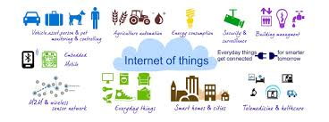

IoT Extends Internet Connectivity
The Internet of Things extends internet connectivity beyond traditional devices like desktop and laptop computers, smartphones and tablets to a diverse range of devices and everyday things that utilize embedded technology to communicate and interact with the external environment, all via the Internet.
Broadband Internet is become more widely available, the cost of connecting is decreasing, more devices are being created with wifi capabilities and censors built into them, technology costs are going down, and smart phone penetration is sky-rocketing. All of these things are creating a “perfect storm” for the IoT.

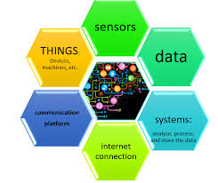

IoT Examples
Examples of objects that can fall into the scope of Internet of Things include connected security systems, thermostats, cars, electronic appliances, lights in household and commercial environments, alarm clocks, speaker systems, vending machines and more.
Businesses can leverage IoT applications to automate safety tasks (for example, notify authorities when a fire extinguisher in the building is blocked) to performing real-world A/B testing using networked cameras and sensors to detect how customers engage with products.

How does this impact you?
The new rule for the future is going to be, “anything that can be connected, will be connected.” But why on earth would you want so many connected devices talking to each other? There are many examples for what this might look like or what the potential value might be. Say for example you are on your way to a meeting, your car could have access to your calendar and already know the best route to take, if the traffic is heavy your car might send a text to the other party notifying them that you will be late. What if your alarm clock wakes up you at 6 am and then notifies your coffee maker to start brewing coffee for you? What if your office equipment knew when it was running low on supplies and automatically re-ordered more? What if the wearable device you used in the workplace could tell you when and where you were most active and productive and shared that information with other devices that you used while working?

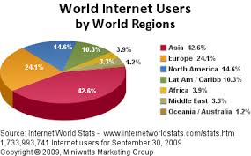

The Future of IoT
As far as the reach of the Internet of Things, there are more than 12 billion devices that can currently connect to the Internet, and researchers at IDC estimate that by 2020 there will be 26 times more connected things than people.
According to Gartner, consumer applications will drive the number of connected things, while enterprise will account for most of the revenue. IoT adoption is growing, with manufacturing and utilities estimated to have the largest installed base of Things by 2020.

WHAT IS EMBEDDED SYSTEMS?

An embedded system is some combination of computer hardware and software, either fixed in capability or programmable, that is specifically designed for a particular kind of application device.
An embedded system is some combination of computer hardware and software, either fixed in capability or programmable, that is specifically designed for a particular function. Industrial machines, automobiles, medical equipment, cameras, household appliances, airplanes, vending machines and toys (as well as the more obvious cellular phone and PDA) are among the myriad possible hosts of an embedded system.
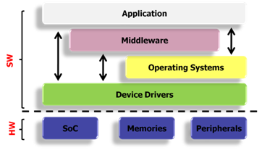

.

Arduino

Arduino is a simple microcontroller board and open source development environment that allows you to make computers that drive both functional and creative projects alike. A popular platform for DIY projects, an Arduino microcontroller is the foundation of literally thousands of projects created by Makers worldwide!
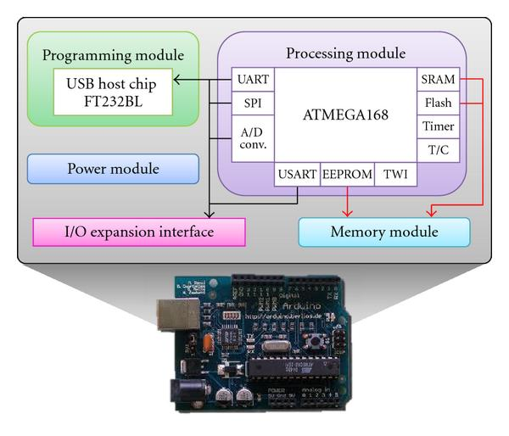

Technical specs :

Microcontroller | ATmega328P
Operating Voltage | 5V
Input Voltage (recommended) | 7-12V
Input Voltage (limit) | 6-20V
Digital I/O Pins | 14 (of which 6 provide PWM output)
PWM Digital I/O Pins | 6
Analog Input Pins | 6
DC Current per I/O Pin | 20 mA
DC Current for 3.3V Pin | 50 mA
Flash Memory | 32 KB (ATmega328P)  of which 0.5 KB used by bootloader
SRAM | 2 KB (ATmega328P)
EEPROM | 1 KB (ATmega328P)
Clock Speed | 16 MHz
Length | 68.6 mm
Width | 53.4 mm
Weight | 25 g

In addition, some pins have specialized functions:

- Serial: 0 (RX) and 1 (TX). Used to receive (RX) and transmit (TX) TTL serial data. These pins are connected to the corresponding pins of the ATmega8U2 USB-to-TTL Serial chip.
- PWM: 3, 5, 6, 9, 10, and 11. Provide 8-bit PWM output with the analogWrite() function.
- SPI: 10 (SS), 11 (MOSI), 12 (MISO), 13 (SCK). These pins support SPI communication using the SPI library.
- LED: 13. There is a built-in LED driven by digital pin 13. When the pin is HIGH value, the LED is on, when the pin is LOW, it's off.
- TWI: A4 or SDA pin and A5 or SCL pin. Support TWI communication using the Wire library.
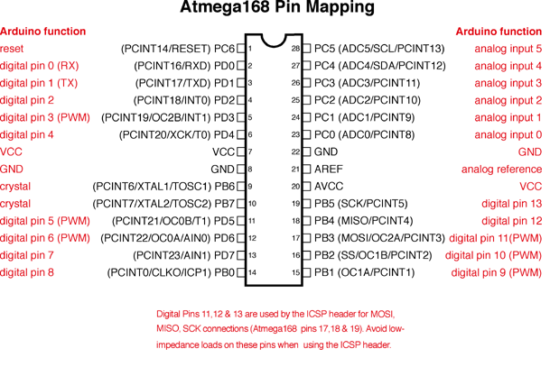

Arduino Ethernet Shield
The Arduino Ethernet Shield allows an Arduino board to connect to the internet. It is based on the Wiznet W5100 ethernet chip (datasheet). The Wiznet W5100 provides a network (IP) stack capable of both TCP and UDP. It supports up to four simultaneous socket connections. Use the Ethernet library to write sketches which connect to the internet using the shield. The ethernet shield connects to an Arduino board using long wire-wrap headers which extend through the shield. This keeps the pin layout intact and allows another shield to be stacked on top.

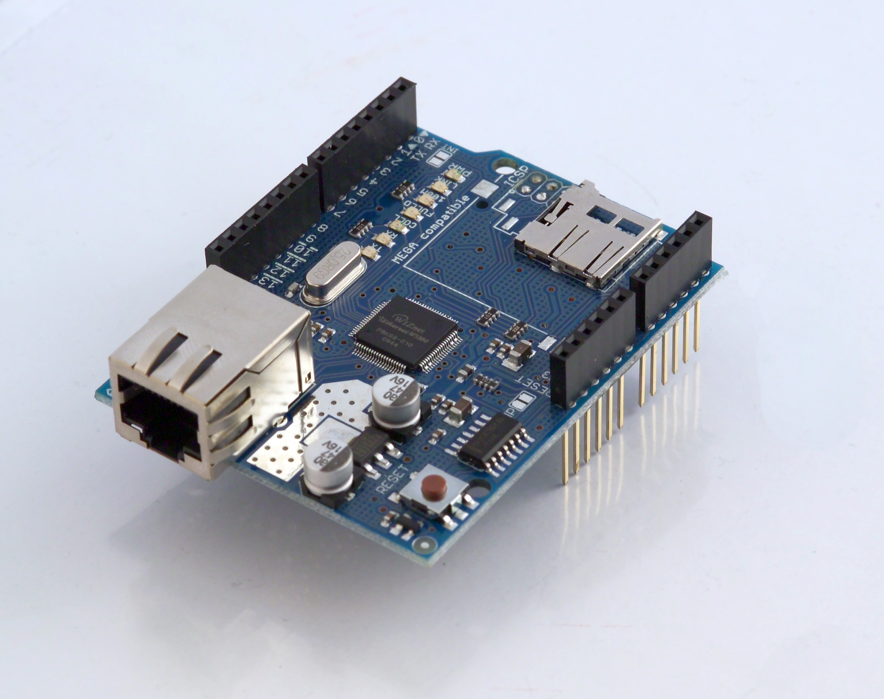

Network Settings:
The shield must be assigned a MAC address and a fixed IP address using the Ethernet.begin() function. A MAC address is a globally unique identifier for a particular device. Current Ethernet shields come with a sticker indicating the MAC address you should use with them. For older shields without a dedicated MAC address, inventing a random one should work, but don't use the same one for multiple boards. Valid IP addresses depend on the configuration of your network. It is possible to use DHCP to dynamically assign an IP to the shield. Optionally, you can also specify a network gateway and subnet.
DS1302 Real Time Clock
The DS1302 is a Real Time Clock (RTC) or TimeKeeping Chip with a build-in Trickle-Charger. Although keeping time can be done without an RTC, using one has benefits:
- Low power consumption(important when running from alternate power)
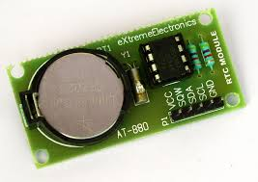
- Frees the main system for time-critical tasks
- Sometimes more accurate than other methods

SCHEMATICS OF MODULES USED :

RTC :
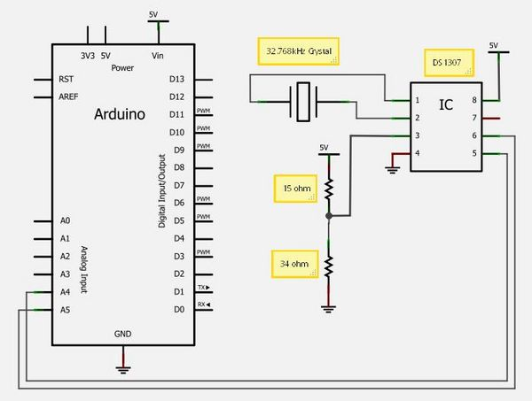

ULTRASOUND SENSOR :
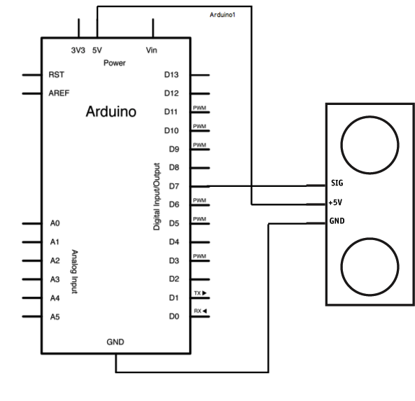

LCD WITH ARDUINO :
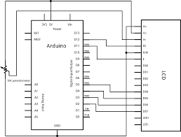

CODE : -
Compiler used : Arduino 1.6.5

#include <Wire.h>
#include <RTClib.h>
#include <Time.h>
#include <TimeAlarms.h>
#include <LiquidCrystal.h>
#include <SPI.h>
#include <Ethernet.h>
#define trig 9
#define echo 10
#define relay 8

// Enter a MAC address and IP address for your controller below.
// The IP address will be dependent on your local network:
byte mac[] = {
0xDE, 0xAD, 0xBE, 0xEF, 0xFE, 0xED
};
IPAddress ip(192, 168, 1, 177);

// Initialize the Ethernet server library
// with the IP address and port you want to use
// (port 80 is default for HTTP):
EthernetServer server(80);

/*-----( Declare Variables )-----*/
int light1onhour1 = 16;
int light1onmin1 = 16;
int light1onsec1 = 00;
int light1offhour1 = 17;
int light1offmin1 = 13;
int light1offsec1 = 00;

#define max_distance 400
int water_low = 10;
int water_high = 20;
int flag = 1;
RTC_DS1307 RTC;

#include <NewPing.h>
NewPing sonar(trig, echo, max_distance);

LiquidCrystal lcd(12, 11, 5, 4, 3, 2);
//character
byte heart[8] = {
0b00000,
0b01010,
0b11111,
0b11111,
0b11111,
0b01110,
0b00100,
0b00000
};

void setup()
{

// Open serial communications and wait for port to open:
Serial.begin(9600);
while (!Serial) {
; // wait for serial port to connect.

// start the Ethernet connection and the server:
Ethernet.begin(mac, ip);
server.begin();
Serial.print("server is at ");
Serial.println(Ethernet.localIP());

pinMode(relay, OUTPUT);
digitalWrite(relay, LOW);

Serial.begin(9600) ;
lcd.begin(16, 2);
lcd.clear() ;
pinMode(trig, OUTPUT) ;
pinMode(echo, INPUT) ;
lcd.createChar(0, heart);

Wire.begin(); // Start the Wire (I2C communications)
RTC.begin(); // Start the RTC Chip
if (! RTC.isrunning())
{
Serial.println("RTC is NOT running");
}
RTC.adjust(DateTime(__DATE__, __TIME__));

DateTime current = RTC.now();
setTime(current.hour(), current.minute(), current.second(), current.day(), current.month(), current.year());
//Lights
Alarm.alarmRepeat(light1onhour1, light1onmin1, light1onsec1, Light1On);
Alarm.alarmRepeat(light1offhour1, light1offmin1, light1offsec1, Light1Off);
}
//int y = ultrasonic();
void loop()
{
Serial.print(hour());
Serial.print(":");
Serial.print(minute());
Serial.print(":");
Serial.print(second());
Serial.print(" ");
Serial.print(day());
Serial.print(" ");
Serial.print(month());
Serial.print(" ");
Serial.print(year());
Serial.println();

int y = ultrasonic();
lcd.clear() ;
///screen saver//////////////
lcd.setCursor(1, 0);
lcd.write(byte(0));
DateTime now = RTC.now();
lcd.print(now.hour(), DEC);
Serial.print(now.hour(), DEC);
lcd.print(':');
// Serial.print(':');
lcd.print(now.minute(), DEC);
// Serial.print(now.minute(), DEC);
lcd.scrollDisplayRight() ;
Alarm.delay(100);
lcd.setCursor(1, 1) ;
lcd.print(y) ;
lcd.write(byte(0));
lcd.scrollDisplayLeft() ;
Alarm.delay(100);

Alarm.delay(100);
if ((y <= water_low) && (flag))
{
Light1On();
flag = 0;
}
if ((y >= water_high))
{
Light1Off();
flag = 1;
}

if (analogRead(A0) >= 512 || analogRead(A1) >= 512 || analogRead(A2) >= 512)
{
lcd.clear() ;
menu() ;
}
// listen for incoming clients
EthernetClient client = server.available();
if (client)
{
Serial.println("new client");
// an http request ends with a blank line
boolean currentLineIsBlank = true;
while (client.connected()) {
if (client.available()) {
char c = client.read();
Serial.write(c);
// if you've gotten to the end of the line (received a newline
// character) and the line is blank, the http request has ended,
// so you can send a reply
if (c == '\n' && currentLineIsBlank) {
// send a standard http response header
client.println("HTTP/1.1 200 OK");
client.println("Content-Type: text/html");
client.println("Connection: close"); // the connection will be closed after completion of the response
client.println("Refresh: 5"); // refresh the page automatically every 5 sec
client.println();
client.println("<!DOCTYPE HTML>");
client.println("<html>");
// output the value of each analog input pin
//for (int analogChannel = 0; analogChannel < 6; analogChannel++) {
int sensorReading = y;
client.print("water level");
//client.print(analogChannel);
client.print(" is ");
client.print(sensorReading);
client.println("<br />");
}
client.println("</html>");
break;
}
if (c == '\n') {
// you're starting a new line
currentLineIsBlank = true;
}
else if (c != '\r') {
// you've gotten a character on the current line
currentLineIsBlank = false;
}
}
}
// give the web browser time to receive the data
delay(1);
// close the connection:
client.stop();
Serial.println("client disconnected");
}
}

void menu()
{
for (int i = 0; i < 3; i++)
{
lcd.setCursor(0, 0) ;
lcd.print("Modes :") ;
lcd.setCursor(0, 1) ;
lcd.print("1.BORE") ;
DELAY(1000) ;
lcd.clear();
lcd.setCursor(0, 0) ;
lcd.print("2.SUPP") ;
DELAY(1000) ;
lcd.clear();
lcd.setCursor(0, 0) ;
lcd.print("3.TIMER") ;
DELAY(1000) ;
lcd.clear();
}
lcd.print("Enter Choice :") ;
DELAY(5000) ;
lcd.clear() ;
lcd.print("NO CHOICE!");
DELAY(1000) ;
lcd.clear() ;

}

void check()
{
if (analogRead(A0) >= 512)
{
while (analogRead(A0) >= 512);
printwater_level() ;
loop() ;
}

if ( analogRead(A1) >= 512)
{
while (analogRead(A1) >= 512);
lcd.clear() ;
lcd.print("TIMER");
DELAY(1000) ;
timer();
lcd.clear() ;
}

if ( analogRead(A2) >= 512)
{
while (analogRead(A2) >= 512);
lcd.clear() ;
lcd.print("N.C") ;
Alarm.delay(1000) ;
lcd.clear() ;
}
}
long x ;
void printwater_level()
{
for (int i = 0; i < 40; i++)
{
lcd.clear() ;
lcd.setCursor(0, 0) ;
lcd.print("Water Level:") ;
lcd.setCursor(0, 1) ;
ultrasonic() ;
lcd.print(x) ;
Serial.println(x);
Alarm.delay(1000);
if (analogRead(A0) >= 512 || analogRead(A1) >= 512 || analogRead(A2) >= 512)

{
Alarm.delay(50);
loop() ;
}
}

}
int ultrasonic()
{
// Wait 50ms between pings (about 20 pings/sec). 29ms should be the shortest delay between pings.
unsigned int uS = sonar.ping(); // Send ping, get ping time in microseconds (uS).
Serial.print("Ping: ");
Serial.print(uS / US_ROUNDTRIP_CM); // Convert ping time to distance in cm and print result (0 = outside set distance range)
Serial.println("cm");
x = (uS / US_ROUNDTRIP_CM);
return x;
}

void DELAY(int x)
{
for (int i = 0; i < x; i++)
Alarm.delay(1) ;
check() ;
}

void timer()
{
DateTime now = RTC.now();
lcd.print(" SET :");
lcd.setCursor(0, 1);
{
lcd.print(now.hour(), DEC);
Serial.print(now.hour(), DEC);

lcd.print(':');
Serial.print(':');
lcd.print(now.minute(), DEC);
Serial.print(now.minute(), DEC);

}
Alarm.delay(2000);

}
void Light1On()
{
DateTime now = RTC.now();
Serial.print(now.hour(), DEC);
Serial.print(':');
Serial.print(now.minute(), DEC);
Serial.println(" Light1: ON");
digitalWrite(relay, HIGH); // Sets the LIGHT1 "ON"
}

/*----( LIGHT1ON: TURN OFF )----*/
void Light1Off()
{
DateTime now = RTC.now();
Serial.print(now.hour(), DEC);
Serial.print(':');
Serial.print(now.minute(), DEC);
Serial.println(" Light1: OFF");
digitalWrite(relay, LOW); // Sets LIGHT1 "OFF"
}

REFERENCES :
- www.arduino.cc
- www.instructables.com
- www.learn.adafruit.com
- www.startingelectronics.org

BOOKS :
1. Making things talk
2. Designing IOT
3. Cookbook for Arduino

