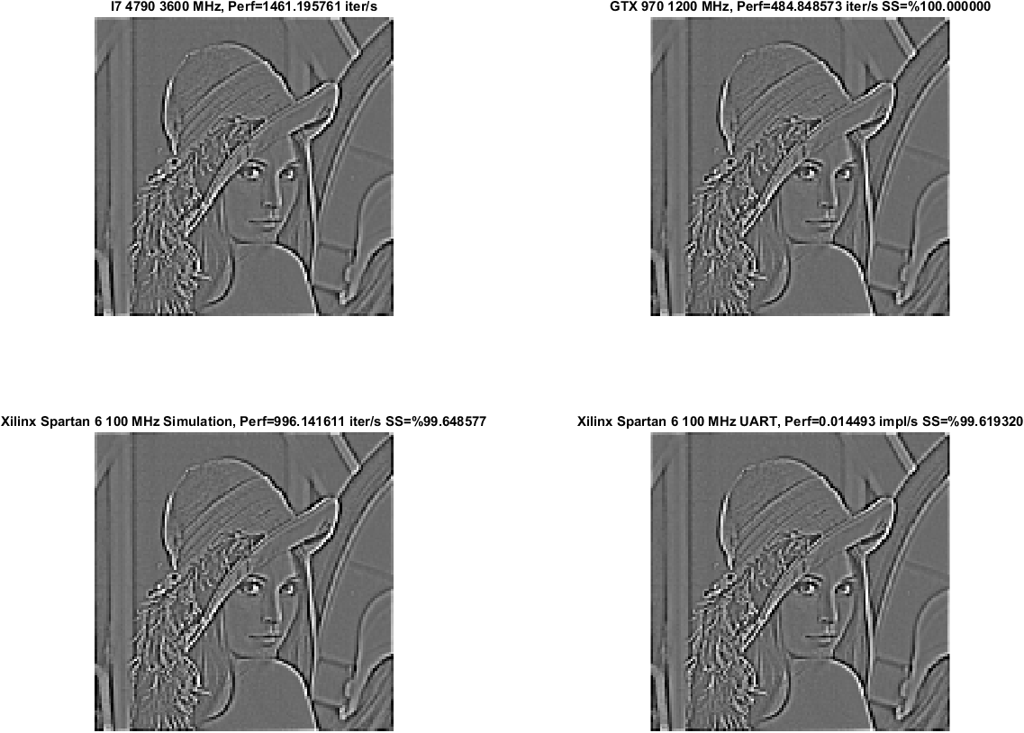

Ts=0.1 - Iteration Count:3 – 3x3 Grayscale Edge Detection Template