Android Application

Project Name
Nerede Yesem

Developer Name
Erdem ÇALIŞIR

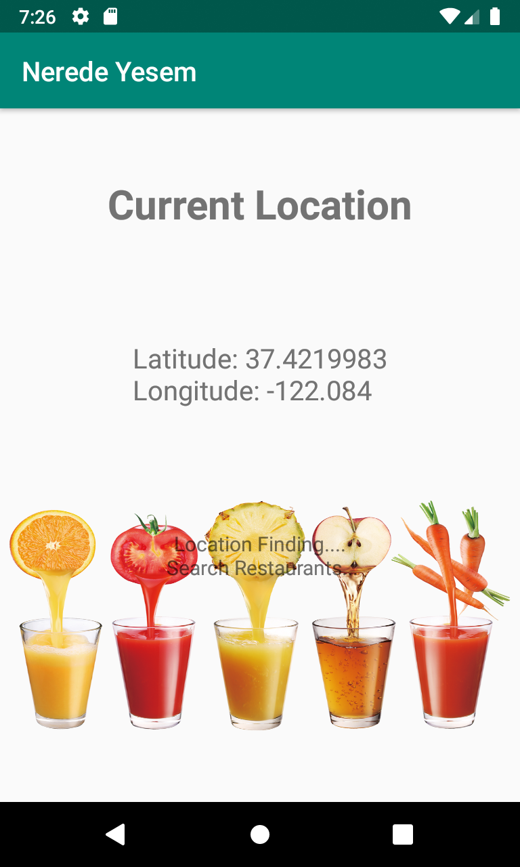
Delivery date 18.05.2019

Platforms and Tools

Platform and IDE

Android Studio 3.4
JRE: 1.8.0_152-release-1343-b16-5323222 amd64
JVM: OpenJDK 64-Bit Server VM by JetBrains s.r.o
Linux 4.18.0-17-generici

Programming Language

Java
Xml

1. Analysis

People have trouble deciding where to eat. We wanted to help them in this choice. The main purpose of this project is to improve the user restaurant search habits.
We thought about getting it by sorting the surrounding restaurants. We limit the number of restaurants to 5 because we use free Zomato API.
After entering the user's fingerprint, user will see the nearest restaurants. Of course as long as the location is found by application.

2. Requirements

1. List at list 5 restaurants.
2.To get user location, use mobile phone location.
3.The application should contain at least two pages, the "BACK" key must be implemented as "HistoryBack".
4.The application should be entered via Fingerprint
5.The application should know its state when the user pushes it at the background.

3. Design

3.1 FingerPrint

BiometricPrompt used to get fingerprints. if reading is successful, the activity proceeded

3.2 Location

The second activity is location finding. FusedLocationProviderClient used to get current location. Also the necessary permissions get for the location services.

3.3 List Restaurant

Restaurant list edited with location information. Retrofit used here to design restaurant list. Also we used <ListView/>

3.4 Detail Restaurant

The details of the restaurants were determined with the previously created examples. Also we used position from listRestaurantActivity for each restaurant location.

4. User Catalog

This program will help you in finding a restaurant. Forget your old habits and enjoy your meals in the restaurants we found for you.
Let's start.

4.1 Welcome screen

Welcome screen is as below picture. Click the button below to enter the application.

4.2 FingerPrint screen

Then the fingerprint screen will appear to switch to the application.

You will meet with the screen in the way of an unsuccessful fingerprint attempt

4.3 Location screen

You need to wait on this screen while locating. The application is currently looking for your location

When the program finds your location, it will display a short-time screen and switch to the list screen

4.3 Restaurant List screen

Transmits this information to the other screen when the location is found. Then, the nearest restaurant to you is listed below. You can choose the restaurant you want to know the details.

4.4 Restaurant Detail screen

In this screen you will see the restaurant with the necessary information. You can scroll downwards due to the feature of the screen

5. Limitations

The phone must be a fingerprint reader
Must be a registered fingerprint
The phone must be connected to the internet
All permissions must have been granted. (eg. location internet )
The phone location app must be running

