

**MIDDLE EAST TECHNICAL UNIVERSITY**

**DEPARTMENT OF ELECTRICAL AND ELECTRONICAL ENGINEERING**

**EE 464 HOMEWORK 3**

**Compensator Design for Buck Converter**

**Student 1:** Erdem Canaz 2374676

**GitHub Page:** https://github.com/erdemcanaz/EE464-HW3

**Submission Date:** 22.05.2024

**Introduction**

You are required to design a 200 W full bridge isolating converter with 24 Vin and 200 Vout with 1% output voltage ripple. Switching frequency of the converter is 250kHz

**Question 1:**

*Explain the meaning of input-to-output transfer function and control-to-output transfer function in words.*

In this context, the input-to-output transfer function refers to the relationship between the input voltage (i.e Vin) and the output voltage (i.e. Vout). On the other hand, the control-to-output transfer function describes the relationship between the control signal (such as the duty cycle) and the output voltage Vout.

**Question 2:**

*Obtain the bode plot for control-to-output transfer function of buck converter with and without ESR (rC ) on single graph on MATLAB. How do nonidealities affect the characteristic? Comment on phase margin & gain margin.*

* *L = 8 uH,*
* *C = 8 uF,*
* *rC = 15 mohm*
* *VIN = 5 V*
* *Vo= 3.3 V*
* *Io = 4 A*
* *fsw = 250 kHz*
* *Vref = 1.2 V*
* *Vosc= 1.8 V*

The bode plot of the given control-to-output transfer function Gp(s) of the buck converter with and without the ESR can be found in Fig. 1. The MATLAB script used can be found in Appendix I.

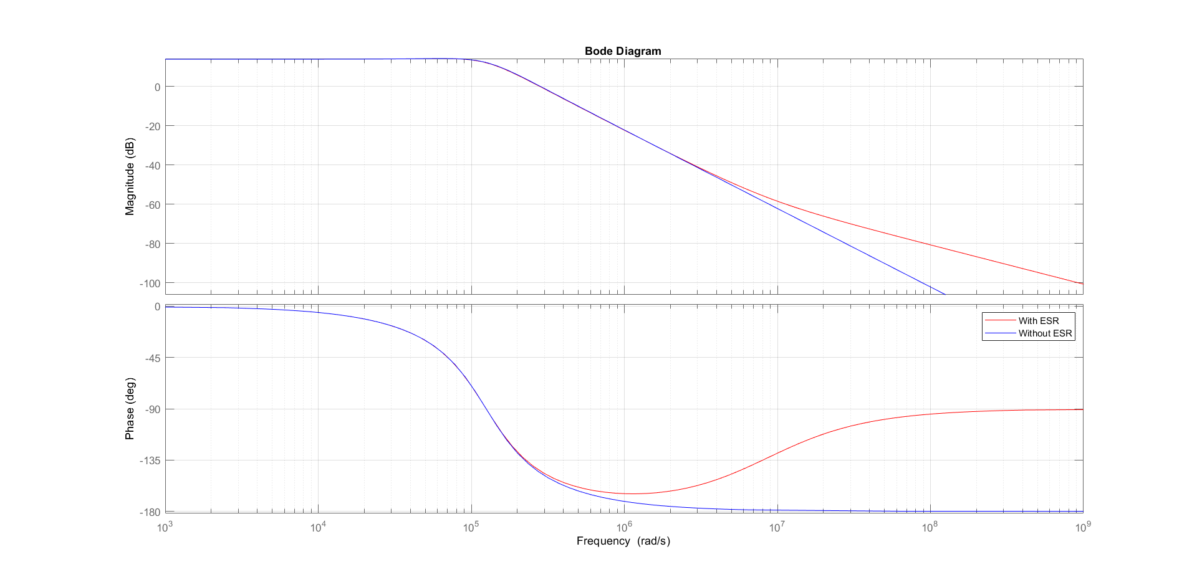

Figure 1 The bode plot of the control-to-output transfer function of the buck converter with and without the ESR

The main differences between circuits with/without the ESR is, a zero is introduced at around 107 rad/s. It causes a change in the slope of the magnitude and phase angle behaviors. Lets say gain G is;. Gp(s) is of the form

We may replace s with (jw)

Then can be found as;

We can assume the modulus of a complex number can be approximated as either real or complex part provided one is much greater (i.e. 10 times) magnitude wise. Then the contribution of zero introduced due to ESR can be written as.

It can be further simplified as;

It is obvious that the contribution is zero until . Then it contributes 20db per decade. For the phase discussion, one can simply consider any complex number as a complex exponential. Knowing real number are of the form Ae0 and complex ones are Bei, we can simplify ESR contribution to phase as follows;

Both of gain and phase discussions are well seen in the Fig. 1.

**Conclusion**

**Appendix I:** The matlab script to plot bode plot for control-to-output transfer function of buck converter

|  |
| --- |
| clear  clearvars  clc  % Parameters  L_out = 8e-6; % H  C_out = 8e-6; % F  R_c = 15e-3; % Ohm  V_in = 5; % V  V_out = 3.3; % V  I_out = 4; % A  f_sw = 250e3; % Hz  V_ref = 1.2; % V  V_osc = 1.8; % V  %determined variables  R_load = V_out/I_out; % Load resistance  % Transfer function with esr: G_p_with_ESR(s)  numerator_with_ESR = V_in*R_load * [C_out * R_c, 1];  denominator_with_ESR = [L_out * C_out * (R_load + R_c), (L_out + R_load * C_out * R_c), R_load];  G_p_with_ESR = tf(numerator_with_ESR, denominator_with_ESR);  % Transfer function without esr: G_p_without_ESR(s)  numerator_without_ESR = V_in*R_load * [0, 1];  denominator_without_ESR = [L_out * C_out * R_load, L_out, R_load];  G_p_without_ESR = tf(numerator_without_ESR, denominator_without_ESR);  % Plot Bode plots  figure;  bode(G_p_with_ESR, 'r', G_p_without_ESR, 'b');  legend('With ESR', 'Without ESR');  grid on;  % Display transfer functions as fractions  disp('Transfer function with ESR:');  G_p_with_ESR  disp('Transfer function without ESR:');  G_p_without_ESR  % Gain margin and phase margin  [Gm_with_ESR, Pm_with_ESR, Wcg_with_ESR, Wcp_with_ESR] = margin(G_p_with_ESR);  [Gm_without_ESR, Pm_without_ESR, Wcg_without_ESR, Wcp_without_ESR] = margin(G_p_without_ESR);  % Display margins  disp('With ESR:');  fprintf('Gain Margin: %.2f dB\n', 20*log10(Gm_with_ESR));  fprintf('Phase Margin: %.2f degrees\n', Pm_with_ESR);  disp('Without ESR:');  fprintf('Gain Margin: %.2f dB\n', 20*log10(Gm_without_ESR));  fprintf('Phase Margin: %.2f degrees\n', Pm_without_ESR); |