CSE 464
DIGITAL IMAGE PROCESSING
HW2
REPORT

HAKKI ERDEM DUMAN
151044005

Task 1

In this task, convolution is implemented. “main.py” file is the one which should be executed. Program does not have any command line arguments.

Once the program is executed, it will ask the file, which involves kernel matrix and image, which will be convoluted.

NOTE: Matrix elements should be separated by commas. There shouldn’t be any whitespaces. There is an example file called “kernel.txt”.

NOTE 2: Once the kernel is read from file, it is flipped on x and y axis.

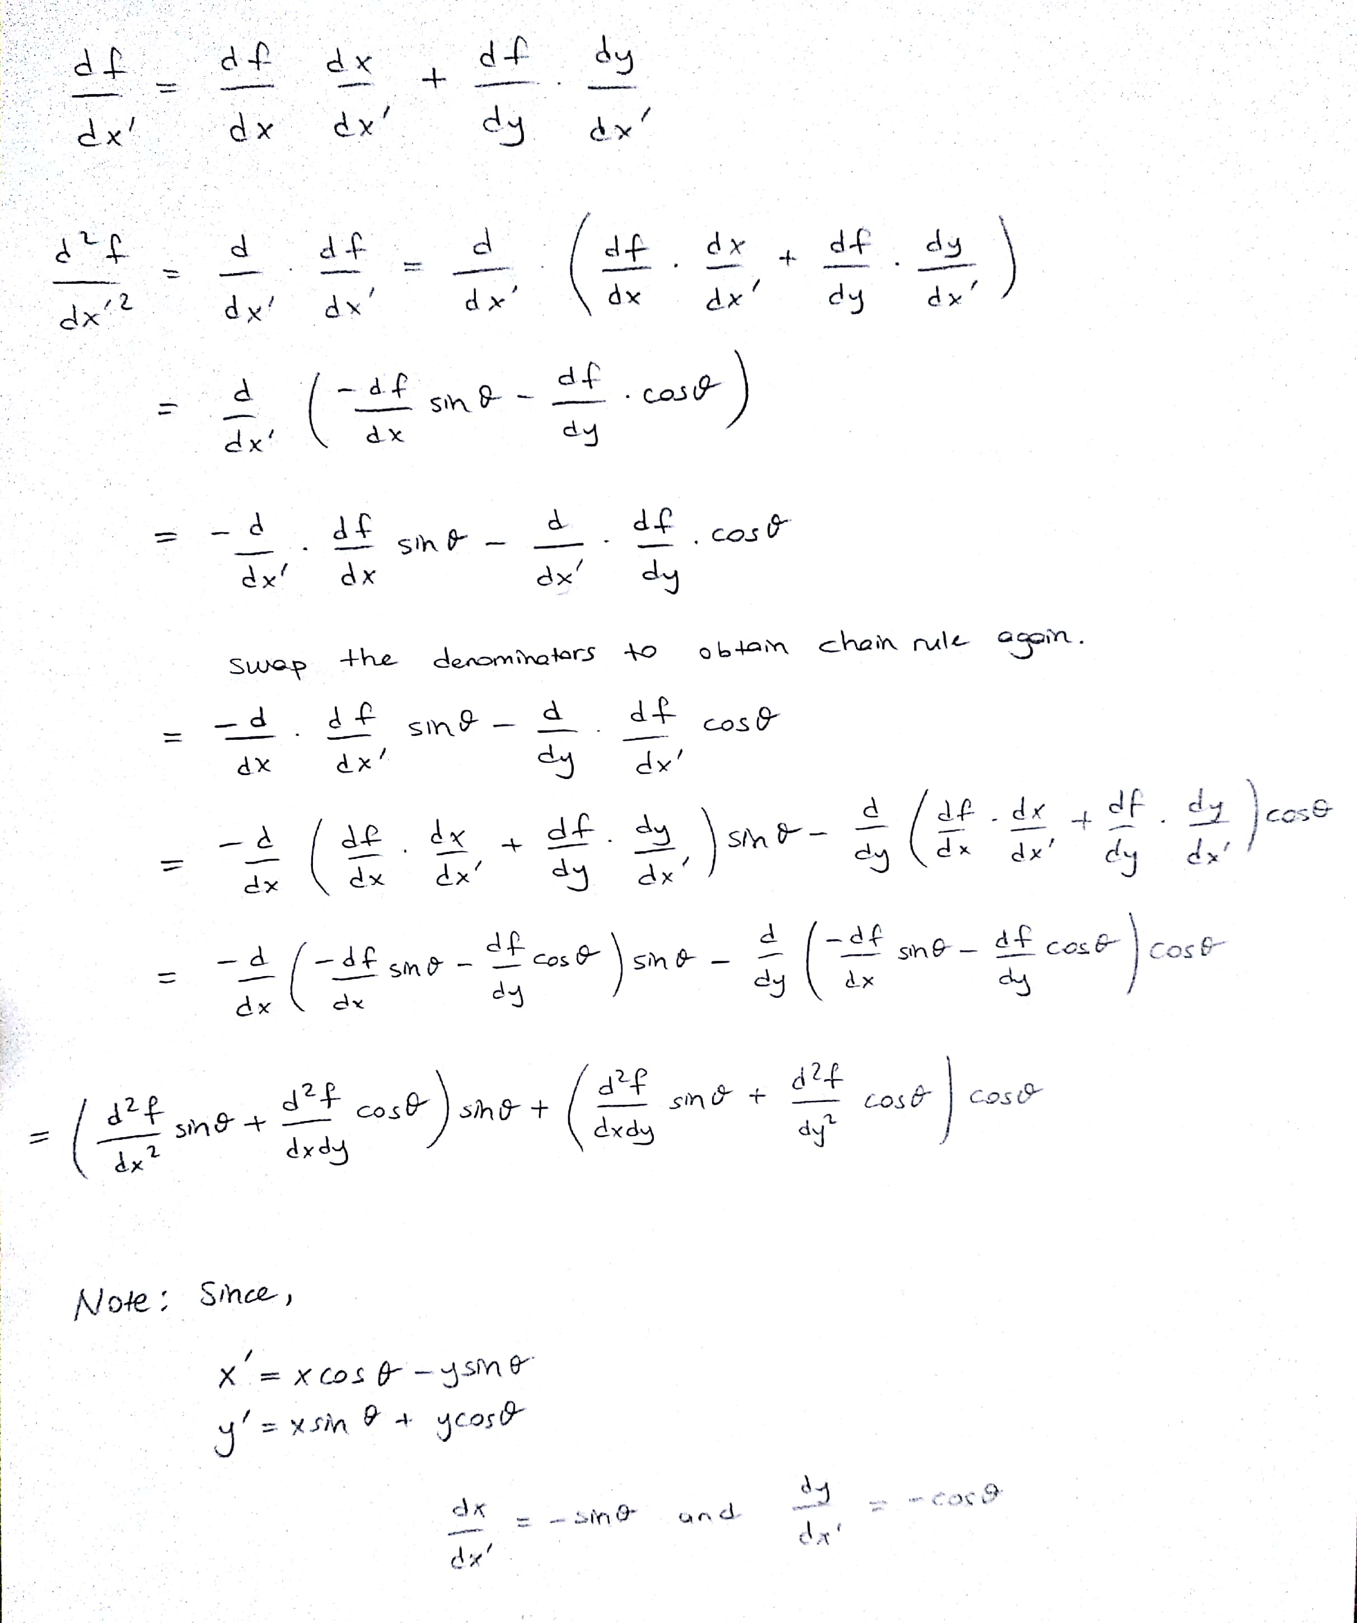
Task 2

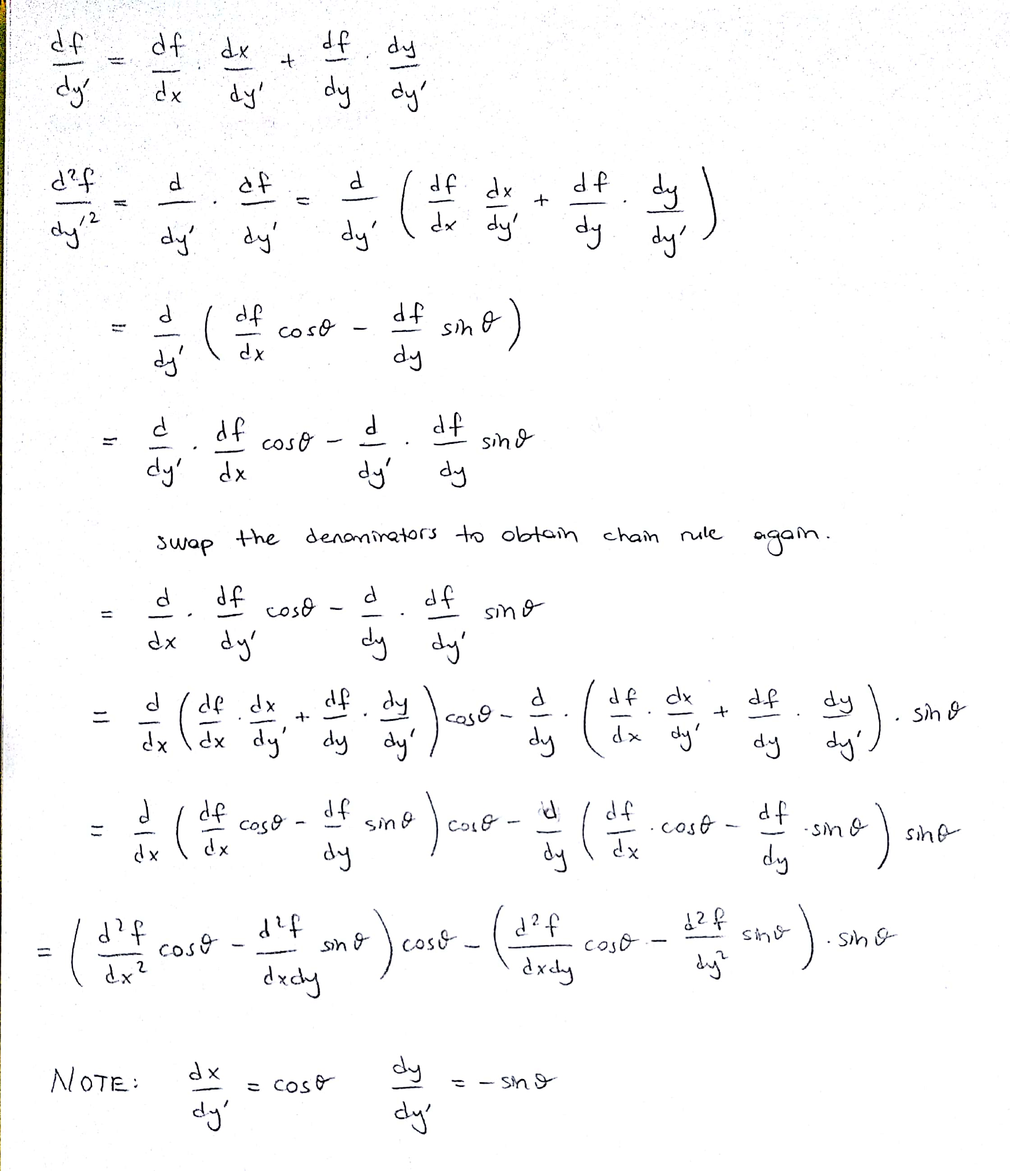

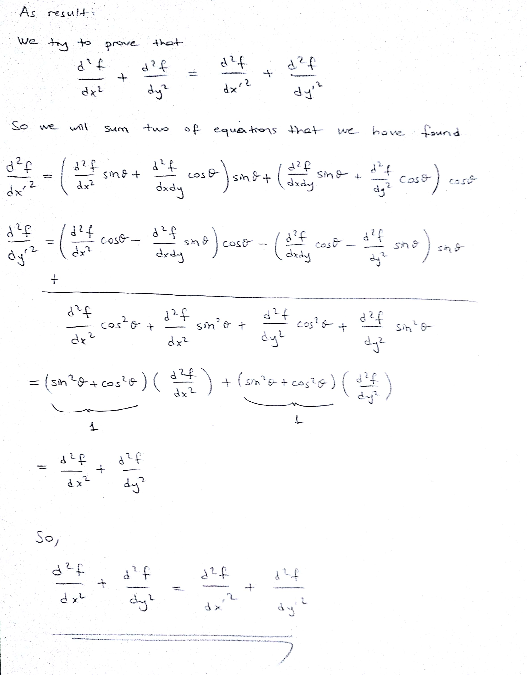

Task 3
