MN521 Network Automation

Laboratory 1: System Setup
MIT251002 Erdenebayar Dovchindorj

- Installation and Configuration

- Virtual Box installation
Since Virtual Box is already installed on Lab computer, I don’t need to reinstall it.
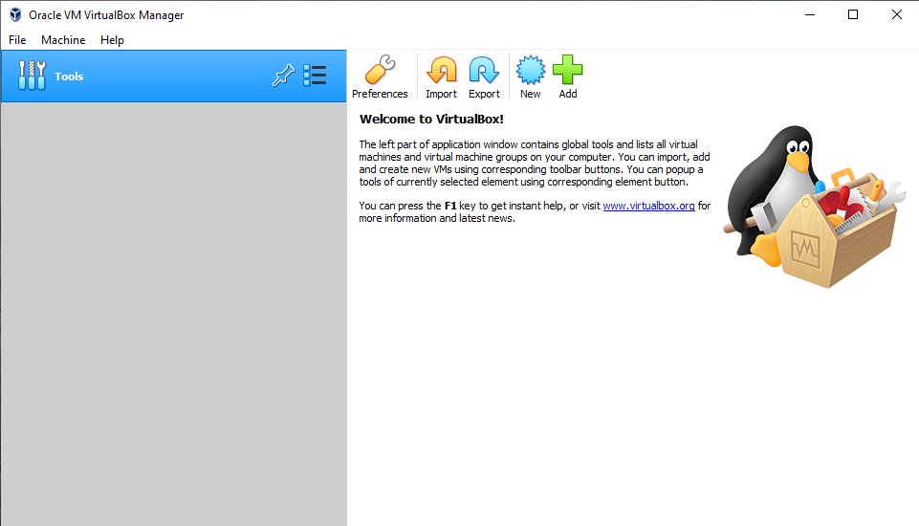

- GNS3 VM Setup
Followed recommendation of downloading installation file from Moodle as shown as below screen shot.
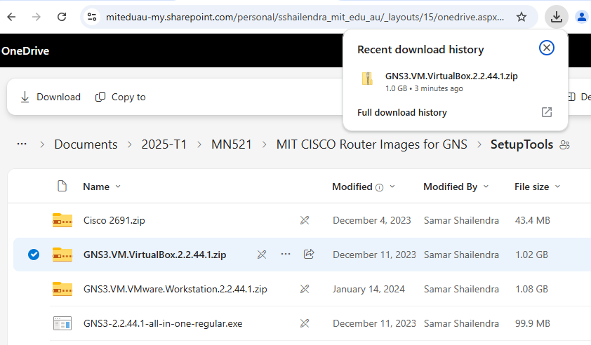
Added GNS3 VM by importing appliances and configured network adapter 1 as NAT
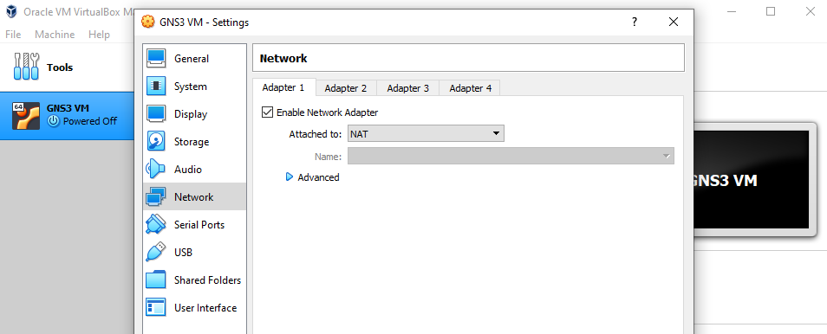
Configured Network Adapter 2 as Host Only Adapter shown below
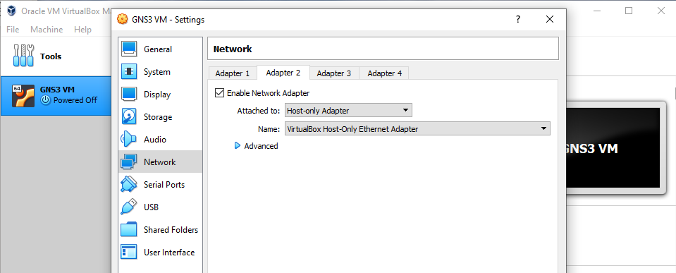
- Ubuntu Installation
Downloaded latest image file from official site
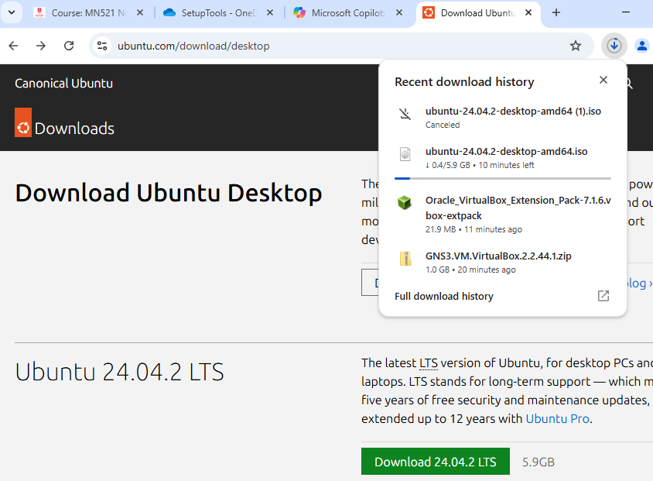
Configured OS type as Linux and Version as Ubuntu 64-bit.
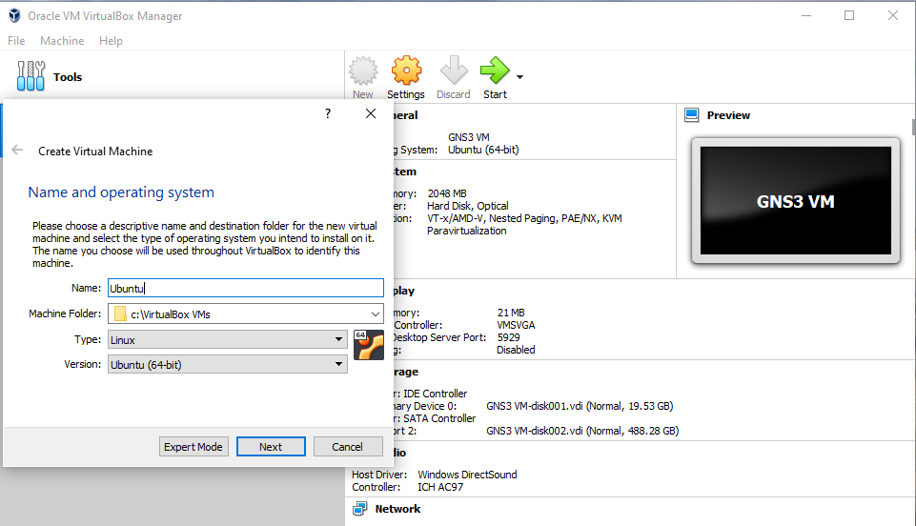
Created a virtual hard disk and chose the downloaded image by clicking CD icon on Storage tab of VM.
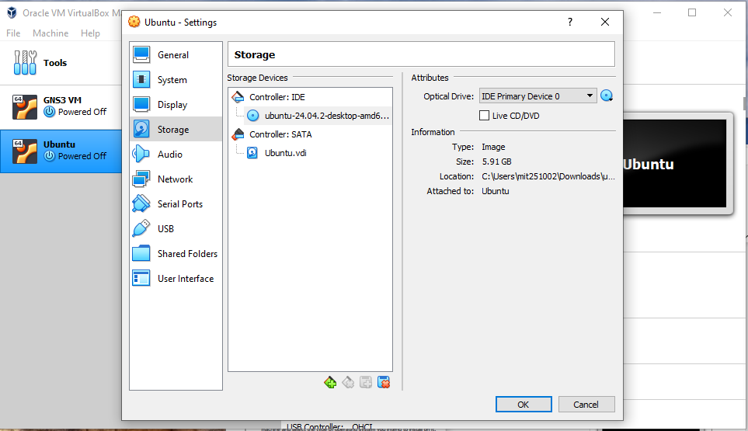
Installed Ubuntu on VM and below screen shot is showing the installation process
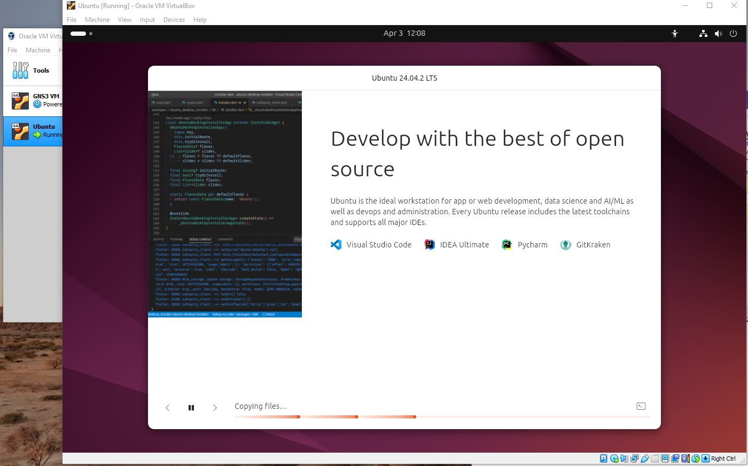
- GNS3 Installation on Ubuntu
Added repository for installation gns3 on ubuntu
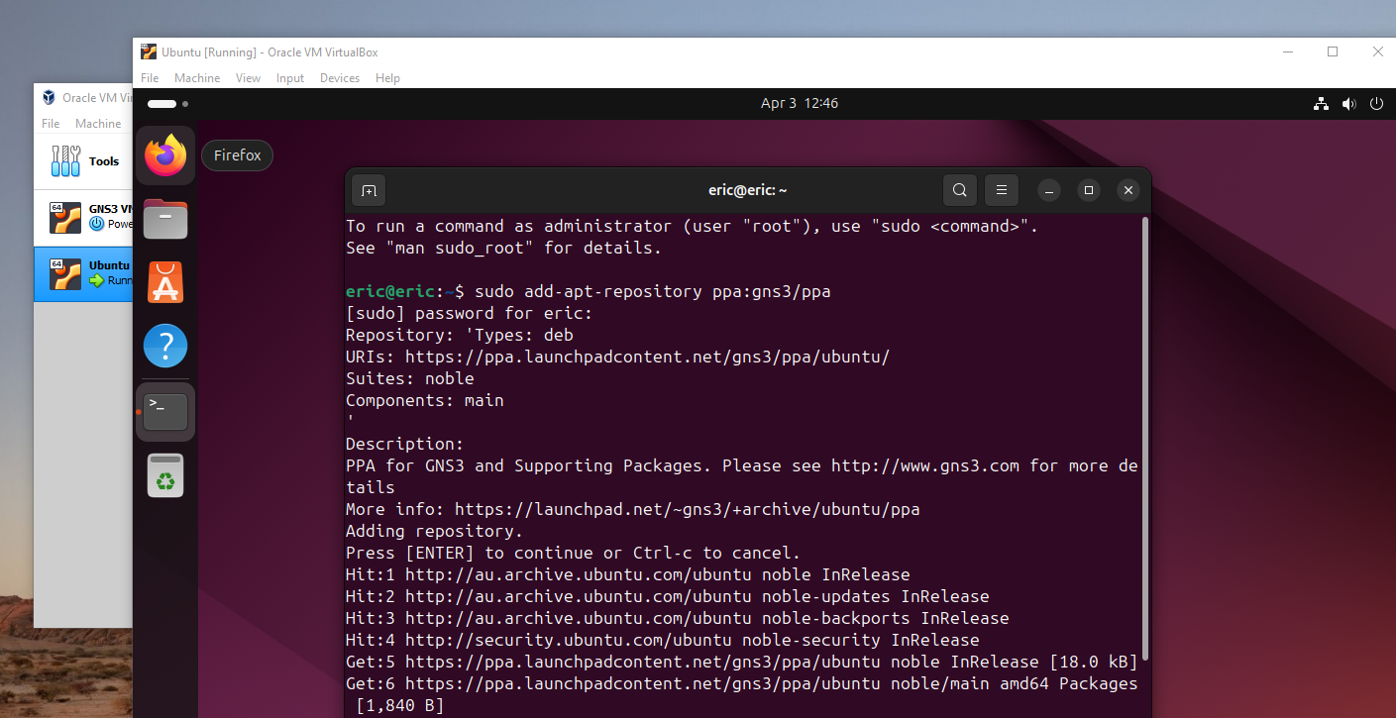
Installed gns3-gui on ubuntu VM
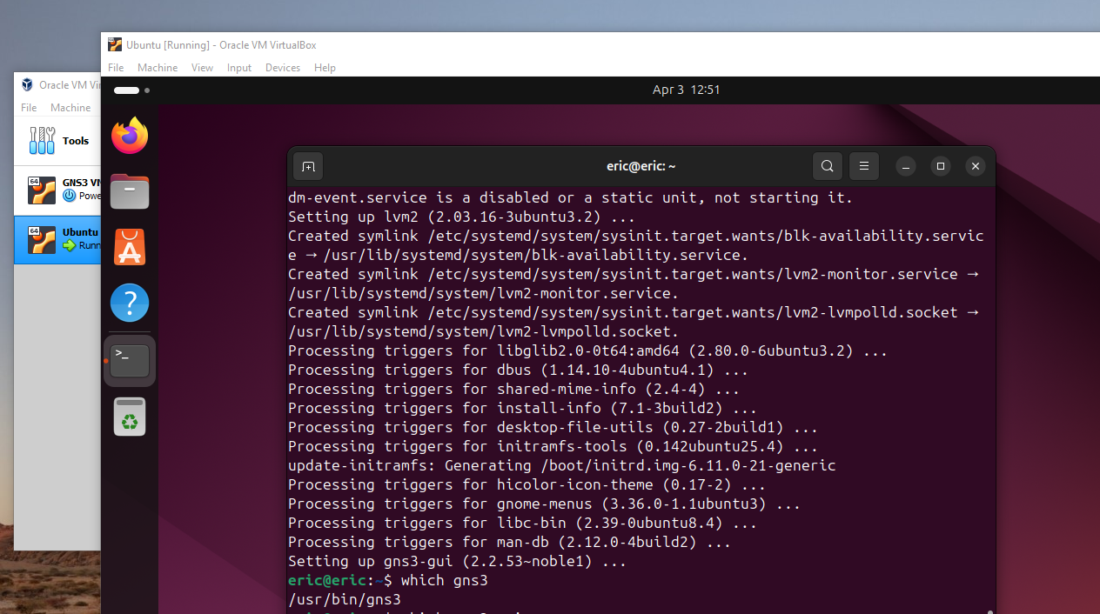
- Connecting GNS3 client to GNS3 VM
Opened GNS3 and Edit -> added, configured server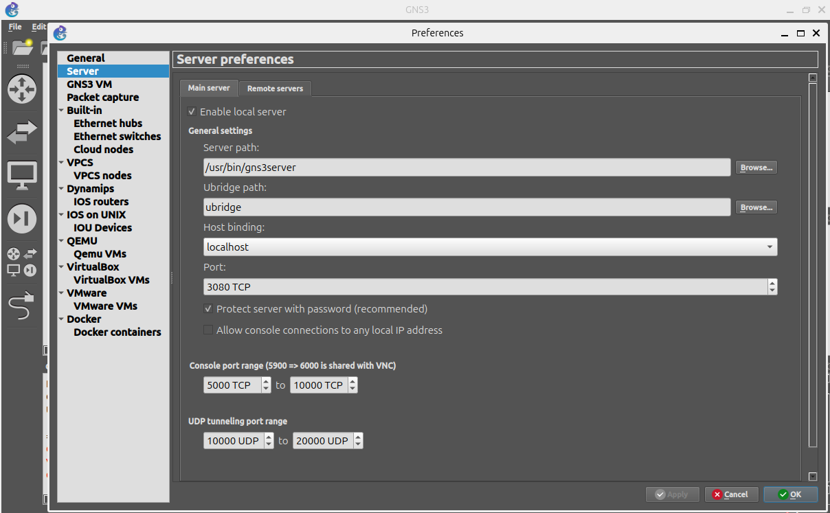
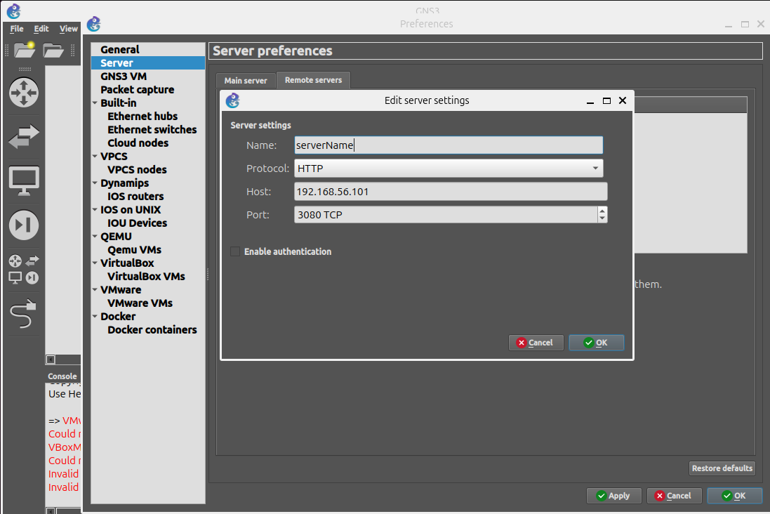
- Cisco Router Image Installation
Downloaded Cisco image from Moodle as recommended
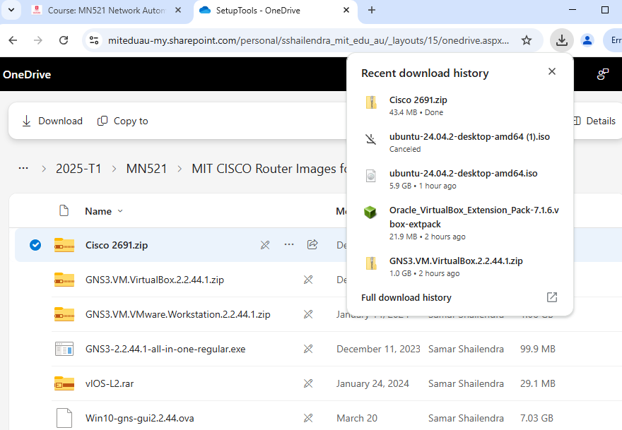
Created new cisco router IOS image c2691 as shown below
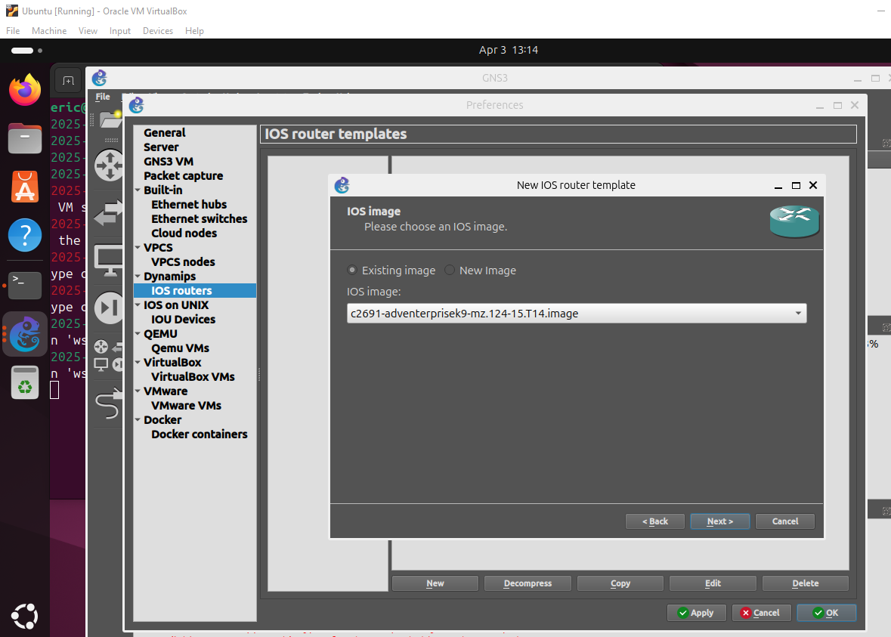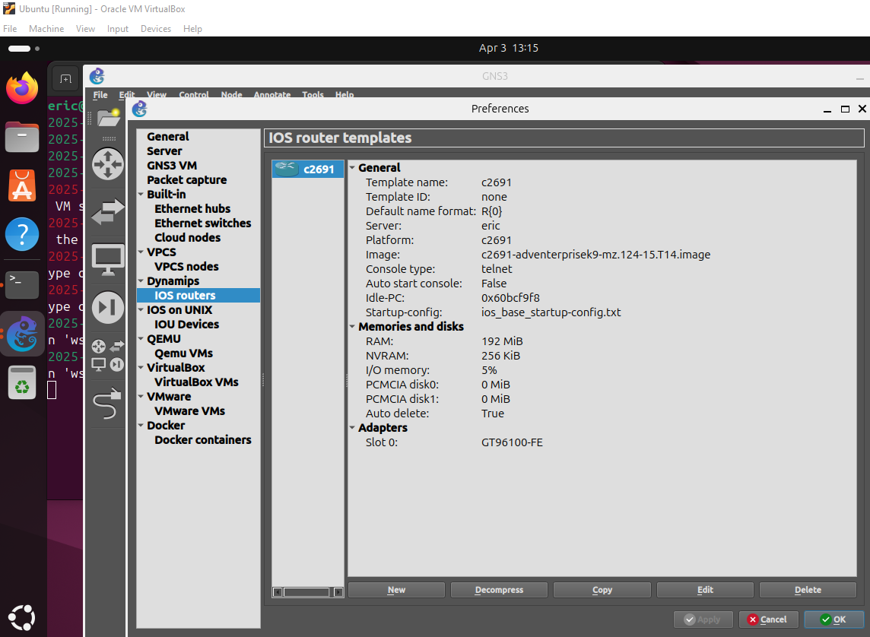
- Connectivity Testing
Created a new blank project and configured the Router c2691 which recently installed, Switch and two VPC.
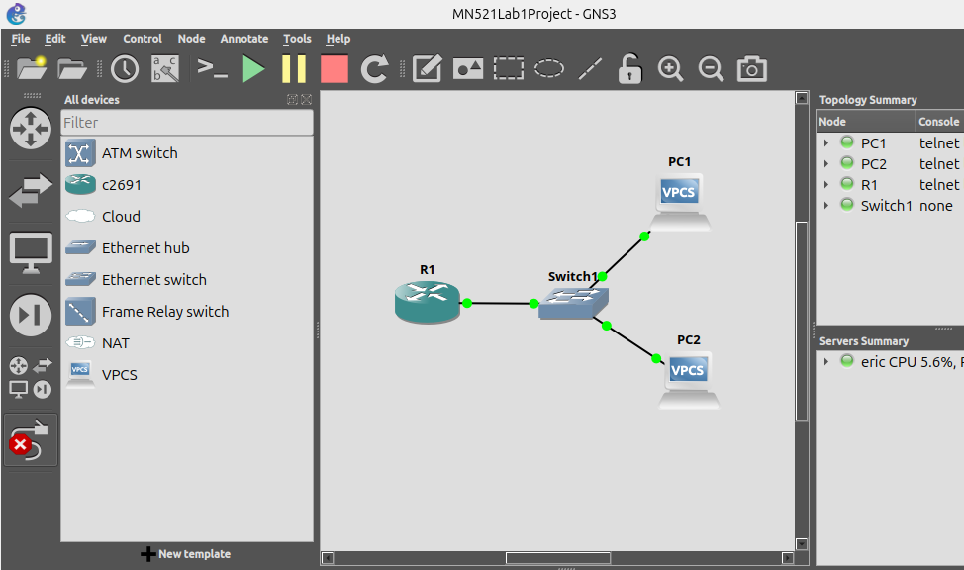

Configured router, VPCs and checked connectivity by pinging
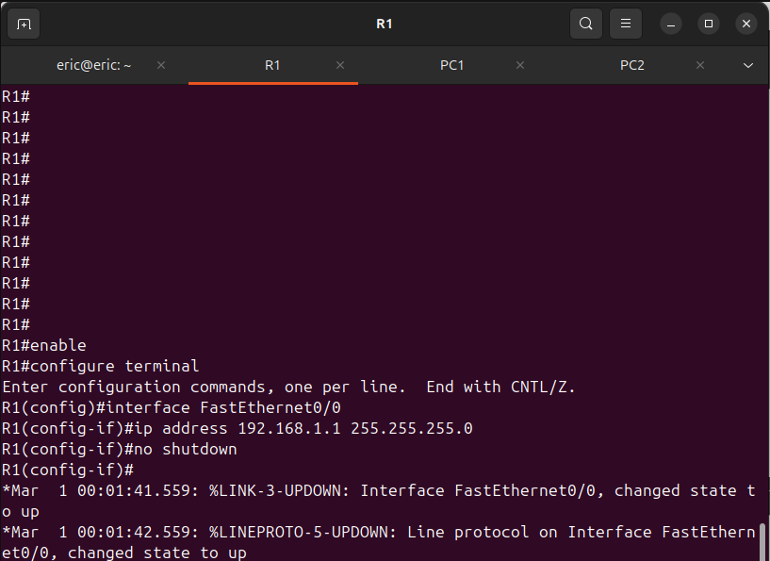
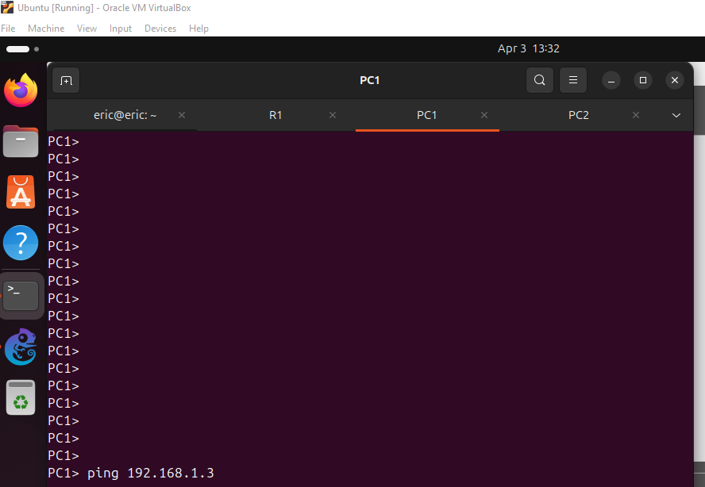
Lab Reflection
In this laboratory exercise, I successfully set up the virtualization environment required for practicing network automation. I learned to install and configure essential virtualization tools, including VirtualBox and GNS3, and integrated them to create a simulated network environment effectively. Importing and configuring the Cisco router image in GNS3 provided a practical understanding of how virtual network devices operate.
Performing connectivity tests with routers, switches, and virtual PCs reinforced my knowledge of basic IP addressing and subnetting. One challenge encountered was ensuring accurate communication between the GNS3 client and VM, particularly configuring the network adapters correctly. This required careful troubleshooting and attention to detail, enhancing my problem-solving abilities.
Overall, the laboratory exercise was insightful, significantly increasing my familiarity with network virtualization tools and foundational network automation concepts.

