MN521 Network Automation

Laboratory 3: Automation using Python
MIT251002 Erdenebayar Dovchindorj

Since we already have the topology.
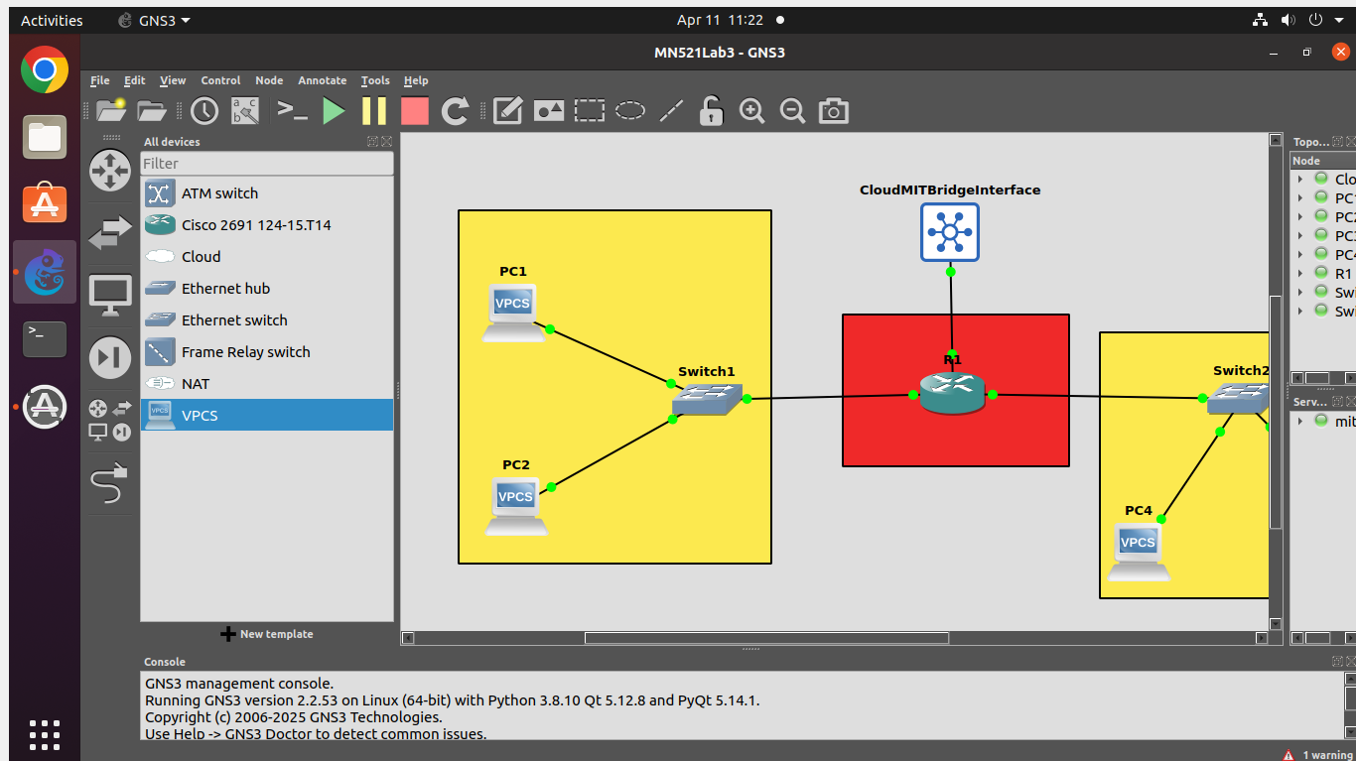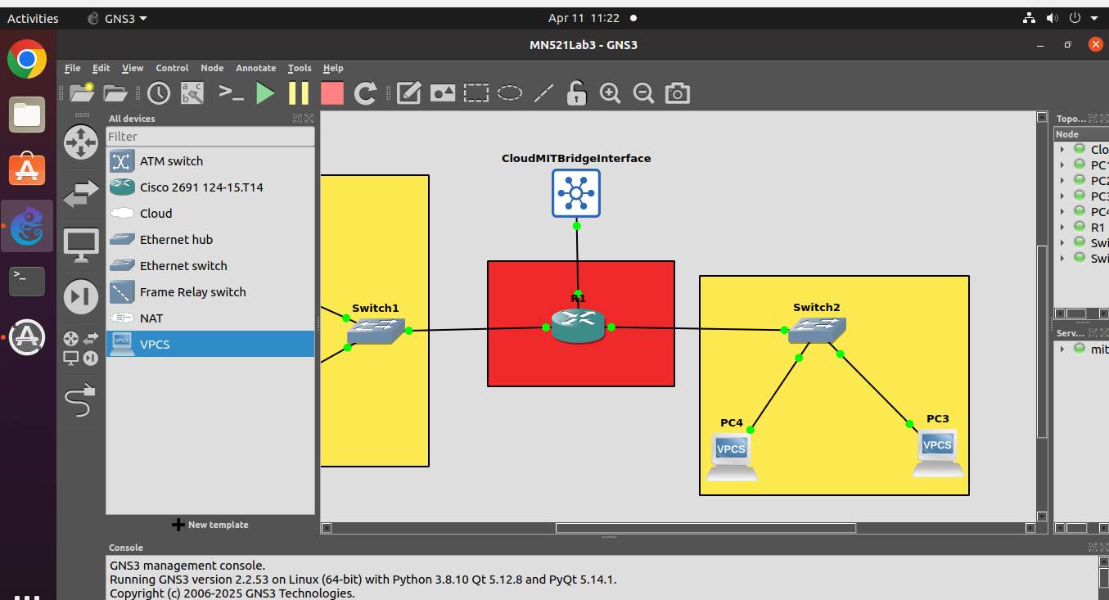
Task 1
Since the ubuntu machine that I am working on has predefined python3, I don’t need to reinstall it. I checked current version of python3 and created virtual env for netmiko library installation.
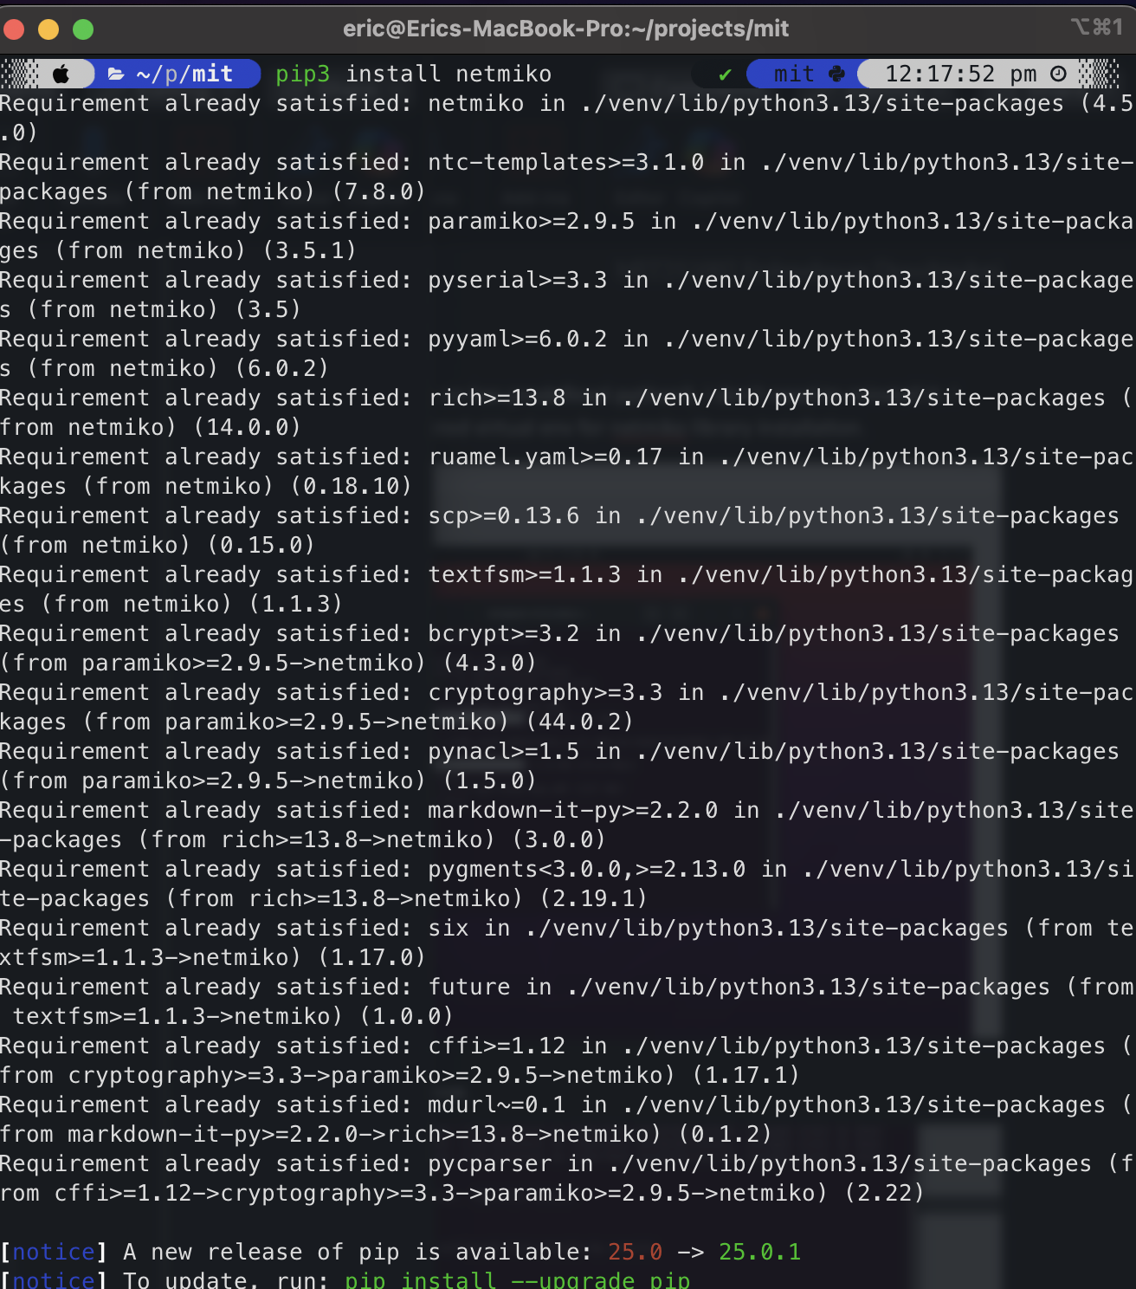

Enabling router to listen Netconf request below.
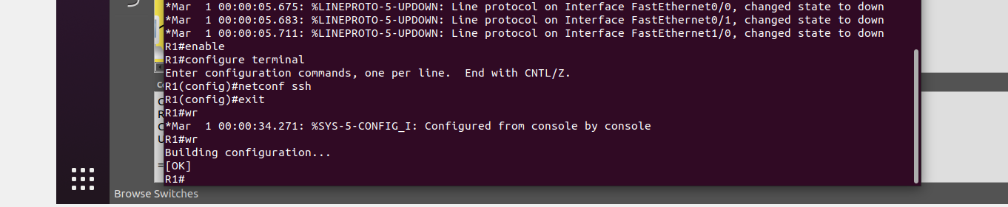
Checked Ip address of Router and tested connectivity to the router via Netconf using cli ssh command.
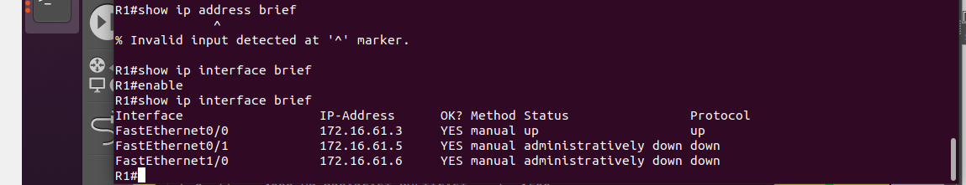
Below is the python script for the task
