MN521 Network Automation

Laboratory 4: Automation using NETCONF/SSH
MIT251002 Erdenebayar Dovchindorj

Since we already have the topology.
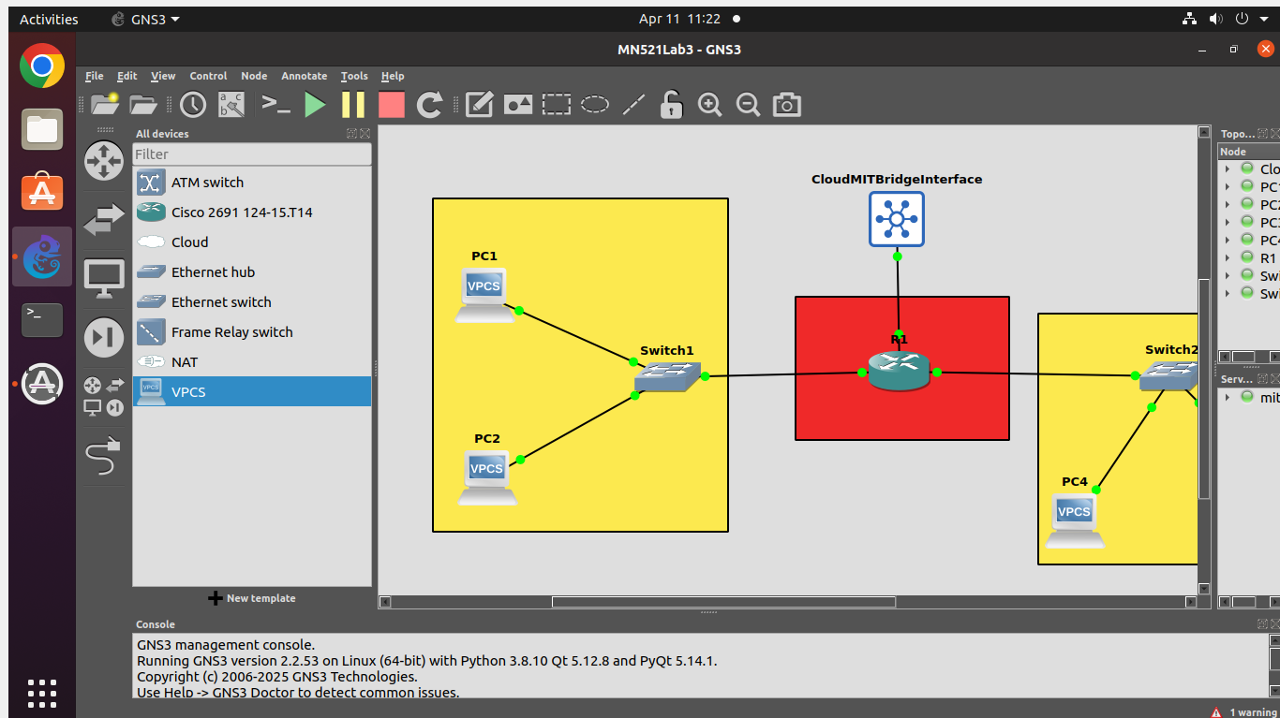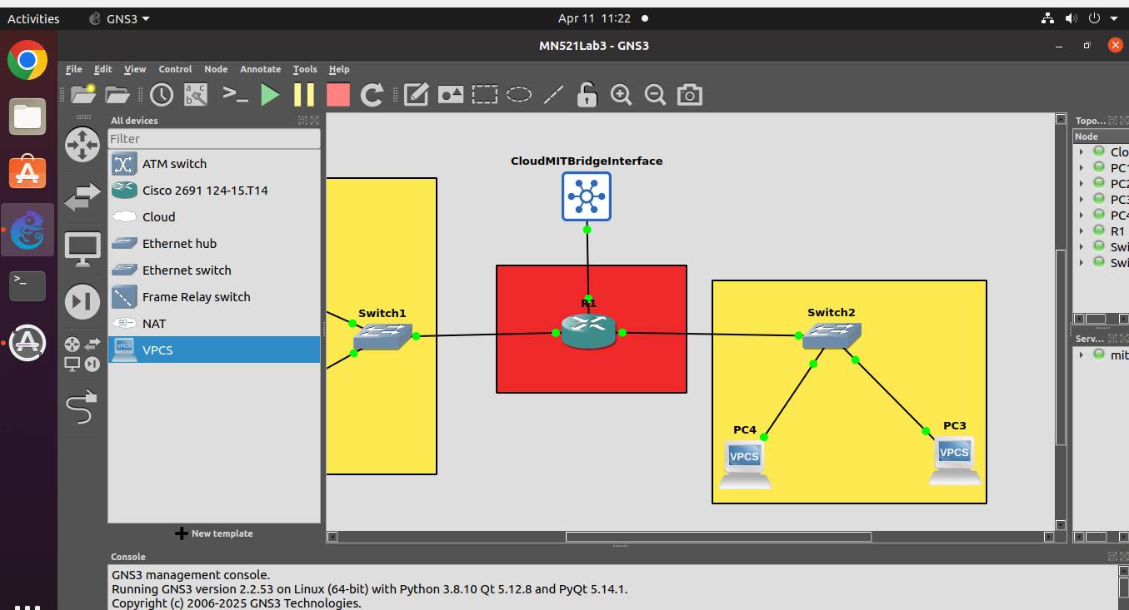
Task 1
Since the ubuntu machine that I am working on has predefined python3, I don’t need to reinstall it. I checked current version of python3 and created virtual env for installation of ncclient.
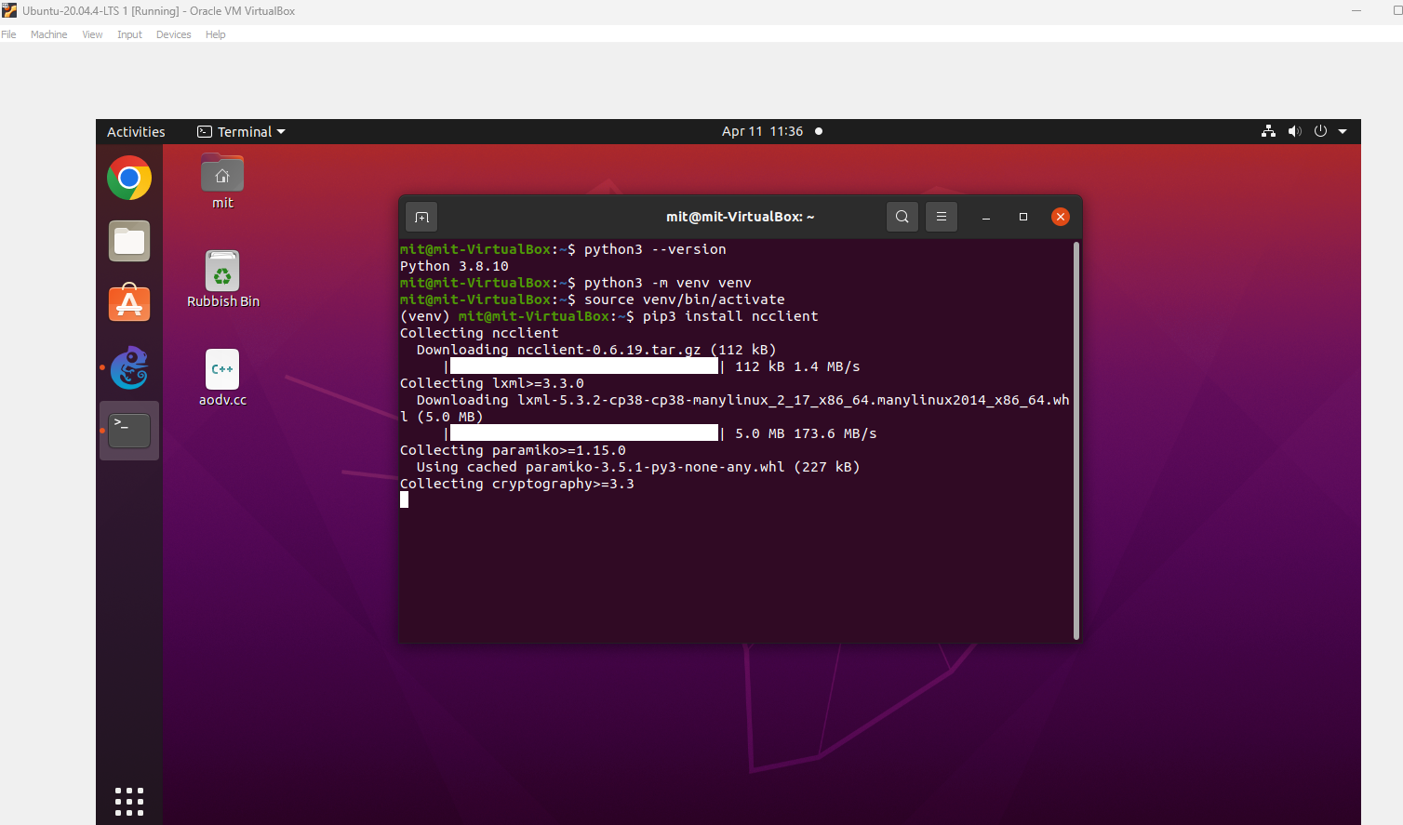
Enabling router to listen Netconf request below.
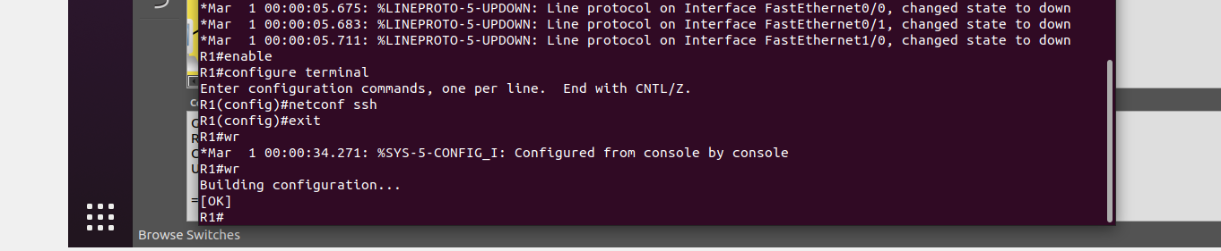

Checked Ip address of Router and tested connectivity to the router via Netconf using cli ssh command.
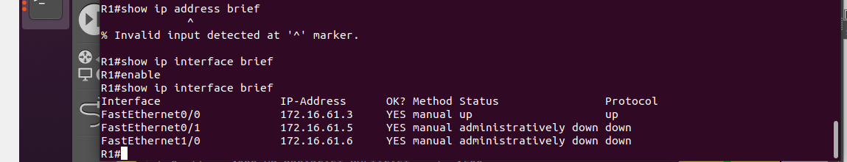
Below is the response of the testing of Netconf via ssh command
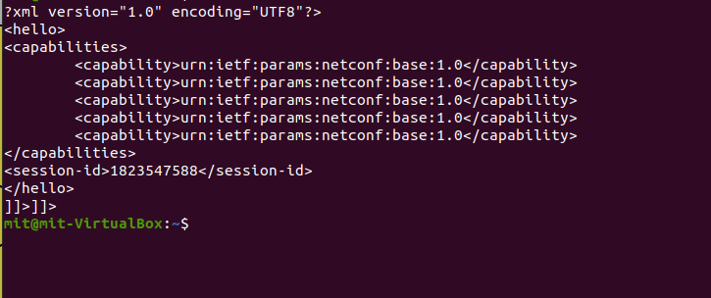

Task 2
Below is python script using ncclient. Since I installed ncclient on venv virtualenv, I activated that environment and run the script that I wrote on that env.
