GAD3025 Advanced Level Design

“Examphobia”

Erdem Süren

1731558

# TABLE OF CONTENTS

TABLE OF CONTENTS 2

1 Game Concept 4

1.1 Main Idea 4

1.2 Play Mechanic 4

1.3 Target Audience 4

2 Product Overview 5

3 Narrative Description Of Opening Gameplay (“Something Is Not Right”) 5

4 Characters 6

4.1 Erdem Süren: 6

4.2 Kerem Soytürk: 6

4.3 Janitor Ali Bekir: 6

4.4 Police Officer 6

5 Parts of Level 6

5.1 Chapters 6

5.1.1 Chapter 1: Something Is Not Right 6

5.1.2 Chapter 2: What Happened 7

5.1.3 Chapter 3: Find a Way To Escape 8

5.1.4 Chapter 4: Can’t be Happening 8

5.2 Chapters Flowchart 9

5.3 Chapters Beatchart 9

6 Obstacles 10

6.1 Enemies 10

6.1.1 Janitors 10

7 Gameplay 10

7.1 Controller Configuration 10

7.2 Character Actions 11

7.2.1 Limitations 11

8 Art Style 11

9 Map Design 12

9.1 2D Layout 12

9.2 Whitebox 13

9.2.1 First Floor 13

9.2.2 Second Floor 13

9.2.3 Basement 14

10 Asset List 15

# 1 Game Concept

## 1.1 Main Idea

-The player is trying to dodge devil worshiper janitors or hiding from them. The main goal is to escape from school by finding objects like door keys.

-The main character is a lazy, bad boy university student Erdem Süren. He is going to school sneaky to steal exam questions at the midnight. After he entered the school, the game starts. His goal is to steal the exam questions and escape the school but our main character finds himself in a cult devoted to the devil. His only goal now is to save his life. Meanwhile, there will be someone else named Kerem Soytürk who will direct our character via earpiece.

## 1.2 Play Mechanic

Players will control Erdem Süren from a first-person perspective. Key components of the gameplay are hiding and following the main mission. With the earpiece guy, the player will mostly follow the main mission. The school will be mostly dark. The player will find a candle by exploring the environment. The player will use a keyboard and mouse or a gamepad. There will be stamina, health, and candle condition. But they will not be on the screen as a bar.

* The player will understand Stamina condition with breathing.
* The player will understand Health condition with blood effects on the screen.
* The player will understand Candle condition with the light it radiates.

## 1.3 Target Audience

People who love horror content. Since it will not have complex mechanics, it will be perfect for casual gamers.

# 2 Product Overview

Examphobia, is a horror/thriller game. The player is trying to dodge devil worshiper janitors or hiding from them. The main goal is to escape from school by finding objects like door keys. The final exam has come at the university. 2 close friends, Erdem and Kerem, do not want to study for the exams and are looking for an easy way to pass the exam. As a result, they made an insidious plan to go to school on the weekend and steal the exam questions. Kerem's house is far from the school. Kerem will not be able to go to school because there is a curfew. That’s why Erdem gets ready and goes to school. Kerem, on the other hand, knows where the exam questions can be hidden because he is a little more hardworking than Erdem. Therefore, Erdem needs Kerem in order to achieve this goal. Erdem goes to school with a camera, an earpiece, and a flashlight.

The challenge in the game is tension. Examphobia is a game with short gameplay that constantly raises and lowers the level of fear and tension. The player generally will be uncomfortable.

The theme is a school theme. Most places will look alike. This will reduce the construction difficulty and cost for the design side. Since there will not be many game mechanics, it will facilitate the work of the software side and reduce its cost. Examphobia will be a small, easy to make, effective game.

# 3 Narrative Description Of Opening Gameplay (“Something Is Not Right”)

The game will begin when we enter the school. Since there is only one path from the main entrance to the corridor, we begin to move towards it. Our friend tells us where we should go. He tells us to go to the teachers' room, that is, to the 2nd floor. We go and enter the teachers' room. After taking the exam questions, player starts to move towards the door we came from again. As we progress, we begin to hear less noise, our eyes are dazzled, and our breathing rate increases. When we come to the door, we see that that door is locked.

# 4 Characters

## 4.1 Erdem Süren:

The main character that we are playing. A little bit aggressive guy. He is hating a lot of things in the world.

## 4.2 Kerem Soytürk:

The side character that we are listening to most of the time. He is a witty and careless person. He does not think of anyone but his own interests

## 4.3 Janitor Ali Bekir:

A naive man who reluctantly joined this cult.

## 4.4 Police Officer

The police officer our friend asked for help. He is under the control of the devil.

# 5 Parts of Level

The story structure has 4 main chapters and 8 main missions. 2 missions in the first part, 2 missions in the second part, 3 missions in the third part, and 1 mission in the ending part. The player must complete the first chapter for the actual game to begin.

## 5.1 Chapters

### 5.1.1 Chapter 1: Something Is Not Right

#### 5.1.1.1 Go to Teachers Work Room and steal exam questions

This is the entrance of the game. The part where there will be occasional paranormal events but no active enemies. With the guidance of our earpiece friend, we will head for the stairs. We will go upstairs and enter the teachers' room. We will find the exam questions and play the questions.

#### 5.1.1.2 Go to the exit.

After complete the first mission. The part where our character doesn't feel well. As he walks to the door we came in, his eyes blur, his hearing decreases, he becomes short of breath. When we came to the exit. We will see the door is locked. In the cinematic. We will see securities dead body. When we come to the door, we see that that door is locked. "You shouldn't be here" a janitor says to us from behind. We turn around and he punches us and knocks us out. We will meet the enemies for the first time in this episode.

### 5.1.2 Chapter 2: What Happened

#### 5.1.2.1 Escape from the basement

We wake up tied to a chair. Our headphones are on the table and we can barely hear our friend's voice. We try to resolve ourselves by force. When we get rid of it, we wear earpieces and have a conversation with our friends. Our character tries to persuade his friend to call the police. Our friend, on the other hand, says he tried to call the police, but he couldn't call anyone but us. At the end of the conversation, our friend goes out to go to the police. We continue to talk on the phone. We will hear our friend's footsteps and his breathing constantly in this chapter. Meanwhile, the door of the room we are in is locked and we cannot go anywhere. After our conversation is over we hear the door unlock and a note is left under the door. The note says "go to the lab". With hiding janitors, we will go try to escape from the basement. In the room, on the table, there will be a candle. Without a candle, the player can’t see outside of the room.

#### 5.1.2.2 Go to the laboratory

After we escaped from the basement. We are trying to do what is written in the note. And meanwhile, janitors start patrolling all over the map. We have to go to the laboratory with hiding from patrolling janitors. After we came to laboratory, our friend is having a conversation with the poliçe and we hear. Our friend asks for help, but the police start to make strange noises. We hear our friend running and we ask him "what's going on" repeatedly. After few seconds, janitor Ali Bekir shows himself and he tells us where the key to the main door is. While talking, we start to hear our friend's voice again, and when he comes to the garden of his house, we hear the police say, "Go home and watch him". And Ali Bekir disappears.

### 5.1.3 Chapter 3: Find a Way To Escape

#### 5.1.3.1 Go to Teachers Work Room and Find The Main Door Key

As Ali Bekir said, we go to the teachers' room and get the student affairs key. Meanwhile, our friend is talking about the police officer. he mentions that the police officer is still out of the garden and looking at his window. Our friend will say that most of the time. In the beat chart, how many janitors patrolling which floor, you can see it. While we researching the key. Janitors show up. We run from them. After we escape from them, one of them shouts us “Looks like you lost your key. Come to the basement and get it back”

#### 5.1.3.2 Go to the Basement and steal the main door keys

The player can run or sneak up in this part. The player goes basement and steals the main door keys but the player will be noticed after gets the key.

#### 5.1.3.3 Get Out of The School.

Run for your life. The janitors won't lose sight of us. After we came to the main door, one of the janitors kills the player. We will die by hearing our friend's scream.

### 5.1.4 Chapter 4: Can’t be Happening

#### 5.1.4.1 Lock the main door.

At the Kerem Soytürk’s home. We will play Kerem Soytürk. Our character will look down from the window. The police officer who is constantly watching him is no more. Kerem Soytürk opens the door of his room but the corridor will be too dark. The player presses the light button right in front of the player. There will be a final cinematic here. The light turns on red. Horrifying music is playing. At the other end of the corridor, Erdem Süren is lying in blood, Police officer lifts his head and looks at the player. Janitors are watching the player from behind the officer. The End.

## 5.2 Chapters Flowchart

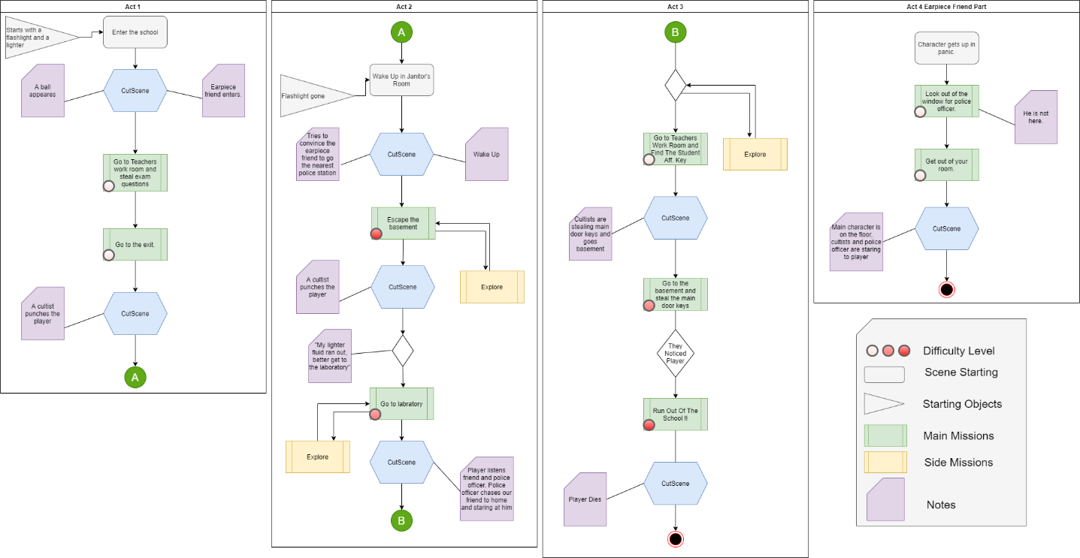

## 5.3 Chapters Beatchart



# 6 Obstacles

## 6.1 Enemies

### 6.1.1 Janitors

-The type of enemy that we will constantly encounter in the game. They want to capture us and sacrifice us to the devil.

-In patrol mode, they will look around.

-Switches to attack mode if the player in field of view. In the attack mode, they will chase the player. When they come closer, they will attack player with machete. If the players health is enough to be death with 1 hit, there will be a cinematic death.

# 7 Gameplay

## 7.1 Controller Configuration

|  |  |  |
| --- | --- | --- |
| Control Category | Keyboard&Mouse | Gamepad |
| Rotate Camera Right | Move Mouse Right | Right Joystick Right |
| Rotate Camera Left | Move Mouse Left | Right Joystick Left |
| Rotate Camera Up | Move Mouse Up | Right Joystick Up |
| Rotate Camera Down | Move Mouse Down | Right Joystick Down |
| Interaction | E | R1 |
| Walk Right | D | Left Joystick Right |
| Walk Left | A | Left Joystick Left |
| Walk Forward | W | Left Joystick Up |
| Walk Backward | S | Left Joystick Down |
| Run Forward | Toggle Shift + W | Push Joystick.Button(8) + Left Joystick Up |
| Crouch | C | Joystick.Button(1) |
| Light/Blow up Candle | R | Joystick.Button(3) |
| Take Item From Pocket | 1 | Joystick.Button(4) |
| Menu | ESC | Joystick.Button(7) |

## 7.2 Character Actions

### 7.2.1 Limitations

1-Character can’t run while crouching.

2-Character can’t hide in the dark while the candle is burning.

# 8 Art Style

Art Style of the game is dark and in the school concept. Usually there are rooms lit with candles.

# 9 Map Design

9.1 2D Layout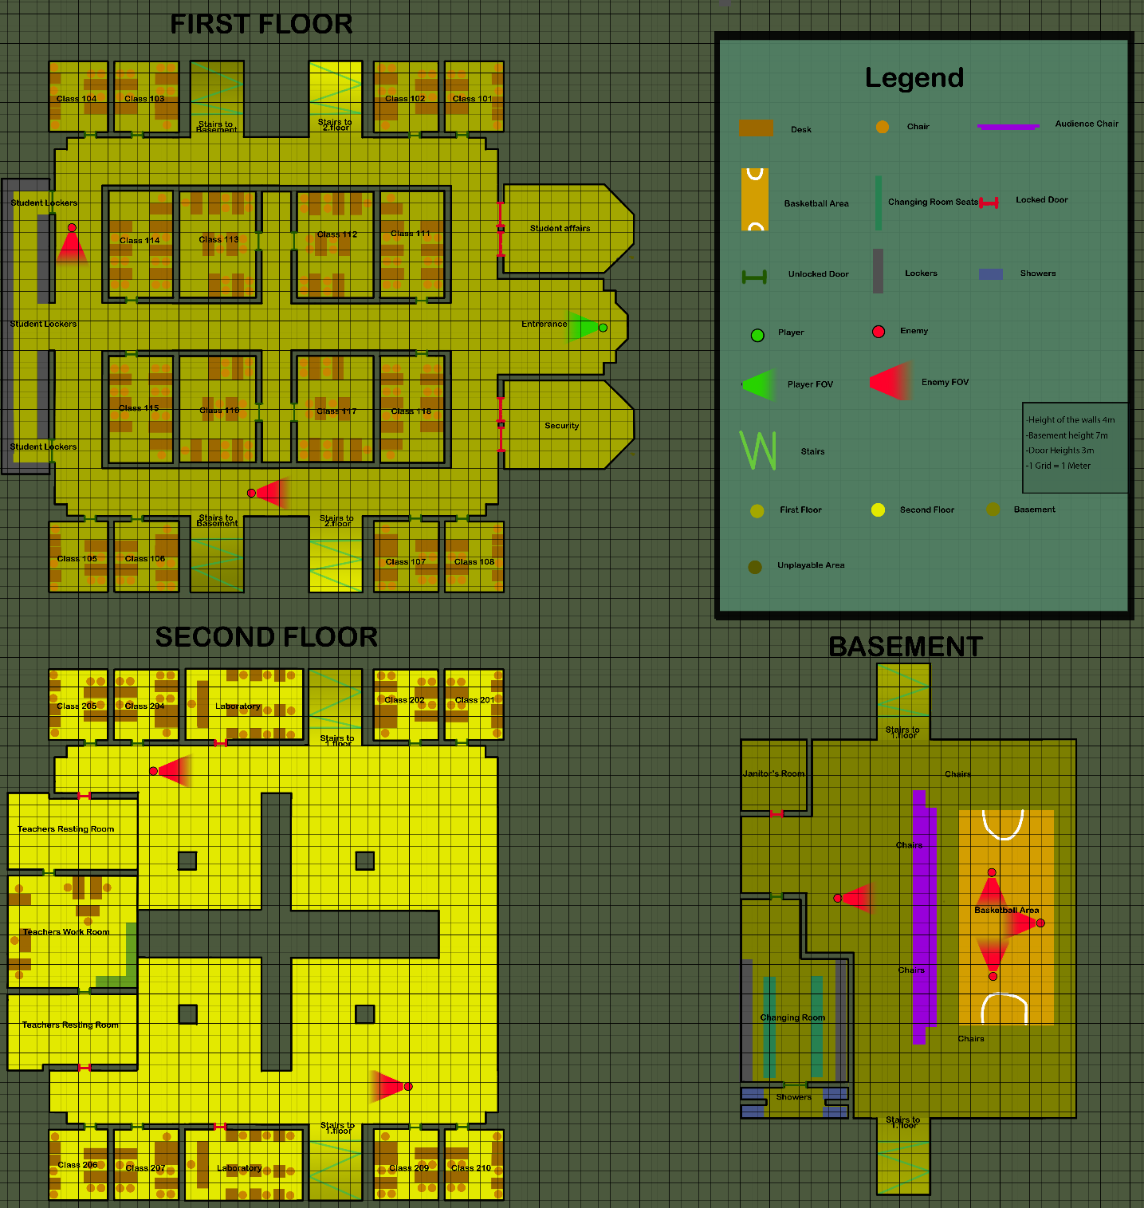

## 9.2 Whitebox

9.2.1 First Floor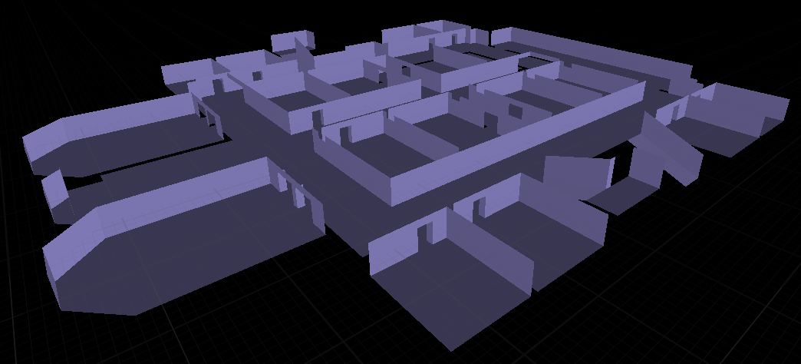

9.2.2 Second Floor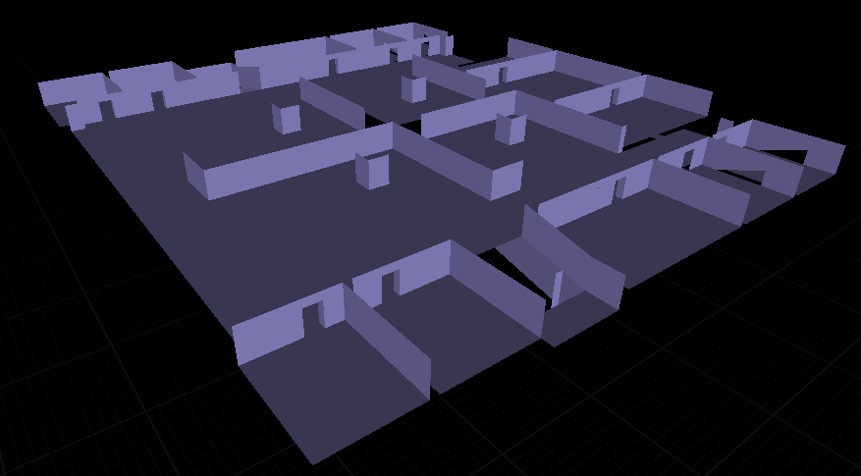

### 9.2.3 Basement

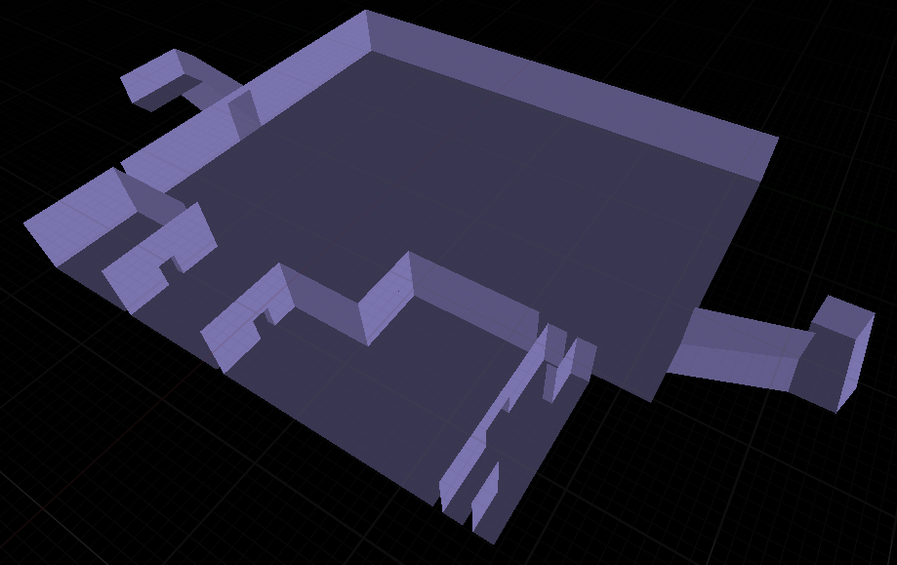

# 10 Asset List

