**CMP3001 Operating Systems**

**Erdem Süren 1731558**

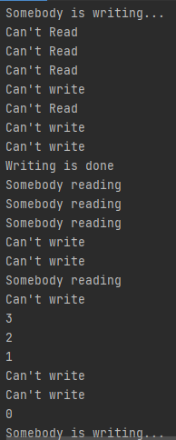In this project I created 1 boolean variable “accessibility”

to determine can a writer or reader access the program

and 1 integer variable “i” for how many readers are still

inside of the program. First of all, I just used “S” semaphore

and “S” semaphores permit value is just 1 so for readLock()

function, when defining acquire(), I write permit value 0 and

for readUnLock() function, when writing release(), I gave permit

value also 0. In that two readLock() and readUnLock() functions

after every acquire(), set “i” value i+1 and after every release(),

set “i” value i-1. In the readLock() function there is a while loop

with the opposite of accessibility boolean. If this Boolean is false

when a reader comes it will enter the loop and couldn’t exit to

loop until the accessibility boolean value becomes true. For

writers in the writeLock() function, there is a while loop looking

“accessibility” and “i” values. If the “accessibility” false or “i”

value is greater than 0, this writer can’t perform. If a writer can

perform the program will take acquire() and set the “accessibility”

boolean value to false. After the writer is done the job,

in the writeUnLock() function accessibility value will be true again

and readers can read or writers can (if there are no readers still in

the program) write.