Revision History

|  |  |  |  |
| --- | --- | --- | --- |
| **Date** | **Version** | **Description** | **Author** |
| 12/03/2014 | 1.5 | Initial Version of SRS | Mehmet Kağan Kayaalp, Erdi Koç, Nazlı Karalar, İsmetcan Hergünşen, Gamze Küçükçolak |
| 13/03/2014 | 1.6 | Introduction (Document Overview, System Overview, Abbreviations, References, Conventions) | Mehmet Kağan Kayaalp, Erdi Koç, Nazlı Karalar, İsmetcan Hergünşen |
| 14/03/2014 | 1.7 | User Requirements (Functional Requirements) | Erdi Koç, Nazlı Karalar, İsmetcan Hergünşen |
| 15/03/2014 | 1.8 | System Architecture, Use Cases, System Requirement Specifications | Mehmet Kağan Kayaalp, Gamze Küçükçolak, Erdi Koç, Nazlı Karalar |

**TABLE OF CONTENTS**

Revision History 1

1 INTRODUCTION 3

1.1 Document overview 3

1.2 System overview 3

1.3 Abbreviations 3

1.4 References 4

1.5 Conventions 4

2 REQUIREMENTS 5

2.1 User Requirements Specification 5

2.1.1 Functional Requirements 6

2.1.2 Nonfunctional Requirements 8

2.2 System Architecture 9

2.3 Use Cases and Usage Scenarios 9

2.4 System Requirements Specification 9

# INTRODUCTION

## Document overview

This document contains all of the requirements for the CCB software development project presented in Software Development Project report. In the first section, the document describes system overview, abbreviations, references and list of conventions.

The next section, “*Requirements”* is written primarily for users and customers and includes user requirements, system architecture, use cases and usage scenarios and system requirements specification.

User requirements part of the document describes:

* Services provided for the user
* Nonfunctional system requirements

System architecture part explains high level overview of the anticipated system architecture.

In the third part of the Requirements, UML case diagrams and sequence diagrams presents usage scenarios of the system.

Final part, System Requirements Specification, explains the functional and nonfunctional requirements in more detail.

Software Requirement Specification acts as the basis agreement between the customer and the project development team. This also causes to reduce the effort needed by the development team while giving the best estimation capabilities.

## System overview

The CCB will be a mini game application project. When the users play the game, game starts with splash screen which includes the introduction and the rules of the game. The users can start the game by pressing any button on the keyboard. In the game, there will be user’s helicopter and enemy helicopters to battle with bombs and bullets. When there is a collision between user’s helicopter and enemy helicopters, user’s helicopter falls and the game ends.

## Abbreviations

|  |  |
| --- | --- |
| **Term** | **Description** |
| CCB Project | Crazy Copter Battle Project Game |
| DOC #v.1.0.x | Document version 1.0.x |
| JDA | Java Desktop Application |
| MVC | Model View Controller |
| UI | User Interface |
| GUI | Graphical User Interface |
| SDD | Software Design Document |
| SDP | Software Development Plan |
| SRS | Software Requirements Document |
| UML | Unified Modeling Language |
| STP | Software Test Plan |
| JDK | Java Development Kit |
| STR | Software Test Report |

## References

|  |  |  |
| --- | --- | --- |
| # | Document Identifier | Document Title |
| DOC#SDP V1.0 | [1] | Software Development Plan |

## Conventions

* Requirements listed in this document are constructed according to the following structure:

Requirement Id

Requirement title

Requirement description

Requirement version

* Name of main sections is written in bold letters.
* All abbreviations and acronyms are defined in 1.3 Abbreviations part.
* All the diagrams are constructed by using ArgoUML.
* The document number is shown with number inside square brackets.

# REQUIREMENTS

## User Requirements Specification

### Functional Requirements

SRS-CCB-001

Splash Screen, Introduction and Buttons

CCB shall present a splash screen including Start Game” and “Help” buttons and exit option when the user opens the game.

Version of CCB-001

SRS-CCB-002

Loading the Game

CCB shall be played after the loading.

Version of CCB-002

SRS-CCB-003

Background Sound

CCB shall be played with background sound.

Version of CCB-003

SRS-CCB-004

Information Board, Timer and Counter

CCB shall provide user’s helicopter information board, a timer and the counter.

Version of CCB-004

SRS-CCB-005

Keyboard control

CCB shall enable the user to control the helicopter object via the keyboard.

Version of CCB-005

SRS-CCB-006

Mouse Control

CCB shall determine the direction of the bullets.

Version of CCB-006

SRS-CCB-007

Explosion Sound

CCB shall include collision sound.

Version of CCB-007

SRS-CCB-008

Pause

CCB shall provide pause option.

Version of CCB-008

SRS-CCB-009

Game Over, Statistics

CCB shall provide a screen which presents game over and statistics of the game.

Version of CCB-009

### Nonfunctional Requirements

SRS-CCB-001

Performance

Operations of CCB shall be processed in less than 5 seconds.

Version of CCB-001

SRS-CCB-002

Performance

CCB shall be less than 20 MB.

Version of CCB-002

## System Architecture

CCB shall use MVC (Model-View-Controller) design pattern which is a software pattern for implementing user interfaces. MVC is a quite useful and popular design pattern in the modern world. The main reason why MVC is used is reusable without any modification.

**Model**: BBC shall have a model which represents the data, and does not doing else. The model does not depend on the controller (Keyboard) or the view (GUI).

**View**: BBC shall use GUI controlled by the view part of the MVC pattern. Also, this part always requests updates from the models and sends user gestures to select view.

**Controller**: The controller provides model data to the view, and interprets user actions. For instance, you can control the helicopter by using keyboard (W, A, S, D or arrow directions). The controller depends on the view and the model.

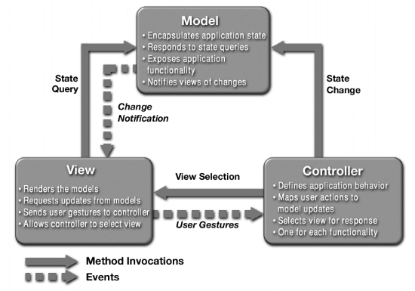

Diagram 1 is a sequence diagram of MVC Pattern

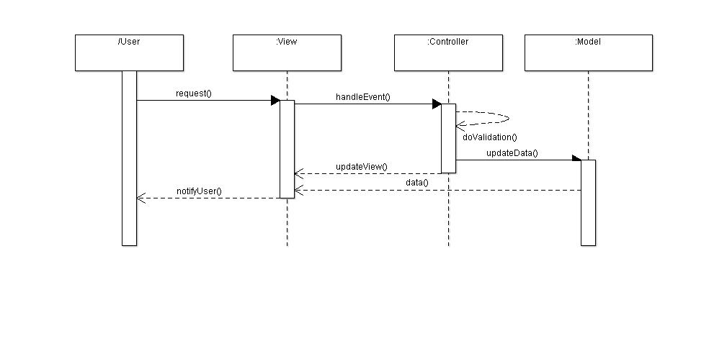

(Diagram 1)

For more information about MVC design pattern:

<https://ist.berkeley.edu/as-ag/pub/pdf/mvc-seminar.pdf>

## Use Cases and Usage Scenarios

Use Case diagram is a representation of a user’s interaction with the system. Diagram 2 indicates us representation between player and system.

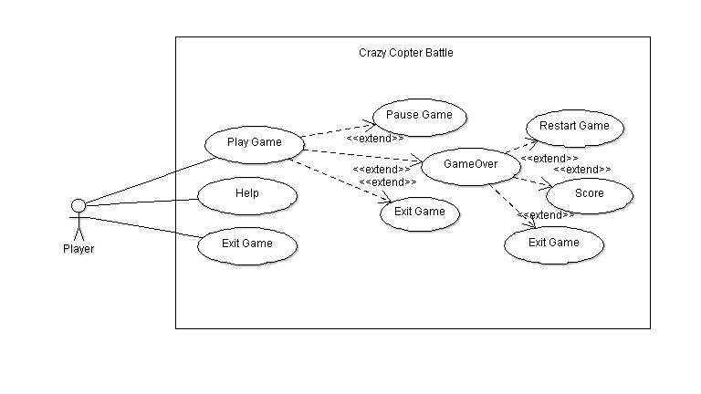

(Diagram 2)

Diagram 3 shows “starting game” sequence diagram.

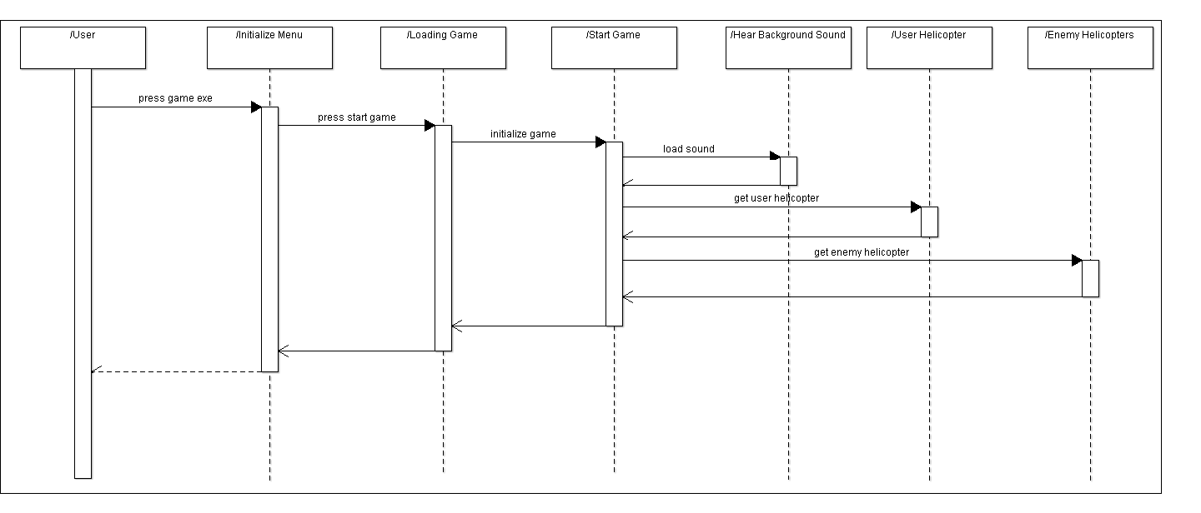

(Diagram 3)

## System Requirements Specification

### Functional Requirements

SRS-CCB-001.1

Splash Screen and Introduction

CCB will have a splash screen and an introduction part when user opens the game so that the user can understand what to press and the rules of the game.

Version of CCB-001

SRS-CCB-001.2

Exit Option

When the player presses the ESC key, the game will close.

Version of CCB-001

SRS-CCB-001.3

Start Game Button

When the user presses “Start Game” button on the splash screen, the game will start.

Version of CCB-001

SRS-CCB-001.4

Help Button

When the user presses “Help” button on the splash screen, instruction panel will appear.

Version of CCB-001

SRS-CCB-002.1

Loading the Game

When the user presses “Start Game” button, “Game is loading…” screen will be appeared.

Version of CCB-002

SRS-CCB-003.1

Background Sound

When the game starts, there will be background sound until the game is over.

Version of CCB-003

SRS-CCB-004.1

Information Board and Time

After the loading, user’s helicopter information board which includes “Destroyed”, “Run Away”, “Bombs”, “Bullets” will be shown on the top-left corner.

Version of CCB-004

SRS-CCB-004.2

Time

There will be a timer on the top of the screen.

Version of CCB-004

SRS-CCB-004.3

Firing and Launching counter

When the user presses the left click, the bullet will be fired and when the user presses the right click, the bomb will be launched.

Version of CCB-004

SRS-CCB-005.1

Keyboard Control

The game will be played with direction keys. It will be either W, A, S, D or arrow keys. Also, right and left click will be used in order to determine the direction of the bullets.

Version of CCB-005

SRS-CCB-006.1

Mouse Cursor

The user controls the direction of the bullets that will be fired.

Version of CCB-006

SRS-CCB-006.2

Firing and Launching

When the user clicks the left, the bullet will be fired. When the user clicks the right, the rocket will be launched.

Version of CCB-006

SRS-CCB-007.1

Collision Sound

When the helicopters crash and the enemy helicopters are shot, collision sound will be heard.

Version of CCB-007

SRS-CCB-008

Pause

When the player presses “P” key, the game will pause.

Version of CCB-008

SRS-CCB-009.1

Game Over

When the helicopters crash, the new screen that contains of game over text, restart, exit text and statistics will be appeared.

Version of CCB-009

SRS-CCB-009.2

Statistics

In statistics, there will be time, bombs and bullets left, destroyed and run away score.

Version of CCB-009

### Non-functional Requirements

SRS-CCB-001.1

Performance

Opening of the splash screen will be less than 4 seconds.

Version of CCB-001

SRS-CCB-001.2

Performance

Transition between frames will be less than 0.5 second.

Version of CCB-001

SRS-CCB-001.3

Performance

Frequency of firing bullets will be less than 0.5 second.

Version of CCB-001

SRS-CCB-001.4

Performance

Frequency of launching bombs will be less than 0.5 second.

Version of CCB-001

SRS-CCB-001.5

Performance

Explosion after collision between helicopters will be less than 0.5 second.

Version of CCB-001