Revision History
Date | Version | Description | Author
12/03/2014 | 1.5 | Initial Version of SRS | Mehmet Kağan Kayaalp, Erdi Koç, Nazlı Karalar, İsmetcan Hergünşen, Gamze Küçükçolak
13/03/2014 | 1.6 | Introduction (Document Overview, System Overview, Abbreviations, References, Conventions) | Mehmet Kağan Kayaalp, Erdi Koç, Nazlı Karalar, İsmetcan Hergünşen
14/03/2014 | 1.7 | User Requirements (Functional Requirements) | Erdi Koç, Nazlı Karalar, İsmetcan Hergünşen
15/03/2014 | 1.8 | System Architecture, Use Cases, System Requirement Specifications | Mehmet Kağan Kayaalp, Gamze Küçükçolak, Erdi Koç, Nazlı Karalar

TABLE OF CONTENTS
Revision History 1
1 INTRODUCTION 3
1.1 Document overview 3
1.2 System overview 3
1.3 Abbreviations 3
1.4 References 4
1.5 Conventions 4
2 REQUIREMENTS 5
2.1 User Requirements Specification 5
2.1.1 Functional Requirements 6
2.1.2 Nonfunctional Requirements 8
2.2 System Architecture 9
2.3 Use Cases and Usage Scenarios 9
2.4 System Requirements Specification 9

INTRODUCTION

Document overview
This document contains all of the requirements for the CCB software development project presented in Software Development Project report. In the first section, the document describes system overview, abbreviations, references and list of conventions.
The next section, “Requirements” is written primarily for users and customers and includes user requirements, system architecture, use cases and usage scenarios and system requirements specification.
User requirements part of the document describes:
- Services provided for the user
- Nonfunctional system requirements
System architecture part explains high level overview of the anticipated system architecture.
In the third part of the Requirements, UML case diagrams and sequence diagrams presents usage scenarios of the system.
Final part, System Requirements Specification, explains the functional and nonfunctional requirements in more detail.

Software Requirement Specification acts as the basis agreement between the customer and the project development team. This also causes to reduce the effort needed by the development team while giving the best estimation capabilities.

System overview

The CCB will be a mini game application project. When the users play the game, game starts with splash screen which includes the introduction and the rules of the game. The users can start the game by pressing any button on the keyboard. In the game, there will be user’s helicopter and enemy helicopters to battle with rockets and bullets. When there is a collision between user’s helicopter and enemy helicopters, user’s helicopter falls and the game ends.

Abbreviations
Term | Description
CCB Project | Crazy Copter Battle Project Game
DOC #v.1.0.x | Document version 1.0.x
JDA | Java Desktop Application
MVC | Model View Controller
UI | User Interface
GUI | Graphical User Interface
SDD | Software Design Document
SDP | Software Development Plan
SRS | Software Requirements Document
UML | Unified Modeling Language
STP | Software Test Plan
JDK | Java Development Kit
STR | Software Test Report

References

# | Document Identifier | Document Title
DOC#SDP V1.0 | [1] | Software Development Plan

Conventions
- Requirements listed in this document are constructed according to the following structure:
Requirement Id
Requirement title
Requirement description

Requirement version

- Name of main sections is written in bold letters.
- All abbreviations and acronyms are defined in 1.3 Abbreviations part.
- All the diagrams are constructed by using ArgoUML.
- The document number is shown with number inside square brackets.

REQUIREMENTS

User Requirements Specification

Functional Requirements
SRS-CCB-001
Splash Screen, Introduction and Buttons
CCB shall present a splash screen including Start Game” and “Help” buttons and exit option when the user opens the game.

Version of CCB-001
SRS-CCB-002
Loading the Game
CCB shall be played after the loading.

Version of CCB-002
SRS-CCB-003
Background Sound
CCB shall be played with background sound.

Version of CCB-003
SRS-CCB-004
Information Board, Timer and Counter
CCB shall provide user’s helicopter information board, a timer and the counter.

Version of CCB-004
SRS-CCB-005
Keyboard control
CCB shall enable the user to control the helicopter object via the keyboard.

Version of CCB-005
SRS-CCB-006
Mouse Control
CCB shall determine the direction of the bullets.

Version of CCB-006
SRS-CCB-007
Explosion Sound
CCB shall include collision sound.

Version of CCB-007
SRS-CCB-008
Pause
CCB shall provide pause option.

Version of CCB-008
SRS-CCB-009
Game Over, Statistics
CCB shall provide a screen which presents game over and statistics of the game.

Version of CCB-009

Nonfunctional Requirements
SRS-CCB-001
Performance
Operations of CCB shall be processed in less than 5 seconds.

Version of CCB-001

SRS-CCB-002
Performance
CCB shall be less than 20 MB.

Version of CCB-002

System Architecture
CCB shall use MVC (Model-View-Controller) design pattern which is a software pattern for implementing user interfaces. MVC is a quite useful and popular design pattern in the modern world. The main reason why MVC is used is reusable without any modification.

Model: BBC shall have a model which represents the data, and does not doing else. The model does not depend on the controller (Keyboard) or the view (GUI).

View: BBC shall use GUI controlled by the view part of the MVC pattern. Also, this part always requests updates from the models and sends user gestures to select view.

Controller: The controller provides model data to the view, and interprets user actions. For instance, you can control the helicopter by using keyboard (W, A, S, D or arrow directions). The controller depends on the view and the model.

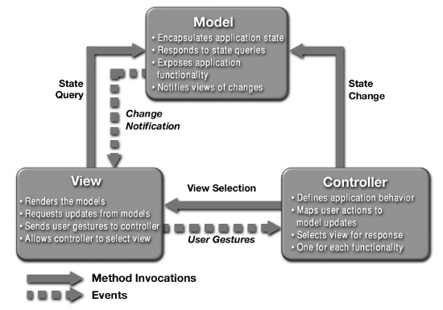

Diagram 1 is a sequence diagram showing the interaction:

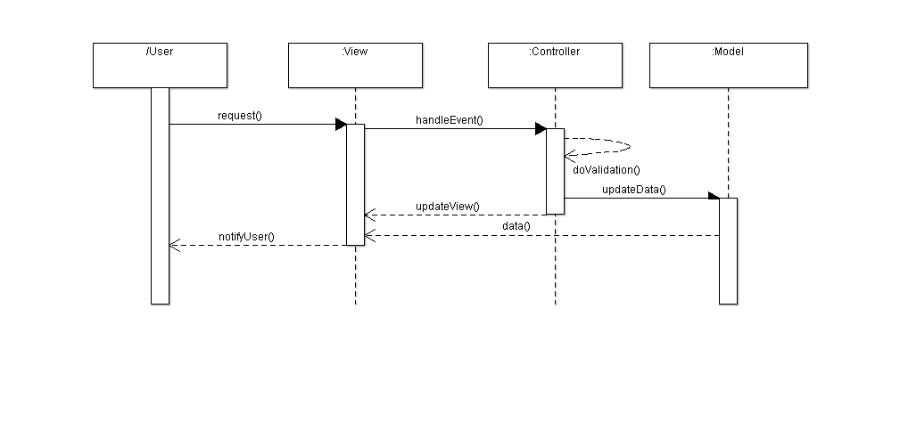
Diagram 1 – Sequence diagram of MVC Pattern

For more information about MVC design pattern:
https://ist.berkeley.edu/as-ag/pub/pdf/mvc-seminar.pdf

Use Cases and Usage Scenarios

Use Case diagram is a representation of a user’s interaction with the system. Diagram 2 indicates us representation between player and system.
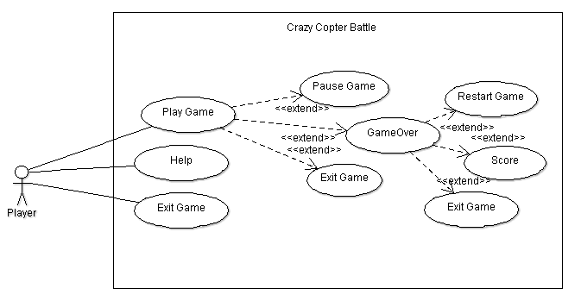
Diagram 2 – Use Case Diagram

In the Diagram 3, player fires a rocket or bullet towards the enemy helicopter.
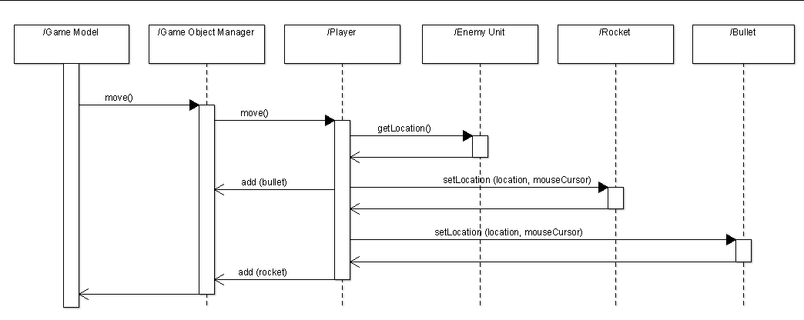
Diagram 3 – Player fires a bullet or rocket towards enemy

A diagram 4 show that a rocket or bullet fired from the player hits the enemy helicopter is destroyed.
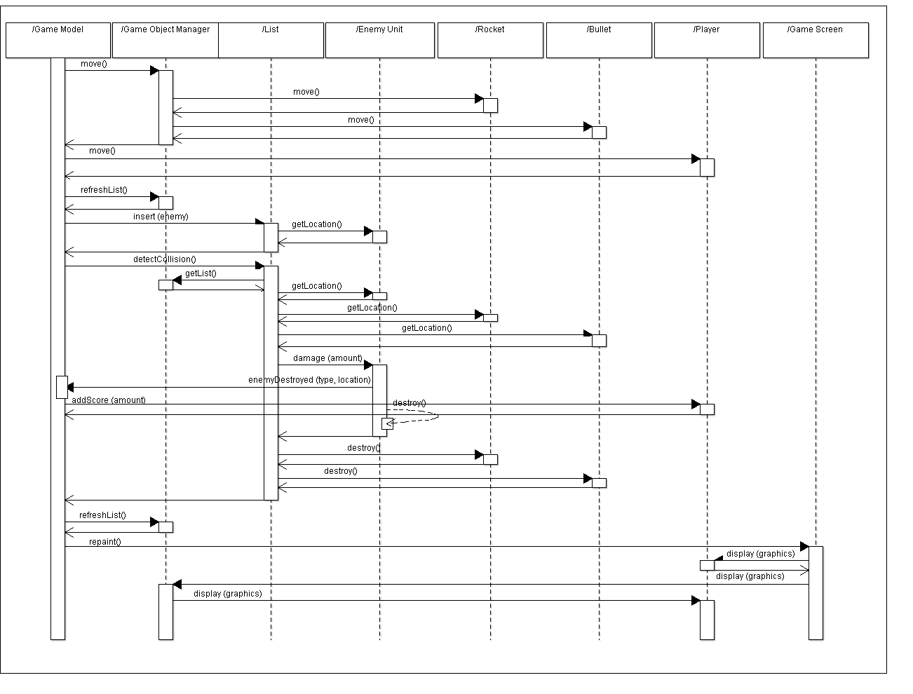
Diagram 4 – A rocket or bullet fired by the player destroys enemy helicopter

System Requirements Specification

Functional Requirements
SRS-CCB-001.1
Splash Screen and Introduction
CCB will have a splash screen and an introduction part when user opens the game so that the user can understand what to press and the rules of the game.

Version of CCB-001
SRS-CCB-001.2
Exit Option
When the player presses the ESC key, the game will close.

Version of CCB-001
SRS-CCB-001.3
Start Game Button
When the user presses “Start Game” button on the splash screen, the game will start.

Version of CCB-001
SRS-CCB-001.4
Help Button
When the user presses “Help” button on the splash screen, instruction panel will appear.

Version of CCB-001
SRS-CCB-002.1
Loading the Game
When the user presses “Start Game” button, “Game is loading…” screen will be appeared.

Version of CCB-002
SRS-CCB-003.1
Background Sound
When the game starts, there will be background sound until the game is over.

Version of CCB-003
SRS-CCB-004.1
Information Board and Time
After the loading, user’s helicopter information board which includes “Destroyed”, “Run Away”, “Rockets”, “Bullets” will be shown on the top-left corner.

Version of CCB-004
SRS-CCB-004.2
Time
There will be a timer on the top of the screen.

Version of CCB-004
SRS-CCB-004.3
Firing and Launching counter
When the user presses the left click, the bullet will be fired and when the user presses the right click, the bomb will be launched.

Version of CCB-004
SRS-CCB-005.1
Keyboard Control
The game will be played with direction keys. It will be either W, A, S, D or arrow keys. Also, right and left click will be used in order to determine the direction of the bullets.

Version of CCB-005
SRS-CCB-006.1
Mouse Cursor
The user controls the direction of the bullets that will be fired.

Version of CCB-006
SRS-CCB-006.2
Firing and Launching
When the user clicks the left, the bullet will be fired. When the user clicks the right, the rocket will be launched.

Version of CCB-006
SRS-CCB-007.1
Collision Sound
When the helicopters crash and the enemy helicopters are shot, collision sound will be heard.

Version of CCB-007
SRS-CCB-008
Pause
When the player presses “P” key, the game will pause.

Version of CCB-008
SRS-CCB-009.1
Game Over
When the helicopters crash, the new screen that contains of game over text, restart, exit text and statistics will be appeared.

Version of CCB-009
SRS-CCB-009.2
Statistics
In statistics, there will be time, rockets and bullets left, destroyed and run away score.

Version of CCB-009

Non-functional Requirements

SRS-CCB-001.1
Performance
Opening of the splash screen will be less than 4 seconds.

Version of CCB-001
SRS-CCB-001.2
Performance
Transition between frames will be less than 0.5 second.

Version of CCB-001
SRS-CCB-001.3
Performance
Frequency of firing bullets will be less than 0.5 second.

Version of CCB-001
SRS-CCB-001.4
Performance
Frequency of launching rockets will be less than 0.5 second.

Version of CCB-001
SRS-CCB-001.5
Performance
Explosion after collision between helicopters will be less than 0.5 second.

Version of CCB-001

