İlker Erdinç 28282

**1. Objective**

The task was to apply a series of transformations (translation, scaling, and rotations) to a 3D cube and animate this transformation over a 10-second period. The animation involves transitioning the cube from its initial state to a transformed state over 5 seconds and then reversing the transformation back to the initial state over the next 5 seconds.

**2. Methodology**

**Task 1: Initial Transformation Calculation**

In **Task 1**, the transformation matrix was calculated using the following transformations:

* **Translation**: 0.3 units along the x-axis and -0.25 units along the y-axis.
* **Scaling**: Scaling the cube by 0.5 along both the x-axis and y-axis.
* **Rotation**:
  + 30 degrees around the x-axis.
  + 45 degrees around the y-axis.
  + 60 degrees around the z-axis.

As a result of the ChatGPT’s answer, it has given the modelview matrix in Float32Array format after the wanted transformation.

ekran görüntüsü, metin, multimedya yazılımı, yazılım içeren bir resim

Açıklama otomatik olarak oluşturuldu

For **Task 2**, the same transformations were recalculated using predefined matrix utility functions:

* createTranslationMatrix()
* createScaleMatrix()
* createRotationMatrix_X(), createRotationMatrix_Y(), and createRotationMatrix_Z()

The transformations were combined in the correct order (rotation, then scaling, and finally translation). The matrix produced by these operations matched the one in **Task 1**.

ekran görüntüsü, metin, yazılım, multimedya yazılımı içeren bir resim

Açıklama otomatik olarak oluşturuldu

In **Task 3**, the cube was animated over a 10-second cycle. The animation worked as follows:

* **First 5 seconds**: The cube transitions from its initial state (identity matrix) to the final transformation (calculated in Task 2).
* **Next 5 seconds**: The cube reverses this transformation, returning to its initial state.
* This cycle repeats indefinitely.

The interpolation between the identity matrix and the target transformation matrix was done using a linear interpolation method, where the interpolation factor t transitions from 0 to 1 during the first 5 seconds, and from 1 back to 0 during the next 5 seconds.

The function getPeriodicMovement() calculates the interpolated transformation matrix at any given time in the animation cycle.

As a result,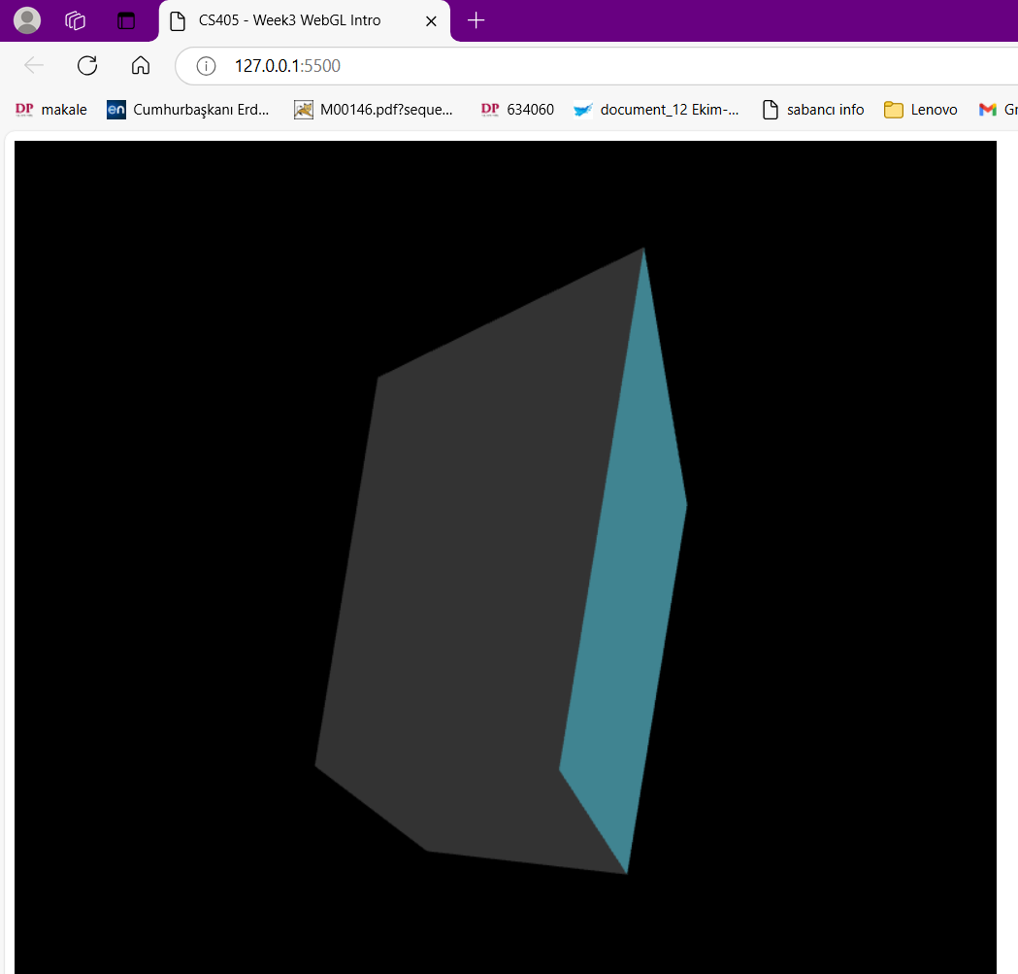 ChatGpt gived a successful animation in wanted formation.

**Conclusion**

The tasks successfully demonstrated applying and animating 3D transformations using matrix operations. The interpolation used in Task 3 effectively created a cyclic animation, giving the desired transition effect between the cube’s initial and transformed states. This approach can be applied in any 3D rendering context where periodic transformations are required.

The ChatGPT Link: https://chatgpt.com/share/6710f33d-0450-8011-98ce-9b4a230f92ea