**Daily Scrum Tool**

As we are home office nowadays, we are joining online meetings more than ever. In online meetings, it is sometimes hard to decide to organize speakers’ turn and manage the time properly. There are sometimes silent gaps or too many people are speaking at the same time. To address this problem, we developed a “Daily Scrum Tool” that randomizes the speakers and creates awareness for time management.

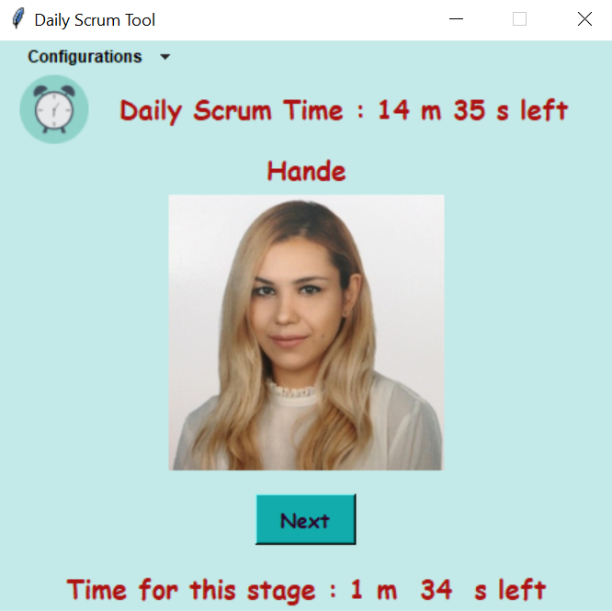

## Customize for your Team

* You can either use your default config file or create a new file such as team1.json etc
* Set “names_file” attribute in the config file and write down your team member names into “names.txt”

|  |  |  |
| --- | --- | --- |
| **Set “names_file” attribute** | **Select names.txt** | **names.txt** |
|  |  |  |

* Then, set “photos_folder” attribute to show your photos folder and make sure that your photo name should be the same as the name in names.txt.

|  |  |  |
| --- | --- | --- |
| **Set “photos_folder” attribute** | **Select photos folder** | **names.txt** |
|  |  |  |

* As the last step, you should import the team1.json file that you have created previously.

|  |  |  |
| --- | --- | --- |
| **Configure** | **Import** | **Start** |
|  |  |  |

Then congratulations! The tool will automatically handle what is required for your daily Scrum.

**Multiple Teams**

You can customize the tool for different team importing different configuration files. Every team should have separate config json file and names file.

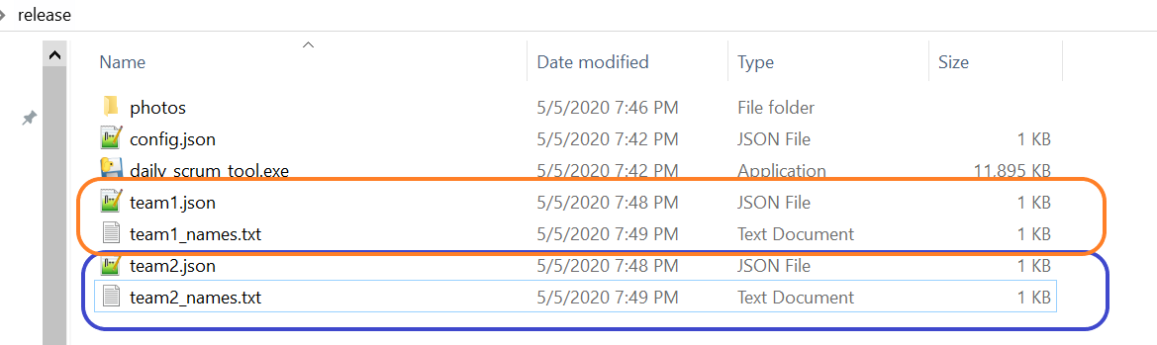

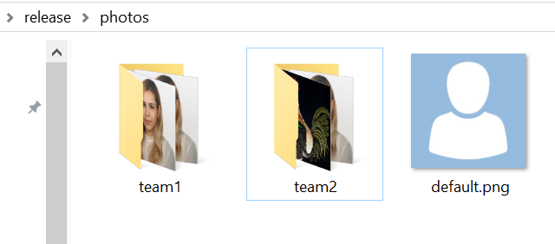

**Randomize Speakers**

You can randomize speakers using Next button and a photo of the speaker will be shown. When all team members have spoken, the tool will ask if you restart time or not.

|  |  |  |  |  |  |
| --- | --- | --- | --- | --- | --- |
| **First Round** | **Second Round** | **N th Round** | **Last Round** |  |  |
|  |  |  |  |  |  |

**Manage Time**

Since Scrum Guide fixes the timebox to 15 minutes, this tool starts to countdown as shown below. So that team is aware of the overall time and organize their speech to fetch the timebox. The other feature is setting an individual time for each speaker. This is just a warning for speakers, following up total time is more important than individual time.

|  |  |  |
| --- | --- | --- |
| **Total Time** | **Individual Time** | **Time is up!** |
|  |  |  |

You can reach source code from the link below:

<https://github.com/erdoganonal/daily_scrum_tool>

Please refer README.md for installation and requirements

Pull requests are welcomed. For major changes, please open an issue first to discuss what you would like to change.