package sequnce_list;  
  
  
import java.util.Scanner;  
  
*/**  
 \** ***@version*** *1.0  
 \** ***@autor*** *孙鹏  
 */*public class homeWork {  
 public static class LNode{  
 int data ;  
 LNode next = null;  
  
 }  
 public static LNode initLNode(){  
 LNode head = new LNode();  
 head.next = null;  
 return head;  
 }  
 public static void creatLNode(LNode head){  
 int n = 0;  
 LNode s;  
 Scanner scanner = new Scanner(System.*in*);  
 System.*out*.println("链表长度：");  
 n = scanner.nextInt();  
 System.*out*.println("数据为：");  
 while(n-->0){  
 s = new LNode();  
 s.data = scanner.nextInt();  
 s.next = head.next;  
 head.next = s;  
 }  
  
  
 }  
 private static int getNum(LNode lNode,int i){  
 int j = 1;  
 LNode p ;  
 p = lNode.next;  
 while(j<i && p!=null){  
  
 p = p.next;  
 j++;  
 }  
 if(j>=i||p==null){  
 return -1;  
 }  
 return p.data;  
 }  
 private static void Listprint(LNode L) //单链表的输出  
 {  
 LNode p;  
 p=L.next;  
 int lengh = 0;  
 while(p!=null)  
 {  
 System.*out*.print(p.data+"\t");  
  
  
 p=p.next;  
 }  
 System.*out*.println();  
 }  
 private static int Lengh(LNode L)  
 {  
 LNode p;  
 p=L.next;  
 int lengh = 0;  
 while(p!=null)  
 {  
  
 lengh++;  
  
 p=p.next;  
 }  
 System.*out*.println();  
 return lengh;  
 }  
  
  
 public static void main(String[] args) {  
 LNode l1 = new LNode();  
 LNode l2 = new LNode();  
 int n = 0;  
 if((l1=*initLNode*())!=null){  
 *creatLNode*(l1);  
 *Listprint*(l1);  
 }  
  
 if((l2=*initLNode*())!=null){  
 *creatLNode*(l2);  
 *Listprint*(l2);  
 }  
 for(int i = 0;i<*Lengh*(l1)-1;i++){  
 for(int j = 0;j<*Lengh*(l2)-1;j++){  
 if(*getNum*(l1,i)==*getNum*(l2,j)){  
 System.*out*.println(*getNum*(l1,i));  
 n++;  
 }  
 }  
 }  
 System.*out*.println("交集的个数为 ："+n);  
  
  
  
  
  
 }  
}

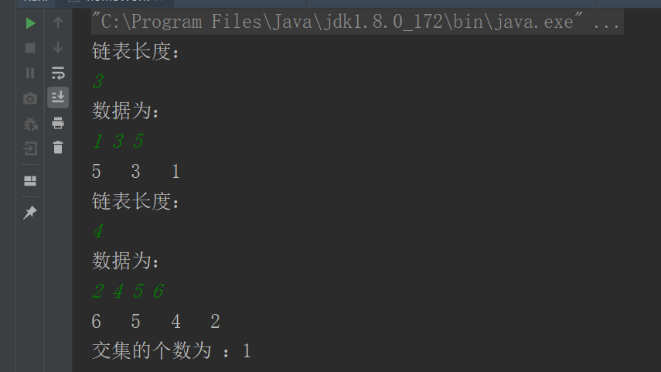

import java.util.Scanner;  
  
*/**  
 \** ***@version*** *1.0  
 \** ***@autor*** *孙鹏  
 */*public class homeWork {  
 public static class LNode{  
 int data ;  
 LNode next = null;  
  
 }  
 public static LNode initLNode(){  
 LNode head = new LNode();  
 head.next = null;  
 return head;  
 }  
 public static void creatLNode(LNode head){  
 int n = 0;  
 LNode s;  
 Scanner scanner = new Scanner(System.*in*);  
 System.*out*.println("链表长度：");  
 n = scanner.nextInt();  
 System.*out*.println("数据为：");  
 while(n-->0){  
 s = new LNode();  
 s.data = scanner.nextInt();  
 s.next = head.next;  
 head.next = s;  
 }  
  
  
 }  
 private static int getNum(LNode lNode,int i){  
 int j = 1;  
 LNode p ;  
 p = lNode.next;  
 while(j<i && p!=null){  
  
 p = p.next;  
 j++;  
 }  
  
 return p.data;  
 }  
 private static void Listprint(LNode L) //单链表的输出  
 {  
 LNode p;  
 p=L.next;  
 int lengh = 0;  
 while(p!=null)  
 {  
 System.*out*.print(p.data+"\t");  
  
  
 p=p.next;  
 }  
 System.*out*.println();  
 }  
 private static int Lengh(LNode L)  
 {  
 LNode p;  
 p=L.next;  
 int lengh = 0;  
 while(p!=null)  
 {  
  
 lengh++;  
  
 p=p.next;  
 }  
  
 return lengh;  
 }  
  
  
 public static void main(String[] args) {  
 LNode l1 = new LNode();  
 LNode l2 = new LNode();  
 int n = 0;  
 if((l1=*initLNode*())!=null){  
 *creatLNode*(l1);  
 *Listprint*(l1);  
 }  
  
 if((l2=*initLNode*())!=null){  
 *creatLNode*(l2);  
 *Listprint*(l2);  
 }  
 for(int i = 0;i<*Lengh*(l1)-1;i++){  
 for(int j = 0;j<*Lengh*(l2)-1;j++){  
 if(*getNum*(l1,i)!=*getNum*(l2,j)){  
  
 n++;  
 }  
 }  
 }  
 System.*out*.println("交集的个数为 ："+n);  
  
  
  
  
  
 }  
}

