# Erebus Labs Sensor

# Design Specification

# scott lawson

# Bryan Button

# Chris clary

# max cope

Version 1*.*6

6/4/2014

# VERSION HISTORY

|  |  |  |  |
| --- | --- | --- | --- |
| Version # | Implemented  By | Revision  Date | Reason |
| 1.6 | Scott Lawson  Max Cope | 6/4/2014 | Updated Software/Firmware details  Added Layouts and Schematics  Added Sensor and power supply details |
| 1.5 | Scott Lawson | 3/31/2014 | Added interface mode flowchart  Added error messages |
| 1.4 | Scott Lawson | 3/30/2014 | Updated 3.1 IRQ information  Updated 3.2 Interface Mode details  Adjusted page numbering to start on Table of Contents |
| 1.3 | Scott Lawson | 3/3/2014 | Added 3.2.3 Virtual COM Port  Added 3.2.4 Interface Mode  Updated 3.1.5 with VBUS details |
| 1.2 | Scott Lawson | 2/1/2014 | Fixed header typos  Added Engineering Requirements to Introduction |
| 1.1 | Scott Lawson | 1/30/2014 | Changed data sample format  Changed Appendix A name to “Glossary” from “Terminology” |
| 1.0 | Scott Lawson | 1/28/2014 | Initial Release  Converted from Software Plan V1.0 |

# TABLE OF CONTENTS

TABLE OF CONTENTS 1

Introduction 3

Purpose of The Document 3

Overview 3

Objective Statement 3

Theory of Operation 3

Engineering Requirements 4

Hardware Plan 6

Overview 6

Block Diagrams 6

Base Unit Level 0 Block Diagram 6

Base Unit Level 1 Block Diagram 7

Base Unit Level 2 Block Diagram 8

PSoC3 Block Diagram 9

Implementation 10

Microcontroller 10

Sensor Design 11

Power Supply 11

Schematics & Layouts 12

Firmware Plan 17

Firmware Overview 17

Initialization Tasks 18

Interrupt Service Routines 18

Event Handlers 19

USB Waiting 19

Take Sample Waiting 21

Start Sampling Waiting 21

Stop Sample Waiting 21

Check Battery Waiting 22

Low Battery Blink Waiting 22

Sample Blocks 22

Data Samples 23

Sample Exporting 24

USB Packets During Sample Export 24

Real-Time Clock Updates 25

User Application Plan 26

User Interface 26

Device Interface Mode 26

Available Commands 26

Incoming Messages from Sensor 27

Virtual COM Port 27

Command Resolution 27

Appendix A: Acronyms 29

Appendix B: System Architecture 30

# Introduction

## Purpose of The Document

This document describes the implementation of both the hardware and software components of the Erebus Labs STEM Sensor. It is intended to be an in-depth technical description of the sensor’s software and firmware for those interested in developing custom sensors or modifying the operation of the system.

## Overview

### Objective Statement

Encourage an interest in STEM in K-12 students by delivering a working prototype of an affordable, simple and flexible device to collect environmental data.

### Theory of Operation

The Erebus Labs STEM Sensor system is an open-source electronic device for collecting environmental data over a period of time and presenting it for analysis. The system is comprised of the following components:

**Base Unit**

The central device that manages power, communication, and data storage, and has one or more sensors attached to it.

**Sensor**

The individual data collection devices such as VOC detectors and thermometers that are attached to the base unit.

**User Interface**

The program that that is run on a laptop or desktop computer that allows the user to analyze the data collected.

The base unit is designed to have one sensor attached to it and passively collect data without being attached to a computer system. The data collection site is chosen by the user. The user interface is a simple GUI for displaying collected data and exporting the data to a text file for analysis with a third-party program.

# Engineering Requirements

See proposal for marketing requirements.

|  |  |  |
| --- | --- | --- |
| Marketing Requirements | Engineering Requirements | Justification |
| 1, 2, 3, 4 | All sensors must use the same interface to connect to the base unit | Minimizes cost and complexity for users while increasing versatility |
| 4 | The user interface must provide a method for the user to access the raw data collected | Allows advanced users to perform their own data analysis |
| 7 | A publicly-accessible repository must be used for code and documentation hosting | Encourages exploration and experimentation by students |
| 2, 7 | If third-party software is used, it must be open-source | Encourages exploration and experimentation by students, minimizes cost |
| 5, 12 | The base unit with sensors attached must operate when exposed to temperatures between -10°C and +70°C | Temperature range required for outdoor operation |
| 2, 3 | If the system is does not use a rechargeable power source, it must not use proprietary battery types | Using widely available batteries minimizes cost |
| 2 | BOM for base unit should not exceed $20.00 each | Necessary for adoption by K-12 classrooms with limited budgets |
| 2 | BOM for sensors should not exceed $5.00 each | Necessary for adoption by K-12 classrooms with limited budgets |
| 3, 4, 9 | The base unit should identify the sensor(s) attached and configure itself appropriately | Simplifies operation for younger users |
| 1, 4, 6 | The system should be able to collect data points at rates between 1 Hz and 1 per day | Accommodates a wide variety of data collection applications |
| 4, 10 | The system should be able to coordinate data collection between 6 base units simultaneously | Accommodates a wide variety of data collection applications |
| 5, 12 | The base units and sensors should be operational after a 1.5m drop-test | The system needs to survive daily use by K-12 students |
| 5, 12 | The base unit with sensors attached should operate when exposed to temperatures between -20°C and +80°C | Temperature range suggested for outdoor operation |
| 3, 8 | The base unit should be able to collect data points for 90 days without user interaction | Simplifies operation for all users |
| 11 | A wireless data dump interface should be utilized by the base unit | Provides a convenient method for users to retrieve data |
| 11 | If a wireless data dump interface is utilized by the base unit, it should not require the user to be closer to the base unit than 3 meters | Provides a convenient method for users to retrieve data |
| 5, 12 | The base and sensors may be constructed with a water-resistant case | The system needs to survive daily use by K-12 students |
| 2, 4, 14 | The base unit may contain multiple attachment points to enable multiple sensors to be used simultaneously | Enhances versatility for advanced data collection |
| 3, 13 | The base unit may use sockets and connectors to attach the controller, power, and communications devices to the PCB | Further modularity provides hardware interactivity and learning opportunities for younger users |

# Hardware Plan

## Overview

The base unit is comprised of a Cypress PSoC3 microcontroller, two voltage regulators, a sensor interface and a USB port.

## Block Diagrams

### Base Unit Level 0 Block Diagram



### 

### Base Unit Level 1 Block Diagram

### Base Unit Level 2 Block Diagram

### 2014-01-29-020249_3280x1080_scrotPSoC3 Block Diagram

## Implementation

### Microcontroller

The PSoC3 microcontroller from Cypress Semiconductor was selected because of its balance between flexibility and cost. It contains several embedded programmable logic blocks that can be used to implement a Full-Speed USB controller and real-time clock. Additionally, the programmable blocks also provide an interface for utilizing the chip’s on-board Flash memory in place of an external EEPROM chip. Therefore, the PSoC3 provides a one-chip solution.

|  |  |
| --- | --- |
| Manufacturer | Cypress Semiconductor |
| Family | PSoC3 |
| Model Number | CY8C3246PVI-147 |
| Architecture | 8-bit 8051 |
| Clock Speed | 50MHz |
| Operating Voltage | 1.71V – 5.5V |
| Current Draw | 0.8mA@3MHz, 1.2mA@6MHz, 6.6mA@48MHz |
| ADC | 12-bit Delta-Sigma |
| Program Memory | 64KB Flash |
| EEPROM | 1KB |
| UDBs | 24 |
| Package | 48-pin SSOP |

### Sensor Design

The base unit comes with two sensors. The first is a light sensor to provide high controllability during testing. The second is a Figaro T2600 low oxygen sensor to provide results in gas detection. The two stock sensors were chosen for high reliability and proof of concept. The sensor interface has up to six available outputs to the base these include: two outputs that go the microcontroller’s comparator, two outputs that go to the microcontroller’s ADC, and two outputs that go to the microcontroller’s I2C input. This flexibility provides the user the ability to use a variety of sensors requiring only software changes. The sensor modules are connected to the base unit via a standard CAT5 cable plugged into RJ-45 jacks on both the base unit and sensor modules.

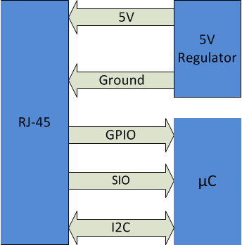

### Power Supply

The Base is designed to run on four AA batteries. To do this the most efficiently, Linear Technologies’ LTC3435 buck-boost regulators are used. Using these regulator allow the maximum use of the batteries by operating in all three regions: over voltage, at regulated voltage, and under voltage. There are two supplies, 3.3V (for digital needs) and 5V (for analog needs), that consume power with 90% efficiency.

### Schematics & Layouts

**Base Unit Microcontroller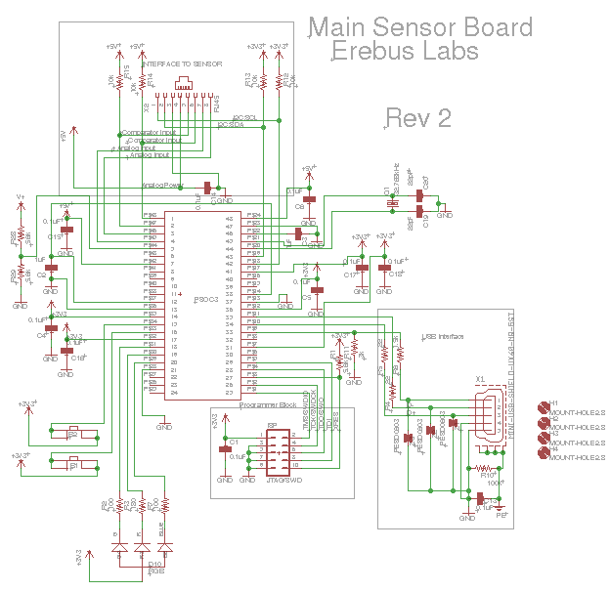 Schematic**

**Base Unit Power System Schematic**

**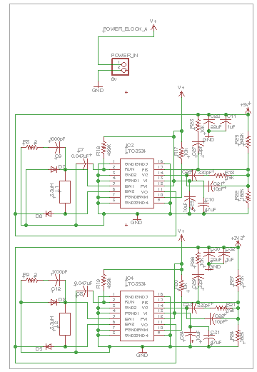**

**Base Unit Layout**

**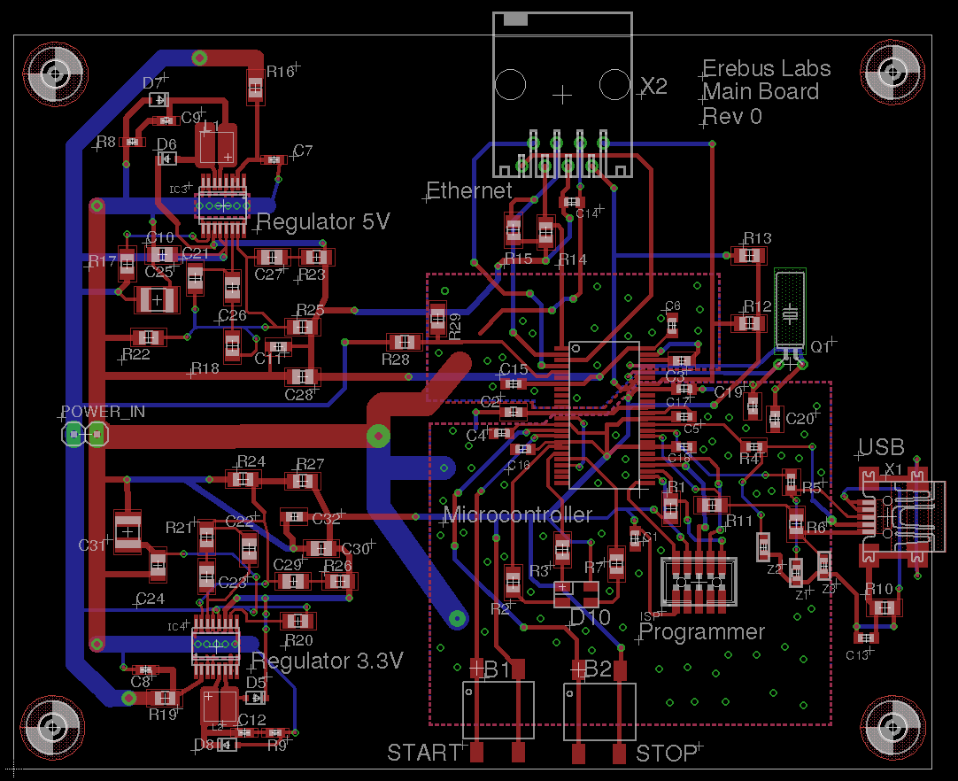**

**Light Sensor Schematic**

**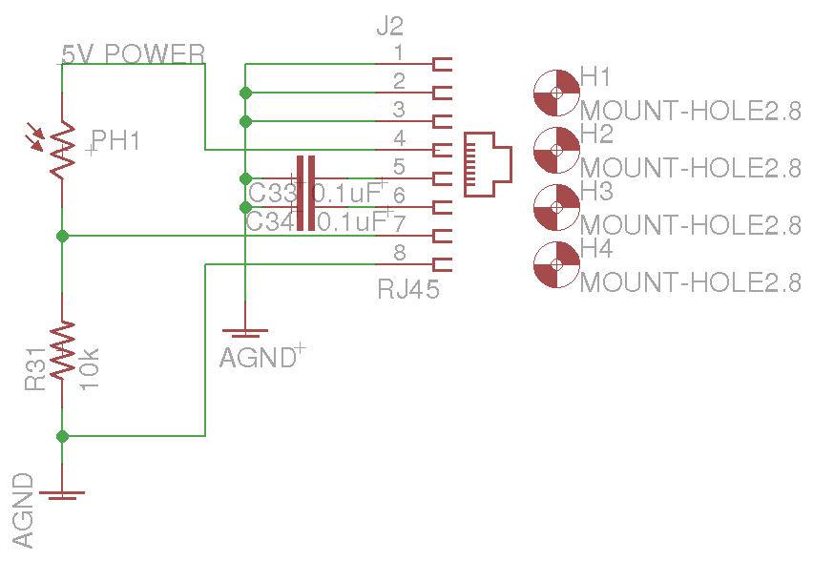**

**Light Sensor Layout**

**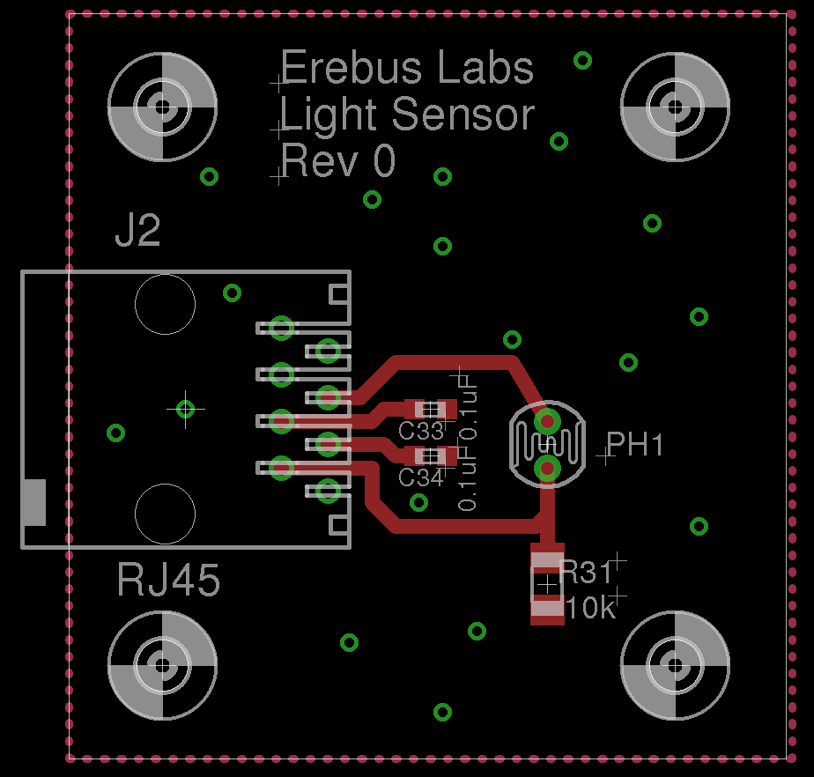**

**Gas Sensor Schematic**

**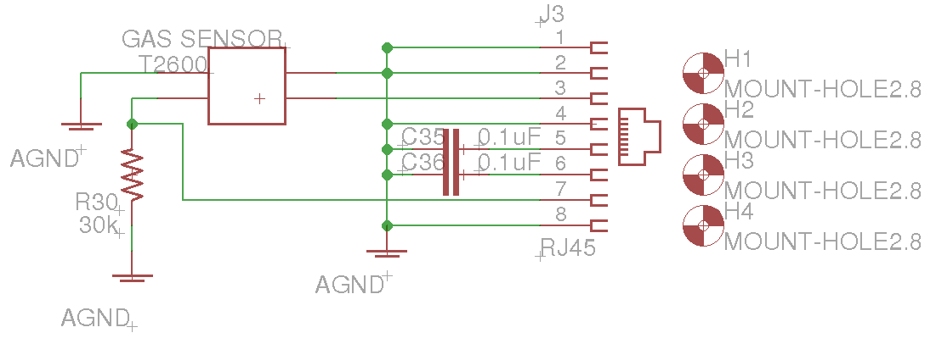**

**Gas sensor Layout**

**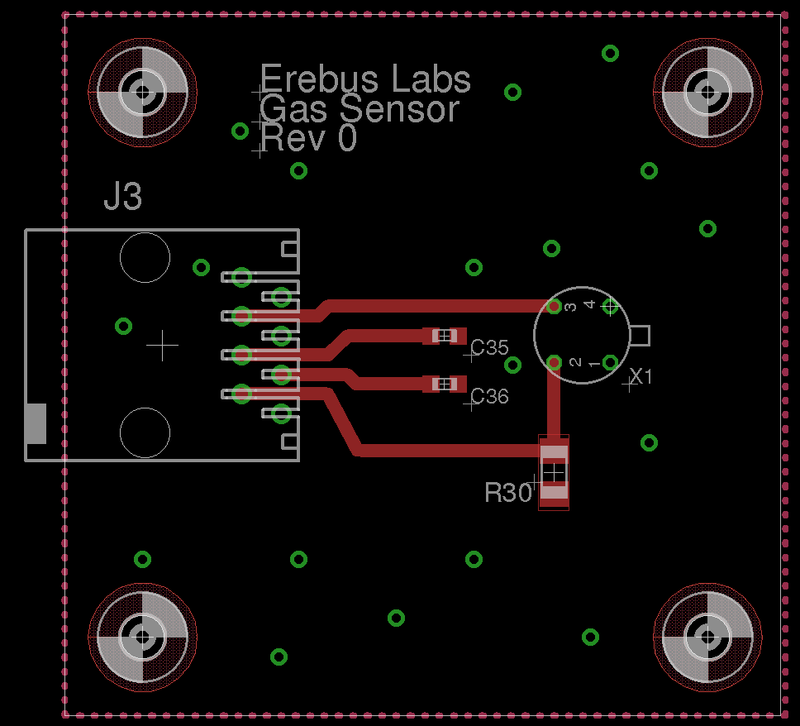**

# Firmware Plan

## Firmware Overview

The Erebus Labs STEM Sensors device firmware is written in standard C compliant with ISO/IEC 9899:2011 and developed in Cypress’ PSoC Creator 3.0. Upon reset, the controller operates as follows:



The STEM Sensor’s main() function is responsible for putting the chip to sleep, restoring clock state on wakeup, and checking for flags that may have been set by an interrupt routine. Depending on flags set, the chip may either go back to sleep or call appropriate event handlers according to the flags.

## Initialization Tasks

1. The following initialization tasks are performed upon reset:
2. Retrieve data sample pointers from Flash
3. Start Components:

EEPROM, Real-Time Clock, PWM Controller, ADC, Analog Multiplexer

1. Retrieve and apply sampling parameters from EEPROM
2. Enable VBus\_IRQ, ModifyCollection\_IRQ, and global interrupts
3. Enable sample initiation

## Interrupt Service Routines

Event flags are set by the following interrupt service routines:

|  |  |  |
| --- | --- | --- |
| Name | Trigger | Action |
| VBus\_IRQ | Logic High voltage on VBUS pin | Activate USB Component, eumerate device on host, receive and store user settings, dump data samples to host, restores entry state on exit |
| ModifyCollection\_IRQ | Either start or stop collection button press | Examine PICU to identify interrupt source, enable or disable sampling accordingly |
| RTC\_EverySecondHandler | RTC Every Second Periodic Interrupt | If sample unit is seconds and sampling enabled, increment counter; if counter == sample interval, take sample. Increment low battery blink counter; if battery power is low and blink count == blink interval, blink low battery LED indicator |
| RTC\_EveryMinuteHandler | RTC Every Minute Periodic Interrupt | If sample unit is minutes and sampling enabled, increment counter; if counter == sample interval, take sample. Increment battery check count; if battery check count == battery check interval, check battery level |
| RTC\_EveryHourHandler | RTC Every Hour Periodic Interrupt | If sample unit is hours and sampling enabled, increment counter; if counter == sample interval, take sample. |
| RTC\_EveryDayHandler | RTC Every Day Periodic Interrupt | If sample unit is days and sampling enabled, increment counter; if counter == sample interval, take sample. |

Note: RTC interrupt routines can be found in Generated\_Source/PSoC3/RTC/RTC\_Int.c. They all share one interrupt vector titled RTC\_isr in Erebus\_Sensor.cydwr -> Interrupts.

## Ev**ent Handlers**

The following events are to be handled by function calls from main by the procedures described in these flowcharts.

### **USB Waiting**

**The USB\_waiting flag indicates that the device’s USB port has been attached to a host. The various commands that may be sent by the host are handled according to the USB Command Handling flowcharts below.**



**USB Command Handling**







### 

### Take Sample Waiting

The take\_sample\_waiting flag indicates that the sample interval has been reached according to the Real-Time clock and a sample must be taken.



### Start Sampling Waiting

The start\_sampling\_waiting flag indicates that the user has pressed the “Start Sampling” button.



### Stop Sample Waiting

The stop\_samping\_waiting flag indicates that the user has pressed the “Stop Sampling” button.



### Check Battery Waiting

The check\_battery\_waiting flag indicates that it is time to check the battery level.



### Low Battery Blink Waiting

The low\_battery\_blink\_waiting flag indicates that as of the last battery sample, the voltage level of the battery is below the threshold, so the LED must be used to alert the user.



## Sample Blocks

Data samples are stored in Flash memory along with program code by utilizing the EEPROM emulator component available for the PSoC3. Each section of data samples begins with a 16-byte header (HE). The header contains information about the sensor used, the sample period, the sample interval, and a date/time stamp from when data collection was started. There are also four reserved bytes at the end of the header to force the header to be 16-byte aligned.

**A new sample block is initiated every time the user presses the Start Sampling button if the sensor is not currently collection samples.**

The header has the following format:

|  |  |  |
| --- | --- | --- |
| **Bits** | **Number of Bytes** | **Description** |
| HE[127:112] | 2 | Unsigned integer containing sample block start signature 0x200 |
| HE[111:96] | 2 | Unsigned integer indicating sample start year |
| HE[95:88] | 1 | Unsigned integer indicating sensor used  0 = Light Sensor  1 = Low Oxygen Sensor  2 = Custom Sensor |
| HE[87:80] | 1 | Unsigned integer indicating sample unit: must be in the range [0:3]  0 = Seconds  1 = Minutes  2 = Hours  3 = Days |
| HE[79:72] | 1 | Unsigned integer indicating sample interval |
| HE[71:64] | 1 | Unsigned integer indicating sample start second |
| HE[63:56] | 1 | Unsigned integer indicating sample start minute |
| HE[55:48] | 1 | Unsigned integer indicating sample start hour of day |
| HE[47:40] | 1 | Unsigned integer indicating sample start day of month |
| HE[39:32] | 1 | Unsigned integer indicating sample start month: must be in the range [1:12]  1 = January  2 = February  3 = March  Etc. |
| HE[31:0] | 1 | Reserved: write as 0x00000000 |

### **Data Samples**

The data samples themselves are recorded in a 2-byte bit-field (DA) comprised of the 12-bit ADC output and a 4-bit reserved field:

|  |  |
| --- | --- |
| **Bits** | **Description** |
| DA[15:12] | Reserved: write as 0x0 |
| DA[11:0] | Unsigned raw ADC output |

During sampling, the Reserved field of the sample should be written as 0x0. The data dump routine in the USB Handler uses these bits to communicate information to the host during dumping, such as End of Data or No Data Present.

### Wear Levelling

The use of the Emulated EEPROM component allowed us to realize the goal of minimizing the number of chips required on the main board, but it created certain challenges as well. The most significant challenge was the need for wear-levelling. Although the Flash memory in the PSoC3 is guaranteed for up to 100,000 write cycles, we wanted the base unit to be as durable as possible. To achieve greater product longevity, a wear-levelling scheme was implemented. The wear-levelling method employed is shown by the following diagram:

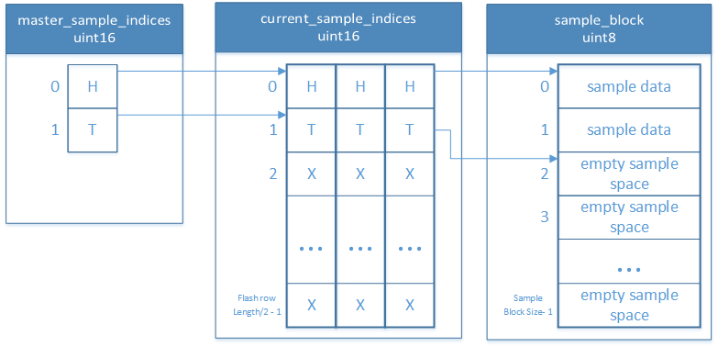

Both the master\_sample\_indices and current\_sample\_indices arrays are stored in flash so that stored data and array indices are retained in the event of power failure. The arrays perform the following roles:

#### sample\_block

The sample\_block array is an array of uint8’s (unsigned chars) and stores sample data and sample block headers. This array is only written to when beginning sampling (to store the block header) and when taking a sample. It behaves like a circular buffer, with the current head and tail indices stored in the current\_sample\_indices array.

#### current\_sample\_indices

The current\_sample\_indices array contains the indices of the sample\_block array that correspond to the current block’s head and tail. As samples are taken and collection periods are started and stopped, the tail pointer is incremented through the sample\_block array. Head does not move until the existing data is successfully exported to a host computer. When a data dump is successfully completed, the head index is set equal to the current tail index, effectively clearing existing data without subjecting the Flash memory to unnecessary erase cycles.

There are three pairs of head and tail indices in the current\_sample\_indices array that are separated a number of bytes equal to the length of a Flash row - 2. This arrangement ensures that the pairs of head and tail pointer pairs are in separate rows of Flash memory.  Every time the head or tail indices are modified, the new index must be updated in the current\_sample\_indices array. The head and tail index pointers are in separate rows so that they can have their wear levelled as well.

#### master\_sample\_indices

The head and tail indices in the master\_sample\_indices array contains the index of the currently used head and tail index pair in the current\_sample\_indices array. As data headers and samples are stored in Flash, the current tail index in the current\_sample\_indices array is incremented, but the master\_sample\_indices array is untouched. Eventually, enough data will be collected that the current tail index is wrapped around the end of the sample\_block array because it is a circular buffer. When that data is dumped and setting the head index equal to the tail index requires the head to be wrapped around the end of the sample\_block array, the head/tail indices in the master\_sample\_indices are set equal to the next pair of head/tail indices in the current\_sample\_indices array.

#### Initialization

After the base unit has been reprogrammed, the indices must be reset to their default locations before the device can be used. To accomplish this, the base unit is connected to a host system and the Reset Device command is issued from the user application. From that point on every time the device is powered up, the master and current sample indices are retrieved from Flash allowing the device to store samples properly.

### Sample Exporting

When data sample blocks are exported to the host system over USB, the current block of data samples and headers are iterated over until the tail pointer matches the head pointer. If the end of the sample block is reached before a 64-byte packet can be filled, the remaining bytes are filled with the pad-byte signature (0x40) to indicate to the user application that those bytes do not contain sample data and should not be counted when calculating the total number of good bytes received.

The data export routine does no interpretation of the data it is iterating over; it simply loads bytes from the sample block into the USBUART buffer. After all data has been transferred, a four-byte trailer (TR) is sent to the host to confirm that the correct number of bytes were received. It has the following structure:

|  |  |  |
| --- | --- | --- |
| **Bits** | **Number of Bytes** | **Description** |
| TR[31:16] | 2 | Number of non-pad bytes transmitted |
| TR[15:8] | 1 | Pad byte: write as 0x00 |
| TR[7:0] | 1 | End of data transmission marker: write as 0x80 |

## USB Packets During Sample Export

Host commands and device replies are sent in single byte packets. Data is transmitted in 64-byte packets, the maximum size allowed by the USB specification. Between each 64-byte packet sent, the firmware waits for the NEXT command (0x07) from the host before initiating the transmission of the next packet. This includes waiting after the last sample has been sent before sending the trailer.

IMPORANT NOTE: After each 64-byte packet, a zero length packet MUST be sent to the host to notify it that the sensor is done with that transaction and is awaiting the NEXT command. Failure to do this may cause the last 64-byte transmission to be held in a USB buffer on the host before being transferred to the Erebus Sensor application, causing both the firmware and user application to stall while waiting for data from the other.

## Real-Time Clock Updates

When the current time of the RTC is to be updated, the current time stamp is expected to be received in an array of bytes (CT) of the following format:

|  |  |  |
| --- | --- | --- |
| **Bits** | **Number of Bytes** | **Description** |
| CT[55:40] | 2 | Unsigned integer indicating current year |
| CT[39:32] | 1 | Unsigned integer indicating current second |
| CT[31:24] | 1 | Unsigned integer indicating current minute |
| CT[23:16] | 1 | Unsigned integer indicating current hour of day |
| CT[15:8] | 1 | Unsigned integer indicating current day of month |
| CT[7:0] | 1 | Unsigned integer indicating current month: must be in the range [1:12]  1 = January  2 = February  3 = March  Etc. |

# User Application Plan

## User Interface

The host computer user interface is a simple GUI that performs two functions:

1. Provide a method for the user to change data collection settings or reset the base unit.
2. Allow the user export data from the device and present it in a text file. Python provides a platform-independent framework for a GUI and for interacting with the sensor.

The user interface is written in Python 3.2x utilizing the PySerial library for serial communications and the tkinter library for GUI rendering.

## Device Interface Mode

While plugged into the computer, the sensor remains in Interface Mode. During this time, the PSoC3 continually monitors its input buffer for commands from the host computer and respond to them accordingly. The microcontroller exits interface mode when power from the USB VBUS pin is no longer detected.

All commands to the sensor from the host and replies from the sensor are one byte long, with the exception of sampled data dumps and when returning current sampling settings. All command and data packets use Big-Endian byte-ordering.

### **Available Commands**

|  |  |  |
| --- | --- | --- |
| Command | Bit Pattern | Sensor Action |
| IDENTIFY | 0x01 | Replies with identifier |
| DUMP\_DATA | 0x02 | Exports sampled data points to host |
| GET\_SETTINGS | 0x03 | Retrieves current sampling settings from EEPROM and sends them to the user application |
| CHANGE\_SETTING | 0x04 | Stores new sampling settings provided in EEPROM |
| RESET\_PTRS | 0x05 | Resets data sample block pointers to default values |
| UPDATE\_RTC | 0x06 | Updates the time and date of the Real-Time Clock with the values provided |
| NEXT | 0x07 | During sample block dump, sensor proceeds with next sample transaction – illicits a FAILURE response if sent when not transferring sample data |

### **Incoming Messages from Sensor**

|  |  |  |
| --- | --- | --- |
| Messages | Bit Pattern | Meaning |
| IDENTIFIER | 0x10 | Differentiates Erebus Labs Sensor from other serial devices |
| SUCCESS | 0x20 | Last action was successful, ready for next command |
| FAILURE | 0x30 | Last action failed, reattempt command |

## Virtual COM Port

The PSoC3 microcontroller USBFS\_UART component is used for communication with the host computer. The Python library PySerial is used to communicate over the serial port with the base unit. Communicating using a virtual serial port provides a cross-platform method of enumerating on and communicating with a host without the need for additional drivers.

## Command Resolution

User communication with the device involves four layers as shown in the following diagram:



As the user selects menu options or enters new settings, the GUI executes callbacks into the Erebus Sensor class object which maintains a handle to the attached sensor. It is the responsibility of the Erebus Sensor object to resolve the user’s commands into the appropriate bit fields and transfer them to the device through calls to the PySerial routines. The Erebus Sensor object must also interpret the device replies to notify the user whether the last command succeeded or failed.

# Appendix A: Acronyms

|  |  |
| --- | --- |
| Acronym | Meaning |
| ADC | Analog-to-Digital Converter |
| BOM | Bill of Materials |
| CO | Carbon Monoxide |
| CSV | Comma-separated-value formatted file |
| EEPROM | Electrically Erasable Programmable Read-Only Memory |
| EPL | The Portland State University Engineering and Prototyping Lab |
| GUI | Graphical User Interface |
| LED | Light Emitting Diode |
| I2C | The Inter-Integrated Circuit communication protocol |
| ISR | Interrupt Service Routine |
| K-12 | Kindergarten through 12th grade school |
| LED | Light Emanating Diode |
| PCB | Printed Circuit Board |
| PICU | Port Interrupt Control Unit |
| PSoC | Programmable System On Chip |
| SI | Silicon |
| SPI | Serial Peripheral Interface Bus |
| STEM | Science, Technology, Engineering and Math |
| TRM | Technical Reference Manual |
| USB | Universal Serial Bus |
| USBUART | Universal Serial Bus Universal Asynchronous Receiver/Transmitter (refers to the PSoC3 USBUART component) |

# Appendix B: System Architecture

**Base Unit**

The central device that manages power, communication, and data storage, and has one or more sensors attached to it.

**Sensor**

The individual data collection devices such as VOC detectors and thermometers that are attached to the base unit.

**User Interface**

The program that is run on a laptop or desktop computer that allows the user to view and interact with the data collected.

**System**

The operational product comprised of base units with attached sensors and a user interface.