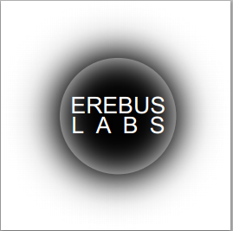

Picture of final project here

**System Requirements**

To communicate with your new sensor, you will need to a version of Linux, Ubuntu is suggested. You can get it by following the link below.

http://www.ubuntu.com/download

Also, you will need to upgrade the stock version of Python, that came with Ubuntu, to version 3.4.1 by following the link below.

<https://www.python.org/downloads/release/python-341/>

Next, you will need to add the tkinter package from

<http://www.tcl.tk/software/tcltk/download.html>

and download and install version tk8.6.1-src.zip. Lastly, you will need to have pyserial which can be found with the following link.

<https://pypi.python.org/pypi/pyseria>

1

#### Commonly Asked Questions

How do I see what my current sampling settings are? You can check by connecting the base station to the laptop/desktop, hit the “Connect to Erebus Sensor” and wait for the connection icon to turn green. Now, go to “Sensor” in the tool bar Sensor🡪Get Current Configuration and click. The “Data Collection Settings” will be populated with the current base unit settings.

Can I change the sampling setting in the field? No, not unless you have brought a laptop to attach to the base unit.

How do I know what sensor I am using? The sensor type is printed on the top of the circuit board.

What if the timestamp on my data dump says it’s the year 1900? The clock that tracks the current date is reset if the power is disconnected. Reconnect power to the base unit, plug it into a laptop or desktop and connect to it through the Erebus Sensor program. This will reset the clock.

Is there any additional support? Yes, the help tab in the tool bar of the user interface will bring up options for the user guide or technical manual.

What if the base unit is not responding to configuration changes? You can go to sensors in the tool bar Sensor🡪Reset Sensor and click. WARNING: THIS WILL ERASE ALL DATA CURRENTLY STORED ON THE BASE UNIT, ONLY DO THIS WHEN ALL OTHER OPTIONS HAVE BEEN EXHAUSTED.

10

# How to Retrieve Your Data

1. Remove the lid from the base station and push the Stop button.
2. Replace the lid and bring it back to your desktop/laptop.
3. Insert the USB cable as before. You should see the solid blue teal LED. If not, unplug it and try again.
4. Bring up the user interface on your desktop/laptop as before and click the “Connect to Erebus Sensor” button.
5. Once, the connection icon has turned green and says “Sensor Connected”, click on sensor from the tool bar Sensor🡪Get Data and click.
6. The data will be stored in a file called “datadump.txt” in the folder that you launched the program from. If the file already exists, new data will be added to the end of the file.
7. The data dump file will be the raw data and needs to entered into Matlab or Excel to be interpreted.

9

Table of Contents

System Architecture……………………………………3

What is in the Box……………………….……………….5

Getting Started…………………………………………..6

What do the Colors Mean………………………………8

How to Retrieve Your Data……...…….………………9

Commonly Asked Questions……….……….……….10

2

### System Architecture

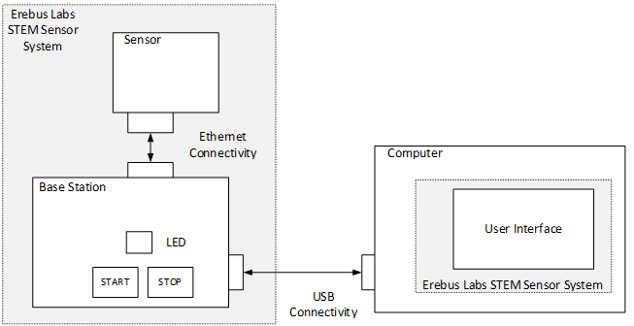

**System**

The operational product Compromised of the base unit with attached sensor and a user interface.

**Base Unit**

The central device that manages power, communication, data storage, and has one or more sensors attached to it.

**Sensors**

The individual data collection devices such as a gas detector or ambient light detector

**User Interface**

The program that will run on a laptop or desktop computer that allows the user to view and interact with the data collected.

3

**What Do the Colors Mean**

Solid Teal: USB is connected to both laptop/

desktop and base station are connected.

Blink Blue: Sample is being taken.

Blink Green: Sampling process has started.

Solid Red: The memory is full and needs to be dumped.

Blink Red: Sampling process has been stopped.

Blink Yellow: The battery is low and needs to be changed.

8

1. If the user interface has connected to the base unit the yellow square will turn green. 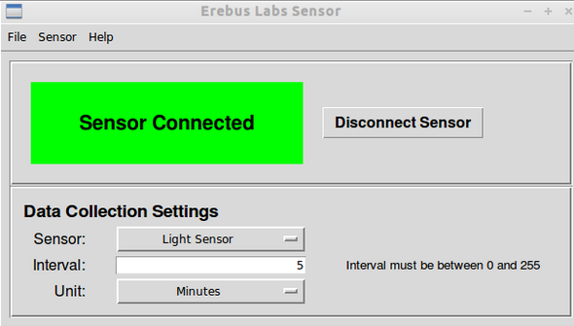
2. If you do not see this screen repeat step 3.
3. Select the sensor you wish to use from the drop down menu “Sensor”
4. Enter a number between 0 and 255 in the “Interval” text box.
5. Choose the time unit for the interval (i.e seconds, minutes, etc.) in the “Unit” drop down box.
6. The next step is click sensor in the toolbar Sensor🡪Apply Setting and click.
7. You are now ready to disconnect base unit from your desktop/laptop.
8. Finally, connect the sensor to base station with the provided Ethernet cable, and take both to the location you wish to collect data, remove the cover, hit the start button, and replace the cover If you see the LED flashing blue at the correct interval, you are set to go.

7

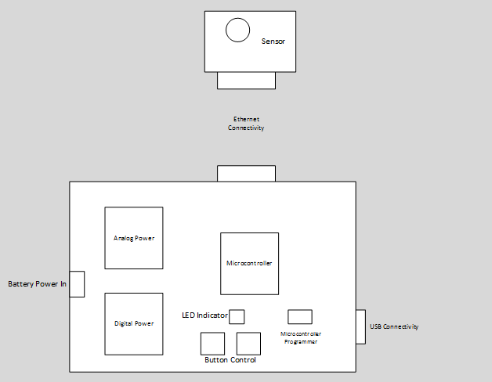

**Power**

There is a 3.3V supply to run all digital peripheral. Also, there is a 5V supply to run the analog peripheral, as well as directly power the sensor.

**Microcontroller**

This is where the sample intervals are stored. The initiation of data collection and the storage of data is done here.

**User Control**

User Controllability with two buttons, start and stop sample collection, and an LED indicator

4

## What is in the Box

1. Base Unit ………(insert Picture)

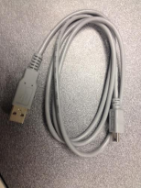

1 Ethernet Cable…….

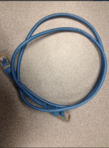

1 USB Cable………….

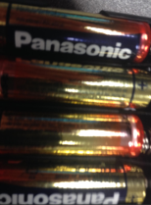

4 AA Batteries……….

1 Photocell Sensor(insert piture) 1 Gas Sensor

5

**Getting Started**

1. Start up the Erebus Labs Sensor interface by opening terminal and enter navigate to the director containing erebus_sensor.py. Enter the command “python3 ./erebus_sensor.py”. The program will launch as shown below.

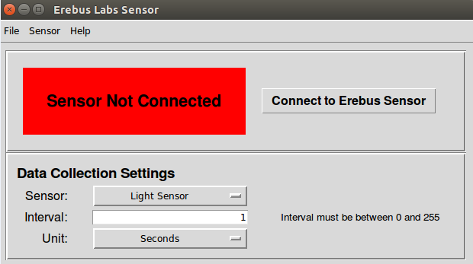

1. Take the USB cable and plug the mini in to the base unit, then plug the standard size end into your desktop/laptop. The LED should turn teal, this lets you know there is a connection.
2. Now you will need to connect the base station to the user interface. Do this by clicking the “Connect to Erebus Sensor” button. The red square should turn yellow and then a pop up will say, ”this may take up 30 seconds. Click OK to continue.

6