STEM Sensors
Software Plan
Version 1.0
1/22/2014

scott lawson
Bryan Button
Chris clary
max cope

VERSION HISTORY
Version  # | Implemented  By | Revision  Date | Reason
1.0 | Scott Lawson | 1/22/2014 | Initial Release

NOTE TO READER
This is a template obtained from:
http://www2.cdc.gov/cdcup/library/templates/default.htm
Template Name: Product Design
UP Template Version: 12/31/07
TABLE OF CONTENTS
1 Introduction 5
1.1 Purpose of The Document 5
1.2 Overview 5
1.3 Theory of Operation 5
2 Initialization Tasks 6
2.1 General 6
2.2 EEPROM 6
2.3 USB 6
2.4 Analog to Digital Converter 6
2.5 Watchdog Timer 6
2.6 Power management 6
2.7 Interrupts 6
3 Interrupt Service Routines 7
3.1 Watchdog ISR 7
3.2 Low Power ISR 8
3.3 USB ISR 8
4 Computer Interface 9
5 Firmware File Structure 9
6 Data Structures 10
Appendix A: Terminology 11
A.1 Acronyms 11
A.2 System Architecture 11

Introduction

Purpose of The Document
This document is a high-level description of how the software is planned to be implemented for the Erebus Labs STEM Sensors device.

Overview
The Ereubs Labs STEM Sensors device firmware will be written in standard C compliant with ISO/IEC 9899:2011. When a microcontroller is selected for the device, the development environment will be specified here. Upon reset, the controller will operate as follows:

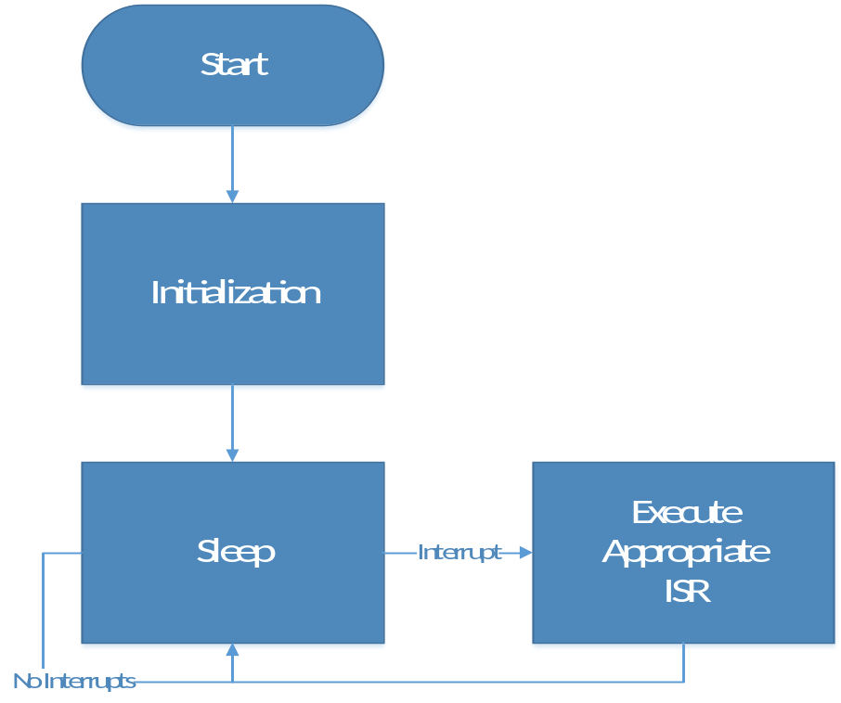

Theory of Operation
The STEM Sensor will contain a null-body loop as its MAIN function. All functionality will be interrupt-driven. The system will remain in sleep mode except when connected to a computer via a USB interface, or when sampling the ADC. The system will be woken from sleep by a watchdog timer to drive ADC sampling. Interrupt service routines are described in Section 3 of this document, and the user interface when connect to a computer is described in Section 4 of this document.

Initialization Tasks
After a restart, the chip must be initialized. There are several individual components that will require register modifications:

General
- Clocks
- Oscillators
- GPIOs including LEDs and buttons
- Real-time clocks

EEPROM
- Set pointers to key memory locations
- Ensure EEPROM can be globally accessed via functions
- I²C/UART/SPI configuration if off-chip

USB
- Set Device / Interface Descriptors
- Enable USB interrupt assertions from USB controller

Analog to Digital Converter
- Enumerate Sensors or retrieve sensor IDs from EEPROM
- Set Op-Amps appropriate for sensor
- Configure ADC clock

Watchdog Timer
- Retrieve frequency settings from EEPROM
- Enable interrupt assertions
- Start timer

Power management
- Set sleep mode parameters
- Allow waking up from USB and watchdog timer

Interrupts
- Set USB, Low-power, and watchdog timer interrupts in interrupt controller
- Map interrupt vectors to ISRs
- Enable global interrupts

Interrupt Service Routines

Watchdog ISR
The microcontrollers under consideration for use in the system allow a watchdog timer to wake the system periodically with a period of between 1 second and ~20 seconds. To achieve the sampling frequency configured by the user, a counter will be maintained in SRAM. This counter will be decremented each time the system is woken from sleep. When the counter reaches zero, the ADC will be sampled, its value stored, and the counter reset.
The initial value of the counter will be equal to Sample Period / Clock Period.
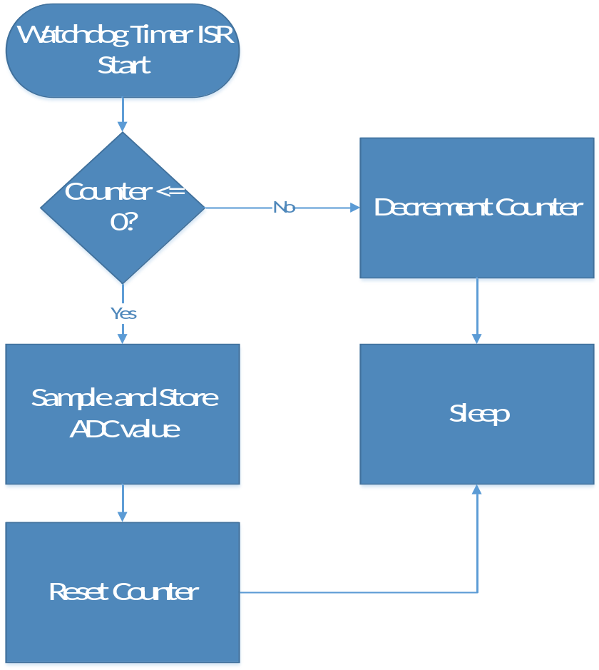

Low Power ISR
If the selected microcontroller is equipped, there will be a low-power interrupt asserted when the power supply drops below a designated threshold. The low power interrupt will determine if the system is critically low on power. If yes, the system will shut down entirely to protect the microcontroller from failure. If no, then turn on a warning LED to the user.
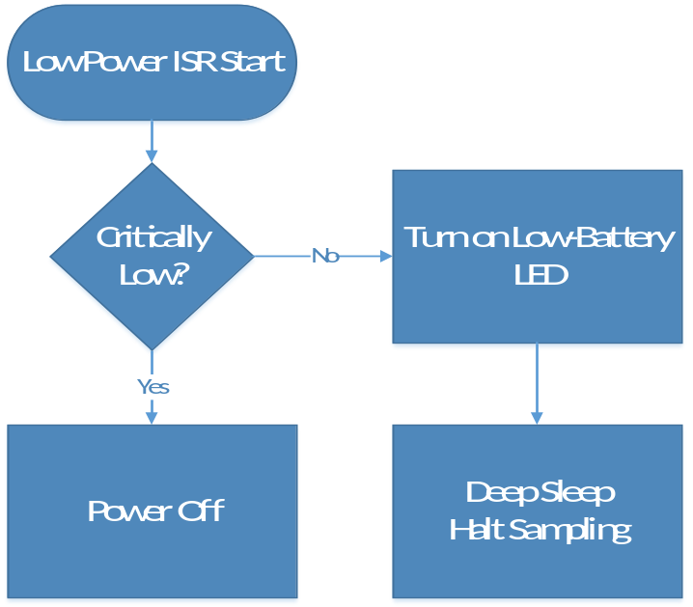

USB ISR
The system will enter an interface mode when plugged into a computer. The sampled data will be made available from the EEPROM, and the user will be able to reconfigure data collection settings.
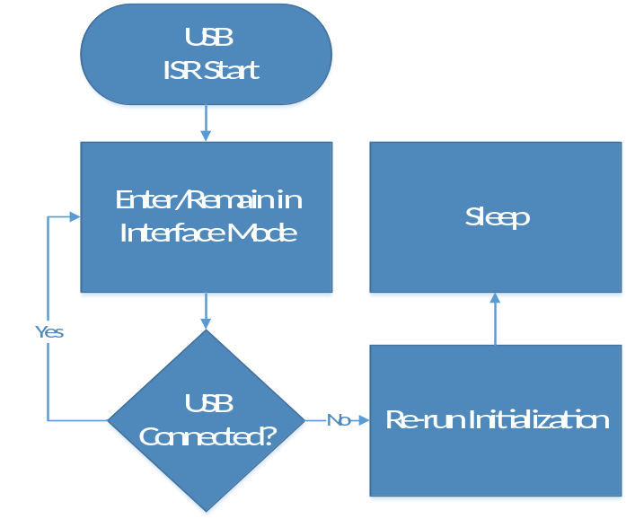

Computer Interface
The structure of the user interface is still under discussion as of the date of this writing. It will likely consist of a GUI that allows the user to download EEPROM data points and display simple graphs. Additionally, the data will be available in a raw .CSV file for importing to other applications suitable for more advanced students.
The user interface will also allow the user to configure settings such as the frequency and duration of data collection.

Firmware File Structure
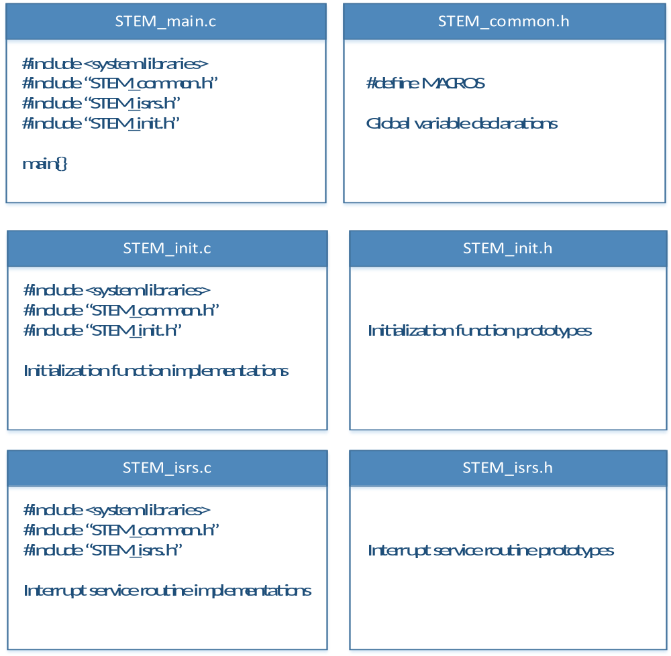

Data Structures
To maximize the use of limited memory, the unsigned binary value read directly from the ADC will be stored. The system will not perform conversions or calculations with this data on board the base unit.
Once the microcontroller is selected, the encoding scheme will be described in this document. The encoding scheme will also contain an identifier for the sensor used and a date/time stamp from the real-time clock. The entire encoded data point will be uploaded to the computer when connected and the computer-based software will translate the data points into human-readable data.

Appendix A: Terminology

Acronyms
Acronym | Meaning
ADC | Analog-to-Digital Converter
BOM | Bill of Materials
CO | Carbon Monoxide
EEPROM | Electrically Erasable Programmable Read-Only Memory
EPL | The Portland State University Engineering and Prototyping Lab
I²C | The Inter-Integrated Circuit communication protocol
ISR | Interrupt Service Routine
K-12 | Kindergarten through 12th grade school
LED | Light Emanating Diode
PCB | Printed Circuit Board
SI | Silicon
SPI | Serial Peripheral Interface Bus
STEM | Science, Technology, Engineering and Math
USB | Universal Serial Bus

System Architecture

Base Unit
The central device that manages power, communication, and data storage, and has one or more sensors attached to it.

Sensor
The individual data collection devices such as VOC detectors and thermometers that are attached to the base unit.

User Interface
The program that will be run on a laptop or desktop computer that allows the user to view and interact with the data collected.

System
The operational product comprised of base units with attached sensors and a user interface.

