STEM Sensors
Design Specification
Version 1.0
1/28/2014

scott lawson
Bryan Button
Chris clary
max cope

VERSION HISTORY
Version  # | Implemented  By | Revision  Date | Reason
1.0 | Scott Lawson | 1/28/2014 | Initial Release  Converted from Software Plan V1.0

NOTE TO READER
This is a template obtained from:
http://www2.cdc.gov/cdcup/library/templates/default.htm
Template Name: Product Design
UP Template Version: 12/31/07
TABLE OF CONTENTS
1 Introduction 5
1.1 Purpose of The Document 5
1.2 Overview 5
1.2.1 Objective Statement 5
1.2.2 Theory of Operation 5
2 Hardware Plan 6
2.1 Overview 6
2.2 Level 0 Block Diagram 6
2.3 Level 1 Block Diagram 7
2.4 Level 2 Block Diagram 8
2.5 PSoC3 Block Diagram 9
2.6 Implementation 10
2.6.1 Microcontroller 10
2.6.2 Power Supply 10
2.6.3 Sensors 10
3 Software Plan 11
3.1 Firmware 11
3.1.1 Firmware Overview 11
3.1.2 Initialization Tasks 12
3.1.3 Interrupt Service Routines 13
3.1.4 Low Power ISR 14
3.1.5 USB ISR 14
3.1.6 Data Samples 15
3.2 Computer Interface 15
3.2.1 User Interface 15
3.2.2 Program Installer 15
Appendix A: Terminology 16
A.1 Acronyms 16
A.2 System Architecture 16

Introduction

Purpose of The Document
This document describes plans for both the hardware and software components of the Erebus Labs STEM Sensor. It does not include any design files such as schematics, layout files, or source code. Rather, it is intended to guide the team members in their creation of such files and describe how various system components interact with each other.

Overview

Objective Statement
Encourage an interest in STEM in K-12 students by delivering a working prototype of an affordable, simple and flexible device to collect environmental data.

Theory of Operation
The Erebus Labs STEM Sensor system is an open-source electronic device for collecting environmental data over a period of time and presenting it for analysis. The system is comprised of the following components:

Base Unit
The central device that manages power, communication, and data storage, and has one or more sensors attached to it.
Sensor
The individual data collection devices such as VOC detectors and thermometers that are attached to the base unit.
User Interface
The program that will be run on a laptop or desktop computer that allows the user to view and interact with the data collected.

The base unit will have one or more sensors attached to it and will passively collect data without being attached to a computer system. The data collection site will be chosen by the user. The user interface will be a simple GUI for displaying collected data and exporting the data to a CSV file for analysis with a third-party program.

Hardware Plan

Overview
The base unit will be comprised of a Cypress PSoC 3 microcontroller, a voltage regulator, a sensor interface and a USB bus, along with miscellaneous passive and capacitive components.

Level 0 Block Diagram
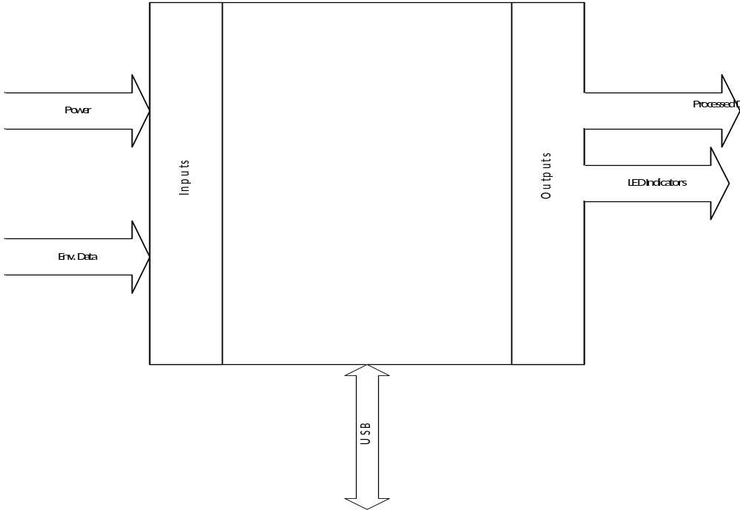

Level 1 Block Diagram
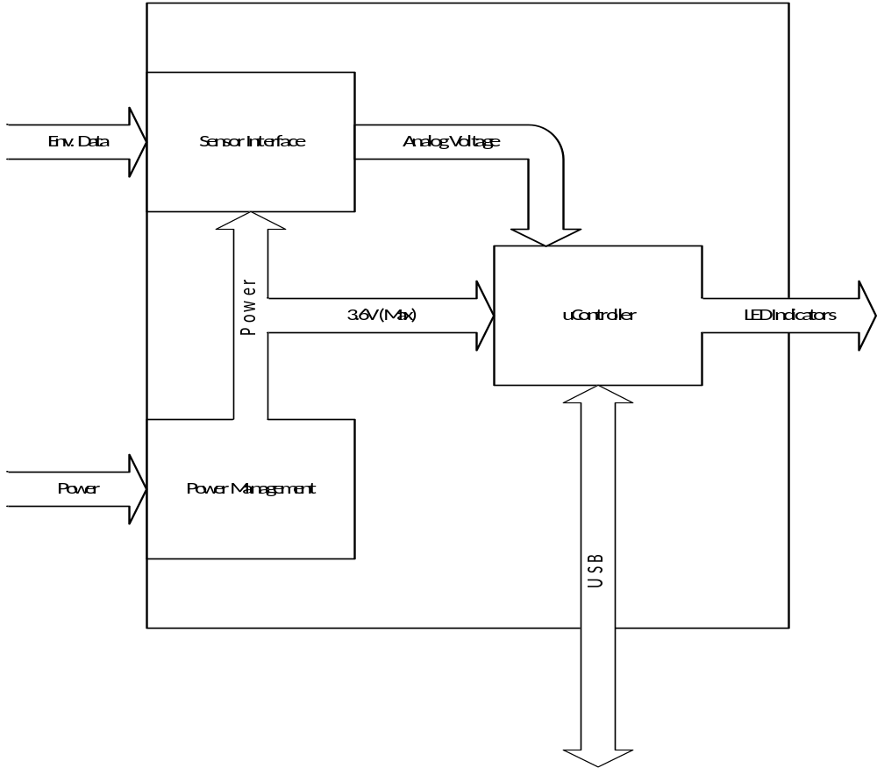

Level 2 Block Diagram
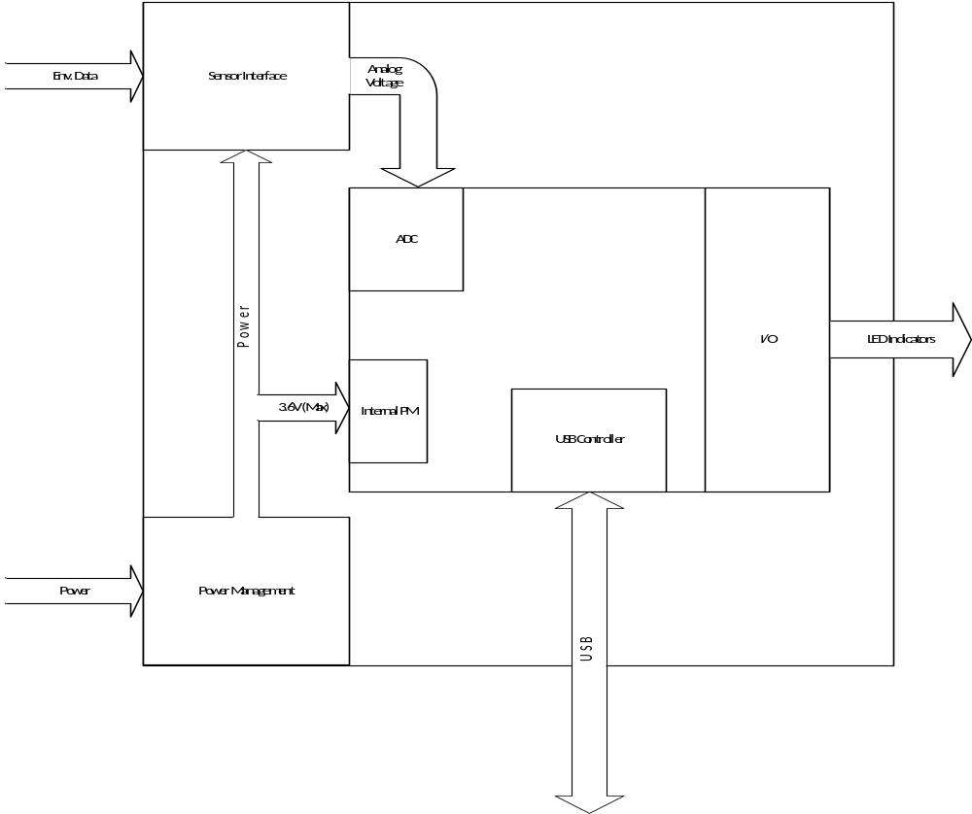

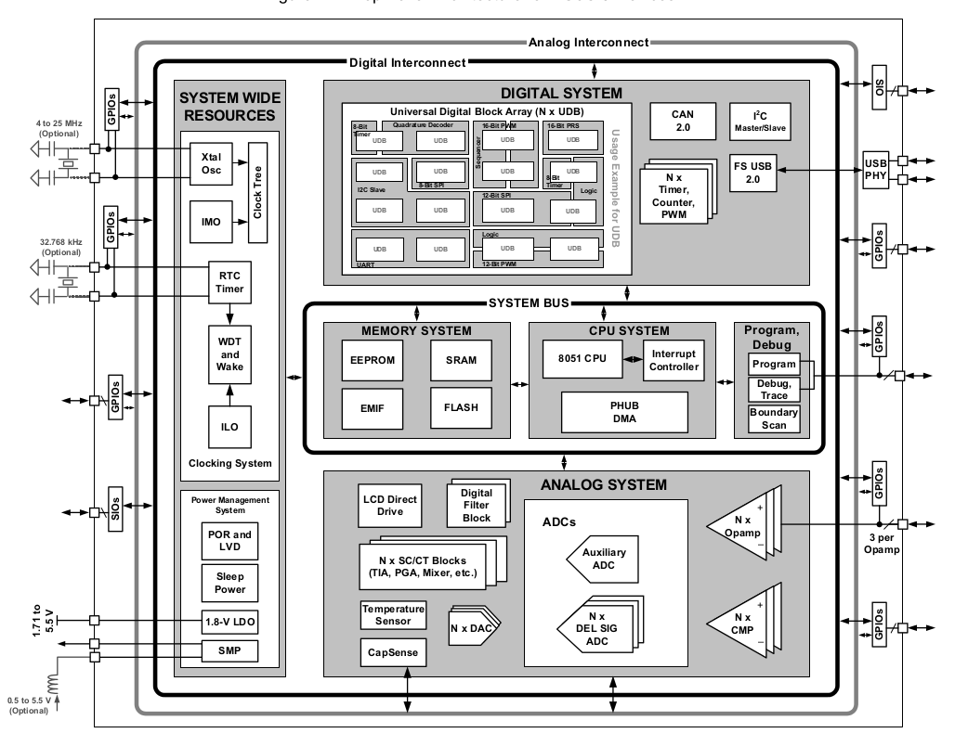
PSoC3 Block Diagram

Implementation

Microcontroller
The PSoC3 microcontroller from Cypress Semiconductor was selected because of its balance between flexibility and cost. It contains several embedded programmable logic blocks that can be used to implement a Full-Speed USB controller and real-time clock. Additionally, the programmable blocks also provide an interface for utilizing the chip’s on-board Flash memory in place of an external EEPROM chip. Therefore, the PSoC3 provides a one-chip solution.

Manufacturer | Cypress Semiconductor
Family | PSoC3
Model Number | CY8C3245PVI-150
Architecture | 8-bit 8051
Clock Speed | 48MHz
Operating Voltage | 1.71V – 5.5V
Current Draw | 0.8mA@3MHz, 1.2mA@6MHz, 6.6mA@48MHz
ADC | 12-bit Delta-Sigma
Program Memory | 32KB Flash
EEPROM | 1KB
UDBs | 20
Package | 48-pin SSOP

Power Supply
No power supply details available at this time.

Sensors
No sensor details available at this time.

Software Plan

Firmware

Firmware Overview
The Erebus Labs STEM Sensors device firmware will be written in standard C compliant with ISO/IEC 9899:2011 and developed in Cypress’ PSoC Creator 3.0. Upon reset, the controller will operate as follows:

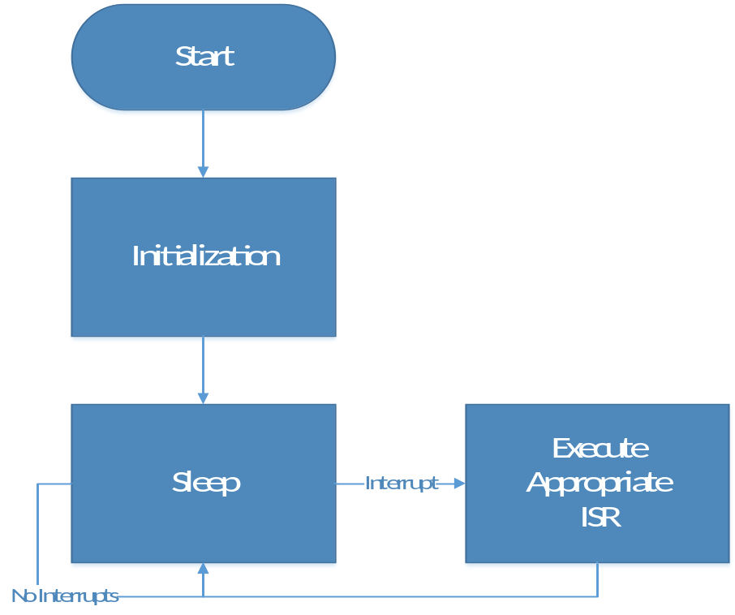
The STEM Sensor will contain a null-body loop as its MAIN function. All functionality will be interrupt-driven. The system will remain in sleep mode except when connected to a computer via a USB interface, or when sampling the ADC. The system will be woken from sleep by the PSoC3’s Central Freewheel Timer to drive ADC sampling.

Initialization Tasks
After a restart, the chip must be initialized. There are several individual components that will require register modifications:
General
- Clocks
- GPIOs including LEDs and buttons
PSoC Components
- USB
  - Set Device / Interface Descriptors
  - Enable USB interrupt assertions from USB controller
- Flash as EEPROM
  - Set wear-leveling pointers
  - Initialize pointers to key data points
- Real Time Clock
Analog to Digital Converter – Delta Sigma
- Enumerate Sensors or retrieve sensor IDs from EEPROM
- Configure clocks, capacitance, gain, and power settings
Central Timewheel
- Retrieve frequency settings from EEPROM
- Branches to ISRs
- Start timer
Power management
- Enable Sleep State
- Power down unused chip components
- Allow waking up from USB (PICU interrupts) and CTW
- Enable voltage monitoring
Interrupts
- Set USB (PICU), low voltage, and CTW interrupts in interrupt controller
- Map interrupt vectors to ISRs
- Enable global interrupts

Interrupt Service Routines
Central Timewheel ISR
The PSoC3 employs a 1-kHz free-running clock to periodically wake the system up from sleep. The free running clock increments an interval counter that can be set as high as 4096, resulting in the counter rolling over every ~4.096 seconds and generating an interrupt, waking the system from sleep. This value will be adjusted based on the user’s desired data sampling frequency.
The firmware will keep a software counter in memory, which will be decremented every time the system is woken from sleep. The value of the counter will be equal to Sample_Period / Wake_Period. See Pg 148 of the PSoC3 TRM for the Central Timewheel information.
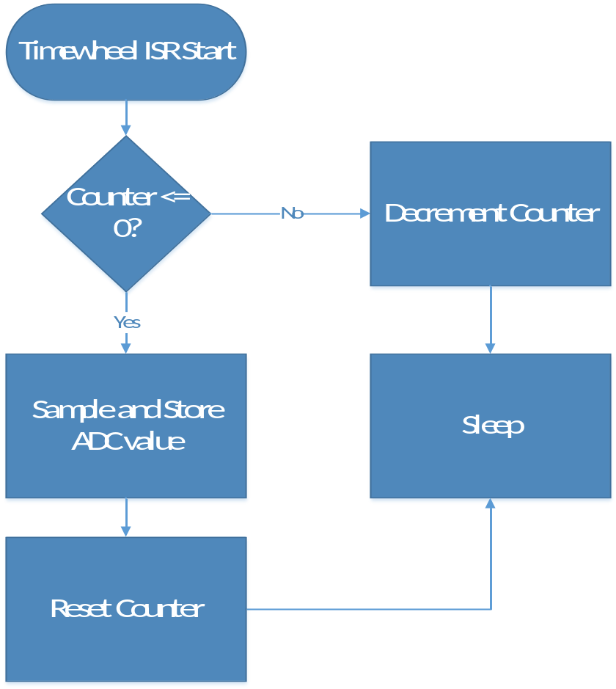

Low Power ISR
The actual power output of the supply batteries cannot be directly measured during operation, so the PSoC3’s voltage monitoring capabilities will be utilized to detect low-voltage conditions. The Low Power ISR will determine if the system is critically low on power. If yes, the system will shut down entirely to protect the microcontroller from failure. If no, then turn on a warning LED to the user.
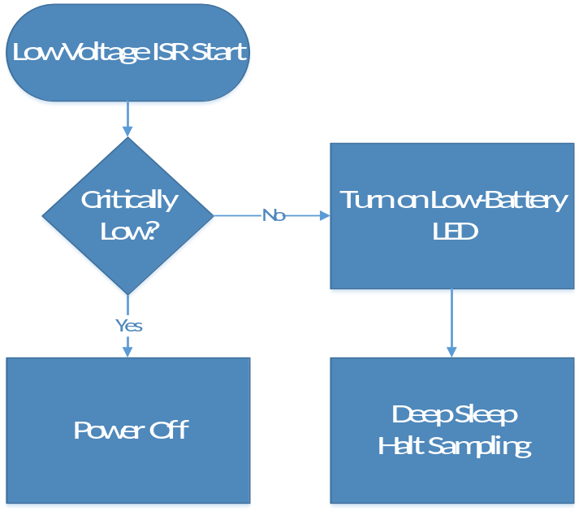

USB ISR
The system will enter an interface mode when plugged into a computer. The sampled data will be transferred to the host computer and interpreted by the user interface software.
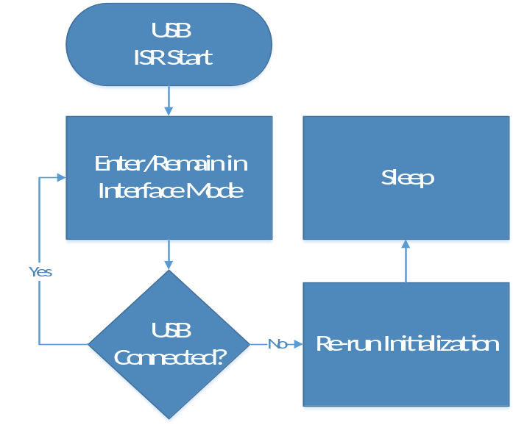

Data Samples
To maximize the use of limited memory, the unsigned binary value read directly from the ADC, concatenated with an identifier of the sensor source and a time stamp, and stored raw. The system will not perform conversions or calculations with this data on board the base unit. Every sampled data point will be stored as a 40-bit field.
- DP[39:36] 4-bit sensor identifier
- DP[35:30] Seconds (0-59)
- DP[29:24] Minutes (0-59)
- DP[23:19] Hours (0-23)
- DP[18:14] Days (1-31)
- DP[13:10] Months
- DP[9:0] Data (Least significant 2 bits are discarded)

Computer Interface

User Interface
The host computer user interface will be a simple GUI that performs three functions:
- Provide a method for the user to change data collection settings or reset the base unit.
- Allow the user export data from the device. When this occurs, the GUI will be responsible for translating the data from the 40-bit fields described in 3.1.6 into human-readable data.
- Allow the user to display simple graphs of previously collected and exported data when the base unit is not connected to the computer.
The interface will be written in Python, compatible with version 3.3 or later.

Program Installer
The user interface software will be packaged in an installer that allows the user’s system to recognize the base unit when attached, and launch the GUI.

Appendix A: Terminology

Acronyms
Acronym | Meaning
ADC | Analog-to-Digital Converter
BOM | Bill of Materials
CO | Carbon Monoxide
CSV | Comma-separated-value formatted file
EEPROM | Electrically Erasable Programmable Read-Only Memory
EPL | The Portland State University Engineering and Prototyping Lab
I²C | The Inter-Integrated Circuit communication protocol
ISR | Interrupt Service Routine
K-12 | Kindergarten through 12th grade school
LED | Light Emanating Diode
PCB | Printed Circuit Board
PSoC | Programmable System On Chip
SI | Silicon
SPI | Serial Peripheral Interface Bus
STEM | Science, Technology, Engineering and Math
TRM | Technical Reference Manual
USB | Universal Serial Bus

System Architecture

Base Unit
The central device that manages power, communication, and data storage, and has one or more sensors attached to it.

Sensor
The individual data collection devices such as VOC detectors and thermometers that are attached to the base unit.

User Interface
The program that will be run on a laptop or desktop computer that allows the user to view and interact with the data collected.

System
The operational product comprised of base units with attached sensors and a user interface.

