STEM Sensors
Project Proposal
Version 1.3
1/18/2014

scott lawson
Bryan Button
Chris clary
max cope

VERSION HISTORY
Version  # | Implemented  By | Revision  Date | Reason
1.3 | Scott Lawson | 1/18/2013 | Fixed objective statement  Corrected formatting issues caused by LibreOffice  Removed “Approval” page  Removed “Approval” columns from this table  Reorganized requirements  Added Appendix A  Updated “General System Overview” diagram
1.2 | Scott Lawson | 1/14/2014 | Updated Objective
1.1 | Maxwell Cope | 1/13/2014 | Updated Objective  Removed extra signature blocks
1.0 | Maxwell Cope | 1/12/2014 | Initial Merger of Individual Sections

NOTE TO READER
This is a template obtained from:
http://www2.cdc.gov/cdcup/library/templates/default.htm
Template Name: Product Design
UP Template Version: 12/31/07
TABLE OF CONTENTS
1 Introduction 5
1.1 Purpose of The Document 5
1.2 Background 5
1.3 Objective 6
2 Guidelines 6
2.1 Marketing Requirements 6
2.2 Engineering Requirements 7
3 Architecture 8
3.1 General System Overview 8
14.1 Sensor Interfacing 8
15 Timeline 9
15.1 Overview 9
15.2 Milestones 9
16 Budget 10
16.1 Development Costs 10
16.2 BOM costs 11

Introduction

Purpose of The Document
This document is the initial project proposal for the STEM (Science, Technology, Engineering, Math) Sensor system. Both signal diagrams and timeline will be extrapolated on depending initial approval.

Background
Current educational curriculum in the US lacks a focus on Science, Technology, Engineering, and Mathematics (commonly referred to as STEM). According to the United States department of education, only %16 of American high school seniors are proficient in mathematics and interested in a STEM career. With a growing demand for STEM related jobs and declining interest in such fields, it is important to get high school graduates into a STEM focused degree program in college. Doing so, however, requires an early start in younger students. In studies referenced by the Business Education Compact, a non-profit focused on bringing STEM education to younger and underserved classrooms, negative interest begins in elementary classrooms where %33 of fourth grade students’ attitudes are already hostile towards science and math; that number goes to %50 by 8th grade.

Unfortunately, many student oriented projects currently available are not as practical or affordable as would be desired to get students encouraged. Many projects that students get their hands on involve simple data analysis which is not necessarily the best way to get young energetic kids involved the sciences. Other types of projects are available which are fairly cheap to start out, but require the use of chemicals which are usually required to be kept in the classroom and are harder to collect actual data from. Lastly, there are data acquisition modules which are great for collecting actual data but generally require more advanced setup (such as programming) and usually cost more than $100 per unit. An example of one such device is the LabJack data acquisition device.

Another issue facing the proliferation of STEM subjects in schools is teacher education and resources. Unfortunately many teachers do not have the time or resources to put together detailed lesson plans or learn complicated material with the small amount of time available. The department of education states that one issue with STEM proliferation is limited teacher resources and education.

In order to drive interest in STEM, students need access to a means of not only collecting data but analyzing it as well. Collection and analysis needs to be both educational and interesting, while remaining simple and easy to use. This simplicity needs to extend to the teachers as well, with example plans and experiments available to ensure a smooth teaching and learning experience.

Objective
Encourage an interest in STEM in K-12 students by delivering a working prototype of an affordable, simple and flexible device to collect environmental data.

Guidelines

Marketing Requirements

- The system must be modular, allowing multiple sensor types to be employed by one base unit.
- The system must be low cost.
- The system must be simple enough to operate that K-12 teachers and students can effectively utilize the device in the classroom
- The user interface must accommodate both novice and advanced users.
- Base unit with sensors attached must be able to operate outside of a classroom.
- The system must provide a method for users to specify the data collection interval.
- Hardware and software designs should be open-source.
- The base unit should be able to collect data for an extended period without user interaction.
- The base unit should require minimal changes or adjustments for the use of different sensors.
- The user interface should provide a method for organizing and comparing data from multiple base units employed simultaneously.
- The base unit should employ a wireless method of exporting data for analysis.
- The system should be durable.
- The base unit may also be modular and require user assembly.
- The base unit may support simultaneous multiple sensor attachments.

Engineering Requirements
See Appendix A for terminology definitions.
Marketing Requirements | Engineering Requirements | Justification
1, 2, 3, 4 | All sensors must use the same interface to connect to the base unit | Minimizes cost and complexity for users while increasing versatility
4 | The user interface must provide a method for the user to access the raw data collected | Allows advanced users to perform their own data analysis
7 | A publicly-accessible repository must be used for code and documentation hosting | Encourages exploration and experimentation by students
2, 7 | If third-party software is used, it must be open-source | Encourages exploration and experimentation by students, minimizes cost
5, 12 | The base unit with sensors attached must operate when exposed to temperatures between -10°C and +70°C | Temperature range required for outdoor operation
2, 3 | If the system is does not use a rechargeable power source, it must not use proprietary battery types | Using widely available batteries minimizes cost
2 | BOM for base unit should not exceed $20.00 each | Necessary for adoption by K-12 classrooms with limited budgets
2 | BOM for sensors should not exceed $5.00 each | Necessary for adoption by K-12 classrooms with limited budgets
3, 4, 9 | The base unit should identify the sensor(s) attached and configure itself appropriately | Simplifies operation for younger users
1, 4, 6 | The system should be able to collect data points at rates between 1 Hz and 1 per day | Accommodates a wide variety of data collection applications
4, 10 | The system should be able to coordinate data collection between 6 base units simultaneously | Accommodates a wide variety of data collection applications
5, 12 | The base units and sensors should be operational after a 1.5m drop-test | The system needs to survive daily use by K-12 students
5, 12 | The base unit with sensors attached should operate when exposed to temperatures between -20°C and +80°C | Temperature range suggested for outdoor operation
3, 8 | The base unit should be able to collect data points for 90 days without user interaction | Simplifies operation for all users
11 | A wireless data dump interface should be utilized by the base unit | Provides a convenient method for users to retrieve data
11 | If a wireless data dump interface is utilized by the base unit, it should not require the user to be closer to the base unit than 3 meters | Provides a convenient method for users to retrieve data
5, 12 | The base and sensors may be constructed with a water-resistant case | The system needs to survive daily use by K-12 students
2, 4, 14 | The base unit may contain multiple attachment points to enable multiple sensors to be used simultaneously | Enhances versatility for advanced data collection
3, 13 | The base unit may use sockets and connectors to attach the controller, power, and communications devices to the PCB | Further modularity provides hardware interactivity and learning opportunities for younger users

Architecture

General System Overview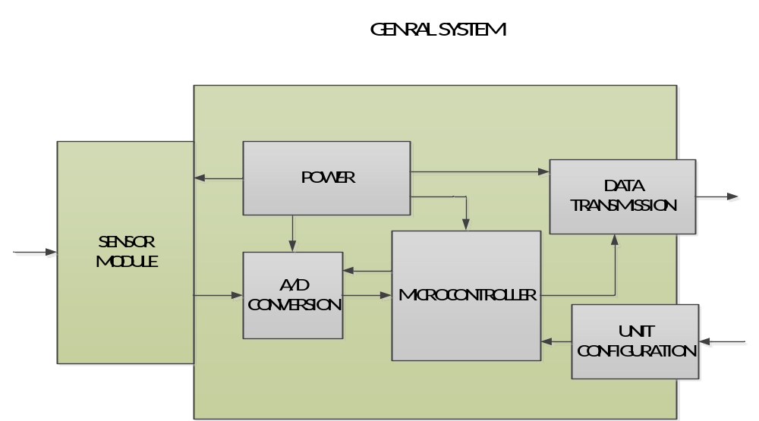

Sensor Interfacing
To reduce interfacing complexity, it is proposed that the sensors be modularized and all interfacing be done through one standard connection. This allows the capability to use a variety of sensors and sensor topologies yet still interface with the base unit for data collection. 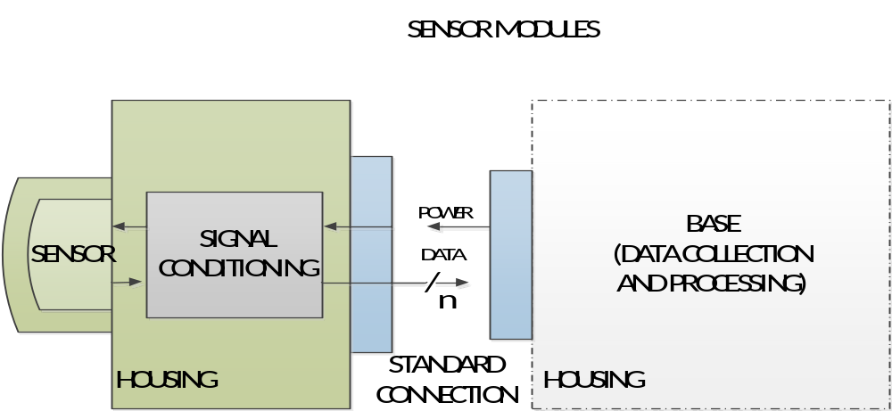

Timeline

Overview
The Timeline is currently only populated with milestones. These milestones are designed to dictate the general sequence of the project. Pending approval of the project as well as these milestones, the team will create a more robust timeline.

The main direction taken with these milestones is the functional prototype (3) at the end of the first term. This will be the half-way point of the project, and a functional prototype by then allots us the time to revise our approach to produce a more robust final product.

Milestones

Task Name |  |  | Deadline | Predecessors
1 Proposal |  |  | Sun 1/12/14 | N/A
2 Design Review One/ Begin Prototype |  |  | Fri 1/31/14 | 1
3 Functional Prototype |  |  | Sun 3/23/14 | 2
4 Design Review Two and Revision |  |  | Sun 4/6/14 | 3
5 Begin Final Project Assembly |  |  | Sun 4/20/14 | 4
6 Final Unit Completion |  |  | Sun 5/18/14 | 5
7 Present/Wrap Up |  |  | Fri 6/6/14 | 5

Budget

Development Costs
All costs are given in U.S. dollars. Development costs assume low enough quantities that there is no volume discount. Quantities assume two breadboard prototypes and two assembled PCB-based prototypes.

Item | Cost (Ea) | Quantity | Ext. Cost | Cost Factors
Sensor | 1.00 – 25.00 | 5 – 8 | 5.00 – 50.00₁ | Type, Quantity of each type
μController | 1.00 – 5.00 | 5 – 8 | 5.00 – 40.00 | Onboard features₂
Batteries | 0.75 – 12.00 | 5 – 16₃ | 12.00 – 60.00₃ | Rechargeable, composition, form factor
Passives₄ | 0.05 – 2.00 | 50 – 100 | 20.00 – 30.00₁ | Values and tolerances required
Interfaces₅ | 0.50 – 8.00 | 16 - 25 | 8.00 – 50.00 | Wireless vs. Wired
PCBs₆ | 4.00 – 18.00 | 4 - 6 | 24.00 – 48.00 | PCB Area, sensor requirements
Other SI₇ | 0.50 – 2.00 | 16 – 30 | 8.00 – 50.00₁ | Battery selection, sensor output
Packaging | 3.00 – 75.00 | 2 – 3 | 9.00 – 225.00 | Materials: laser-cut acrylic vs. 3D-printer
Total: |  |  |  |  | 100.00 – 500.00

- Extended cost does not scale linearly with quantity because it is assumed that the maximum quantity would not be entirely comprised of the most expensive components.
- Onboard features include ADC, power conditioning, amount of memory, etc
- Quantity and extended cost assume either a small amount of expensive rechargeable proprietary batteries, or a larger amount of cheap (AA or 9V) batteries.
- Resistors, capacitors, inductors, LEDs
- Antennas, transceivers, receivers, cable jacks
- Assumes a PCB for the base unit as well as separate PCBs for the interchangeable sensors.
Example: Minimum extended cost is based on a 2in x 2in base unit PCB with two 1in x 1in sensor PCBs at $2.00 per square inch, x2 prototypes.
- Other semiconductors: op-amps, voltage regulators, discrete transistors

BOM costs
Low Price-point Example: one base unit with two external interchangeable sensors. Single unit cost assuming volume is low enough that there are no quantity discounts.
Item | Cost (Ea) | Quantity | Ext. Cost | Notes
Sensor | 0.19, 5.99 | 2 | 6.18 | Temperature Sensor, CO sensor
μController | 1.36 | 1 | 1.36 | ATTiny84 – onboard ADC, 8KB flash
Batteries | 2.14 | 1 | 2.14 | Standard 9v Battery
Passives₄ | 0.05 – 0.50 | 10 | 3.00 | Misc resistors, capacitors, LEDs
Interfaces₅ | 0.50 | 4 | 2.00 | Generic jack for sensors, USB for base
PCBs₆ | 4.00 – 8.00 | 3 | 16.00 | 2”x2” base PCB, 1”x2” PCB per sensor
Other SI₇ | 0.50 | 0 | 0.00 | Assuming μC ADC can handle sensor output
Packaging | 3.00 | 1 | 3.00 | Laser-cut acrylic from EPL, hand assembled
Total: |  |  |  | $33.68

Appendix A: Terminology

Acronyms
Acronym | Meaning
ADC | Analog-to-Digital Converter
BOM | Bill of Materials
CO | Carbon Monoxide
EPL | The Portland State University Engineering and Prototyping Lab
K-12 | Kindergarten through 12th grade school
LED | Light Emanating Diode
PCB | Printed Circuit Board
SI | Silicon
STEM | Science, Technology, Engineering and Math
USB | Universal Serial Bus

Requirements
“Must”
The system design is not considered complete if these requirements are not satisfied.
“Should”
These requirements describe strongly desired features or options, but the product may be considered complete without them.
“May”
It would be nice to implement these features if time and budget allow.

Architecture

Base Unit
The central device that manages power, communication, and data storage, and has one or more sensors attached to it.

Sensor
The individual data collection devices such as VOC detectors and thermometers that are attached to the base unit.

User Interface
The program that will be run on a laptop or desktop computer that allows the user to view and interact with the data collected.

System
The operational product comprised of base units with attached sensors and a user interface.

www.ed.gov/stem
http://becpdx.org/nem/stemconnect.aspx

